ALERT Survey and Alignment Procedure

October 14, 2024

Bob Miller, Chris Gould, Bobby Mares

Contents

Target Location Repeatability 3

Survey Procedure 3

Clean Room Initial Survey 4

Prerequisite 4

Survey Procedure 5

Clean Room Survey after Cabling 6

Survey Procedure 6

Hall Alignment 7

ALERT without BAND 7

ALERT with BAND Installed and Cabled 8

Hall Alignment after Target Change 9

The ALERT detector will be surveyed and aligned at different stages of its assembly and installation in the Hall. The ALERT detector consists of a target straw, a drift chamber, and a time of flight detector. The entire assembly is aligned in the Hall to put the target straw axis on the beam line.

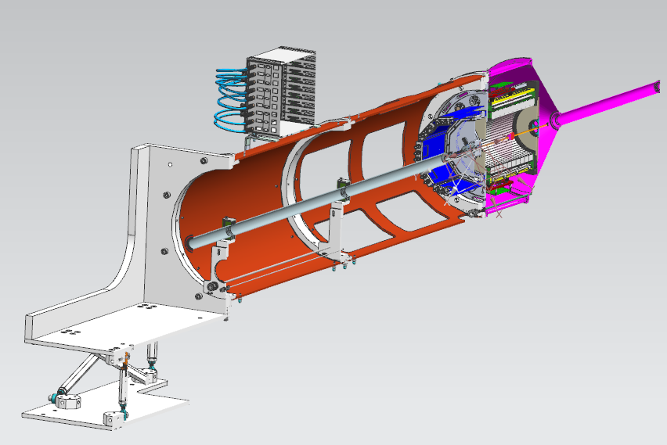

Detector Ring

Support Ring

Cantilever Mount

Gas Enclosure

Target Straw

Figure 1: ALERT on Support Tube and Mount

# Target Location Repeatability

If the target straw needs to be replaced in the Hall, does it need to be surveyed? This test will determine the target straw repeatability and the need for a survey in the Hall.

The target base is centered in the detector ring and really can not move, so it will not be measured. The downstream end of the target is centered by 2 rigid foam target support block halves. There is some clearance around the halves, so the target location will be measured.

## Survey Procedure

1. install the target
2. mark the top half of the target support block to the tooling support plate
3. use Faro arm to measure
   1. detector ring
   2. support ring
   3. target support block halves
4. pressurized the target to 68 psig
5. use CMM blue light scanner to measure the target straw downstream window frame outside diameter
6. reduce straw pressure to 0 psig
7. remove the target support block halves and reinstall to the mark from step 2
8. repeat steps 4-7, 2 times to determine the repeatability
9. if the repeatability is within 250 microns, then target straw changes will not require a survey

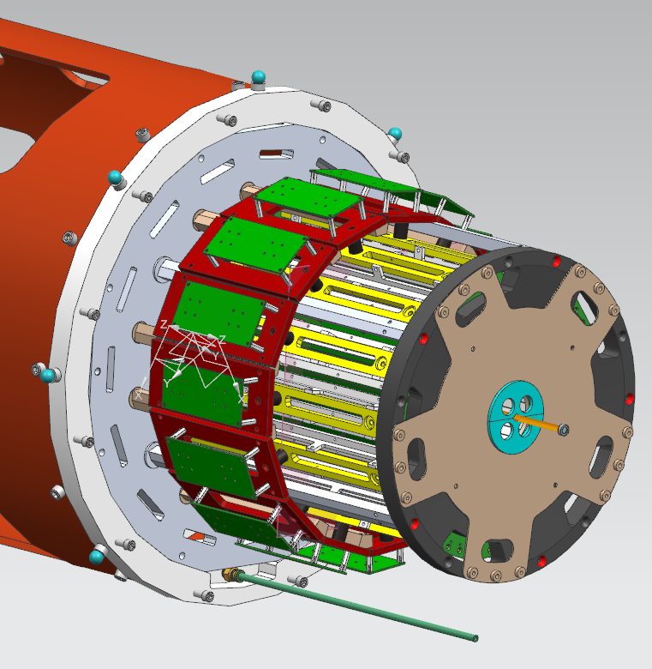

Figure 2: Downstream End of ALERT with Target Support Block Halves in Cyan

# Clean Room Initial Survey

## Prerequisite

* integration cart trolley bolted to cart stop
* integration cart leveled with feet extended to lift wheels off the ground
* cantilever mount installed with links set to mid span and leveled
* DC and ATOF installed
* target installed

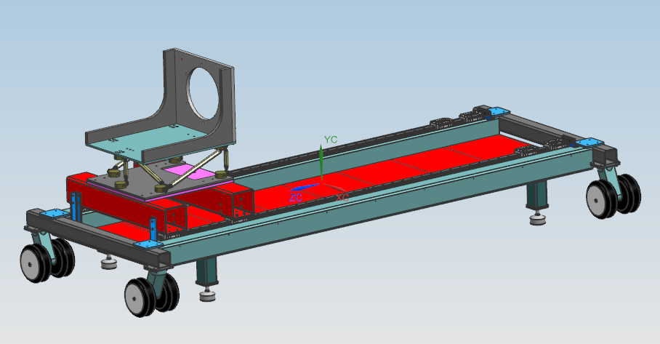

Cart Feet

Cart Stop

Cantilever Mount

Figure 3: Integration Cart

## Survey Procedure

1. use Faro arm to measure
   1. cantilever mount
   2. support tube ring
   3. detector ring
   4. target base outside diameter
   5. ATOF screws for roll
2. pressurize the target straw to 68 psig
3. use CMM blue light scanner to measure the target straw downstream window frame outside diameter
4. reduce straw pressure to 0 psig
5. set z axis based on target upstream and downstream centers
6. fiducialize target axis to detector ring
7. install beam tube in support tube
8. align beam tube mounts to put beam tube coaxial with target straw
9. install gas enclosure
   1. measure gas enclosure ds window frame
      1. compare to Z axis
   2. measure detector ring
   3. compare detector ring Y with and without gas enclosure
      1. if delta Y is more than 250 microns,
         1. remove gas enclosure
         2. add weight near detector ring to simulate gas enclosure until detector ring is at the same Y location as it was with the gas enclosure installed

# Clean Room Survey after Cabling

Cabling will add weight to the ALERT assembly and block access to the target base.

## Survey Procedure

1. remove the gas enclosure
2. add gas enclosure weight near detector ring if applicable
3. use Faro arm to measure
   1. cantilever mount
   2. support tube ring
   3. detector ring
4. pressurize the target straw to 68 psi
5. use CMM blue light scanner to measure the target straw downstream window frame outside diameter
6. reduce straw pressure to 0 psig
7. set z axis based on detector ring fiducial to target base outside diameter, and the target straw downstream window frame outside diameter
8. fiducialize the target straw location to the cantilever mount upstream face survey markers

# Hall Alignment

The BAND detector will block access to the survey markers on the support tube ring and the detector ring. Therefore, ALERT will be aligned without BAND initially, then aligned again after BAND is installed.

## ALERT without BAND

1. set CVT cart so that ALERT is just upstream of the CTOF inner diameter
2. set target pressure to 10 psig
3. set DC pressure to 1060 mbar
4. use the laser tracker to measure
   1. cantilever mount upstream face survey markers
   2. support tube ring
   3. detector ring
   4. gas enclosure downstream window frame
5. align ALERT to put the target straw coaxial with the beam line
6. move ALERT downstream until the gas enclosure downstream window frame is 500 mm upstream of Hall center
7. check the Moller cone location, and the gas enclosure downstream window frame X and Y location to make sure it will fit into the Moller cone
8. move ALERT to align ALERT center to solenoid center
   1. solenoid center is 176.99 mm downstream of detector ring
9. use the laser tracker to measure
   1. cantilever mount upstream face survey markers
   2. support tube ring
10. determine the offset of the target straw to the beam line axis
11. move ALERT upstream so it is out of the CTOF inner diameter and align
12. repeat steps 8-11 until the target straw is within 0.5 mm of the beam line axis

## ALERT with BAND Installed and Cabled

1. set CVT cart so that ALERT is just upstream of the CTOF inner diameter
2. set target pressure to 10 psig
3. set DC pressure to 1060 mbar
4. use the laser tracker to measure
   1. cantilever mount upstream face survey markers
5. align ALERT to put the target straw coaxial with the beam line
6. move ALERT downstream until the gas enclosure downstream window frame is 500 mm upstream of Hall center
7. check the Moller cone location, and the gas enclosure downstream window frame X and Y location to make sure it will fit into the Moller cone
8. move ALERT to align ALERT center to solenoid center
   1. solenoid center is 176.99 mm downstream of detector ring
9. use the laser tracker to measure
   1. cantilever mount upstream face survey markers
10. determine the offset of the target straw to the beam line axis
11. move target upstream so it is out of the CTOF inner diameter and align
12. repeat steps 8-11 until the target straw is within 0.5 mm of the beam line axis

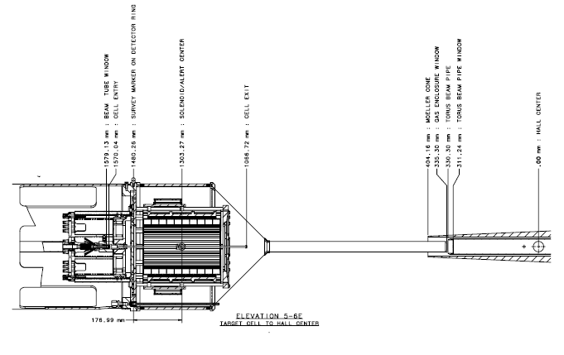

Figure 4: Gas Enclosure fits inside of Moller Cone

# Hall Alignment after Target Change

A target change in the Hall will require the removal of the gas enclosure and some cables. The repeatability test will determine if a target survey is required for target changes.