ALERT Target Installation and Replacement Procedures

August 27, 2024

**Target Initial Installation**

1. Insert target straw assembly into 24” installation wand
   * Mount the installation wand gently in a soft jaw vice, vertically, with the upstream threaded end facing up
   * Lower the target straw into the tooling
   * Thread the target base onto the installation wand
2. Install tooling support plate on ALERT downstream ring, torque M5 screws to 1.5 Nm (13 in-lbs)
3. Install nylon downstream centering ring and bolt it to the tooling support plate, torque M5 screws to 1.5 Nm (13 in-lbs)
4. Install the target:
   * Feed installation wand, from the upstream end of ALERT, into the upstream plate
   * Clock the target so the gas fitting is at the 11 o’clock position and the target holes line up with the studs
   * Insert the target until the shaft goes through the nylon downstream centering ring and the target assembly rests on the upstream plate
5. Bolt the target assembly to the upstream plate, torque the M4 nuts to 1.5 Nm (13 in-lbs)
6. Connect the 1/8” tube to the target and leak test the target and tube assembly per the ALERT Target Straw Leak Test Procedure
7. Remove the 24” tooling shaft
   * Unthread tooling shaft from target assembly
   * Slide tooling shaft downstream, all the way out (the nylon downstream centering ring will prevent the tooling shaft from hitting the drift chamber)
8. Remove the nylon downstream centering ring – avoid hitting the target straw
9. Install the downstream target straw support halves and tape into position

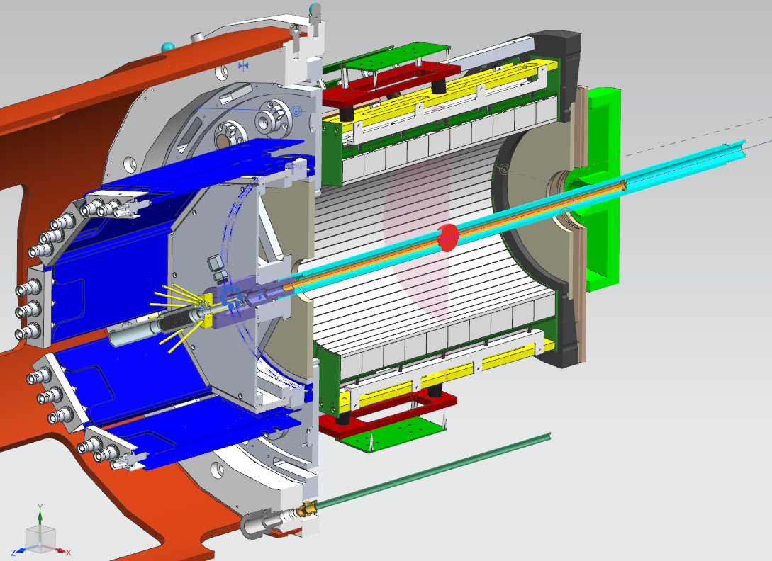

Tooling support plate (brown)

Nylon downstream centering ring (green)

Installation wand (cyan)

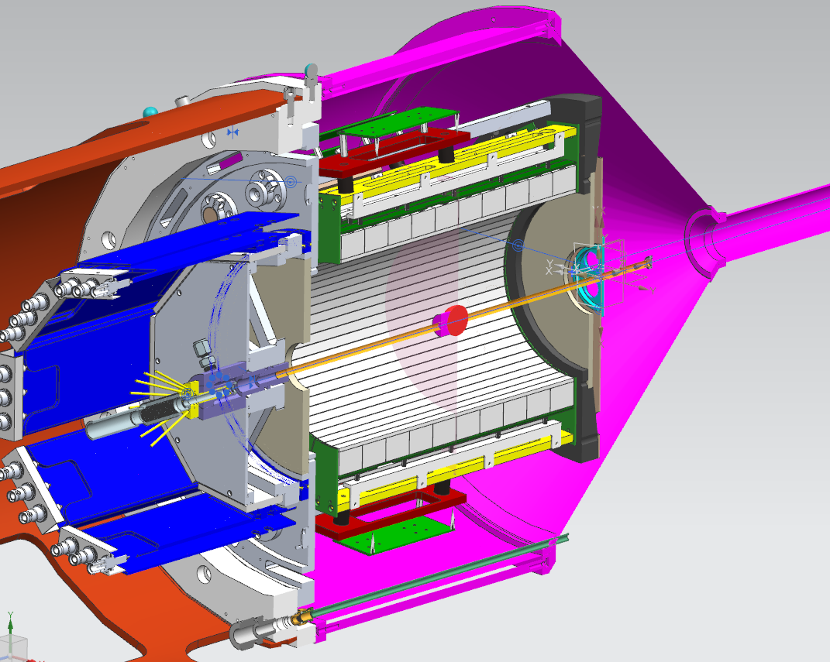

Gas Enclosure -Pink

Upstream Beam Tube - Gray

BOM - Yellow

**Target Replacement**

1. Purge target with N2, then reduce pressure to 0 psi
2. Remove any covers over the ALERT support tube access holes and move cables to gain access to the target
3. Turn off BOM, remove beam tube and BOM
4. Disconnect gas line fitting from target assembly
5. Remove gas enclosure
6. Mark orientation and remove target straw support halves
7. Install tooling support plate on ALERT downstream ring, torque M5 screws to 1.5 Nm (13 in-lbs)
8. Guide nylon downstream centering ring over the straw and bolt it to the tooling support plate, torque M5 screws to 1.5 Nm (13 in-lbs)
9. Install tooling on the target
   1. locate the installation wand and orient it so the internal threads are facing ALERT
   2. position the wand over the straw and insert it into the installation guide
   3. insert the wand until it hits the target base, then thread the want onto the target base until it bottoms out
10. Remove the target
    1. remove 3 nuts securing the target base to ALERT
    2. move the target upstream until the wand clears the ALERT upstream plate
    3. remove target and tooling through support tube access ports
11. Install the target:
    1. the new target straw should already be installed in the installation wand
    2. Feed tooling shaft, from the upstream end of ALERT, into the upstream plate
    3. Clock the target so the gas fitting is at the 11 o’clock position and the target base holes line up with the studs
    4. Insert the target until the shaft goes through the nylon downstream centering ring and the target assembly rests on the upstream plate
12. Bolt the target assembly to the upstream plate with 3 nuts, torque the M4 nuts to ...
13. Connect the 1/8” tube to the target and leak test the target and tube assembly per the ALERT Target Straw Leak Test Procedure
14. Remove the 24” installation wand
    1. Unthread tooling shaft from target base
    2. The upstream 1” of the installation wand is painted red so you will know when the installation wand will clear the installation guide. At this point, the wand must be held so it does not hit the straw.
    3. Slide the wand downstream, all the way out (the nylon downstream centering ring will prevent the tooling shaft from hitting the drift chamber)
15. Remove the nylon downstream centering ring – avoid hitting the target straw
16. Remove the tooling support plate – avoid hitting the target straw
17. Install the downstream target straw support halves and tape into position
18. Connect the gas line fitting to the target assembly
19. Use the gas controls to pressurize the target with N2 to system pressure and leak check fitting. Conduct leak down test by closing target supply, return, and N2 purge valves. Target should not lose any pressure for 10 minutes
20. Install the gas enclosure
21. Install BOM and beam tube
    1. Pump down beam tube to verify window integrity
    2. Install Tedlar layer to BOM to make it light tight
    3. Turn on BOM and test
22. Install the cover over the support tube