ALERT Target Straw Leak Test Procedure

October 14, 2024

Bob Miller

Contents

Initial Leak Test 2

Leak Test after Installation into ALERT Detector 3

Leak Test after Connection to the Gas Panel 4

Failed Straw Removal 5

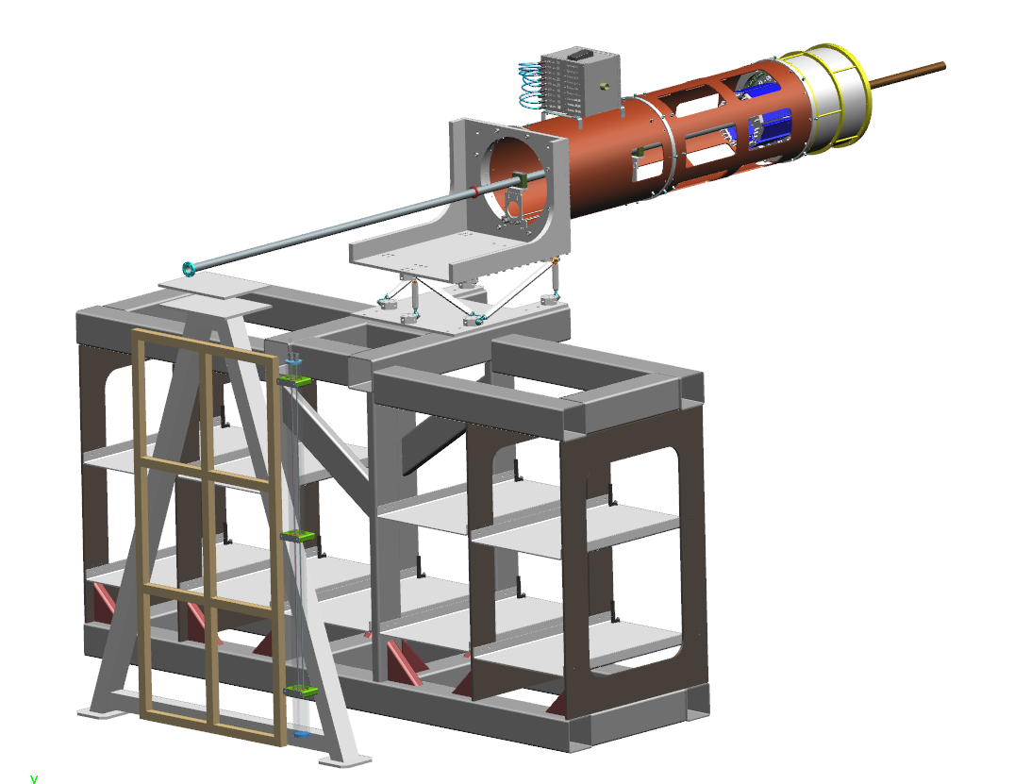

Target Straw Connector

Bulkhead Connector

Gas Panel

Figure 1: Gas Panel and ALERT Target

# Initial Leak Test

The initial leak test will be done with N2 at 90 psig for 12 hours.

1. Assemble the target straw and install the installation wand over the straw
2. Assemble the target test system per drawing BL2401-03-07-PD02
3. Connect the target to the target test system with 27” of ¼” OD tubing
   1. this is the same volume as the full length 1/8” tubing that will be used in the Hall
   2. the same length tubing will result in the same fill and discharge time
4. Set the regulator to 68 psig for straw purging
5. Purge the straw 5 times between 5-68 psig to remove any moisture
6. Set the regulator to 90 psig for leak testing
7. Fill the straw to 90 psig and leak check all connections
8. Record straw pressure and close isolation valve to the straw for a leak down test
9. Wait 30 minutes and record pressure
   1. if pressure is above 85 psig, move to the next step
   2. if pressure has dropped below 85 psig, recheck all connections
   3. if connections are leak tight, the straw has failed
10. Open the isolation valve to the straw and maintain 90 psig for 12 hours
11. Record straw pressure and close isolation valve to the straw for a leak down test
12. Wait 30 minutes and record pressure
    1. if pressure has dropped to below 85 psig, recheck all connections
    2. if connections are leak tight, the straw has failed
13. Reduce the straw pressure and disconnect from the target test system
14. Leave connection open to maintain straw at atmospheric pressure

# Leak Test after Installation into ALERT Detector

The target straw has previously been proven leak tight at 90 psig, so this leak check is just for the connections from the straw adapter to the bulkhead connector at the upstream end of the support tube.

1. Install the target in the ALERT detector
   1. leave the target installation wand on the target until after the leak test
2. Connect the 1/8” SST tube from the bulkhead connector to the target
3. Connect the target from the bulkhead connector to the target test system with 16” of ¼” OD tubing
   1. this is the same volume as the full length 1/8” tubing that will be used in the Hall
   2. the same length tubing will result in the same fill and discharge time
4. Use 80 psig relief valve (McMaster 9889K685) on test rig, or use gas panel with 82 psig relief valve
5. Set the regulator to 68 psig for straw purging
6. Purge the straw 5 times between 5-68 psig to remove any moisture
7. Fill the straw to 68 psig and leak check all connections
8. Record straw pressure and close isolation valve to the straw for a leak down test
9. Wait 30 minutes and record pressure
   1. if pressure is above 60 psig, move to the next step
   2. if pressure has dropped below 60 psig, recheck all connections
   3. if connections are leak tight, the straw has failed
10. Open the isolation valve to the straw and maintain 68 psig for 12 hours
11. Record straw pressure and close isolation valve to the straw for a leak down test
12. Wait 30 minutes and record pressure
    1. if pressure has dropped to below 60 psig, recheck all connections
    2. if connections are leak tight, the straw has failed
13. Reduce the straw pressure and disconnect from the target test system
14. Leave connection open to maintain straw at atmospheric pressure

# Leak Test after Connection to the Gas Panel

The target straw has previously been proven leak tight at 90 psig, so this leak check is just for the connections from the bulkhead connector at the upstream end of the support tube to the gas panel.

Prerequisites:

1. Gas pad gas panel is installed and leak checked per “Leak and Pressure test procedure for Hall B Bonus pressure systems PS-PHY-19-003 and PS-PHY-19-004”
2. Hall gas panel is installed and leak checked per “Leak and Pressure test procedure for Hall B Bonus pressure systems PS-PHY-19-003 and PS-PHY-19-004”
3. Target straw has been leak checked
4. Connections at target and bulkhead connector have been leak checked
5. N2 target gas is connected and pressure set to 68 psig

Procedure

1. Connect the target from the bulkhead connector to the gas panel with 1/8” OD stainless steel tubing
2. Purge the straw 5 times between 5-68 psig to remove any moisture
3. Fill the straw to 68 psig and leak check the connections from the target from the bulkhead connector to the gas panel

# Failed Straw Removal

1. Tie thin wire around downstream window to hold straw tight
2. Install downstream target wand installation guide
3. Use conduit instead of wand, (SST 0.71" OD, 0.62" ID, 1831T11, $87, cut and debur to 30” long)
4. Feed thin wire through conduit
5. Feed conduit over straw while holding some tension on thin wire, until conduit goes over threaded target base
6. Cut thin wire at end of conduit
7. Remove target nuts
8. Push target upstream with conduit until conduit is near the installation guide
9. Pull conduit from upstream end until it and the target are out of ALERT

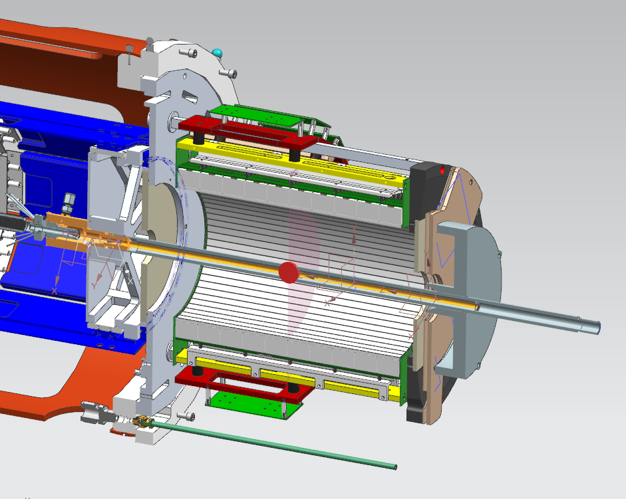

Installation Wand

Target Base

Installation Guide

Figure 2: Target Straw and Tooling in ALERT