Viewing Employee Time Sheets  Supervisors and Division Coordinators can view employee timesheets by selecting the search option while on the timesheet screen | 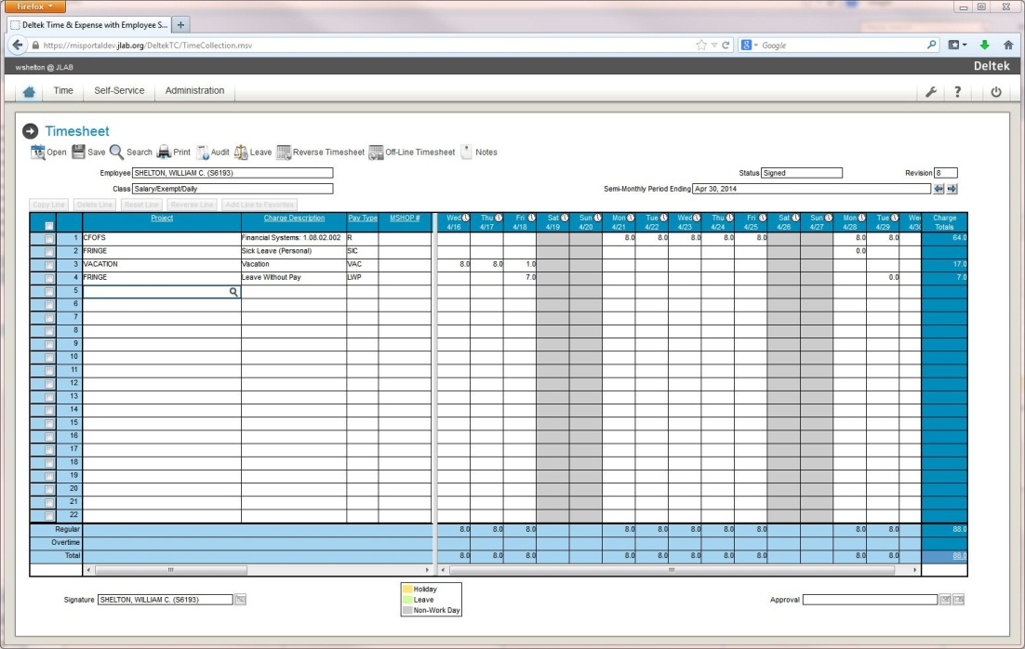
Select the timesheet period  Function  To view timesheets of your direct reports, select the functional role of Primary Supervisor  To view timesheets for employees of your direct reports, select the functional role of Backup Supervisor | 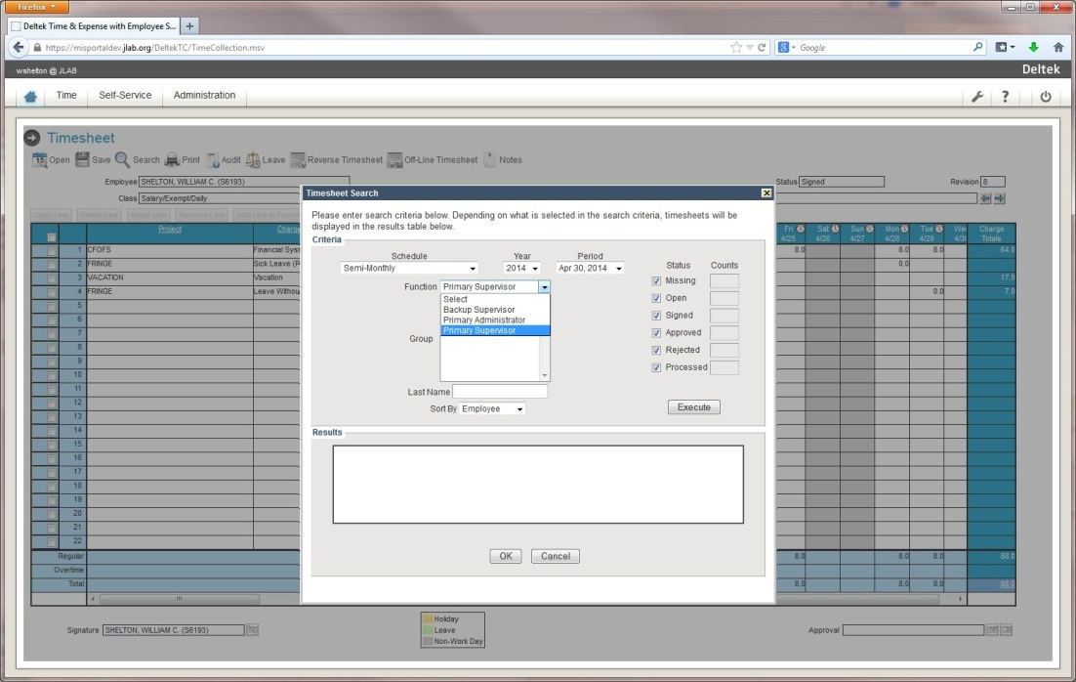  - Not everyone will have the same functional roles, some may be only Primary Supervisors, some may be only Division Coordinators  - The Division Coordinator role is available only to a few employees in each division
Highlight the group for which you want to view timesheets  Status  Once the functional role has been selected, click beside the boxes in the status section to select specific timesheet statuses | 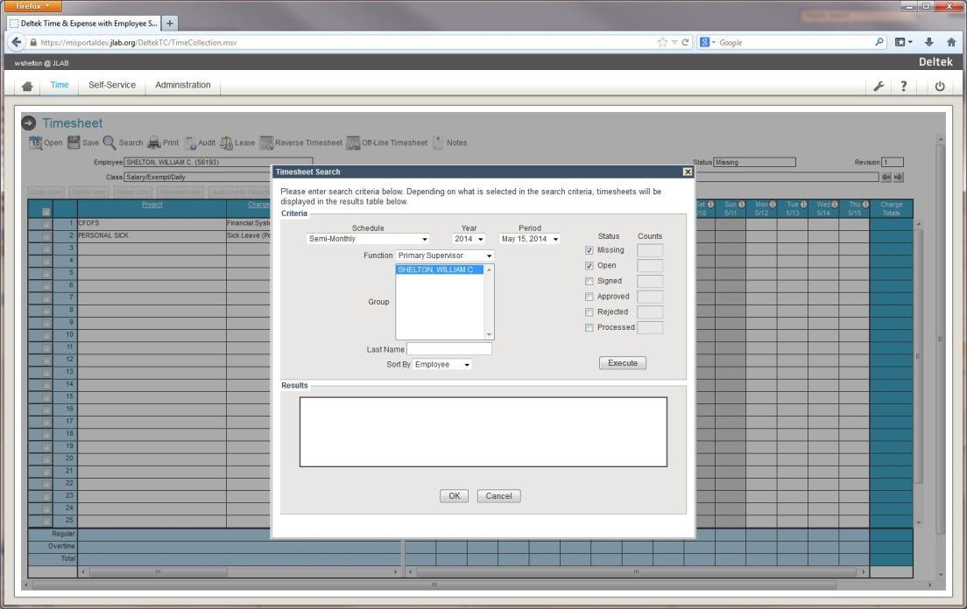  - Missing – Timesheet has not been updated at all  - Open – Timesheet has been saved, but may not be complete  - Signed – Timesheet has an employee-type signature  - Approved – Timesheet has been approved by someone in a supervisory role  - Rejected – Timesheet was rejected by someone in a supervisory role  - Processed – Timesheet was pulled in and processed for payroll

Click on Execute once the Period, Function, and Status types have all been selected  To view a specific timesheet, click the check box next to the employee’s name  Click on OK | 