AN ANALYSIS OF “EXPANSION EXPERIMENT” IN SEPTEMBER 2010

Byung C. Yunn

November 30, 2010

Experiment
Time: September 23, 2010 - September 27, 2010
Description: Temperatures of LCW in east arcs (arcs 1, 3, 5, 7, 9) were raised resulting in expansion of arcs in the East Arc region. During the experiment temperature at various elements was measured every 10 minutes, and path length was measured at roughly one to two hour intervals.

Data
Temperature data are in TestAverage600.csv (by J. Benesch)
Path length data are recorded in the elog by capturing scope images. Picture quality is generally very poor. An improvement on data quality is highly desirable.

Analysis
Path length data from 9/23/2010 16:57:25 to 9/26/2010 10:54:06 are used. Path length was adjusted right after the last data were taken. Otherwise one could have had one more day of useful data taking.

It is reasonable to expect and I assume any path length changes due to warming up happening only in east arcs based on experimental condition. In order to estimate total path length change one needs to find a change in arc 1 which can be found in principle from NL scope images. Any changes in the rest of arcs can be found from SL scope images. Scope picture data are in unit of millivolt and need to be converted to path lengths in RF degree. For the completion of this analysis I adopted the conversion factor of 10 mV/degree in both NL and SL. It must be noted here that there exists a recent scope calibration (elog entry #1548673) reporting the conversion factor of 15.7 mV/degree in NL and 21.6 mV/degree in SL. This result is not without a problem (by M. Spata). In any case it is easy to rescale results in this paper with more accurate conversion factor, if found later.

First I had to post-process scope images with the software xv as the picture quality of scope images is very bad in about half of the data taken. Results are summarized in the following Table.

Table. Path length measurements during an expansion test in the east arc.

Date | Temp (F) | 1L-3L (mV) | 2L-AL (mV) | 1L-3L (deg) | 2L-AL (deg) | Total (deg)
9/23 16:57:25 | 87.5 | 0 | 0 | 0 | 0 | 0
9/23 17:48:29 | 87.55 | 0 | 0 | 0 | 0 | 0
9/23 18:45:19 | 87.7 | 0 | -1.7 | 0 | -0.17 | -0.17
9/23 19:47:35 | 87.7 | 0 | 1.7 | 0 | 0.17 | 0.17
9/23 21:12:27 | 87.8 | 0 | 5 | 0 | 0.5 | 0.5
9/23 21:50:06 | 87.85 | 3.6 | 1.7 | 0.36 | 0.17 | 0.53
9/23 22:51:21 | 87.9 | 4.3 | 5 | 0.43 | 0.5 | 0.93
9/23 23:57:54 | 88.0 | 4.3 | 6.7 | 0.43 | 0.67 | 1.1
9/24 00:47:37 | 88.05 | 3.6 | 6.7 | 0.36 | 0.67 | 1.03
9/24 01:56:09 | 88.05 |  | 7.5 |  | 0.75 | 0.75
9/24 03:12:46 | 88.2 |  | 8.3 |  | 0.83 | 0.83
9/24 03:44:37 | 88.2 |  | 8.3 |  | 0.83 | 0.83
9/24 05:25:10 | 88.2 | 3.6 | 10 | 0.36 | 1.0 | 1.36
9/24 06:08:28 | 88.3 | 4.3 | 11.7 | 0.43 | 1.17 | 1.6
9/24 08:50:45 | 88.5 |  | 13.3 |  | 1.33 | 1.33
9/24 09:51:09 | 88.6 |  | 15 |  | 1.5 | 1.5
9/24 11:06:15 | 88.6 |  | 13.3 |  | 1.33 | 1.33
9/24 11:48:02 | 88.7 | 2.9 | 13.3 | 0.29 | 1.33 | 1.62
9/24 12:52:07 | 88.6 | 4.3 | 15 | 0.43 | 1.5 | 1.93
9/24 13:12:39 | 88.6 | 4.3 | 15 | 0.43 | 1.5 | 1.93
9/24 17:16:05 | 89.0 | 8.6 | 19.2 | 0.86 | 1.92 | 2.78
9/24 18:12:27 | 88.9 | 2.9 | 25 | 0.29 | 2.5 | 2.79
9/24 18:59:24 | 89.0 | 5.7 | 23.3 | 0.57 | 2.33 | 2.9
9/24 20:05:56 | 89.0 | 5.7 | 28.3 | 0.57 | 2.83 | 3.4
9/24 21:09:24 | 89.1 | 4.3 | 30 | 0.43 | 3.0 | 3.43
9/24 22:23:29 | 89.1 | 7.9 | 35 | 0.79 | 3.5 | 4.29
9/24 23:22:37 | 89.1 | 5.7 | 33.3 | 0.57 | 3.33 | 3.9
9/25 00:01:18 | 89.15 | 5.7 | 36.7 | 0.57 | 3.67 | 4.24
9/25 02:10:24 | 89.3 | 7.1 | 38.3 | 0.71 | 3.83 | 4.54
9/25 04:10:45 | 89.25 | 5.7 | 40 | 0.57 | 4.0 | 4.57
9/25 05:07:44 | 89.3 | 7.1 | 40 | 0.71 | 4.0 | 4.71
9/25 06:07:28 | 89.3 | 5.7 | 41.7 | 0.57 | 4.17 | 4.74
9/25 07:09:18 | 89.3 | 7.9 | 41.7 | 0.79 | 4.17 | 4.96
9/25 10:41:05 | 89.4 | 5.7 | 42.5 | 0.57 | 4.25 | 4.82
9/25 17:36:38 | 89.55 | 9.3 | 44.2 | 0.93 | 4.42 | 5.35
9/25 19:20:45 | 89.35 | 12.9 | 50 | 1.29 | 5.0 | 6.29
9/25 20:58:01 | 89.4 | 10.0 | 53.3 | 1.0 | 5.33 | 6.33
9/26 00:00:36 | 89.3 | 12.9 | 55 | 1.29 | 5.5 | 6.79
9/26 01:46:39 | 89.2 | 10.7 | 59.2 | 1.07 | 5.92 | 6.99
9/26 10:54:06 | 89.0 | 10.0 | 55.8 | 1.0 | 5.58 | 6.58

The first column: time when data were taken.
The second column: temperature at concrete – 5 ft high.
The third column: difference between 1L and 3L which measures a path length change in arc 1.
The fourth column: difference between 2L and AL which measures a path length change in arc 2 through arc 9.
The fifth column: path length change in arc 1 (in RF degree).
The sixth column: cumulative path length change in arc 2 through arc 9 (in RF degree). The seventh column: total path length change in RF degree (the fifth column + the sixth column).

Figure 1. Temperature vs. time.
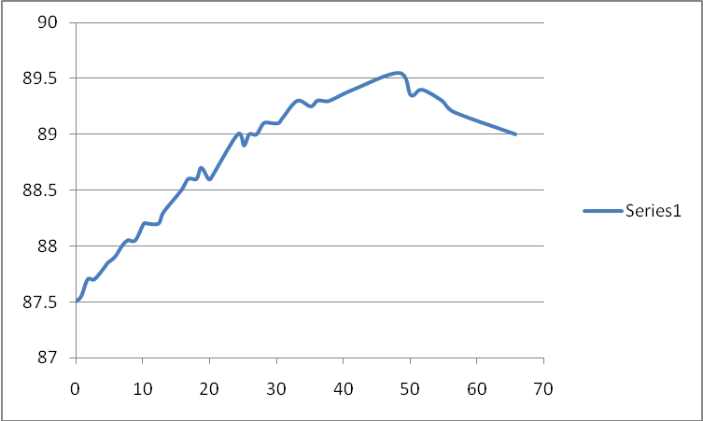

Figure 2. Path length change in arc 1 (in mV) vs. time.
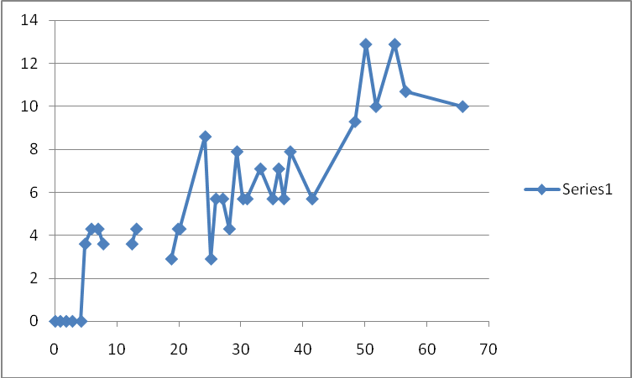

Figure 3. Path length change in arc 2 – arc 9 (in mV) vs. time.
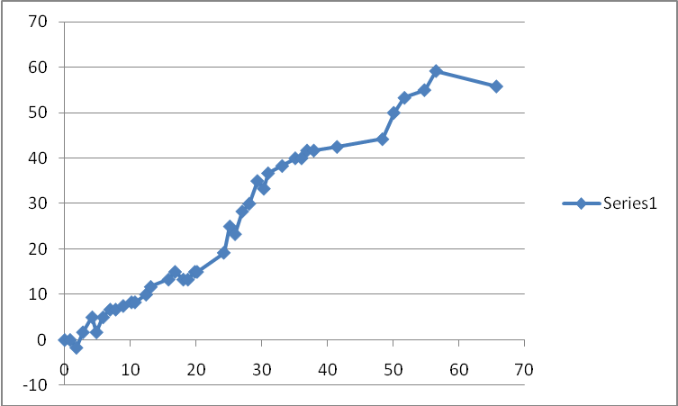

Figure 4. Path length change in arc 1 (in deg) vs. time.
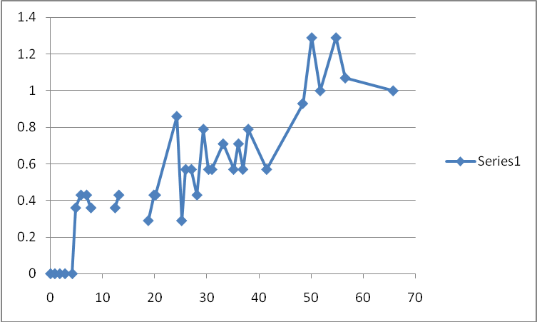

Figure 5. Path length change in arc 2 – arc 9 (in deg) vs. time.
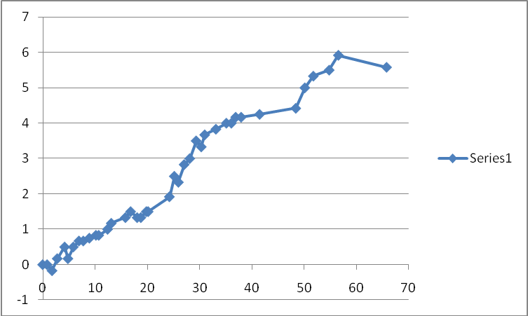

Figure 6. Total path length change (in deg) vs. time.
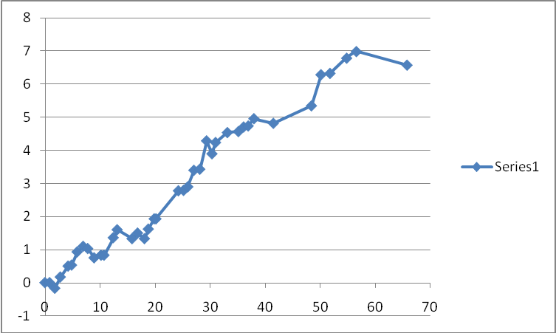

Figure 7. Total path length change (in deg) vs. temperature.
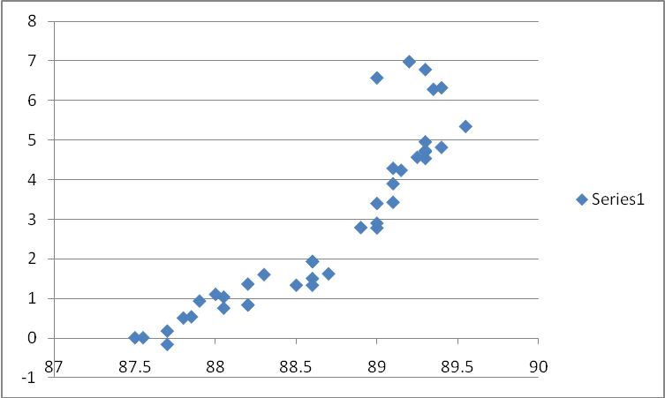

Conclusions
Several qualitative observations can be made.
- Maximum temperature change for the duration of the experiment was about 2 degrees in F with a linear rise and fall with time.
- Path length change in arc 1 is about 1.2 RF degrees.
- Path length change in the rest of arcs is about 6 RF degrees.
- Total path length change is about 7 RF degrees with roughly linear variation with time.
- Total path length change also varies linearly with temperature. However, it appears to have some memory (i.e. double valued as can be seen in Figure 7.).

