First look at arc BLM activity before/after seed laser swap
Jay Benesch

During the FY20 physics run, regions in the higher arcs have been activated in a manner never before seen. Chopper viewer images suggested a tail on the C beam was a cause of the difficulty. Accordingly, on March 19 while Hall C was down to switch experiments from a1n to d2n, the laser seeds for B and C were swapped. The B beam is defined by a narrow chopper slit and is low current so it it less likely than C beam, which passes through an open slit, to contain a tail. Response of selected BLMs in arcs 1 and 2 as a function of A and C current were compared for three six hour periods:

A. March 10 1400-2000 with both high current halls, before the laser seed swap
B. March 20 0700-1300 with Hall A the only high current hall
C. March 23 0100-0700 with both high current halls, after the laser seed swap

Arc 1 BLMs 04, 09, 16, 22, 29, 33 and 37 were downloaded for the six hour periods. Arc 2 BLMs 4, 10, 16, 23, 29, 32 and 36 were also downloaded. The less correlated BLMs are shown first and ignored thereafter.
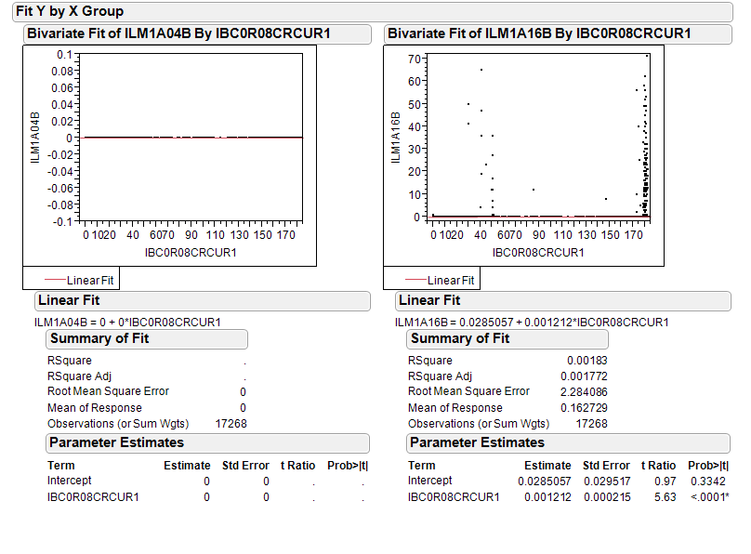
Figure 1. Arc 1 BLMs with no correlation to total current in arc. Period A, before seed change.

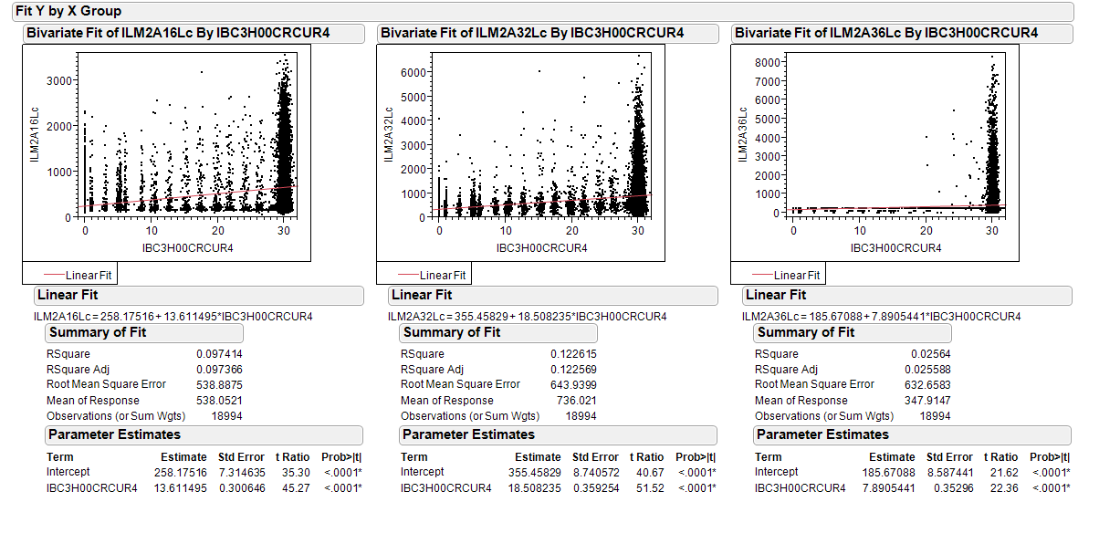
Figure 2. Arc 2 BLMs with little or no correlation to Hall C current. Period A, before seed change.

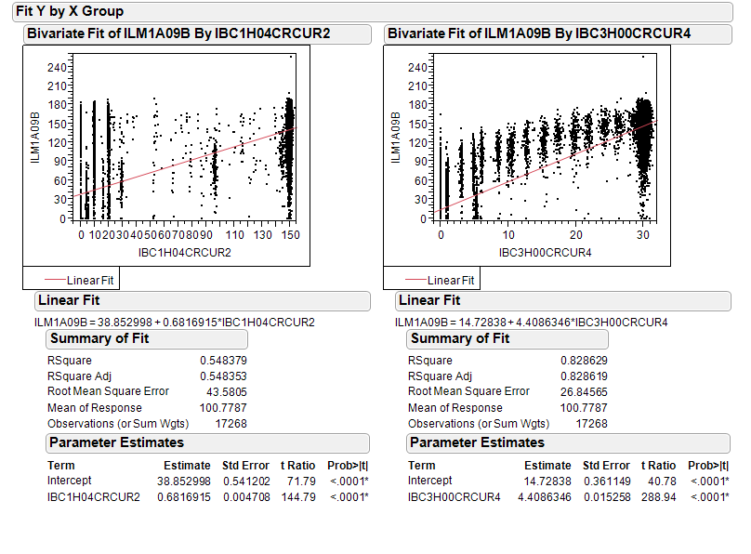
Figure 3. ILM1A09 vs Hall A and Hall C currents with both in the machine, before seed change. Correlation with Hall C (3H00) current is better than with Hall A, even though Hall A has five times the current for most of the period.

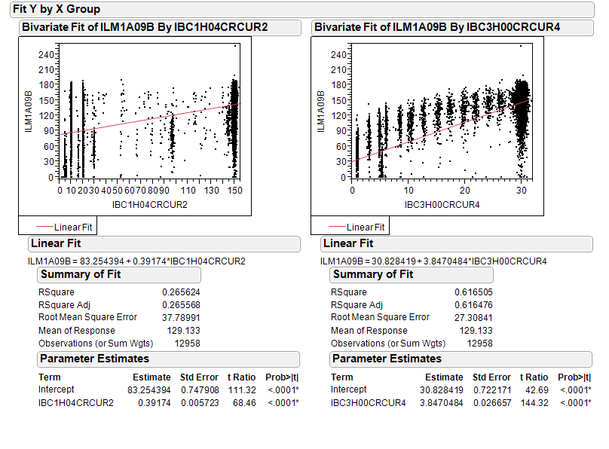
Figure 4. Same as figure 3 except points with both A and C currents under 1 µA are removed. Cutting out the near-zero currents reduced R² for Hall A current by just over half while it reduced R² for Hall C current by only a fourth. This suggests that Hall C beam was responsible for the majority of the BLM activity even in arc 1 where Hall A current is five times as great.

I will now proceed to waste space by showing similar plots for the other four arc 1 BLMs whose data for period A I have on hand.
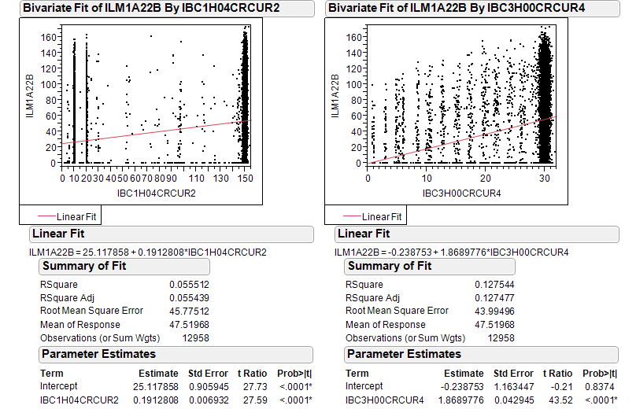
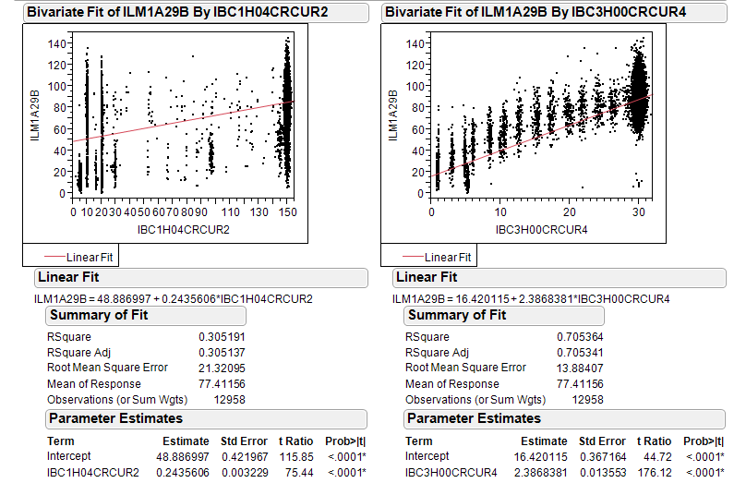
Figure 5. ILM1A22 is almost useless, so I won’t show it again.
Figure 6. ILM1A29 has much better correlation with current
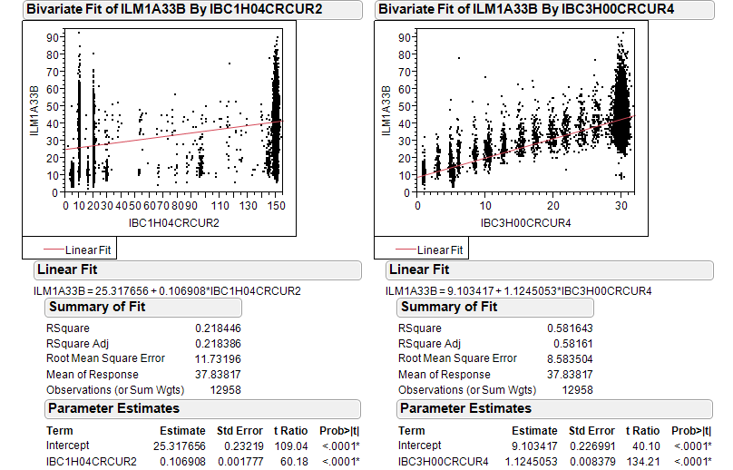
Figure 7. ILM1A33 vs currents
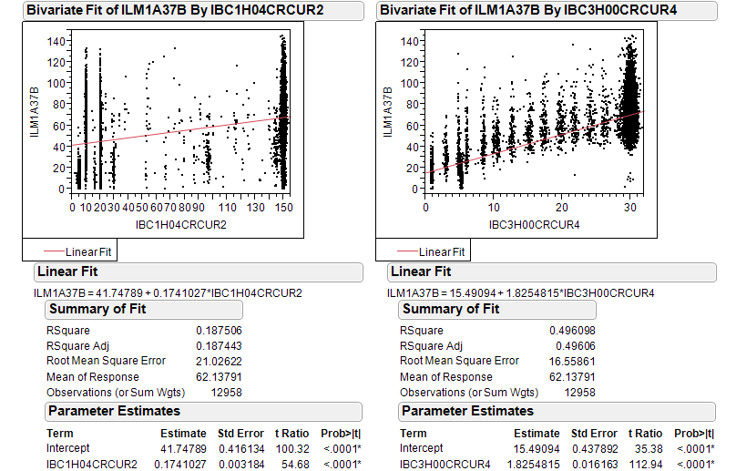
Figure 8. ILM1A29 vs currents
I conclude that before the laser seed swap that the Hall C beam was the cause of perhaps two-thirds the arc 1 BLM activity. I will now examine period B when Hall C was off for ILMs 9, 29, 33 and 37.
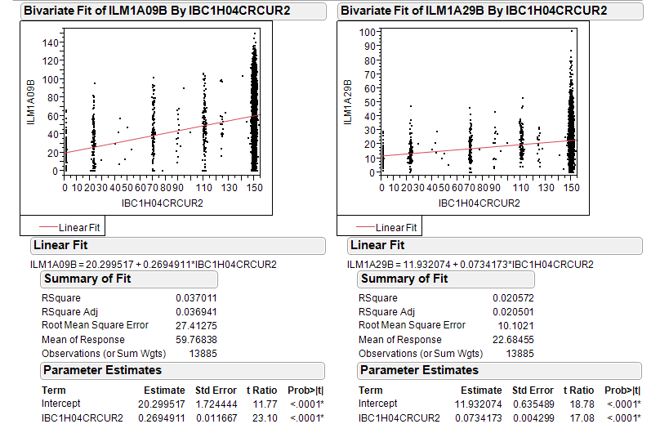
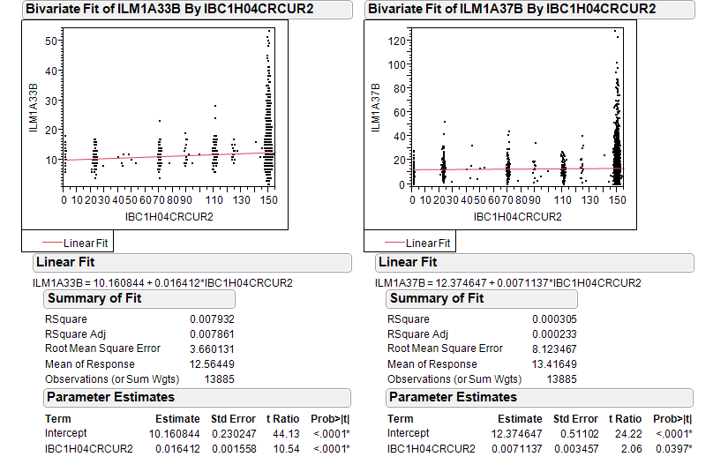
Figure 9: BLMs 9 and 29 with only Hall A, B and D beam in the machine.
Figure 10. BLMs 33 and 37 with only Hall A, B and D beams in the machine
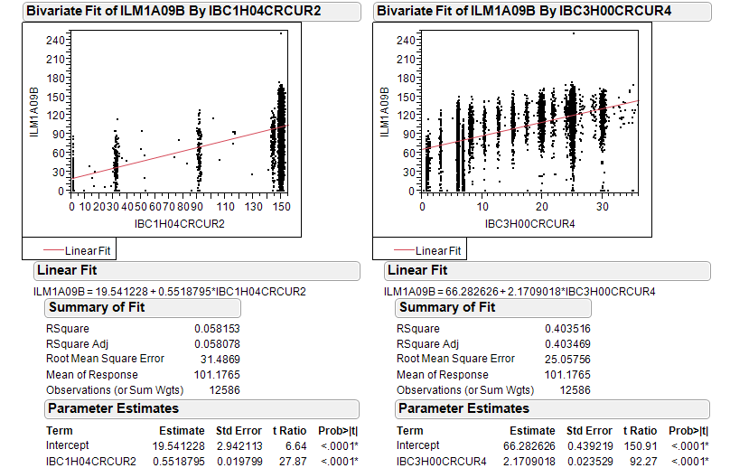
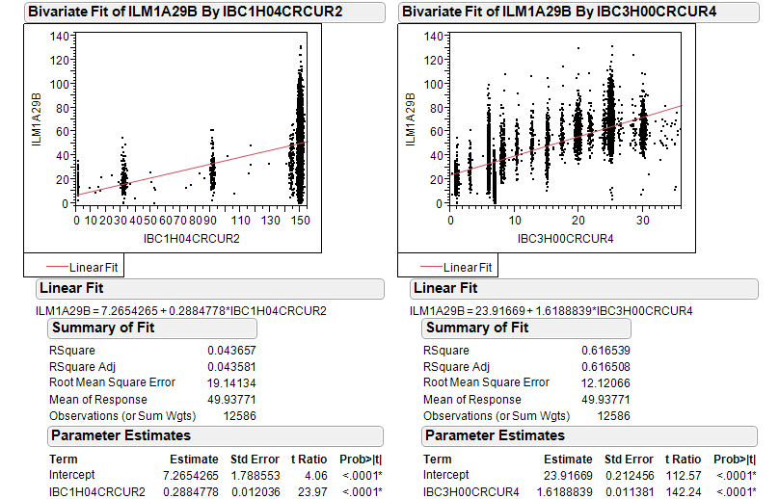
Figure 11. BLM after seed swap with four halls operating, period C. Points removed if both A,C<1.
Figure 12. BLM 1A29 after seed swap with four halls operating.
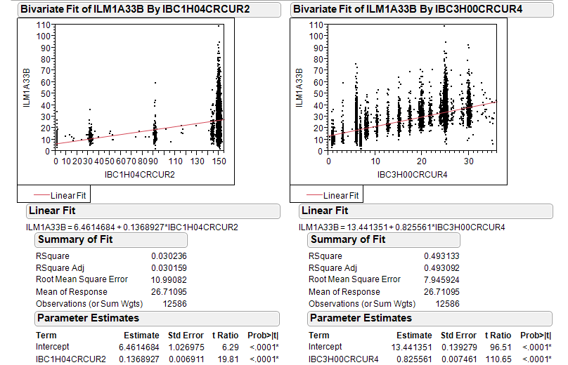
Figure 13. BLM 1A33 after seed swap with four halls operating.
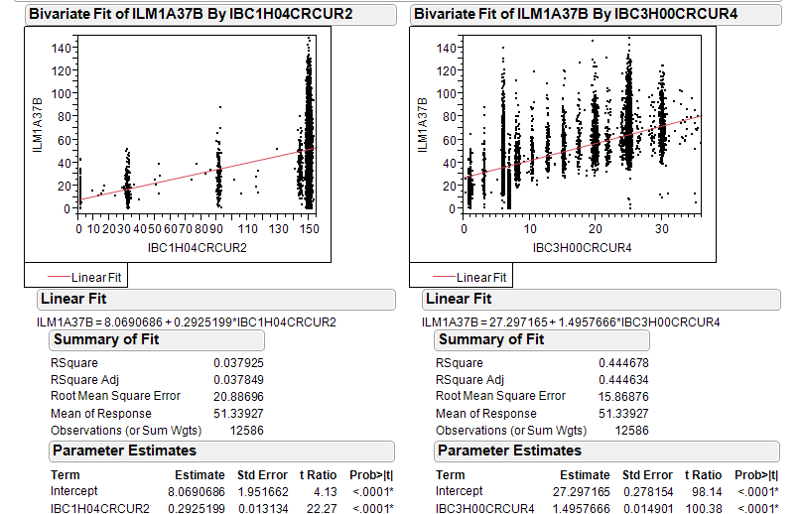
Figure 14. BLM 1A37 after seed swap with four halls operating.
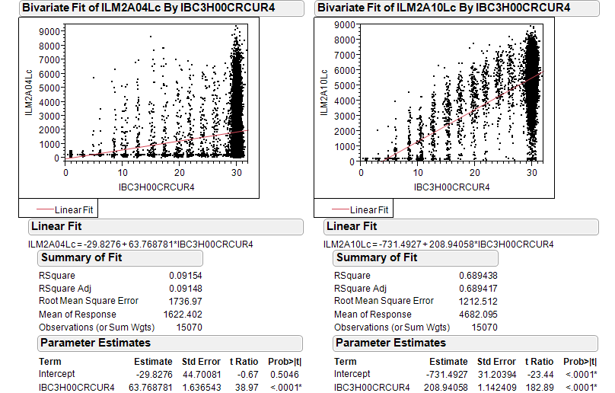
Figure 15. Arc 2 BLMs with Hall C > 1 µA before seed change. Note scale difference vs arc 1.
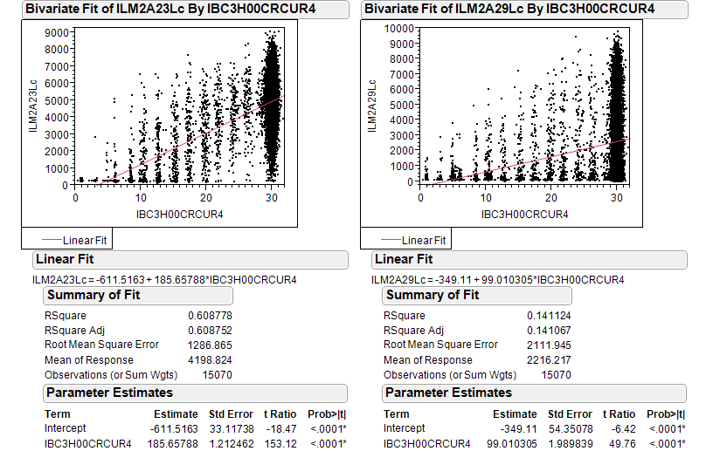
Figure 16. Arc 2 BLMs with Hall C > 1 µA before seed change.
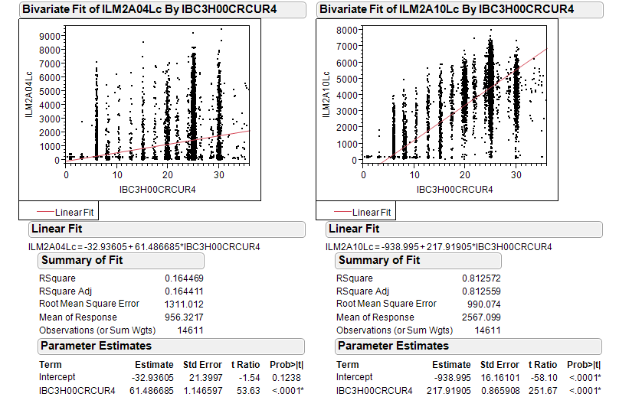
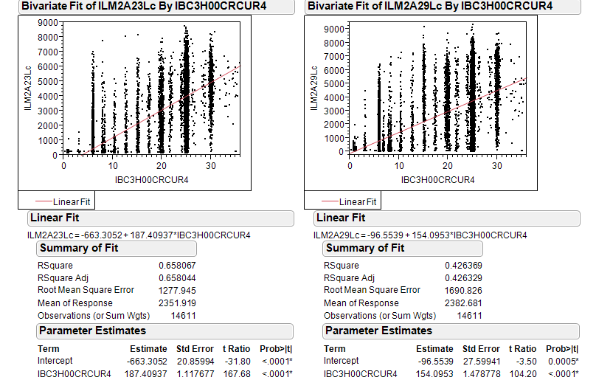
Figure 17. Arc 2 BLMs after seed change with Hall C > 1 µA.
Figure 18. Arc 2 BLMs after seed change with Hall C > 1 µA.
Unfortunately, if I evaluate the linear fits at 30 uA I find that there is modestly less BLM activity attributable to Hall C beam in arc 1 and no significant change in arc 2 except doubling 2A29. Compare the last two columns in the table below. Scale of BLM response is very different in Arc 1 vs Arc 2.

Table 1. Linear fit coefficients and values at 30 uA before and after the laser seed change.
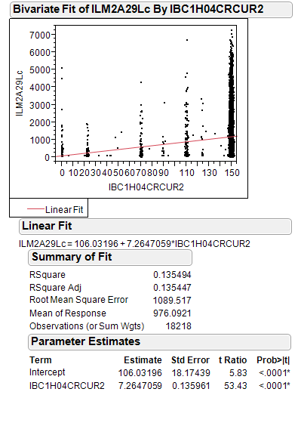

Figure 19. In an attempt to understand the last line of the table, I plot response of 2A29 BLM against Hall A current while Hall C was down. It appears that about half the discrepancy can be explained by either B and D beam or signal leakage. Replace the PMT?

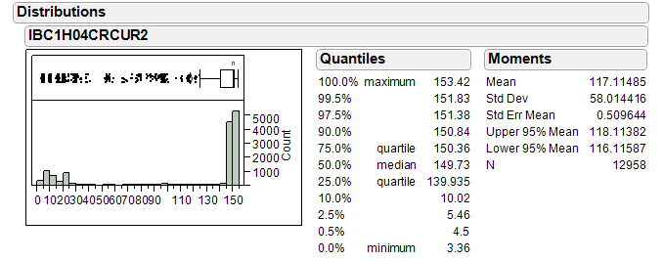
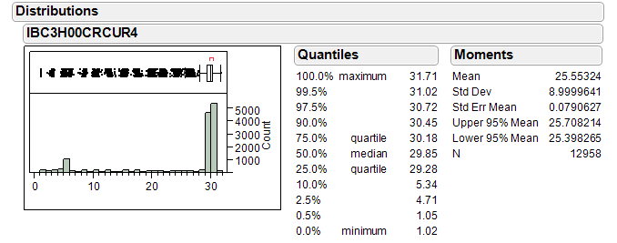
Figure 20. Distributions of currents in period A, the “before” sample

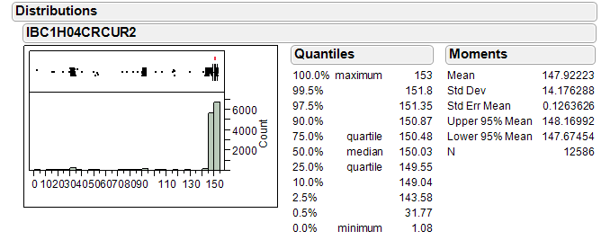
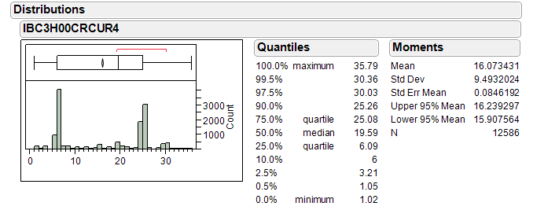
Figure 21. Distribution of currents in period C, the “after” sample.

This data is provided the readers so they may decide whether to ask the author to make additional cuts on the data. Recall that these sets have both A and C currents ≥ 1 µA.

Conclusion: None

Second look at arc BLM activity before/after seed laser swap
Jay Benesch

During the FY20 physics run, regions in the higher arcs have been activated in a manner never before seen. Chopper viewer images suggested a tail on the C beam was a cause of the difficulty. Accordingly, on March 19 while Hall C was down to switch experiments from a1n to d2n, the laser seeds for B and C were swapped. The B beam is defined by a narrow chopper slit and is low current so it it less likely than C beam, which passes through an open slit, to contain a tail. Response of selected BLMs in arcs 1 and 2 as a function of A and C current were compared for three six hour periods:

A. March 10 1400-2000 with both high current halls, before the laser seed swap
B. March 24 0100-0700 with both high current halls, after the laser seed swap
C. April 13 0100-0700, twenty days after last beam

This second look begins with the arc 1 statistics with 0R08 = 0 in period C. Four of the BLMs show zero mean and standard deviations. The arc 1 BLMs have old electronics which do not allow both analog readback and MPS comparator operation. 1L04 and 1L06 are such BLMs. The others in the arc should read non-zero due to electronics noise.

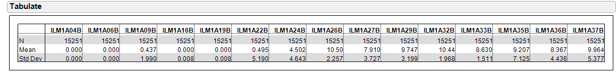
Figure A1. April 13 data. Samples N, mean and standard deviation. 1L16 and 1L19 should not read zero but do. An OPS-PR has been filed.

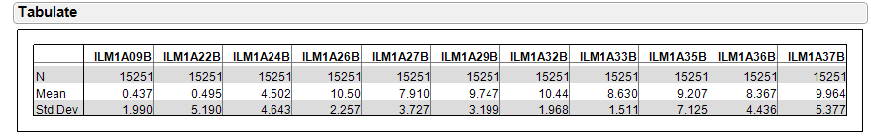
Figure A2. April 13 stats with four BLMs eliminated: 1L04, 1L06, 1L16 and 1L19.

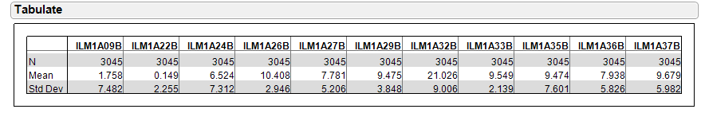
Figure A3. March 10 stats for samples with 0R08=0. One sees similar means for seven of eleven BLMs when compared to Figure A2. 1A32 is the only outlier. https://logbooks.jlab.org/entry/3809796 shows activation at 7A31 which may have contributed. The only other BLM near a warm region is 27, near a 9A27 hot spot with low whole body dose; standard deviation is up by half March 10 vs April 13.

I conclude that I can try to increase signal to noise ratio in examining dependence of BLM activity on beam current by subtracting the mean values in Figure 3 from all values in the data set. Only after I tried this did I realize that subtracting a constant from the data will affect only the intercept, not the slope, its t value (standard_error/parameter) or correlation coefficient. I tried subtracting a value from the normal distribution with mean and standard deviation in Figure A3 from the each of the 1L09 data points and checked the fit. That doesn’t help either because the distributions of BLM response with 0R08=0 before the laser seed swap (the only data set I checked) are not normal: too many values ~1 and tails, which I truncated at 30, out to 100 in 12% of the data set. Rows excluded if ANY of the BLM signals in a given row were greater than 30. I’d have to extract eleven subsets from the full data sheet, one per BLM, to cut just the high values from each individually.

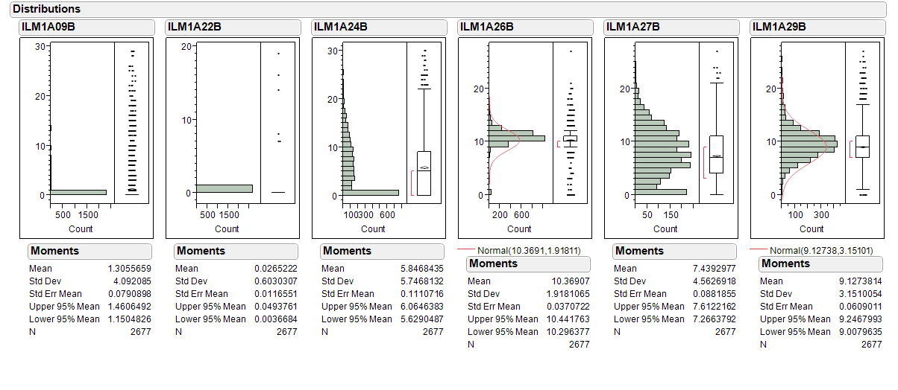
Figure A4. Response distributions of first six BLMs with 0R08=0 in period A, before the seed swap. Normal curves which are NOT significant are shown in fourth and sixth panels.

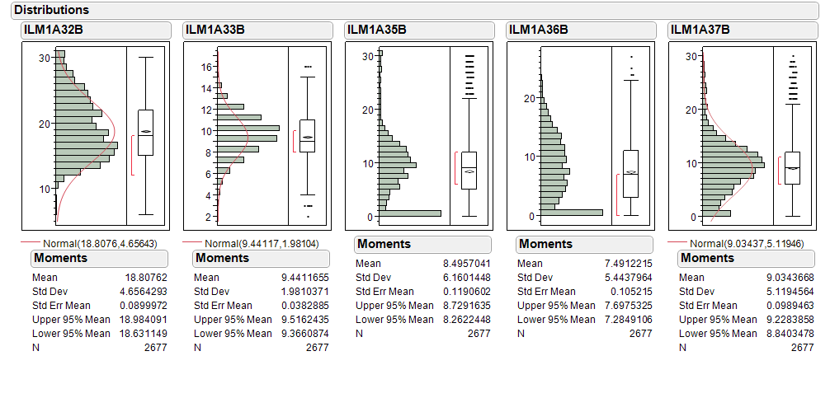
Figure A5. Response distributions of remaining BLMs with 0R08=0 in period A, before the seed swap. Normal curves which are NOT significant are shown in first, second and fifth panels.

Conclusion A1: A lot of very tedious work will be required to determine if the R² values in the previous look at arc1 BLM response versus Hall C current can be improved. I’ll look at arc 2 before I try that as the signal should be cleaner.

Table A1. Correlation coefficients of arc 2 BLMs vs Hall C current before and after the seed swap

The BLM correlation with Hall C current is lower after the seed swap with the exception of 2A29. Since this was shown to have a physically impossible but significant correlation to Hall A current in figure 19 of the first look, I discount this observation and again suggest this PMT be checked. The average R² value after/before is halved for the other ten BLMs. Mean 0.48, std dev 0.26 so mean is two sigma from null hypothesis. This suggests the seed swap helped.

Table A2. Linear regression of Hall C current against BLM response before and after laser seed swap
The reduction in regression prediction at 30 uA is only a fourth on average rather than half as with R² but is still reasonably consistent. Since the standard deviation of the ten values is 0.27 one can’t formally draw any conclusions from this table but it is suggestive. 2A29 not considered.

Why does this second look come to a different conclusion than the first?
- All eleven BLMs were considered
- Only 2A29 was removed from set
- The “after” period is the last shift of beam delivery to Hall C, March 24, rather than a day earlier. More time was spent at 30 µA on March 24. “Before” is still March 10.

