A Versatile and Highly Reliable Green-light Drive Laser

for High Current Photoinjectors

S. Zhang† and M. Poelker

Jefferson Laboratory, 12000 Jefferson Avenue, Newport News, Virginia, 23692, USA

Abstract

A laser system composed of a gain-switched diode laser operating at wavelength 1.066 m, followed by a multi-stage Yb-doped fiber amplifier chain and wavelength converter, was constructed that provides light with radio-frequency-structure at 533 nm and Watts of power. The laser system possesses features that are highly desirable for photocathode-based electron accelerator applications employing DC high voltage photoguns: adjustable pulse repetition rates from sub-MHz to a few GHz, nominal pulsewidth 30 to 50 picoseconds, and direct synchronization to an external RF signal (i.e., the accelerator) without requiring complicated frequency locking systems required by mode-locked lasers. The challenge of obtaining sufficient power at 533 nm imposed by low pulse energy and lower optical coherence associated with gain-switched diode lasers operating near 1 m was addressed by using a high quality narrow linewidth laser diode and a PPLN frequency doubling crystal. The performance of this laser system – demonstrating unrivalled simplicity, reliability and flexibility – could boost the productivity of accelerator-based research programs that rely on DC high voltage photoguns that operate with green-light drive lasers, as evidenced by our recent experience operating accelerators using such lasers systems.

INTRODUCTION

High power picosecond-pulse lasers are used for industrial applications such as precision machining and material processing [1-3]. Picosecond-pulse lasers are also used for scientific research, particularly in the field of electron accelerators where ultraviolet, visible, and near IR lasers are used to generate bright electron beams with very high average current and/or bunch charge. But accelerator applications impose strict demands on drive lasers, namely in the context of long term reliability and timing stability, and sometimes these requirements are beyond the state-of-the-art. The drive laser systems at most accelerator photoinjectors rely on master oscillator power amplifier (MOPA) configurations, typically employing mode-locked seed lasers to generate short optical pulses and free-space or fiber power amplifiers to reach required power levels [4-5]. To achieve a stable optical pulse train, the cavity length of the mode-locked laser must be actively stabilized to minimize the timing jitter and the phase drift. Often, the accelerator environment is noisy, with vibrations and stray electrical signals that adversely impact laser cavity-length feedback electronics. For free-space drive laser systems operating at lower pulse repetition rates, cavity length stabilization can be challenging, particularly when a long laser cavity length is needed [6]. And because of the inherent complexity of mode-locked lasers, it is not simple to quickly change the laser pulse repetition rate or laser pulse width. Mode-locked drive laser instabilities often lead to accelerator downtime which can significantly impact the scientific program through diminished scientific accomplishment.

In contrast, gain-switching [7-9] is a pulse generation technique completely independent of the laser cavity length – it dominantly relies on an external electrical drive signal applied to the diode laser. For accelerator applications, the electrical drive signal originates from the accelerator site-wide radio-frequency (RF) system. As a result, the emitted optical pulse train remains precisely synchronized and phase-locked to the accelerator RF cavities without requiring any feedback stabilization systems. Diode lasers can be gain-switched over a broad range of pulse repetition rates, from sub-MHz to a few GHz. The biggest drawback of gain-switching relates to optical pulsewidth: whereas mode-locked lasers can generate very short optical pulses, from 10s of femtoseconds to over 100 picoseconds, gain-switched diode lasers generate optical pulses in the range of 10s to 100s of picoseconds, with no option for internal temporal pulse shaping or dispersion compensation.

*Authored by Jefferson Science Associates, LLC under U.S. DOE Contract No. DE-AC05-06OR23177. The U.S. Government retains a non-exclusive, paid-up, irrevocable, world-wide license to publish or reproduce this manuscript for U.S. Government purposes.

† email address: [shukui@jlab.org](mailto:jjzou@ecit.cn)

The first gain-switched-based laser system employed at an accelerator photoinjector operated at wavelengths of 780 or 850 nm using free-space diode lasers and diode amplifiers [9], but provided only low average power. With the advent of telecommunications fiber-coupled diode lasers and Er-doped fiber amplifiers operating at 1.56 m, higher power infrared laser systems based on gain-switching were developed [10]. Advances in laser technology now permit construction of similar systems at 1.06 m to access the green wavelength range required by alkali-antimonide photocathodes [X]. Dupriez et al., demonstrated 321 W average power with 20-ps pulses at 1-GHz repetition rate using a MOPA configuration with Yb-doped fiber amplifiers and operating with a gain-switched diode seed laser at 1.06 μm [11]. Similarly, K. Chen, et al, generated over 100 W average power with 1 to 21 ps pulses at repetition rates ranging from 56 MHz to 0.9 GHz [12], also with a 1.06 μm gain-switched diode seed laser and Yb-doped fiber amplifier chain.

Although the output power levels at ~ 1 m wavelength have increased dramatically over the years due to the rapid advance of fiber amplifier technology, high efficiency wavelength-conversion of low or moderate power gain-switched based laser systems to the green wavelength range has been less successful, providing only low to moderate power due to lower peak-intensity and optical coherence of gain-switched lasers operating at 1 m. In this paper we describe an all-fiber MOPA drive laser consisting of a gain-switched diode laser at 1.066 m and a fiber amplifier system and wavelength converter used to obtain light at 533 nm. The problem of low wavelength-conversion efficiency was overcome using a PPLN frequency doubling crystal to obtain doubling efficiency up to 40%. A production system operating at 374.25 MHz pulse repetition rate provided 50 ps optical pulses (FWHM) and 3 Watts average power at 533 nm, which was significantly more power than needed to produce an electron beam at 28 mA average current from CsxKySb photocathode installed within a DC high voltage photogun [14,15]. The laser system operated continuously for months without intervention. The laser was also tested at a much lower repetition rate, 4 MHz at Jefferson Lab Low Energy Circulator Facility (LERF) to demonstrate CuXXX isotope production for medical applications [X], with excellent long-term phase stability.

Laser system

A schematic of the laser system is shown in Figure 1. The sub-mW light from the gain-switched diode laser is amplified using two homebuilt Yb-doped fiber amplifiers. The first Yb-doped amplifier, or pre-amplifier, is a 4 m long Yb-gain fiber (Nufern PM-YSF-HI) pumped with 976 nm light using a wavelength division multiplexer (WDM), then another WDM followed by a 90/10 fiber tap coupler for diagnostics. The second fiber amplifier, or power amplifier, consists of a 5 m long Yb-doped double-clad PM fiber (Nufern PLMA-YDF-10/125) with a 10-μm diameter core and 125-μm diameter cladding, a signal-pump combiner, a multi-mode 976-nm pump diode laser, and a stripper for separating the pump beam from the seed. Optical isolators after each amplifier prevent retro-reflections from returning to the amplifiers. Bandpass filters after each amplifier are used to remove residual pump light and amplified spontaneous emission (ASE) from the 1.066 m output beam. All of the fibers are polarization-maintaining (PM) which improves system stability compared to non-PM single mode fibers. More details are provided in the following sections.

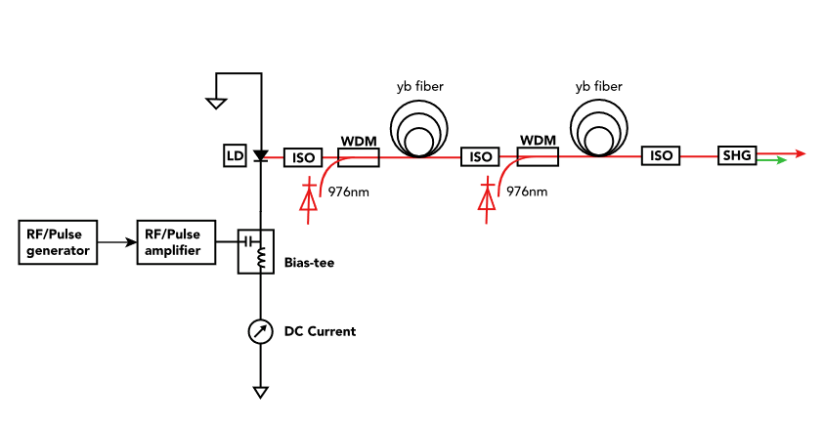

Figure 1: Optical schematic of the green-light drive laser composed of the gain-switched master oscillator, fiber amplifiers, and wavelength converter. GS, gain-switched. Iso/F, isolator/filter. WDM, wavelength division multiplexer. The 90/10 fiber tap coupler after the pre-amplifier is not shown in the scheme. Gain-switching can be performed using an RF pulse generator as shown, or a simple sine wave at ~ 1 W average power, not shown.

Seed laser and Amplifiers

Although there are numerous reports of short optical pulses obtained via gain switching at wavelengths near 1.06 m, our experience suggests commercially available diodes lasers operating near 1 m lack the quality of those operating at the 1.56 m telecommunication wavebands. Recently, companies have developed better 1 μm laser diodes with stabilized wavelength and narrow spectral line width, but at very high cost. The diode we chose (QD Laser diode, 1.064 μm) presents a very narrow sub-nm spectral line width, a key consideration for producing high coherence that often appears to be compromised by the short cavity of the laser diodes.

~~As illustrated in Figure 1,~~ Gain switching can be realized by driving a laser diode with amplified ps-electrical pulses or using a simple sine wave while biasing the diode near the lasing threshold with DC current through a bias-tee network. The gain-switched laser pulses have exactly the same repetition rate as that of the electrical drive frequency. The pulse width obtained from a gain-switched diode depends primarily on the diode laser cavity length (which influences the photon lifetime) and the magnitude of the RF and DC signals applied to the diode. More RF power and more DC current result in longer pulses. When too much current is applied, the diode exhibits relaxation oscillation as manifest by secondary optical pulses trailing behind the desired main pulse. Recently, low-noise short electrical pulse generators (for example, Alnair Labs Products) have helped to achieve shorter optical pulses and with timing jitter comparable to diode lasers driven by RF sources and from mode-locked lasers. Our diode could be gain-switched using an RF signal source plus an RF amplifier (~ 1 Watt average power) operating over a range of frequencies from 100 MHz to 5 GHz. Lower pulse repetition rates could be accessed using a short-pulse electrical pulse generator, down to sub-MHz.

~~Typical laser pulses from a gain-switched diode laser are shown in Figure 2 (top).~~ The gain-switched pulse shape strongly depends on the DC bias current and the RF drive signal. In order to achieve a symmetric Gaussian-like pulse shape at a fixed repetition rate, the bias voltage and the RF signal amplitude must be tuned and balanced. This usually results in an output power below 1 mW, which complicates diagnostic evaluation. Examples of typical laser pulses from a gain-switched diode laser are shown in Figure 2 (top). The pre-amplifier provides a linear gain of about 10, boosting the laser power to several milliWatts, allowing diagnostic measurement with a fiber tap without altering the original temporal properties. By adjusting the DC bias current while keeping the RF signal applied to the diode constant, the optical pulsewidth could be readily adjusted from 30 ps to over 70 ps (Figure 2, bottom). And by adjusting both the DC bias and the RF pulse generator parameters, clean optical pulses over 100 ps could be achieved.

|  |  |
| --- | --- |
|  |  |

(a)

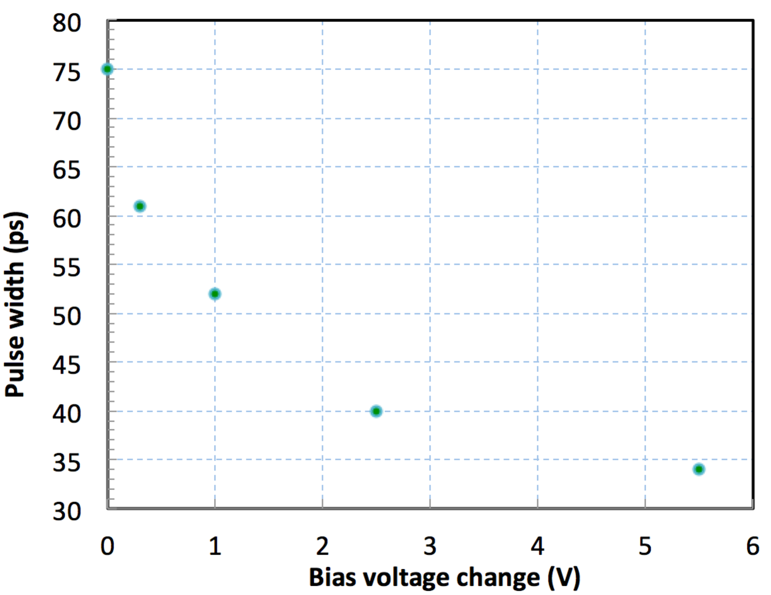

(b)

Figure 2: (a) Waveforms of a 30 ps electrical drive pulse (left) and 60 ps optical pulse (right). (b) Laser pulse width change vs. diode bias voltage adjustment when driven by 30ps electrical pulses at 476.3 MHz. Pulse widths are all measured in FWHM.

Timing and Power Stability, Spectral Content

A very important specification of any photoinjector drive laser is timing jitter which directly affects electron accelerator operation. Timing jitter represents integrated phase noise over a specified frequency range and it is typically measured using a fast photodetector and a spectrum analyzer, or a more sophiscated signal source analyzer (HP4424B). For a gain-switched system operating at 499 MHz (which is a drive laser repetition rate at CEBAF [x]), the rms timing jitter is about 1 ps within a fequency range of 1 Hz ~10 MHz and only 0.4 ps within the range 10 Hz ~10 MHz (Figure 3 top). And as illustrated in Figure 3 (bottom), the timing jitter of a gain-switched laser system gets smaller as the repetition rate increases. These metrics satisfy the requirements of many state-of-the-art research acclerator faciltites, and are comparable to most state-of-the-art mode-locked lasers that employ sophisticated feedback loops.

Importantly, the timing jitter does not change with time: no matter the time of day, or the day of the week, the timing jitter values remain constant. This is extremely important for stable and reliable accelerator operation. Observations made using both types of accelerator drive lasers, gain-switched and modelocked, indicate the phase drift of a gain-switched based laser is less than a degree of the accelerator RF clock cycle measured over 10 hours, whereas with modelocked lasers employing phase locking electronics and pizo-actuators, the phase drift can be a few degrees. Stated from a practical perspective - no intervention is required when using a gain-switched based laser system during routine acclerator operation over many days, weeks or even months.

(a)

(c)

Figure 3: Timing jitter measurements. (a) a typical phase noise spectrum of gain-switched laser pulses at 499 MHz repetition rate from 1 Hz to 40 MHz, (b) timing jitter versus pulse repetition rate (1 Hz~10 MHz).

The power stability of the gain-switched based laser system is consistantly better than 1% measured over 8 hours, at any stage of the amplifier chain. The drift of the center wavelength is well below a fraction of 1 nm, which is much better than required. The residual pump light at 976 nm and broadband ASE due to the higher gain from the pre-amplifier are removed from the output using bandpass filters between amplifier stages. Figure 4 shows the spectral output of the laser system with (inset) and without the bandpass filters. It should be mentioned that the spectrometer (OceanOptics fiber spectrometer HR4000) used here was meant to cover a broadband range so that all spectral components of interest could be captured, the actual laser bandwidth is less than 0.5 nm which is narrower than the instrument resolution. There is no noticeable change in the temporal laser pulse profile before and after the power-amplifier despite a gain of over three orders of magnitude: as shown in Figure 4 b and c, the pulse width is about 55 ps in both cases.

|  |  |
| --- | --- |
| (a) | |
| (b) | (c) |

Figure 4: (a) Laser spectra from pre-amplifier and power amplifier, (b) A 55 ps pulse from pre-amplifier, and (c) the amplified pulse from power-amplifier at 10 W.

To check if laser optical pulses experience spectral distortion during amplification, we recorded the spectra of laser pulses at different power levels by using a spectrum analyser with 10 pm resolution. Looking at the three images presented in Figure 5 which show the spectral content of the seed laser and the amplified light at two power levels, the center wavelength remains constant but there were noticable changes in the shape and bandwidth of the spectra, from 0.12 ~ 0.05 nm (FWHM) at different power levels: bandwidth decreases as the output power increases. This could be due to the combined effects of non-linear amplification gain and fiber filters. At higher amplification, spikes appeared on the top and sides of the spectral profile. ~~, which are excited by the high gain and~~ This is typical of ~~resembles many~~ high-power fiber amplification, and stems from…..but is not detrimental to laser system performance at least at power levels evaluated here. ~~There is no deterimenatal spectral distortion was observed through the amplification process.~~ It worth mentioning though, the laser spectral content tends to grow when the amplification gain is high enough, as in the cases of amplifiers at the level of 10s to 100s of Watts.

|  |  |
| --- | --- |
| (a) | |
| (b) | (c) |

Figure 5: Laser spectra for: (a) seed laser at mW power level, centered at 1065.088 nm, bandwidth FWHM is 0.124 nm, (b) amplifier at 3 W, centered at 1065.083 nm, bandwidth FWHM is 0.065 nm, and (c) amplifier at 6.5 W, centered at 1065.083 nm, bandwidth FWHM is 0.048 nm.

Harmonic converter

The photocathodes for unpolarized high-current accelerator applications, such as GaAs and the large family of alkali-antimonide compounds, require visible light. The quantum efficiency (QE) of a freshly prepared semiconductor photocathode can easily exceed a few percent at green wavelengths where laser light is readily available, but for this discussion assume a lower QE of 1%, in which case approximately 2 W of green light is needed to generate 10 mA electron beam current~~, which means less than 10 W of IR light is required. In most cases, a high current accelerator with 10s of mA current would only require a few Watts of green light.~~ For DC high voltage photoguns like the ones used at Jefferson Lab, laser pulses in the range of 20 to 80 ps are ideal because shorter pulses introduce unwanted space charge induced emittance blow-up. As described above, gain-switching provides a perfect match for this optical pulse range.

A non-critical-phase matched (NCPM) LBO crystal immediately comes to mind as an excellent choice for converting picosecond pulses at the near-IR wavelength of 1 μm to 0.5 μm through second harmonic generation (SHG). For high power picosecond lasers, over 40% SHG efficiency is common and nearly 70% has been achieved with 50 W 50 ps pulses [2] using LBO. And with a much shorter pulse (1.1 ps) and much higher power (110 W), up to 74% SHG efficiency was reported [5]. ~~LBO is an excellent nonlinear optical material and has been the dominant crystal used for high average power SHG~~. However, in the case of high repetition rate drive lasers with lower pulse intensity, and with just a few Watts of power and ~50 ps pulse widths, the SHG efficiency of LBO tends to be poor. In addition, our experience indicates most laser diodes operating at 1 m exhibit poor optical coherence when gain-switched and this severely impacts the SHG efficiency.

PPLN is a different nonlinear crystal that provides much higher SHG efficiency for low pulse energy lasers and even CW lasers [add Compton reference here?]. Our attempts to produce useful SHG power using a 20 mm long LBO were unsuccessful, but a much better result was obtained using a temperature-tuned PPLN crystal (0.5 x 0.5 x 10mm long): nearly 30% SHG efficiency was achieved for the laser conditions described above, and with increased input power, the SHG efficiency reached a maximum of 40%. As shown in Figure 6, the SHG efficiency begins to saturate at approximately 5 W input power, likely due to tight focusing in the crystal (focus diameter about 0.15 mm). As mentioned earlier, PPLN crystals are normally used for lower power laser beams, due to their characteristically limited physical size (less than 1mm in one dimension) and low damage threshold compared with LBO crystals. To further increase the SHG power of our laser without the risk of optical damage, a larger aperture crystal can be used. This could provide a means to allow more input power and produce considerably more power at green wavelength while keeping beam power density below damage threshold and without deep saturation. The spatial distribution of the second harmonic beam was evaluated with a Spiricon beam profiler, indicating nearly perfect beam quality (M2 ~ 1.15, Figure 7).

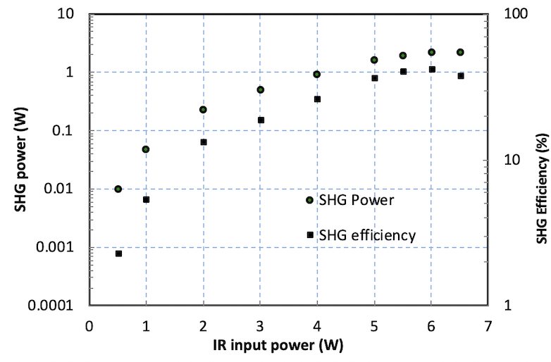

Figure 6: Experimental data for SHG power and conversion efficiency with ~~LBO and~~ PPLN. The laser pulse width 50ps and pulse repetition rate 346 MHz.

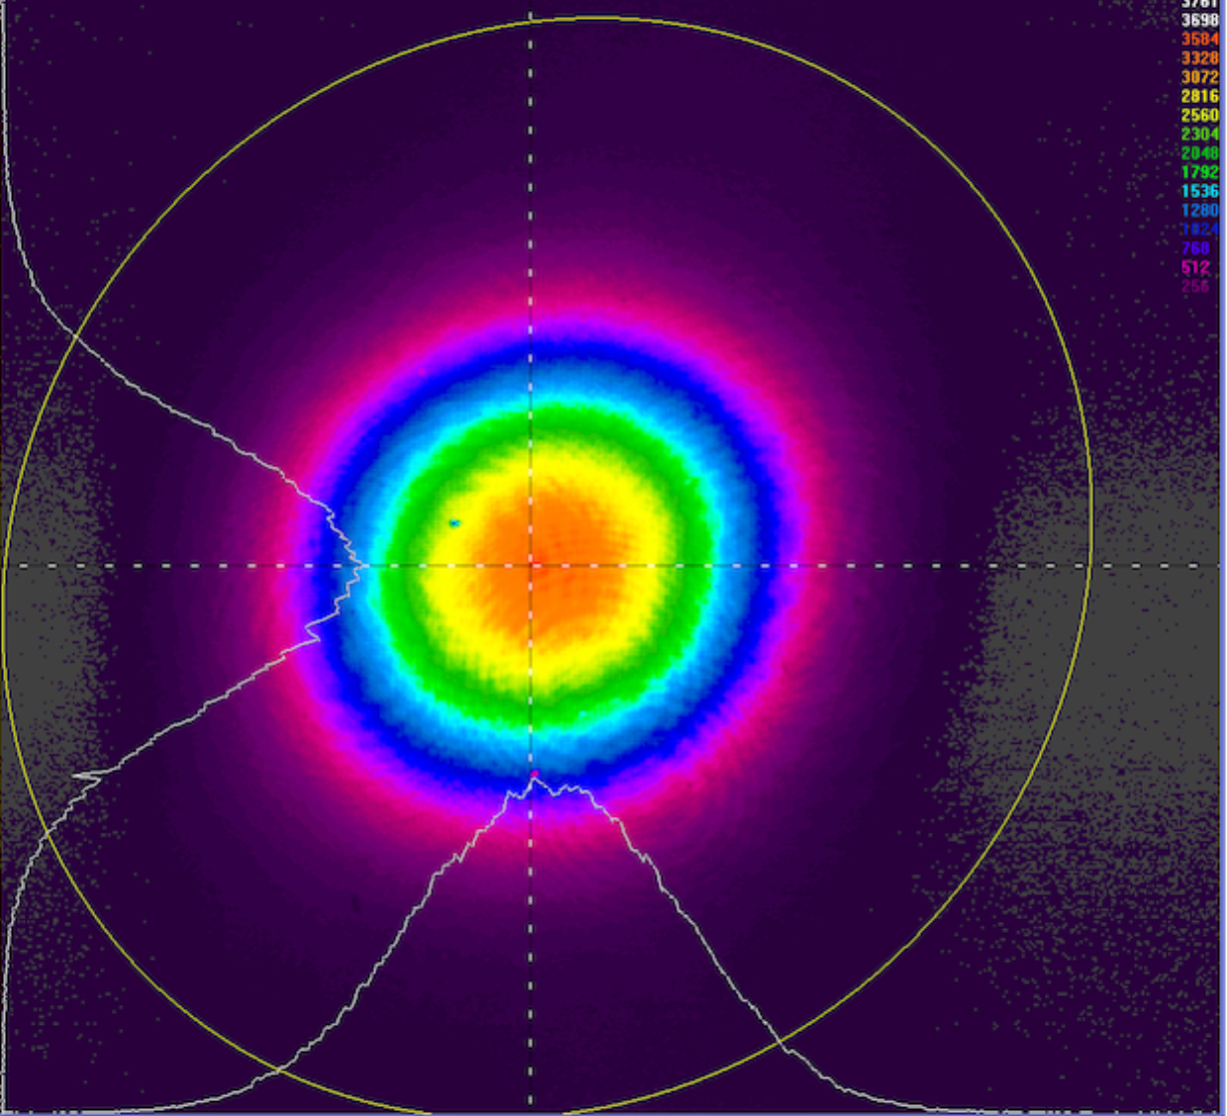

Figure 7: Beam profile of the 532 nm generated beam measured with a Spiricon beam profiler

Driver laser for high current photoinjectors

The green-light gain-switched laser system was used to create electron beam at two accelerator locations at Jefferson Lab. One location serves as a photogun/photocathode test stand where the laser was used to produce magnetized electron beam at record-level current, see details in references [13, 14]. During a high current test over two days, the stable and reliable gain-switched-based drive laser system produced picosecond-pulse magnetized beams at 28 mA average current and 1.5 A peak current at the photocathode. The drive laser was set up to provide 50 ps (FWHM) pulse width and 374.25 MHz repetition rate, with the repetition rate chosen for a proposed electron cooler application for the Electron Ion Collider [X]. The laser system operated for months without intervention, permitting focused study of the photogun and photocathode, which was the fundamental basis for the tests.

The same laser was then used to drive a photogun at the JLab LERF for medical isotope production [x], where it served to dramatically improve accelerator performance compared to that obtained using a mode-locked drive laser. For this application, a very low pulse repetition rate was required: 4 MHz, which is not easy to obtain using mode-locked lasers. To check the phase stability, we recorded the electron beam position signals from the beam position monitors (BPMs) at two different locations in the injector where such signals are sensitive to the electron bunch phase and have been routinely used to monitor the bunch phase during beam operation with a mode-locked drive laser in the past [FEL refs?]. As shown in Figure 10, the signals basically remained constant during 15 hours of operation, in sharp contrast to our previous experience using a mode-locked drive laser when it was quite common to see a notable phase drift over just a few hours of operation. Under such circumstances, intervention was required to maintain stable electron beam and this caused downtime. It should be noted that the slight variations on the top curve (red) in Figure 10 may be induced by other devices on the accelerator beamline, in particular the superconducting RF cavities. The few sharp drops of the signals were due to the loss of electron beam when the machine tripped off.

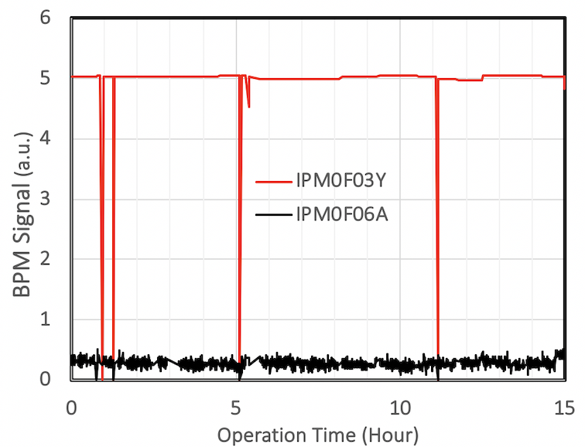

Figure 10: Electron beam position monitor signals at two different locations at LERF were recorded during 15 hours of accelerator operation. The sharp drops of the signals were due to loss of beam when the accelerator tripped OFF caused by unstable superconducting RF cavities.

SUMMARY

Electron accelerators with photoinjectors are particularly sensitive to drive laser beam quality and stability, specifically the spatial distribution of the drive laser light and amplitude and phase variation over time. By employing fiber amplifier technology, problems related to laser amplitude stability and spatial quality are solved. In this paper, we suggest the last issue – long-term phase stability - can be solved using gain-switching, at least for photoinjector applications that do not require extremely short pulses (for example, RF photoguns) and the demanding timing jitter requirements of X-ray free electron lasers. We reported a stable and flexible photocathode drive laser system that combines gain-switching with fiber laser amplifier technology, allowing variable pulse repetition rates from a sub-MHz to a few GHz and pulse width from 10s to 100s ps. The performance of this laser system opens a path for building high power photocathode drive lasers that exhibit unrivalled simplicity, reliability and flexibility for accelerators applications and beyond. For example, this laser system could be used to improve the performance of Compton polarimeters [15-18] and Compton-backscatter photon light sources [19-20]. Compared to mode-locked lasers, the simplicity and reliability of the gain-switched based laser system may outweigh the comparatively long pulse disadvantage.

acknowledgment

Authored by Jefferson Science Associates, LLC under U.S. DOE Contract No. DE-AC05-06OR23177 and supported by Laboratory Directed Research and Development funding. The U.S. Government retains a non-exclusive, paid-up, irrevocable, world-wide license to publish or reproduce this manuscript for U.S. Government purposes. The authors would like to thank those at Jefferson Lab who provided support to this project, in particular, S. Benson for the help identifying diagnostics and acquiring electron beam phase data during LERF operation.

References

1. Liu, X., Du, D. & Mourou, G., "Laser ablation and micromachining with ultrashort laser pulses", IEEE J. Sel. Top. Quant. Electron. **33**, 1706–1716 (1997)
2. N. Muhammad, et al., "Picosecond laser micromachining of nitinol and platinum–iridium alloy for coronary stent applications", Applied Physics A **106**, 607–617 (2012)
3. K. Wlodarczyk, et al., "Picosecond laser cutting and drilling of thin flex glass", Optics and Lasers in Engineering, Volume 78, 64-74 (2016)
4. S. Zhang, "Drive Laser Systems for Electron Accelerators and Free-Electron-Lasers Based on Photocathode-Injector Energy-Recovery-Linac", invited talk, WG110, ERL’2009, June, 2009, Ithaca, NY. Also see S. Zhang,et al., “Summary Paper: Drive Lasers for Photocathode Gun”, Proceedings of ERL’2009, page 24~26, June, 2009, Ithaca, NY
5. Z. Zhao, et al., "High-power fiber lasers for photocathode electron injectors", Phys. Rev. ST Accel. Beams 17, 053501 (2014)
6. Jürgen Diefenbach, “Stabilization System of the Laser System of the A4 Compton Backscattering Polarimeter”, European Physical Journal A - Hadrons and Nuclei **24**, 131 (2005)
7. D. M. Pataca, et al., "Gain-switched DFB lasers ", J. Microwaves Optoelecton. **1**, 46–63 (1997)
8. D. Birkin, et al.,"Near-transform-limited picosecond pulses from a gain-switched InGaAs diode laser with fiber Bragg gratings", Appl. Phys. Lett. **79**, 151 (2001)
9. M. Poelker, "High Power Gain Switched Diode Laser Master Oscillator and Amplifier", Appl. Phys. Lett. 67, 2762 (1995)
10. J. Hansknecht and M. Poelker, "Synchronous Photoinjection Using a Frequency-Doubled Gain-Switched Fiber-Coupled Seed Laser and ErYb-Doped Fiber Amplifier", Phys. Rev. ST Accel. Beams **9**, 063501 (2006)
11. P. Dupriez, et al.," High average power, high repetition rate, picosecond pulsed fiber master oscillator power amplifier source seeded by a gain-switched laser diode at 1060 nm", IEEE Photonics Technology Letters 18(9), 1013-1015 (2006)
12. K. Chen, et al., "Polarization maintaining 100W Yb-fiber MOPA producing µJ pulses tunable in duration from 1 to 21 ps", Optics Express Vol. 18, No. 14 14392 (2010)
13. C. Hernandez-Garcia et al. et al.,"Compact − 300 kV dc inverted insulator photogun with biased anode and alkali-antimonide photocathode", Phys. Rev. Accel. Beams **22**, 113401 (2019)
14. Y. Wang, M. A. Mamun, P. Adderley, B. Bullard, J. Grames, J. Hansknecht, C. Hernandez-Garcia, R. Kazimi, G. A. Krafft, G. Palacios-Serrano, M. Poelker, M. L. Stutzman, R. Suleiman, M. Tiefenback, S. Wijethunga, J. Yoskowitz, and S. Zhang, "Thermal emittance and lifetime of alkali-antimonide photocathodes grown on GaAs and molybdenum substrates evaluated in a -300 kV dc photogun", Phys. Rev. Accel. Beams **23**, 103401
15. P. Adderley, et al., “Production of Magnetized Electron Beam From a DC High Voltage Photogun”, IPAC19, Melbourne, Australia, May 2019, TUPTS105
16. S. Escoffier et al., “Accurate measurement of the electron beam polarization in JLab Hall A using Compton polarimetry”, Nucl. Instrum. Methods A **551** (2005) 563
17. M. Baylac, et al., “First electron beam polarization measurements with a Compton polarimeter at Jefferson Laboratory”, Phys. Lett. B **539** (2002) 8
18. A. Narayan, et al., “Precision Electron-Beam Polarimetry at 1 GeV Using Diamond Microstrip Detectors”, Phys. Rev. X **6**, 011013 (2016)
19. S. Baudrand et al., “A High Precision Fabry-Perot Cavity Polarimeter at HERA”, J. Instrum. 5 (2010) P06005,
20. I. Drebot “Two-colour X-gamma ray inverse Compton backscattering source”, EPL, 120 (2017) 14002
21. Weller, H. R., M. W. Ahmed, and Y. K. Wu, “Nuclear Physics Research at the High Intensity Gamma-Ray Source (HIγS)”, Nuclear Physics News 25, no. 3 (January 1, 2015): 19–24.

This reference can be used for CEBAF and 499 MHz lasers:

C. K. Sinclair, M. Poelker, P. A. Adderley, B. M. Dunham, J. C. Hansknecht, P. Hartmann, J. S. Price, P. M. Rutt, W. J. Schneider, and M. Steigerwald, "A High Average Current Polarized Electron Source with Long Cathode Operational Lifetime", [Phys. Rev. ST Accel. Beams](http://journals.aps.org/prstab/abstract/10.1103/PhysRevSTAB.10.023501) **[10](http://journals.aps.org/prstab/abstract/10.1103/PhysRevSTAB.10.023501)**[, 023501 (2007)](http://journals.aps.org/prstab/abstract/10.1103/PhysRevSTAB.10.023501)

## Here’s the LEReC paper:

## S. Seletskiy, M. Blaskiewicz, A. Drees, A. Fedotov, W. Fischer, X. Gu, R. Hulsart, D. Kayran, J. Kewisch, C. Liu, M. Minty, V. Ptitsyn, V. Schoefer, A. Sukhanov, P. Thieberger, and H. Zhao*, “*Obtaining transverse cooling with nonmagnetized electron beam”, accepted 16 November, 2020 for publication in Phys. Rev. Accel. Beams