**Hall B - Run Group K**

**Color Confinement and Strong QCD**

**Executive Summary**

1. **Experiments LIST**

The proposals listed below have been approved as a group by the PAC 44 with A- rating. They are using the same run conditions and the same CLAS12 configuration: electron beam energies equal to **6.6 GeV** and **8.8 GeV** with fully longitudinally polarized electrons (Pb ≥ 80-85%) impinging on a liquid-hydrogen target with a beam current equivalent to full nominal luminosity.

**E12-16-010** **A Search for Hybrid Baryons in Hall B with CLAS12**

Contact Person: **Annalisa D’Angelo**

Spokespersons: Volker Burkert, Daniel S. Carman, Victor Mokeev,

Evgeny Golovach, Ralf W. Gothe

**E12-16-010A** **Nucleon Resonance Structure Studies Via Exclusive KY Electroproduction at 6.6 GeV and 8.8 GeV**

Contact Person: **Daniel Carman**

Spokespersons: Victor Mokeev, Ralf W. Gothe

**E12-16-010B Deeply Virtual Compton Scattering with CLAS12 at 6.6 GeV and 8.8 GeV** Contact Person: **Latifa Elouadrhiri**

Spokespersons: Francois-Xavier Girod.

**Note:**

Additional experimental aspects that address strong QCD and confinement may be opportunistically studied from the same data-set:

* excited nucleon structure studies at low Q2
* exclusive K*Y and KY* final states
* vector/pseudoscalar meson production at low Q2

1. **Physics Program Highlights**

The set of RGK experiments aims at establishing a comprehensive research program to tackle some of the most intricate problems in hadron physics. They have also **strong connections** to proposals that have already been approved as part of the **CLAS12 RGA** physics program and will very significantly extend the science reach of those experiment, while at the same time presenting new avenues towards clarifying the **degrees of freedom active in the excitation of baryons** and providing new insight into the so far unresolved problem of **understanding the confinement of light quarks**.

The scope of this program covers three major research efforts:

* **Search for new baryon states and investigate the role of the glue in the N* spectrum.**
* Search for new hybrid baryon states with the glue as an extra constituent beyond the three constituent quarks by focusing on measurements at Q2 < 1.0 GeV2 where the expected magnitudes of the hybrid electro-excitation amplitudes are maximal;
* Search for three-quark “missing” resonances in the electro-production of different hadronic final states with the highest fluxes of virtual photons ever achieved in exclusive meson electro-production experiments with a wide coverage in W.
* **Measure the Q2 dependence of electro-coupling amplitudes.**
* Quantifying the role of the active degrees of freedom in the nucleon spectrum and their evolution with distance scale, providing information on the interplay between the external meson-baryon cloud and the inner core of dressed confined quarks.
* Study the structure of prominent nucleon resonances in the mass range up to 3 GeV in the regime of large meson-baryon cloud contributions and explore the N* longitudinal electro-excitation approaching the photon point.
* **Study GPDs and their moments from DVCS**
* Making inroads towards understanding the confinement of light quarks, gluons, and the meson cloud, their emergence from the confinement regime, and the role they have in providing dynamical stability of the nucleon.

1. **Allocated PAC days**

PAC 44 has approved the RGK with **A- rating** allocating a total of 100 PAC days of beamtime as follows:

* **50 days** at **6.6 GeV** electron beam energy
* **50 days** at **8.8 GeV** electron beam energy.

1. **Fall 2018 - RGK Run**

RGK has opportunistically accepted to run from November 28th to December 20th at the available energies, closest to the request ones:

* 11 calendar days at 7.5 GeV
* 9 calendar days at 6.5 GeV

corresponding to **12 PAC days**, considering the high beam availability obtained.

The accumulated charge was Q~45mC, equal to 7% of the expected 648 mC at full luminosity.

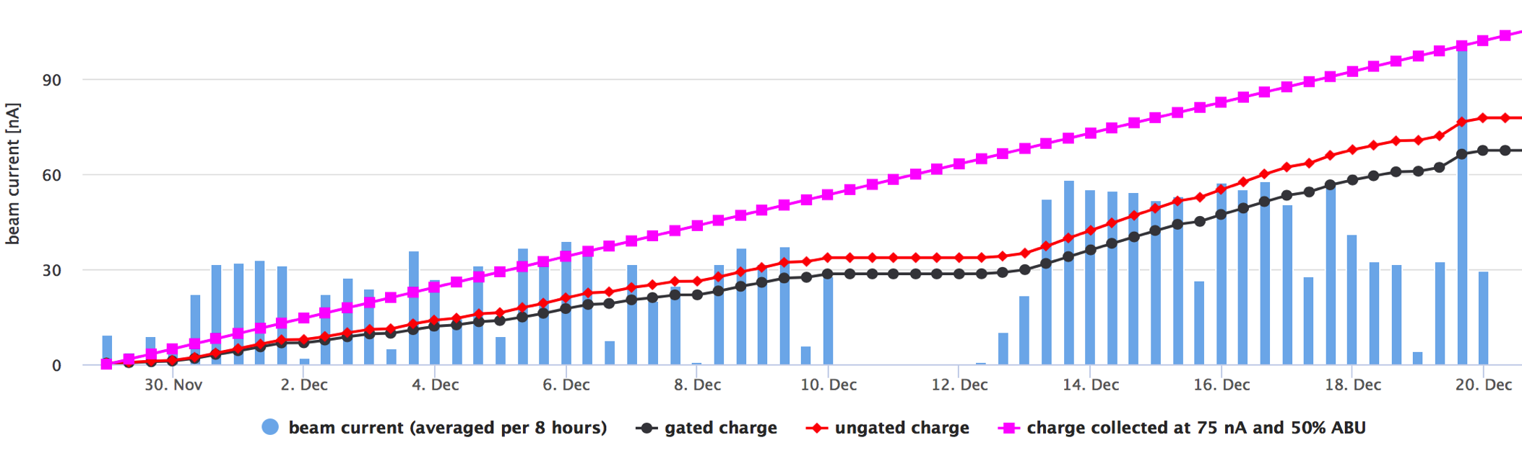

**Machine down**

**FT-OFF**

**Figure 1.** Accumulated Charge during RGK Fall 2018 Run.

A total of 16.5 G events have been collected, according to table 1.

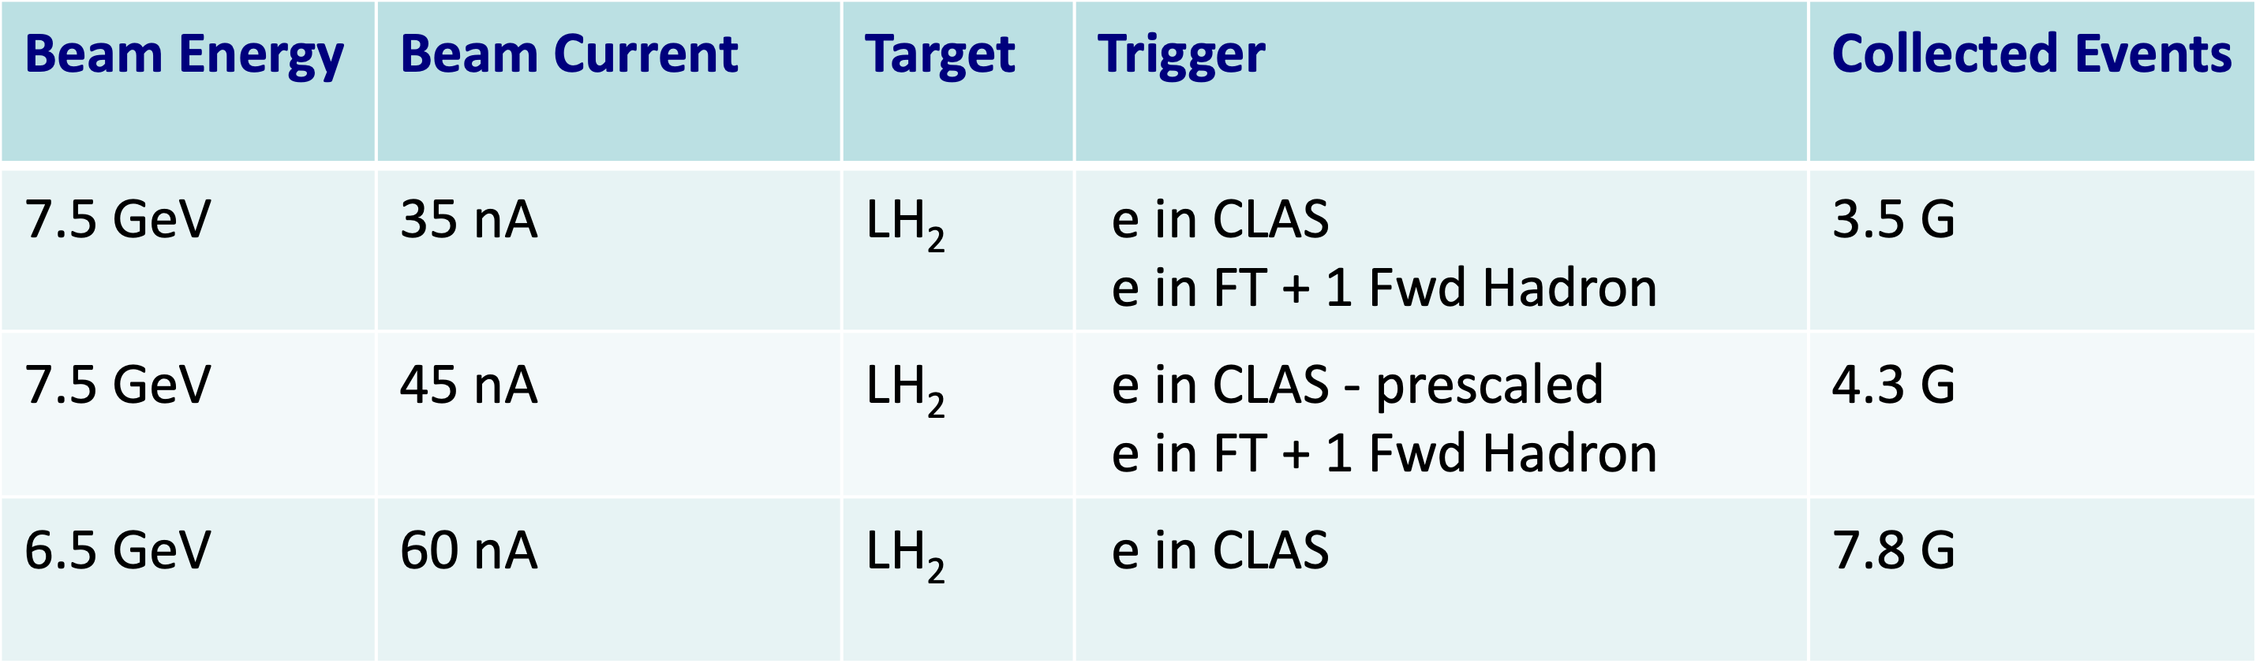

**Table 1.** Accumulated events for the three different run conditions during RGK Fall 2018 Run.

1. **Run Conditions**

RGK still needs to run for a total of **78 PAC days** to complete the approved experimental program, which corresponds to 78% of the allocated beamtime.

These should be divided into two different electron beam conditions:

* **39 PAC days** at **6.6 GeV** electron beam energy
* **39 PAC days** at **8.8 GeV** electron beam energy.

The three RGK experiments share the same experimental conditions :

|  |  |
| --- | --- |
| **Torus Current** | 100% (3375 A) - **negative outbending** |
| **Solenoid** | -100 % |
| **Beam/Target** | Polarized electrons, unpolarized LH2 target |
| **Luminosity** | 10 35 cm-2s-1  **FULL LUMINOSITY** |
| **CLAS12 detectors** | All standard sub-components are used. |
| **Triggers** | e in CLAS (300 MeV ECAL threshold)  e in FT (1.8 GeV -5.6/7.6 GeV)+ 1 forward hadron |

**Optimal planning**

The RGK would benefit from having the assigned 38 PAC days to run **in one continuous time slot**, for each of the two approved beam energies (6.6 GeV and 8.8 GeV).

Combination of data from small samples using different beam/experiment conditions is very difficult and time consuming.

**Minimal planning**

In a minimal planning assigned RGK time should be at least:

* **20 PAC days** at **6.6 GeV** electron beam energy
* **20 PAC days** at **8.8 GeV** electron beam energy.

to reach at least 50% of the assigned PAC days at each energy.

1. **Compatibility with other Run Group running conditions.**

RGK is the only run group running at electron beam energies lower that the maximum. Therefore is not compatible with any other run group.

1. **List of non-standard equipment.**

RGK only requires CLAS12 standard equipment.

1. **Readiness of the Experiment.**

**ERR for RGK has been completed** and RGK has already successfully run in Fall 2018. All equipment, DAQ setting and triggers **are ready** and it would be possible to run as soon as data taking is scheduled.

1. **Motivation to run in 2021/2022.**

Fall 2018 RGK run was particularly successful and data have proven to be very useful in understanding the CLAS12 detector performances.

Compared to the other run groups, higher missing mass resolutions are obtained and a better discrimination among exclusive channels (such as KΛ and KΣ) is achieved, due to the lower electron beam energies.

The available 12% fraction of the expected statistics shows very promising results for high cross-section channels, such as the two pions electro-production channel, but the approved experimental program would require a substantial increase of the accumulated statistics. Reaching at least 50 % of the assigned PAC days, would allow combination of the DVCS results from RGK with those from RGA with a significant impact on GPD extraction.

1. **Known Issues/Difficulties and necessity of on-beam tests.**

The RGK experiments are ready to run: no issues or difficulties are present and no additional test is necessary to assess the experiment readiness. The running conditions may be finely optimized once the event reconstruction efficiency, as a function of luminosity, is determined from collected data.