**Hall B - Run Group K**

**Color Confinement and Strong QCD**

**Request for PASS 1 Cooking**

1. **Fall 2018 RGK Run and available data.**

RGK was approved by the PAC 44 to run for 100 PAC days using electron beam energies equal to **6.6 GeV** and **8.8 GeV** with fully longitudinally polarized electrons (Pb ≥ 80-85%) impinging on a liquid-hydrogen target with a beam current equivalent to full nominal luminosity.

RGK has opportunistically accepted to run from November 28th to December 20th 2018 at the available energies, closest to the request ones:

* 11 calendar days at 7.5 GeV
* 9 calendar days at 6.5 GeV

corresponding to **12 PAC days**, considering the high beam availability obtained.

The accumulated charge was Q~45mC, equal to **7% of the expected** 648 mC at full luminosity.

A total of **16.5 G** events have been collected, according to table 1.

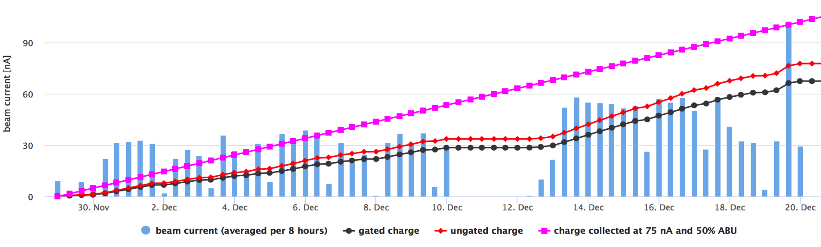

**Machine down**

**FT-OFF**

**Figure 1.** Accumulated Charge during RGK Fall 2018 Run.

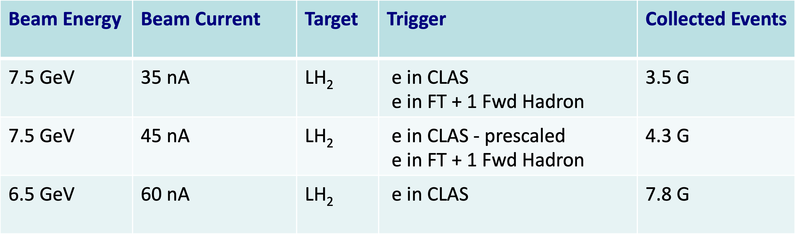

**Table 1.** Accumulated events for the three different run conditions during RGK Fall 2018 Run.

1. **Physics Program Towards CLAS12 First Publications**

The set of RGK experiments aims at establishing a comprehensive research program to tackle some of the most intricate problems in hadron physics. They have also **strong connections** to proposals that have already been approved as part of the **CLAS12 RGA** physics program and will very significantly extend the science reach of those experiment, while at the same time presenting new avenues towards clarifying the **degrees of freedom active in the excitation of baryons, in particular, elucidating the role of glue as the baryon structural component in the search for hybrid-baryons.** These studies also will offer new insight into the so far unresolved problem of **understanding the confinement of light quarks**.

Among all the topics that will be covered by the RGK data analysis, two of them have the potential to contribute to the first publications from CLAS12, since the analysis procedure is not penalized by possible variations in the particle tracking efficiency in the central detector:

* **Beam asymmetry measurements of Deeply Virtual Compton Scattering with CLAS12** **on the proton at 7.5 GeV and 6.5 GeV.**

Which is expected to contribute to the understanding of the confinement of light quarks, gluons, and the meson cloud, their emergence from the confinement regime, and the role they have in providing dynamical stability of the nucleon.

Data analysis requires the detection of the electron in the forward detector, of the final state photon either in the forward calorimeter of the forward tagger and of the recoil proton. The beam asymmetry observable is not sensitive to the possible variations of the detection efficiency of the proton in the central region, since it cancels out in the evaluation of the difference over the sum of events with opposite helicities.

* **Inclusive electron scattering cross sections on the proton at 7.5 GeV and 6.5 GeV**

Which represent an effective tool in the exploration of the structure of the proton ground state in terms of parton distribution functions (PDFs)[rest is removed]. The results on the nucleon resonance electroexcitation amplitudes from CLAS enhance considerably the capabilities for getting insight into the ground state nucleon PDFs in the resonance region at Q2 from 0.1 GeV2 to 4.5 GeV2.

Data analysis requires the detection of the electron in the forward detector only.

Both channels are also being analyzed as part of the **CLAS12 RGA** physics program at 10.6 GeV, and are expected to provide the first CLAS12 publications. The CLAS collaboration would benefit from the parallel analysis of the same channels from **RGK** at 7.5 GeV and 6,5 GeV for several reasons:

* Comparing the data analysis results from CLAS12 at 6.5 GeV data with similar ones performed with the CLAS detector will help to **understand the detector response** and **validate also the results** obtained at higher energies;
* Analysis of the same reactions at different electron beam energies (6.5 GeV, 7.5 GeV and 10.6 GeV) provides a wider kinematical coverage; moreover results from overlapping kinematical regions obtained from different beam and detector settings allow for **controls on systematic uncertainties**;
* Calibration, cooking and data analysis of the aforementioned reactions are performed for RGA and RGK by the same team, with **no additional staff involvement required**.

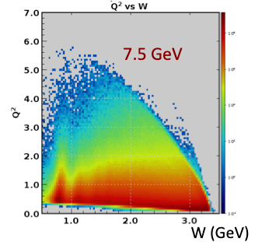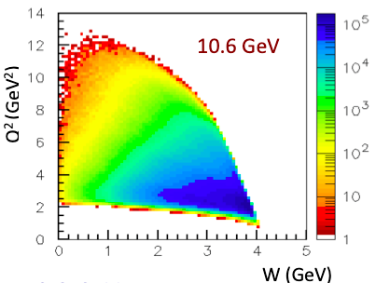

**Figure 1.** Complementary kinematical coverage of the Q2 vs W plane for RGK and RGA runs.

1. **Available Reconstructed Data for Physics Analysis.**

**2.75 G events** in **32 runs** collected at 7.5 GeV electron beam have been reconstructed and skimmed in trains for a total of **5.5 TB** disk storage space, corresponding to about **17% of available data.**

The major part of available reconstructed RGK data for physics analysis dates back to October 2019 when the **6b.3.0** coatjava release was used for preparation of the talks presented at the 2019 Fall DNP Meeting. The data processing **did not take into account the electron beam offset** with respect to CLAS12 central axis.

Data processing with the latest coatjava release, also taking into account the beam offset, has proved to provide improved CLAS12 resolution (from 48 MeV to 37 MeV on the elastic peak from inclusive electron invariant mass spectrum – see Figure 2). This result proves that a new PASS1 process of RGK would provide data of **significantly improved quality**.

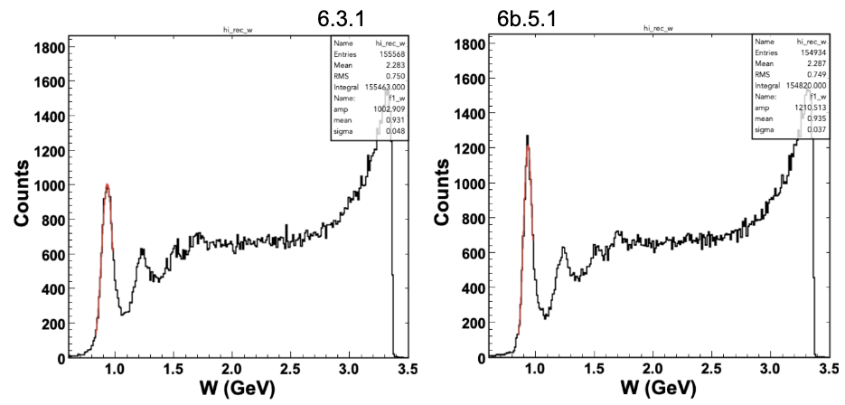

**Figure 2**. Invariant mass spectrum of inclusive electron scattering at 6.5 GeV obtained from 3b.3.1 (left) and 5b.5.1 (right) coatjava releases. Elastic peak resolution is significantly improved from 48 MeV to 37 MeV.

1. **Calibration Status and Full RGK PASS1 Data Processing Estimation**

RGK calibration has been performed on two runs: 5700 and 5893, collected at 7.5 GeV and 6.5 GeV, respectively. RGK data calibration, as well as the **pass0 cooking for timelines, is underway** in parallel with RGA data.

Data processing estimates are shown in Table 2: a total of 33 calendar days are expected to be enough for full PASS1 of RGK.

|  |  |
| --- | --- |
| Data set | RGK |
| Beam energy | 7.546 GeV and 6.546 GeV |
| Target | Liquid H2 |
| Torus field | -100% |
| Run range | 5681-6000 |
| Total events count | 16.5 G |
| Processing speed | 1G events/day |
| Processing time, 100% efficiency | 16.5 days |
| Contingency factor | 50% |
| Processing time, with contingency factor | 33 days |
| Daily output, DSTs | 1.6 TB |
| Daily output, trains | 1.2 TB |
| Total data size, DSTs | 26 TB |
| Total data size, train | 20 TB |

**Table 2.** Full RGK PASS1 Data processing estimation.

1. **Examples of preliminary results on multi-energy Beam-Spin Asymmetry for DVCS on the proton.**

Analysis of multi- energy DVCD beam spin asymmetry is the topic of Jusha Artem Tan PhD thesis. The analysis of 2.75 G events from the available reconstructed runs provides a total of 250K ep->e’pγ events, which could be increased to a total 1.5 M events if the full RGK statistics would become available for data analysis, a value already comparable with the statistics of published CLAS measurement.

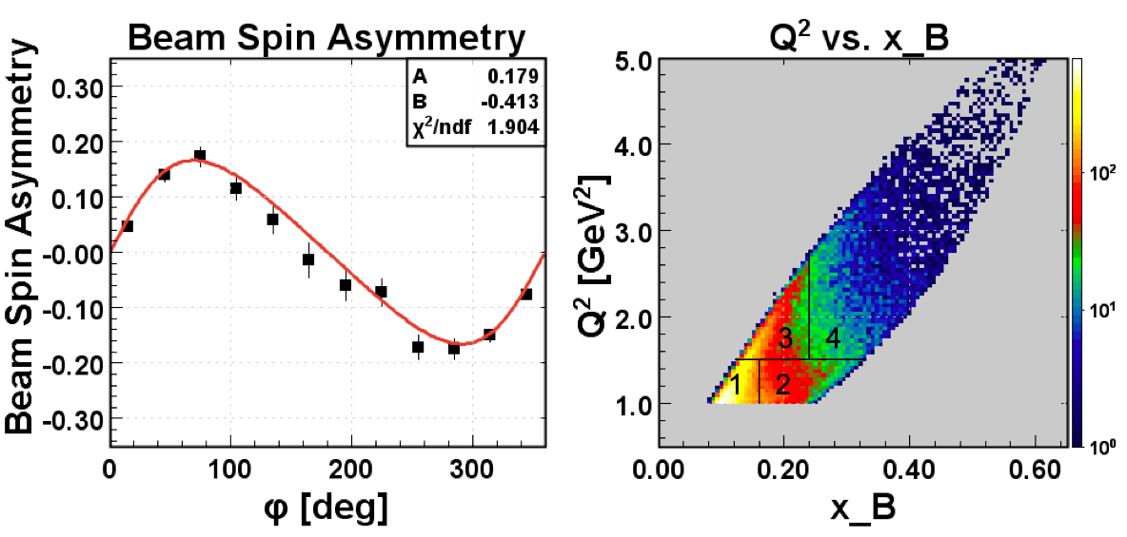

**Figure 3** Preliminarybeam-asymmetry results on DVCS on the proton at 7.5 GeV.

1. **Summary**

Full PASS1 of RGK runs, amounting to a total of collected **16.5 G events**, requires 16.5 100% efficiency days of data processing, which may correspond to **33 calendar days**, taking into account a 50% contingency factor.

The work may be performed by the RGA team, after the RGA Fall Pass1 process has been completed.

Combined analysis of RGK and RGA data allows to obtain multi-energy results on both DVCS beam-asymmetry on proton target and inclusive electron scattering in complementary kinematical regions, which may be the subject of the first publications from CLAS12.

Comparison of RGK results at 6.4 GeV with published CLAS data is crucial for the **understanding of the detector response** and **validation of the results** at 10.6 GeV beam energy.