**Hall B - Run Group K**

**Color Confinement and Strong QCD**

**Request for Pass-1 Cooking**

1. **Fall 2018 RG-K Run and Available Data**

RG-K was approved by PAC 44 to run for 100 PAC days using electron beam energies equal to **6.6 GeV** and **8.8 GeV** with longitudinally polarized electrons (Pb ≥ 80-85%) impinging on a liquid-hydrogen target with a beam current equivalent to full nominal luminosity.

RG-K opportunistically accepted to run from November 28 to December 20, 2018 at the available energies, closest to the request ones:

* 11 calendar days at 7.5 GeV
* 9 calendar days at 6.5 GeV

corresponding to **12 PAC days**, considering the high beam availability obtained.

The accumulated charge was Q~45mC, equal to **7% of the expected** 648 mC at full luminosity.

A total of **16.5 G** events have been collected, according to table 1.



**Machine down**

**FT-OFF**

**Figure 1.** Accumulated Charge during the RG-K Fall 2018 Run.

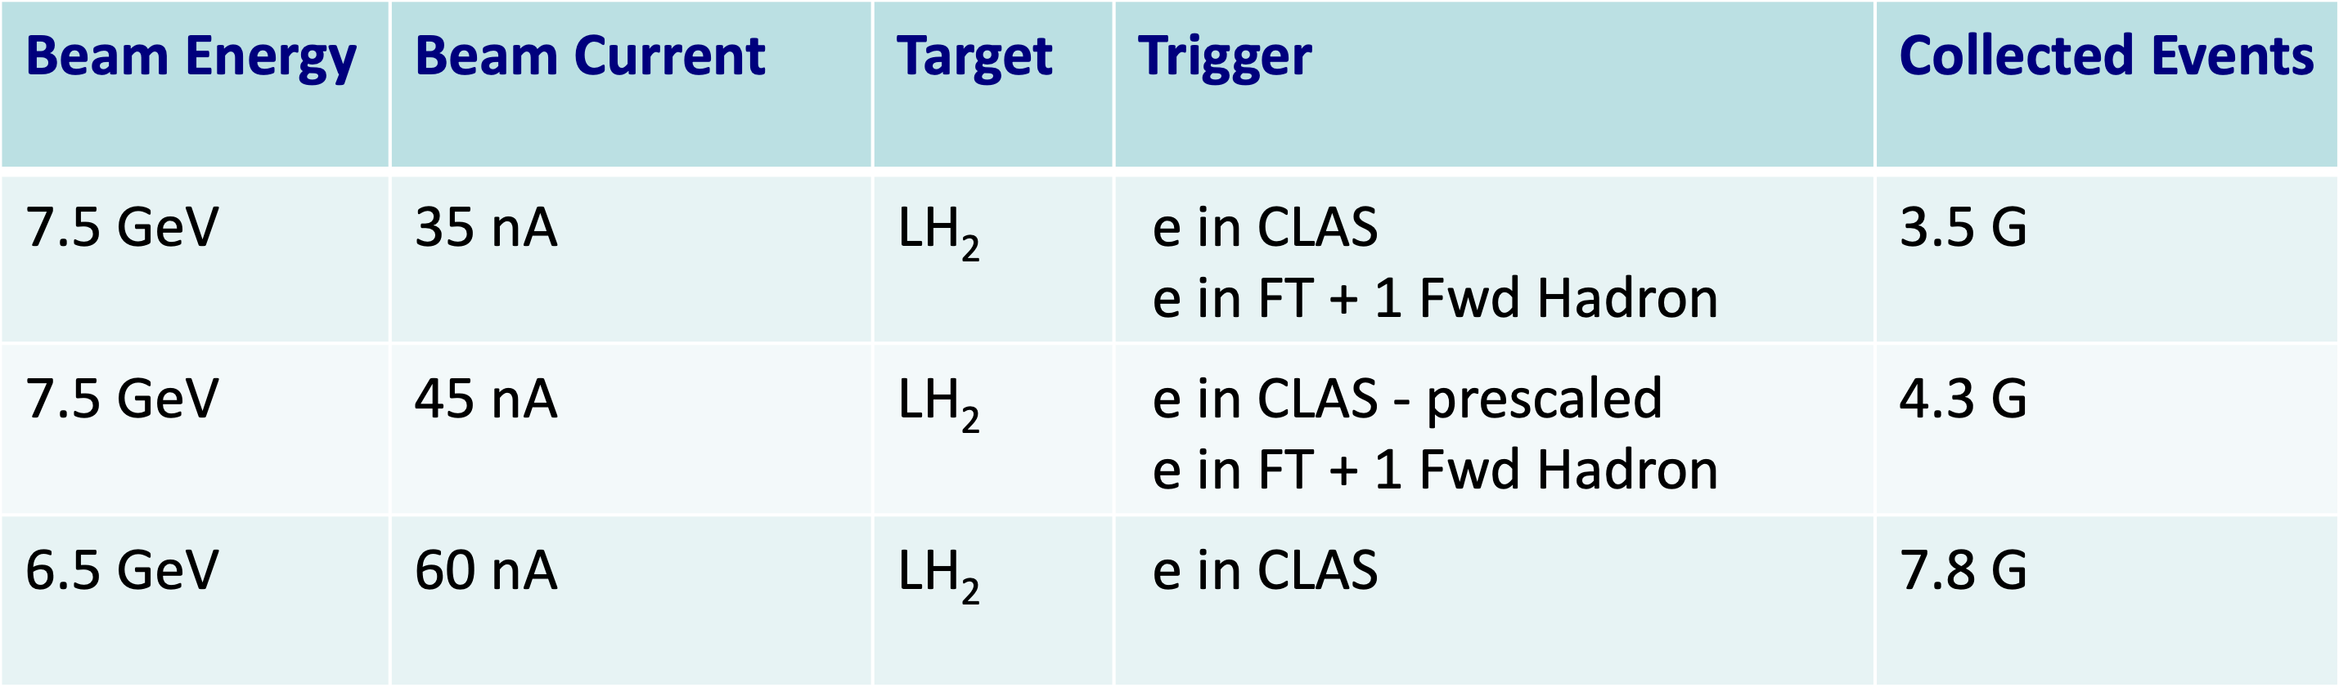

**Table 1.** Accumulated events for the three different run conditions during the RG-K Fall 2018 Run.

1. **Physics Program Towards CLAS12 First Publications**

The set of RG-K experiments aims at establishing a comprehensive research program to tackle some of the most intricate problems in hadron physics. They also have **strong connections** to proposals that have already been approved as part of the **CLAS12 RG-A** physics program and will very significantly extend the science reach of those experiments, while at the same time presenting new avenues towards clarifying the **degrees of freedom active in the excitation of baryons** and providing new insight into the so far unresolved problem of **understanding the confinement of light quarks**.

Among all the topics that will be covered by the RG-K data analysis, two of them have the potential to contribute to the first publications from CLAS12, since the analysis procedure is not penalized by possible variations in the particle tracking efficiency in the Central Detector:

* **Beam asymmetry measurements of Deeply Virtual Compton Scattering with CLAS12** **on the proton at 7.5 GeV and 6.5 GeV**

This is expected to contribute to the understanding of the confinement of light quarks, gluons, and the meson cloud, their emergence from the confinement regime, and the role they have in providing dynamical stability of the nucleon.

Data analysis requires the detection of the electron in the Forward Detector, of the final state photon either in the Forward Electromagnetic Calorimeter or the Forward Tagger, and of the recoil proton. The beam asymmetry observable is not sensitive to the possible variations of the detection efficiency of the proton in the central region, since it cancels out in the evaluation of the difference over the sum of events with opposite helicities.

* **Inclusive electron scattering cross sections on the proton at 7.5 GeV and 6.5 GeV**

This represents an effective tool in the exploration of the structure of the proton ground state in terms of parton distribution functions (PDFs) for different flavors of quarks and gluons. Results on inclusive electron scattering may provide insight into the xB (and W) evolution of the ground state nucleon PDFs over the entire resonance region in each bin of Q2 from 0.1 GeV2 to 4.5 GeV2.

Data analysis requires the detection of the electron in the forward detector only.

Both channels are also being analyzed as part of the **CLAS12 RG-A** physics program at 10.6 GeV, and are expected to provide the first CLAS12 publications. The CLAS Collaboration would benefit from the parallel analysis of the same channels from **RG-K** at 7.5 GeV and 6,5 GeV for several reasons:

* Comparing the data analysis results from CLAS12 at 6.5 GeV data with similar ones performed with the CLAS detector will help to **understand the detector response** and **validate also the results** obtained at higher energies;
* Analysis of the same reactions at different electron beam energies (6.5 GeV, 7.5 GeV, and 10.6 GeV) provides a wider kinematical coverage; moreover, results from overlapping kinematical regions obtained from different beam and detector settings allow for **controls on systematic uncertainties**;
* Calibration, cooking, and data analysis of the aforementioned reactions are performed for RG-A and RG-K by the same team, with **no additional staff involvement required**.

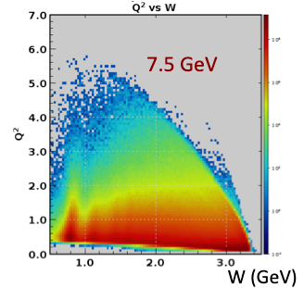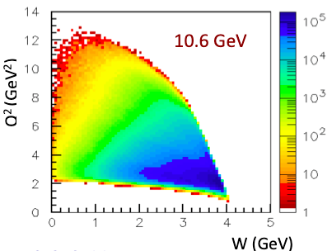

**Figure 1.** Complementary kinematical coverage of the Q2 vs W plane for the RG-K and RG-A runs.

1. **Available Reconstructed Data for Physics Analysis**

**2.75 G events** in **32 runs** collected at 7.5 GeV electron beam have been reconstructed and skimmed in trains for a total of **5.5 TB** disk storage space, corresponding to about **17% of available data.**

The major part of available reconstructed RG-K data for physics analysis dates back to October 2019 when the **6b.3.0** coatjava release was used for preparation of the talks presented at the 2019 Fall DNP Meeting. The data processing **did not take into account the electron beam offset** with respect to CLAS12 central axis.

Data processing with the latest coatjava release, also taking into account the beam offset, has proved to provide improved CLAS12 resolution (from 48 MeV to 37 MeV on the elastic peak from inclusive electron invariant mass spectrum – see Figure 2). This result proves that a new pass-11 process of RG-K would provide data of **significantly improved quality**.

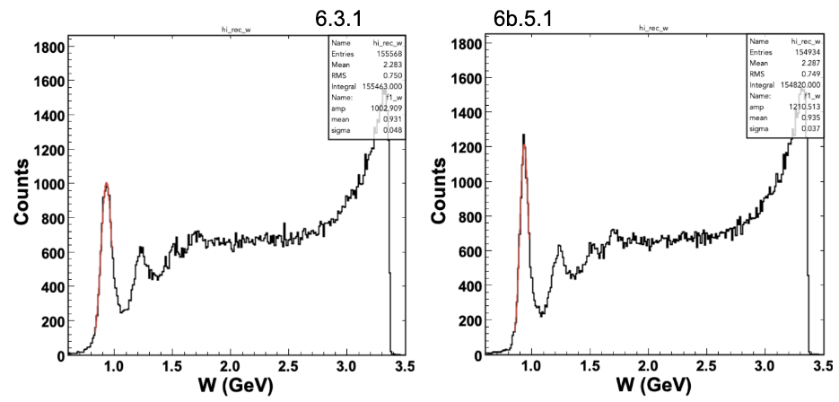

**Figure 2**. Invariant mass spectrum of inclusive electron scattering at 6.5 GeV obtained from 6.3.1 (left) and 6b.5.1 (right) coatjava releases. The elastic peak resolution is significantly improved from 48 MeV to 37 MeV.

1. **Calibration Status and Full RG-K Pass-1 Data Processing Estimation**

RG-K calibration has been performed on two runs: 5700 and 5893, collected at 7.5 GeV and 6.5 GeV, respectively. RG-K data calibration, as well as the **pass-0 cooking for timelines, is underway** in parallel with the RG-A data.

Data processing estimates are shown in Table 2: a total of 33 calendar days are expected to be enough for the full pass-1 of RG-K.

|  |  |
| --- | --- |
| Data set | RG-K |
| Beam energy | 7.546 GeV and 6.546 GeV |
| Target | Liquid H2 |
| Torus field | +100% (neg. outbending) |
| Run range | 5681-6000 |
| Total events count | 16.5 G |
| Processing speed | 1G events/day |
| Processing time, 100% efficiency | 16.5 days |
| Contingency factor | 50% |
| Processing time, with contingency factor | 33 days |
| Daily output, DSTs | 1.6 TB |
| Daily output, trains | 1.2 TB |
| Total data size, DSTs | 26 TB |
| Total data size, train | 20 TB |

**Table 2.** Full RG-K pass-1 Data processing estimation.

1. **Examples of Preliminary Results on Multi-Energy Beam-Spin Asymmetry for DVCS on the Proton**

Analysis of multi-energy DVCD beam spin asymmetry is the topic of Joshua Artem Tan’s Ph.D. thesis. The analysis of 2.75 G events from the available reconstructed runs provides a total of 250k ep->e’pγ events, which could be increased to a total 1.5 M events if the full RG-K statistics would become available for data analysis, a value already comparable with the statistics of the published CLAS measurement.

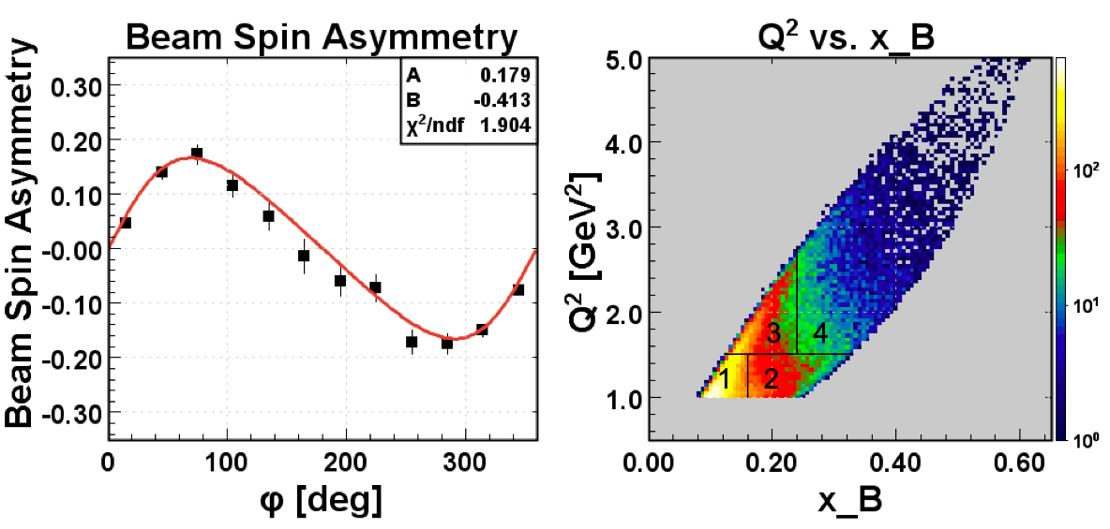

**Figure 3** Preliminarybeam-asymmetry results on DVCS on the proton at 7.5 GeV.

1. **Summary**

The full pass-1 of the RG-K runs, amounting to a total of collected **16.5 G events**, requires 16.5 100% efficiency days of data processing, which may correspond to **33 calendar days**, taking into account a 50% contingency factor.

The work may be performed by the RG-A team, after the RG-A Fall pass-1 process has been completed.

The combined analysis of the RG-K and RG-A data allows for the study of multi-energy results on both DVCS beam-asymmetry on proton target and inclusive electron scattering in complementary kinematical regions, which may be the subject of the first publications from CLAS12.

Comparison of the RG-K results at 6.4 GeV with the published CLAS data is crucial for the **understanding of the detector response** and **validation of the results** at 10.6 GeV beam energy.