**Relief Valves for RICH Cooling System**

*Saptarshi Mandal*

*June 9, 2016*

The cooling system for the RICH is shown in the diagram below.

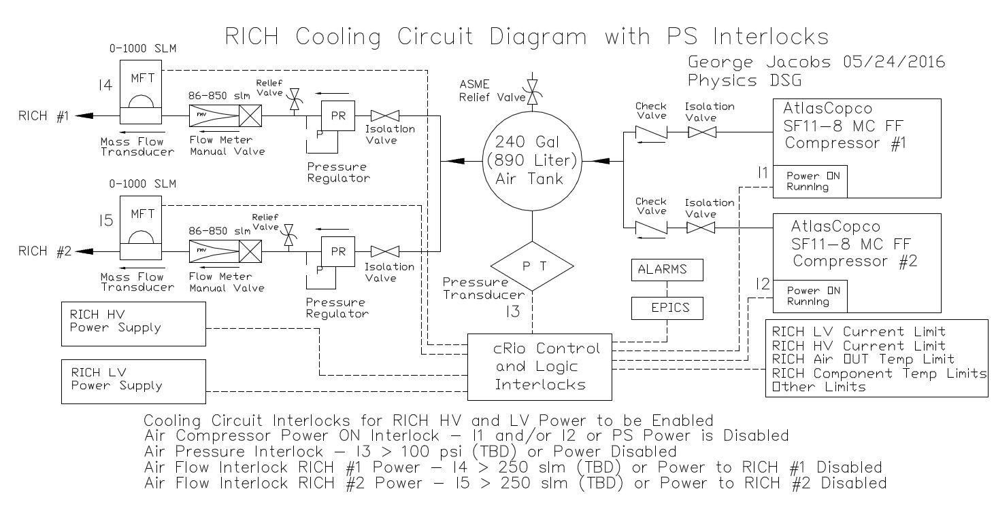

The system has two compressors filling a 240 Gallon storage tank. One of the compressors is used as a back-up in case of failure to the other. The storage tank chosen for this system is McMaster Part # 9554K71. The maximum allowable working pressure on this tank is 200 psi. The normal operating pressure on the tank will be 8 bar(e) or 116 psig. From the storage tank, air flows into two different RICH modules through parallel lines. Each line has a pressure regulator, flow meters and mass flow transducer. The pressure on the regulator will be set to a maximum of 55 psig. There are relief valves provided on each of the lines going to the RICH. The expected flow rate through each of the lines is 150 LPM during normal operation. The relief valves selected are discussed below.

Relief Valve for Air Storage Tank

The worst case pressure relief scenario for the storage tank is when the outlet from the tank is shut-off with the compressor still running.

The maximum allowable pressure (MAWP) of the tank is 200 psig. The set pressure of the relief valve is adjusted to 175 psig (87% of MAWP). The relief valve vents into the atmosphere.

The compressor that is being used by the RICH group is Atlas Copco SF 11-8 MC FF. The maximum discharge pressure is 8 bar(e) or 116 psig.

The FAD of each compressor at 116 psig is ~43 cfm.

There are two identical compressors in the system. So conservatively estimate a maximum flow rate of 86 cfm at 116 psig.

Calculate the Flow rate in SCFM:

Absolute pressure at discharge * Actual cfm = Atmospheric pressure * Flow rate in SCFM

(175 + 14.7 psi) * 86 cfm = 14.7 psi * SCFM

Flow rate = 1110 SCFM

Relief valve suitable for this purpose would be McMaster Part # 4700K15. This relief valve is capable of discharging 2878 SCFM at 175 psig set pressure, which is greater than the flow rate required by the relief system.

Relief Valve after Pressure Regulator

For the flow through the pressure regulator, assume the maximum flow rate of the compressor i.e. 1200 LPM (~43 cfm). The pressure regulator is set for a maximum outlet pressure of 55 psig. The working pressure of the tube is 230 psig. The Dwyer flow control tubes are rated to 100 psi. So, the set pressure on the relief valve is adjusted to 90 psi.

Calculating the flow rate in SCFM:

Absolute pressure at discharge * Actual cfm = Atmospheric pressure * Flow rate in SCFM

(90 + 14.7psi) * 43 = 14.7 * SCFM

Flow rate = 306 SCFM

Relief valve suitable for this purpose would be McMaster Part # 4700K83. This relief valve is capable of discharging 619 SCFM at 90 psig set pressure, which is greater than the flow rate required by the relief system.