Please join us with your spouse or a date and your children for a day at the beach!

Hosted by Dave, Melissa, Volker and Latifa

Where: Dave and Melissa Kashy’s home

131 York Point Drive Seaford VA 23696

phone 988-1978

Get directions - [click here](http://maps.google.com/maps?daddr=37.17519,-76.393822)

Starts at 13:00

Lunch at about 3pm

We will have plenty of burgers, hot dogs and beverages.

PLEASE RSVP via e-mail by July 20, 2015 to [Kashy@JLab.org](mailto:Kashy@JLab.org)

What to bring:

* ***Dish to pass*** (Main dish, Salad, Side dish, or Desert *with a cover to keep flies away*)
* ***Sunscreen***
* OPTIONAL

Swimsuit, Water shoes, Fishing poles, bait and tackle, Water toys, Floats, Beach chairs, Sunglasses, Hat, Children, Spouse or a date, Ping Pong paddles, Corn Hole boards other games….

*On-Line Training Required*

(if you want to try)

Stand Up Paddling - [Click here for a paddle lesson](https://www.youtube.com/watch?v=8RNPewqloNw) [Click here for more training](http://www.youtube.com/watch?v=swh-mTUJQ9k)

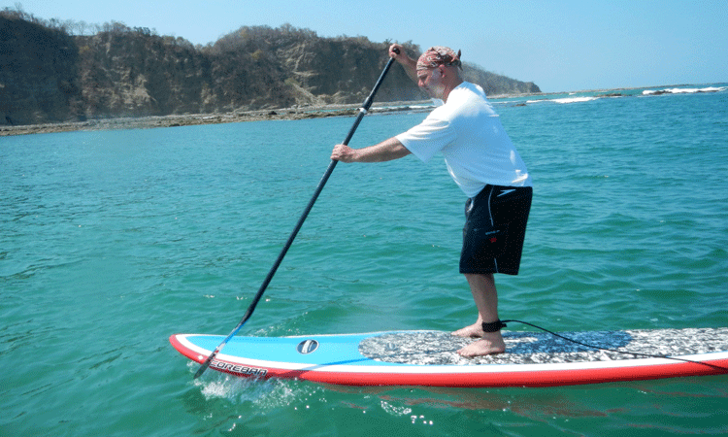

Windsurfing - [Click here for a lesson](http://www.youtube.com/watch?v=q59X9izcjQc) [Another lesson? click here](http://www.youtube.com/watch?v=RefOEmoiSmc). Finally [click here](http://www.youtube.com/watch?v=8GbSXn37f5k)

Then give it a go!!

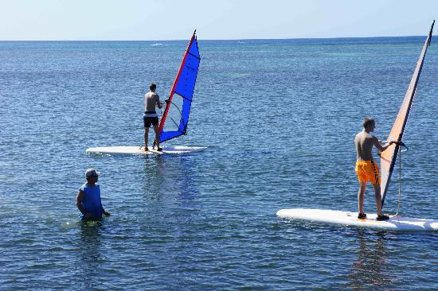

Note: Parking on the street, but limited so carpool if you can. Thanks