Firefox – Clear Cache

The following instructions are for clearing your browser cache within Firefox.

Select the Settings Button - Highlighted

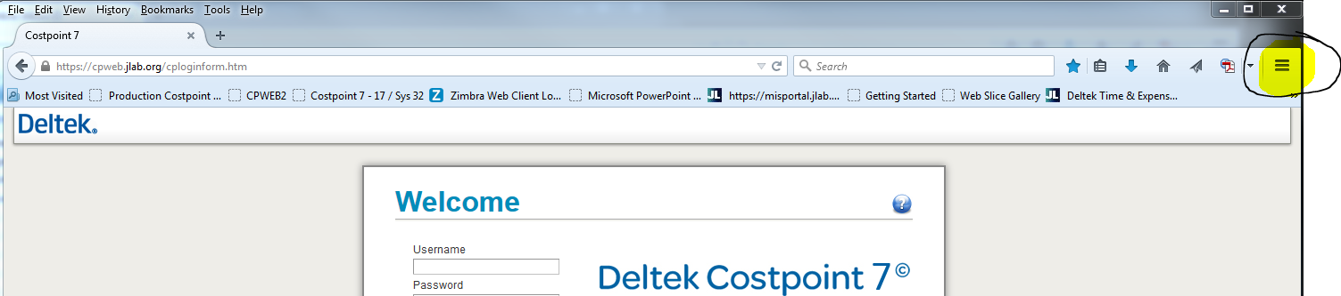

Once you click the settings button, click the Options Tab.

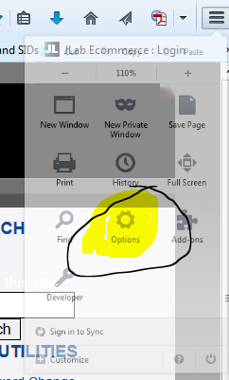

This will open a new tab….

Select Advanced, then Network and click “Clear Now”…. You may need to click it a few times…. 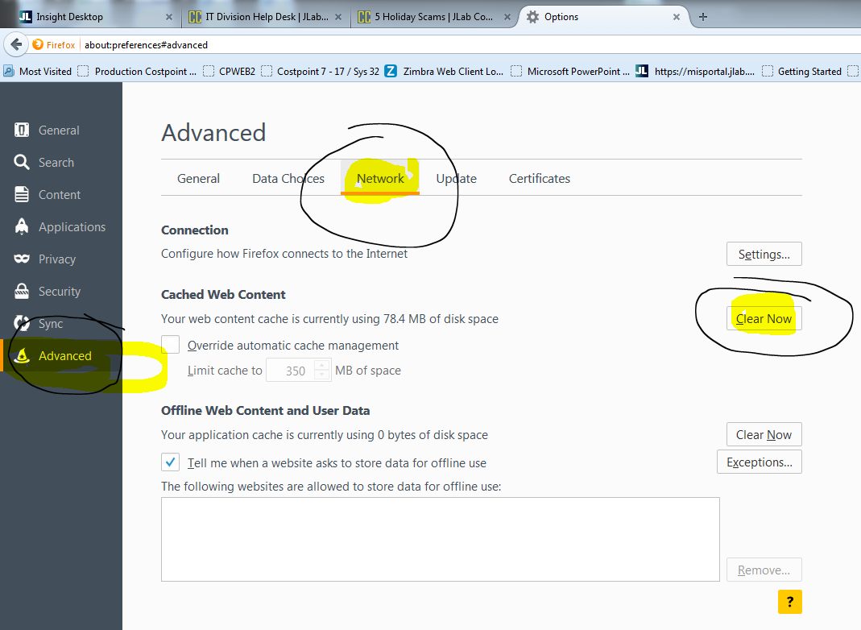

The Cached Web Content will say it is using 0 bytes…

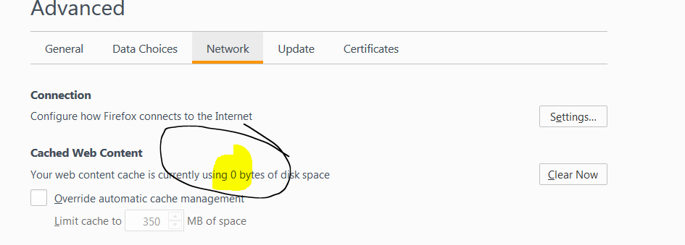

Finally close the browser…and go back in!