**Internet Explorer 11 Clear Cache**

The following instructions are for clearing your cache within Internet Explorer 11.

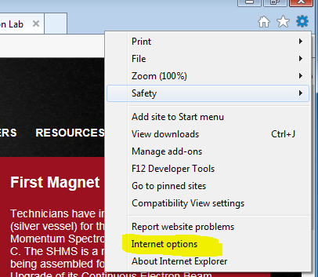

Click the “Gear” symbol found on the upper right hand section of IE 11 and the following screen will appear:

Select Internet Options

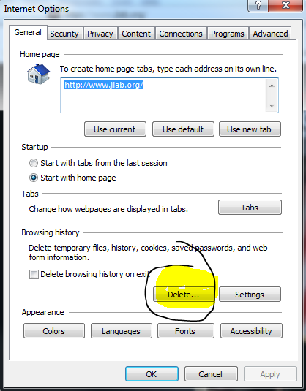

From the General Tab within Internet Options, click the Delete Button.

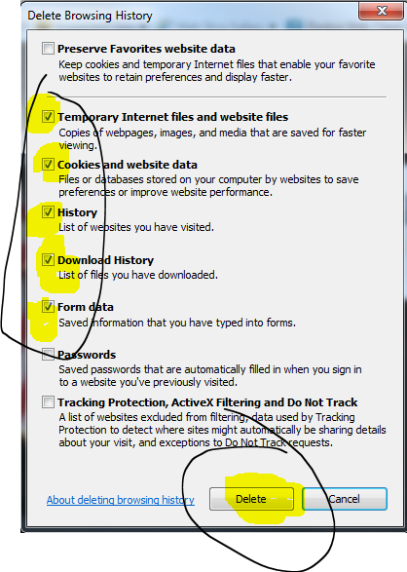

The following screen will appear, insure the five check boxes are checked:

Click Delete.

Please close the browser and then reopen and return to Costpoint.