Firefox v60.2.0 and Later

Clear Cache

The following instructions are for clearing your browser cache within Firefox.

* ***Close ALL browser windows…***
* ***Every window where Firefox is running, even if it ONLY has your e-mail open….they must be closed***

Select the Settings Button - Highlighted

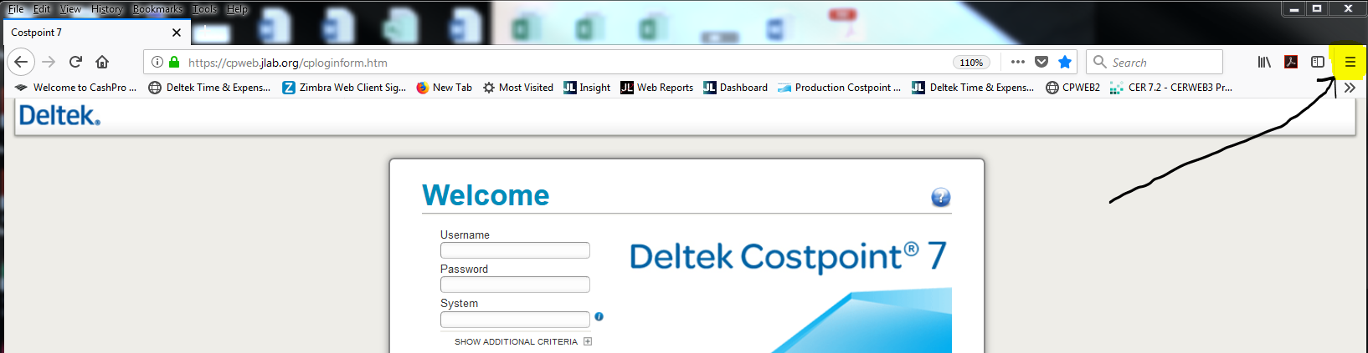

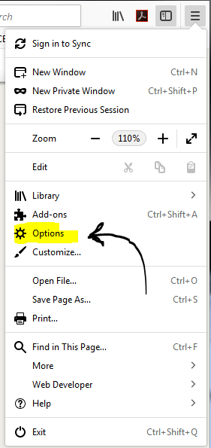

Once you click the settings button, click Options from the Pull down menu.

This will open a new tab. Select Privacy and Security.

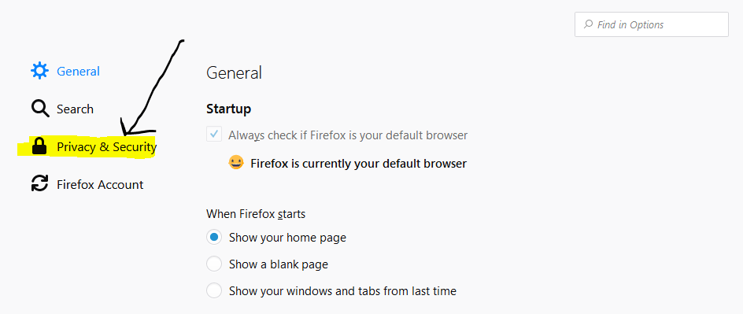

Select the option, “Clear History”

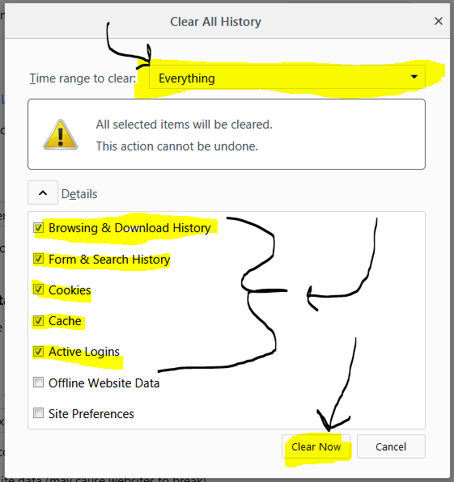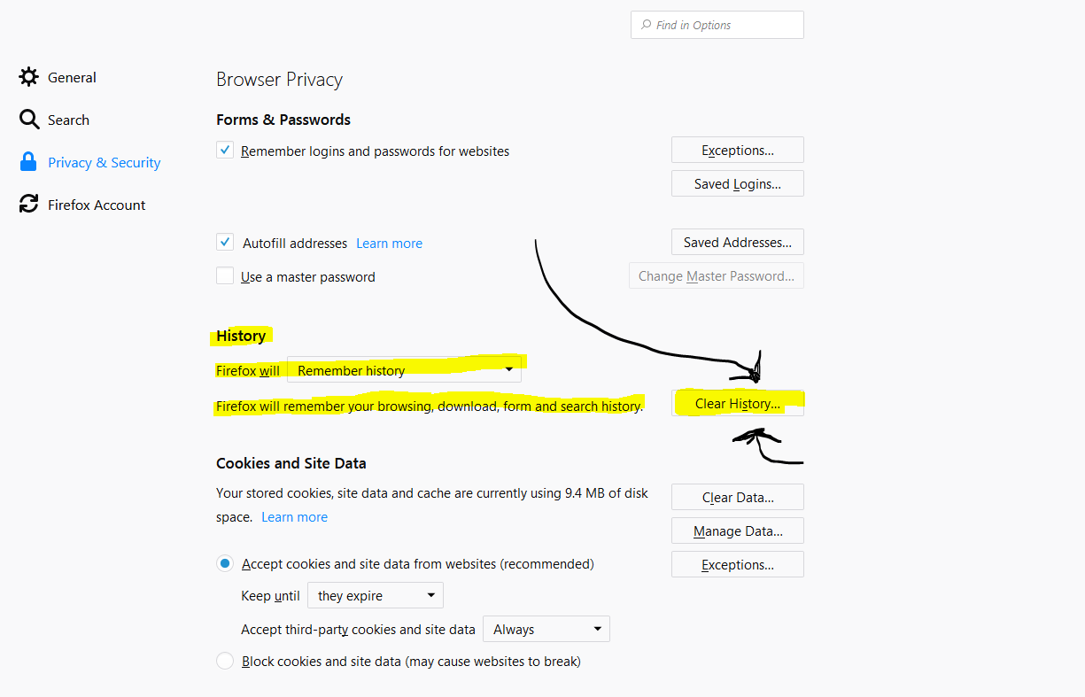

This new dialog box appears.

Change the Time Range to “Everything”.

Check the five boxes identified to the left.

Click “Clear Now”.

Finally close the browser…and go back in!