**Costpoint Auto-Positioning Mode**

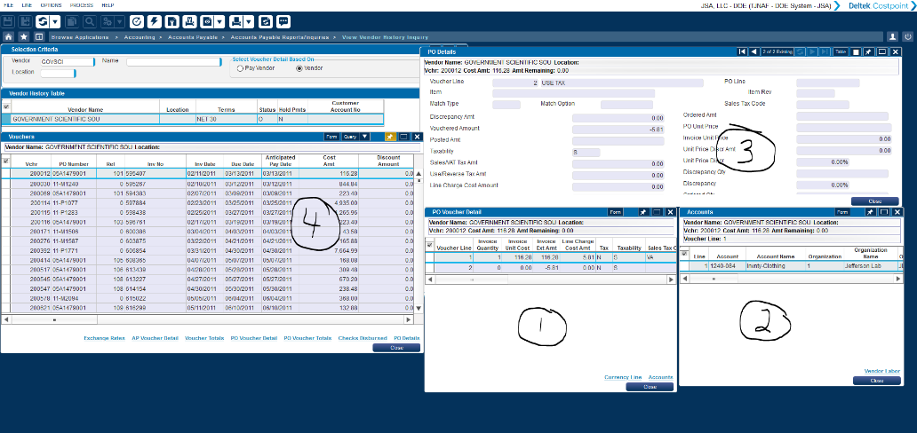Welcome to the new Costpoint Interface, you may need to clear your cache to see it! Beyond the changes to the Icons and general look and feel, Costpoint supports a model called Auto-Positioning. We are moving all employees to this model to simplify the timekeeping system look and feel. The intent of this model is to have the system automatically scale the display to your individual resolution. Because everyone who uses Costpoint could have a different display setting, the goal was to simplify the look and feel so you do not have to constantly use the scroll bar at the bottom of the screen to “see everything” if the layout was developed on a screen with more real estate. Auto-Positioning attempts to achieve this goal.

However, this also means that those of you who have established creative layouts as shown here (4 individual tables displayed with multiple columns); these multi-column layouts are not supported with the auto-positioning model.

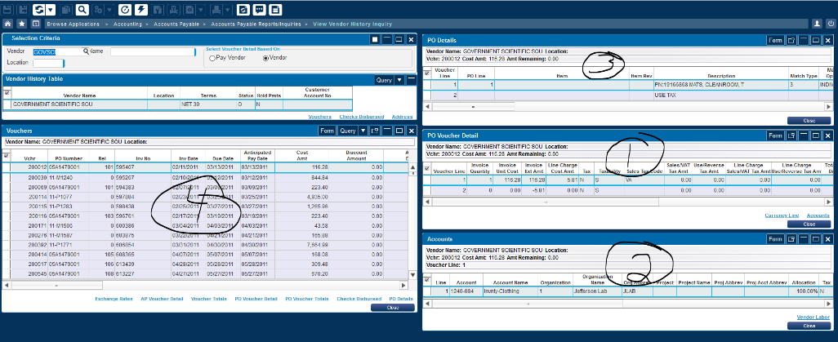

This is an equivalent model with auto-positioning; make note of the 2 column display.

The key is the system attempts to auto-size these layouts based upon your specific screen resolution when you log in. So what does this mean for you? If you elect to retain the Auto Positioning model, your current layouts will need to be re-established and saved. **Please be aware that while this model changes the position for each sub-screen, it does NOT change the formats you setup, such as column sequence.**

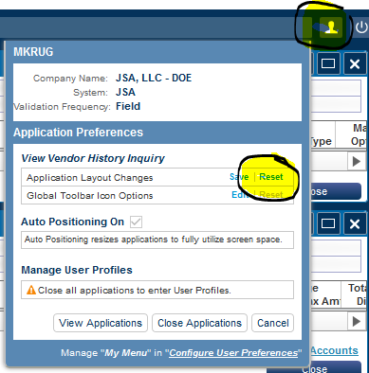I recommend giving this layout a try to see if it will work for you. Make note that there is a new icon on your screen that allows you to toggle between a 2 column layout and 1 column layout. If you find your display is all on one column click the two column layout at the top as shown on the upper image. You may also return to a single column layout as shown on the lower image.

If you wish to simply return to the original layout (e.g. not use the Auto Position mode), you may do so either permanently or every time you login to the system. **Warning: Please do not reset your layout through the application settings shown here, your original screen layout will be eliminated.** This option eliminates your layout and you will be requried to recreate it in either the Auto Positioning mode or with Auto Positioning turned off.

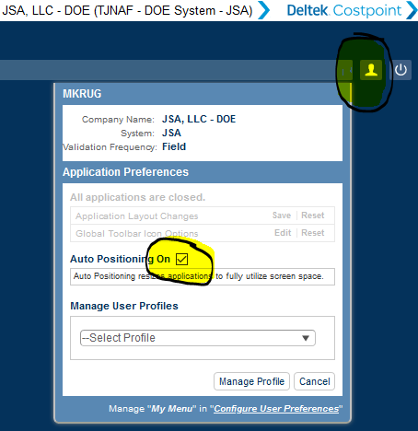

**Toggling Auto Positioning On/Off for the Current Session**

To disable the Auto Positioning feature for ONLY the current session (e.g. the next time you login, Auto Position will be back to your original state), please follow the following steps:

1. Log onto Costpoint and close all applications, return to the main menu. From the main menu, select the User Preferences located on the upper right hand side of the screen.
2. Toggle the “Auto Positioning On” field by clicking the check box

**Toggling Auto Positioning On/Off for all Future Sessions**

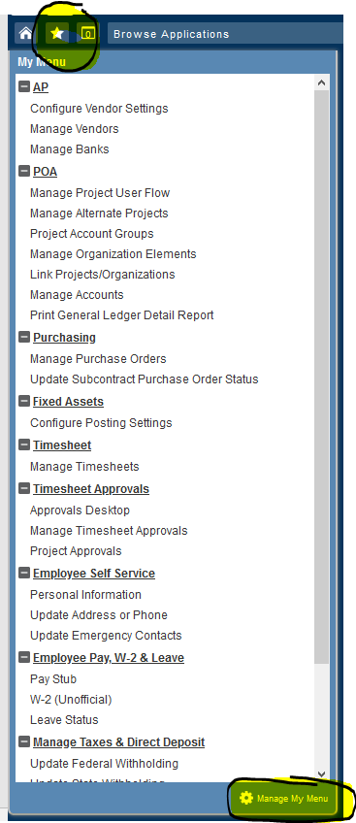To disable the Auto Positioning feature for all future sessions (e.g. the next time you login, Auto Position will be either on or off depending upon your preference), please follow the following steps:

1. Log onto Costpoint and close all applications, return to the main menu. From the main menu, select the “Star Menu located on the upper left hand side of the screen.
2. Click the “Manage My Menu Option at the bottom right hand section of the Menu as shown on the image to the right.
3. The screen that appears (below) allows you to edit your menu and change the Auto Positioning setting. Update the Auto Positioning setting to Yes or No depending upon your preference and then save the changes.
4. 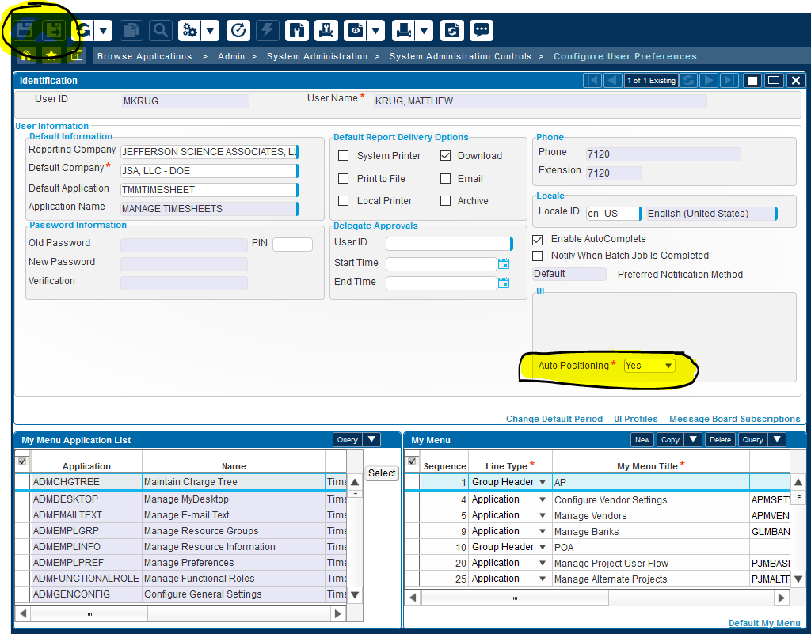Log out and Log back in and verify your changes were set as you wish.