The 8th Workshop on Hadron Physics in China

and Opportunities Worldwide

August 8-11, 2016

Wuhan, China

Final Circular, Jul 27, 2016

Dear colleagues,

This is the 2nd and also the final circular for the 8th Workshop on Hadron Physics in China and Opportunities Worldwide to be held at the College of Physical Sciences and Technology, Central China Normal University (CCNU), located in the city of Wuhan, China during August 8-11, 2016.

ABOUT THE CONFERENCE

Hadron Physics has drawn great interests from the Chinese nuclear and high-energy physics communities and has been one of the main research areas at major accelerator facilities in China. At the same time, the Chinese collaborations are playing increasingly important roles at international hadron physics facilities (Jefferson Lab, RHIC, COMPASS@CERN, J-PARC, …), in particular, at the recently upgraded 12 GeV-energy Jefferson Lab in US, which will provide a broad range of opportunities for frontier research in hadronic physics. Furthermore, the U.S. 2015 long range plan for nuclear science recommended Electron-Ion Colliders (EIC), as the highest priority for new facility construction after the completion of the FRIB as the next frontier for QCD physics. In China, an EIC@HIAF has been widely discussed to be a future facility for hadron physics study. In light of these new developments, the 8th workshop will be held at the College of Physical Sciences and Technology, Central China Normal University (CCNU), located in the city of Wuhan, China during August 8-11, 2016, to discuss the current status, to promote further development of hadron physics in China and to further enhance collaborations between the Chinese and the international hadron physics community.

This workshop will be co-hosted by the Central China Normal University (CCNU), Huazhong University of Science and Technology (HUST) and Wuhan University (WHU), and co-chaired by Jian-ping Chen (Jefferson Lab), Xiangsong Chen (HUST), Haiyan Gao (Duke University and Duke Kunshan University), and Nu Xu (CCNU/LBNL).

The workshop URL is <https://indico.cern.ch/event/502161/> .

REGISTRATION

Participants please register at the workshop via the IHEP Indico system: <https://indico.cern.ch/event/502161/registrations/28094/> .

The deadline for registration and hotel reservation is **1 Aug 2016**. Please notice that the On-site Registration [Registration fee can be paid by Chinese currency(￥1200), US dollars ($190), Euros (€170) or swiping a Chinese bank card at Guiyuan Hotel]:The regular and student registration fee is inclusive of conference participation, coffee breaks, meals, banquet and reception. The time and place of the on-site payment is shown below:

* August 7:

15:00 -18:00, Lobby of Guiyuan Hotel

* August 8：

8:00 – 18:00 , Outside of the Meeting Room

SCIENTIFIC PROGRAM

The main topics of the workshop are:

Spin Physics, 3-D Nucleon Structure (TMDs and GPDs), Form factors, Spectroscopy, Short Range Correlations, neutrinos, Low Energy Test of Standard Model and BSM Physics, Future Facilities and Detectors, and Others.

The program can be found at the conference website:

<https://indico.cern.ch/event/502161/timetable/#all.detailed>

ACCOMMODATION

Blocks of rooms at the Guiyuan Hotel of CCNU and Optics Valley Kingdom Plaza are reserved for participants during the conference. Please select your hotel and room type when you process the workshop registration.

Guiyuan Hotel of CCNU

The Guiyuan Hotel of CCNU locates in campus of Central China Normal University, Which is a five-minutes walk distance from the workshop venue.

* Single room: RMB 268/night (one breakfast included)
* Business single room: RMB 368/night (one breakfast included)
* Double room: RMB 288/night (two breakfasts included)

Optics Valley Kingdom Plaza

The Optics Valley Kingdom Plaza Hotel is a five-star commercial hotel in China, around 3 kilometers away from the workshop venue.

* Single room: RMB 598/night (one breakfast included)
* Double room: RMB 498/night (one breakfast included, RMB70 for additional one)
* Suite: RMB 1388/night (one breakfast included)

The detailed information can be found at the conference website

<https://indico.cern.ch/event/502161/page/6527-accommodation>

VENUE

The meeting will be held in the Multi-functional Hall on the 1st floor of Guiyuan Hotel on

campus of Central China Normal University.

SHUTTLE BUS

For the participants living at Kingdom hotel, there will be a shuttle bus between Kingdom hotel and CCNU. The bus will leave Kingdom hotel at 8:30 a.m. during Aug. 8-11 and leave Guiyuan Hotel after dinner everyday from Aug. 8.

DINES

**August 7**: For the participants staying at Optics Valley Kingdom Plaza , you will have dinner on your own. Other participants will have dinner at Guiyuan Hotel at 6 p.m.

**August 8 -- 11:** Lunch and Dinner will be taken at Guiyuan hotel. If you have special requirements for food(vegetarian), please send email to Ms. MA Ya: [maya@mail.ccnu.edu.cn](mailto:maya@mail.ccnu.edu.cn).

**Conference dinner:** Conference dinner will be taken at Taizi Restaurant” on August 10. The bus will leave in front of building 9 to the restaurant at 18:30.

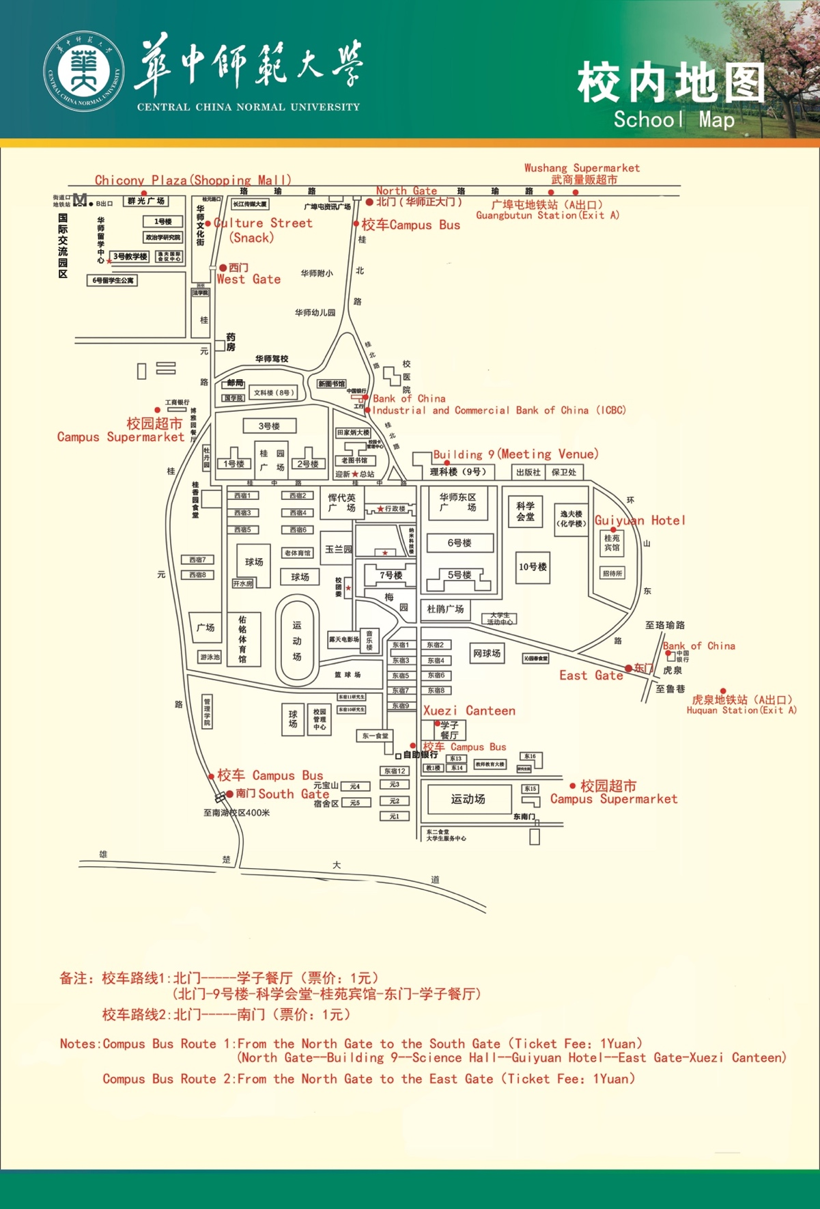

TRANSPORTATION

**Note: If you plan to take a taxi, please take it from taxi station.**

1. Transportation to Central China Normal University（CCNU）is convenient.  People can take Subway 2nd line to North gate of CCNU ( Guangbu Tun station ,exit A ,walk back 100 meters) and East Gate of CCNU (Huquan station, exit A, walk about 400 meters to the north) .

Gui Yuan Hotel is located in the campus of CCNU.

**From north gate of CCNU to Gui Yuan Hotel:** Walk along the Guibei road to the front of the administration building, then turn left to Guixi road , walk about 200 meters and then turn right , it takes about 15 minutes by walk. Or you can take the campus bus from the north gate to hotel.

**From east gate of CCNU to Gui Yuan Hotel**: Walk 100 meters along the Guidong road, turn right to uphill road , walk about 300 meters . It takes about 10 minutes.

**From Guiyuan hotel to conference venue** : It takes about 5 minutes’ walk from the hotel to Building 9.

**From Airport to hotel:（从机场到酒店）**

**Airport to Gui Yuan hotel(机场至桂苑宾馆)**

**1）Taxi:** go through airport high-way,  2nd Yangtze River bridge or Er-qi Yangtze River bridge,  Shui Guohu  tunnel, Luoyu road, Zhuo Daoquan  South road,  east gate of CCNU (Zhuo Yue Hotel), Gui Yuan hotel. It takes about 1 hour, and the fare is about 150 RMB.

**2) Airport bus + taxi:** take airport bus line 1(Wuchang direction) to Fujiapo bus station (32RMB), then take taxi through Wuluo road, Luoyu road, Zhuo Daoquan  South road,  east gate of CCNU , Gui Yuan hotel. The taxi fare is about 20RMB.

**3) Airport bus + Subway:** take airport bus (Hankou direction) to Jinjiadun bus station (17RMB), walk about 400 meter to Hankou railway station, take subway 2nd line (Optics Valley direction) , to  Guangbutun station(广埠屯站, CCNU north gate) or to  Huquan station(虎泉站,CCNU east gate).

**Airport to Optics Valley Kingdom Plaza(机场至金盾光谷大酒店)**

1) Taxi: go through airport high-way,2nd Yangtze River bridge or Er-qi Yangtze River bridge,  Shui Guohu tunnel, Luoyu road, to Optics Valley Kingdom Plaza.It takes about 1 hour, and the fare is about 150 yuan.

2) Airport bus + taxi: take airport bus line 1(Wuchang direction) to Fujiapo   bus station (32 RMB), than take taxi along  Luoyu road to hotel,  the taxi fare is about 20RMB.

**From Train station to Guiyuan hotel：（从火车站到桂苑宾馆）**

There are 3 train stations in Wuhan. People can take Metro Line 2 to reach the North Gate  of CCNU (Guangbutun station(广埠屯站),  exit A ,walk back about 100m) and the East Gate of CCNU (Huquan station(虎泉站), exit A, walk about 400m to the north)

**Wuhan Railway Station to CCNU (Gui Yuan hotel)（武汉火车站到华师，桂苑宾馆 ）**

1. Taxi: It takes about 30 minutes. The fare is about 50 RMB.

2）Subway: Take subway line 4, transfer to line 2 at Zhong Nan road station（Optics Valley direction),to Guangbutun station(Exit A) north gate or to Huquan station(Exit A,CCNU east gate) (Huquan station).It takes about 30 minutes .

**Wuhan Railway Station to Optics Valley Kingdom Plaza:**

Taxi: go through Shui Guohu  tunnel, Luoyu road, It takes about 35 min. , the fare is about 50 RMB.

**Wuchang Railway Station to CCNU (Gui Yuan hotel)（武昌火车站到华师，桂苑宾馆 ）**

1）Taxi:It takes about 20 minutes. The fare is about 25 RMB.

2）Subway: Take subway line 4(Wuhan railway station direction), transfer to line 2 at Zhong Nan road station（Optics Valley direction) (中南路站转2号线，往光谷方向),to Guangbutun station(广埠屯站),CCNU north gate or to Huquan station(虎泉站,CCNU east gate) (Huquan station(虎泉站).It takes about 30 minutes .

**Wuchang railway Station to Optics Valley Kingdom Plaza: （武昌火车站到金盾光谷大酒店）**

Taxi:It takes about 15 minutes. The taxi fare is about 20 RMB.

**HanKou railway Station to CCNU (Guiyuan hotel)（汉口火车站到华师，桂苑宾馆 ）**

1)Taxi: go through Shui Guohu tunnel, Luoyu road, Zhuo Daoquan, east gate of CCNU Gui Yuan hotel. It takes about 30 min. The fare is about 80 RMB.

2）Subway: take subway line 2 （Optics Valley direction) ，to  Guangbutun station(广埠屯站),  CCNU north gate) or to  Huquan station(虎泉站,CCNU east gate). It takes about 50 minutes .

**HanKou railway Station to Optics Valley Kingdom Plaza:**

**（汉口火车站到金盾光谷大酒店）**

Taxi:go through 2nd Yangtze River bridge or Er-qi Yangtze River bridge,  Shui Guohu  tunnel, Luoyu road, to Optics Valley Kingdom Plaza. It takes about 40min., the fare is about 90RMB.

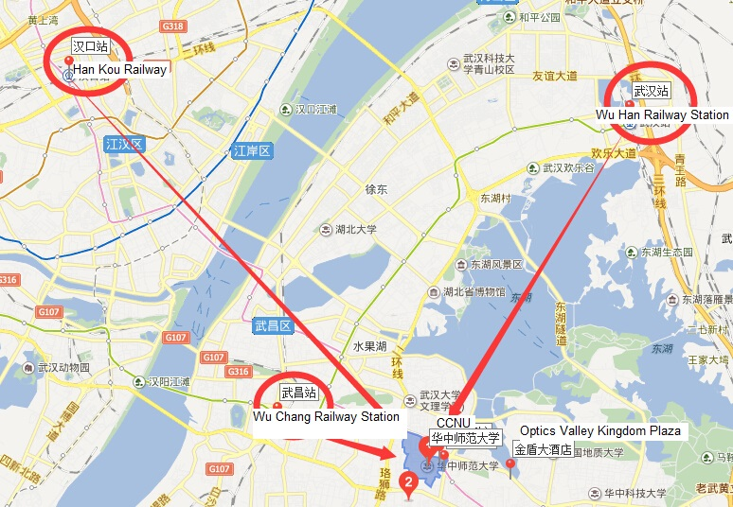

**PRACTICAL INFORMATION**

1. The late summer of Wuhan is hot and humid. The temperature would be about 26-38 ℃/ 79-100 ∘F. Please pack an umbrella.

2. Shopping and City Tour information:

**Around North gate of CCNU**: There is a shopping mall (Chicony Plaza) and a supermarket(Wushang Supermarket). It is about 500 meters from north gate of CCNU.

More information about shopping and city tour, such as Luxiang Square, Hanko Shopping Center, Han Street, Yellow Crane Tower, East Lake, Guiyuan Tample, Hankou Marshland, will be put at the conference website.

**Driving Directions(to show the taxi driver)**

|  |
| --- |
| 1. **Please drive me to Optics Valley Kingdom Plaza, Wuhan.Thank you.**   **请送我去武汉光谷金盾大酒店，地址：武汉**[**洪山区**](http://www.366hotel.com/city_103_3145_0_0_0_1.htm)[**光谷科技中心**](http://www.366hotel.com/city_103_3843_0_0_0_1.htm)**吴家湾特1号,**  **Emergency contact：Feng Liu:86 13377896186(cell)**  **Ya Ma:86 15527890078(cell)**  **紧急联系人：刘峰：13377896186，马亚:15527890078** |
|  |
| 1. **Please drive me to Guiyuan Hotel in Central China Normal University**   **Thank you.**  **请送我去华中师范大学桂苑宾馆。（从洪山区虎泉天桥旁华师东门进）**  **Emergency contact：Feng Liu:86 13377896186(cell)**  **Ya Ma:86 15527890078(cell)**  **紧急联系人：刘峰：13377896186，马亚: 15527890078** |
| 1. **Please drive me to Building 9 in Central China Normal University.**   **Thank you.**  **请送我去华中师范大学9号楼（理科教学楼）（从华师北门或东门进<从金盾酒店方向需要从东门进>）。**  **Emergency contact：Feng Liu:86 13377896186(cell)**  **Ya Ma:86 15527890078(cell)**  **紧急联系人：刘峰：13377896186，马亚: 15527890078** |

CONTACTS

**Ya Ma (CCNU) (Email:** [maya@mail.ccnu.edu.cn](mailto:maya@mail.ccnu.edu.cn), Tel**:** +**86 15527890078)**

Zhenyu Zhang (WHU) (Email: [zhenyuzhang@whu.edu.cn](mailto:zhenyuzhang@whu.edu.cn), Tel: +86 18717199087)

Feng Liu (CCNU) (Email: [fliu@mail.ccnu.edu.c](mailto:fliu@mail.ccnu.edu.c), Tel: +86 13377896186)

We look forward to seeing you in August!

**Hadron 2016 in China**