  

*Laboratoire de l’Accélérateur Linéaire Université Paris-Sud Orsay France*

Dear Professor :

On behalf of the organizing committee, I would like to invite you to attend the 2nd World Physics Summit: “ Exploring the Dark Side of the Universe” that will be held in Pointe à Pitre (Guadeloupe Islands) on June 25-29, 2018. This is the second meeting, following the first one organized by Universidad San Francisco de Quito in the Galápagos Islands with as topics: “Beyond the Standard Model”.

The main goal of the meeting is to discuss progress and future directions related to our great ignorance of the energy and matter content of our Universe. Topics will include dark matter, dark energy, neutrino cosmology, black holes and gravity. This meeting will bring together theorists, astrophysicists and particle physicists, and we hope that original new ideas will emerge from discussions.

We expect a very active and engaged audience and your presence will certainly contribute to the success of the event.

Should you accept this invitation please confirm as early as possible to Betty Calpas and/or Pierre Pétroff ([edsu2018@cern.ch](mailto:edsu2018@cern.ch)). For more informations about the conference please refer to the conference web site at the following address: <https://indico.cern.ch/event/645015/overview>

I am looking forward to meeting you soon in Point à Pitre

Sincerely,

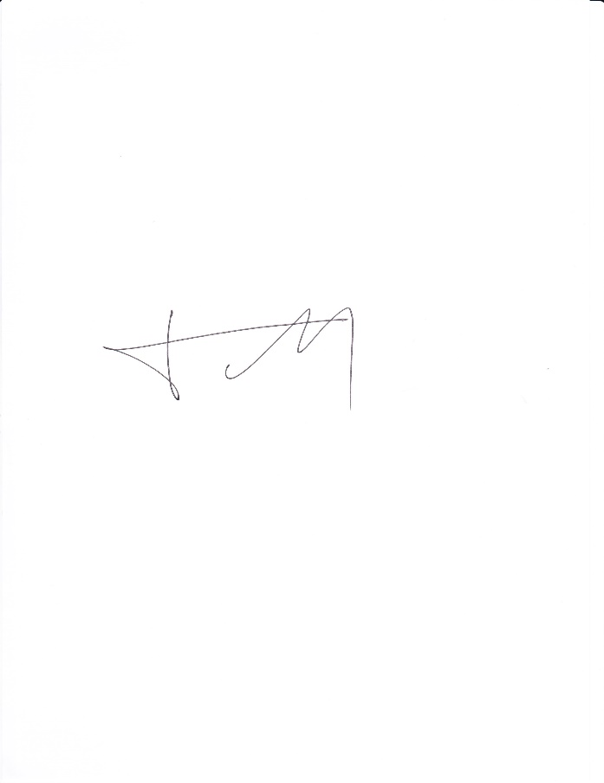

Pierre Pétroff

Conference Chairman

[petroff@lal.in2p3.fr](mailto:petroff@lal.in2p3.fr)