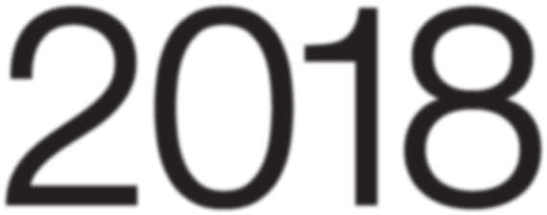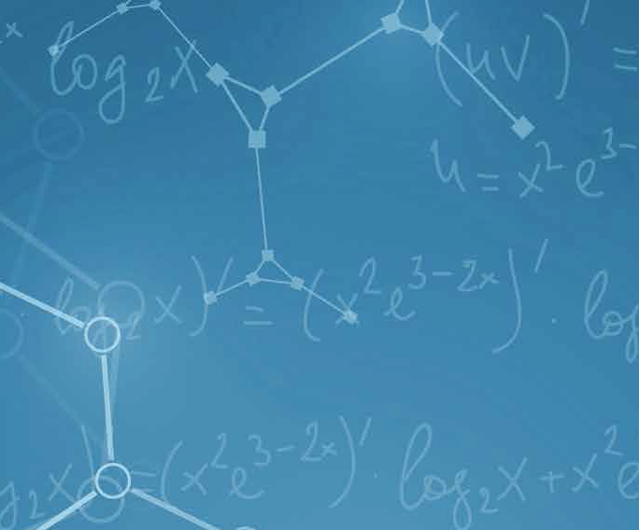

**Fifth Announcement of the HYP2018 Conference**

The 13th International Conference on Hypernuclear and Strange Particle Physics (HYP2018) will take place in Portsmouth Virginia, U.S.A., from June 24 (Sunday evening) through June 29 (Friday midday), 2018.

The HYP conference series brings together theoreticians and experimentalists working on hadron processes and nuclear systems containing strangeness, from single to multi-strangeness systems, and from few-body systems to neutron stars. The topics of the HYP conference have been extended to related fields such as low-energy aspects of QCD, dense and cold matter, as well as hadronic and nuclear systems with heavier flavors.

HYP2018 will be the thirteenth in the series of HYP conferences that were initiated in 1982 in Heidelberg and held periodically every three years. After HYP2003 at Jefferson Lab in U.S.A., the conference was successfully held and rotated between Japan and Europe (HYP2006 in Mainz, Germany, HYP2009 in Tokyo, Japan, HYP2012 in Barcelona, Spain, and HYP2015 in Sendai, Japan.)

HYP2018 is sponsored jointly by Hampton University and Thomas Jefferson National Accelerator Facility (JLab). All sessions (plenary, parallel, and poster) will take place in the Renaissance Portsmouth-Norfolk Waterfront Hotel, offering luxurious accommodations for an excellent rate. The Norfolk airport is only 20 minutes away by car or taxi.

***Confirmed Invited Speakers***

B. Dönigus, P. Bydzovsky, J. Chen, Z. Davoudi, A. Dote, L. Fabbiatti, A. Feliciello, A. Gal, S. Gandolfi, B. Gibson, E. Hiyama, T. Inoue, M. Iwasaki, T. Koike, G. Krein, D. Lonardoni, J. Millener, K. Miwa, T. Motoba, T. Nagae, S. N. Nakamura, K. Nakazawa, K. Piscicchia, Th. A. Rijken, R. Roth, N. Saha, T. Saito, H-J. Schulze, H. Tamura, I. Upsal, I. Vidana, N. Walford, J. Yao, B-S. Zou,

***Conference Website***

<https://www.jlab.org/conferences/hyp2018>

***Scientific Program***

The scientific program will be organized under the following topics:

1. Production, structure and decay of hypernuclei

2. Multistrange systems

3. Production of strangeness

4. Interactions of mesons and baryons with strangeness

5. Strangeness in hadron structure

6. Strange mesons in nuclei

7. Strangeness in astrophysics and in extreme forms of matter

8. Heavy flavor systems

9. Hypernuclei in heavy ion collisions

10. Future experiments and facilities

The scientific program (Monday, June 25 to Friday, June 29) comprises invited talks in the plenary and parallel sessions, and contributed papers in the parallel and poster sessions. In addition, a few special sessions may be held on specific subjects selected by IAC and OC. The oral presentations in the parallel sessions will be selected from the contributed abstracts. The call for abstracts opens on October 16, 2017 and extends to March 2, 2018.

***Venue ( has changed since the First Announcement ! )***

Renaissance Portsmouth-Norfolk Waterfront Hotel, 425 Water Street, Portsmouth, Virginia, 23704, USA. All sessions will take place in the hotel facilities. The conference location makes it easy for participants to relax at the beautiful Portsmouth waterside along the Elizabeth River (and visit the Nauticus Naval Museum with the Battleship Wisconsin) and enjoy a variety of foods in the restaurants along the street beside the hotel as well as in the nearby Norfolk Waterside District and MacArthur Shopping Malls. Participants can also reach famous Virginia Beach by a 25-minute drive, for dinner and/or a swim in the Atlantic Ocean.

***Submission of Abstracts***

With this announcement we are extending the deadline of abstract submission to **April 16** for those who wish to give **poster presentations** at HYP2018. To submit an abstract, follow the instructions on the HYP2018 web page. All the abstracts need to be submitted through the web system (Indico). Please make sure (1) attach a pdf file and (2) check the box “Abstract submission” under “Tract Classification” before submission.

***Registration***

Online registration will start on January 8, 2018. Early (price discounted) registration will extend until May 18, 2018.

The early registration fee is $375, which covers the Sunday reception, scientific program events, and the proceedings. A reduced early registration fee of $150 is offered for students. The registration fee after May 18 is $450 for regular participants and $225 for students. Payment should be done in dollars via major credit cards through the web page when registering. A boat-cruise and banquet dinner will be held (at an additional cost to be determined). On-site payment at the same rates will be possible.

***Accommodations***

Accommodations with be at the conference hotel mentioned above. A reservation link will be available on the conference registration webpage, and a deposit for the first night will be collected (or credit card guarantee). The number of rooms at the conference rate of $93 is limited, so please plan to book in a timely way.

***Transportation***

The best way to reach the conference site is by taxi or Uber from the Norfolk airport. The taxi fee is about $35.

***Social Program***

A welcome reception on the hotel balcony will be held on Sunday evening, June 24, 2018.

A networking reception will be held at the Norfolk Waterside Marriott on Monday evening, June 25, 2018. The venue is a short Ferry ride across the beautiful Elizabeth River. The Elizabeth River Ferry fare is complimentary, and included for the whole week with your conference registration.

A dinner and boat cruise of the Norfolk harbor area will take place on Wednesday afternoon and evening. The fee for this excursion and dinner will be given on the registration web page.

***Proceedings***

The conference proceedings, including peer-reviewed oral and poster presentations will be published.

***Important Dates***

|  |  |
| --- | --- |
| First announcement | August 1, 2017 |
| Second announcement, call for abstracts | October 16, 2017 |
| Early registration starts | January 8, 2018 |
| Deadline for abstract submission | March 2, 2018 |
| Abstract acceptance/rejection notice | April 15, 2018 |
| Final announcement | May 4, 2018 |
| Early registration ends | May 18, 2018 |
| HYP2018 Conference | June 24 to 29, 2018 |

***Contacts***

All the correspondence concerning the conference should be addressed to the conference secretariat: [HYP2018@jlab.org](mailto:HYP2018@jlab.org) .

***Host organization***

The Organizing Committee of HYP2018 Conference

Co-hosted by Jefferson Laboratory and Hampton University

***Organizing Committee***

L. Tang (Hampton/JLab, Chair), R.A. Schumacher (CMU, Co-Chair), C. Lockwood (JLab), J. Cameron (JLab), S. Vermeire (JLab)

***Scientific Program Committee***

L. Tang (Hampton/JLab, Chair), R.A. Schumacher (CMU, Co-Chair), D. Carman (JLab), S. Gandolfi (LANL), B. Gibson (LANL), P. Markowitz (FIU), R. McKeown (JLab), J. Millener (BNL), J. Reinhold (FIU), Z. Xu (BNL)

***International Advisory Committee***

H.C. Bhang (Seoul), E. Botta (Torino), T. Bressani (Torino), C. Curceanu (Frascati), D.H. Davis (London), A. Feliciello (Torino), V.N. Fetisov (Moscow), A. Gal (Jerusalem), B.F. Gibson (Los Alamos), J. Haidenbauer (Juelich), K. Imai (JAEA/J-PARC), T. Kishimoto (Osaka), H. Lenske (Giessen), Y. G. Ma (Shanghai), J. Mares (Rez), D.J. Millener (BNL), T. Motoba (Osaka), T. Nagae (Kyoto), S.N. Nakamura (Tohoku), H. Noumi (RCNP), M. Oka (Tokyo I. T.), E. Oset (Valencia), J. Pochodzalla (Mainz), A. Ramos (Barcelona), R.A. Schumacher (CMU), H. Tamura (Tohoku), L. Tang (Hampton), R.G.E. Timmermans (Groningen), T. Yamazaki (Tokyo), S. L. Zhu (Peking)