**DSG-EIC DIRC Meeting**

**Date: September 23, 2022**

**Time: 3:00 PM – 4:00 PM**

1. **Timeline for when test station is needed?**
2. **Tests should be controlled from outside of EEL 108 sub-room**
   1. Ensuring area is not occupied and door to room is interlocked makes the set up “class 1” where the 3B laser cannot possibly be interacted with when powered
   2. If tests need to be controlled from inside sub-room, can optical table be enclosed?
3. **DSG is working on interlock system for laser**
   1. Relay connection to laser power supply’s interlock connection
   2. Sub-room door interlock
   3. Two emergency-stop buttons
      * One internal and one external to room
   4. Yellow beacon that is illuminated at least 10 seconds before laser is enabled
   5. Any other considerations?
4. **Test station set up questions**
   1. Will we use a polarizing cube (b in Fig. 1)?
      * Did not find one in boxes of equipment or in Beni’s PR
   2. Do we have an absorber/laser beam dump?
   3. Purpose of iris diaphragms?
   4. Do we have a controller for rotary stages?
      * HDR50 stages in equipment boxes require an external stepper motor controller
   5. Only one linear stage of each type (150-mm travel and 300-mm travel) is in equipment order, is there another set on hand already?
      * Two are pictured in Fig. 2

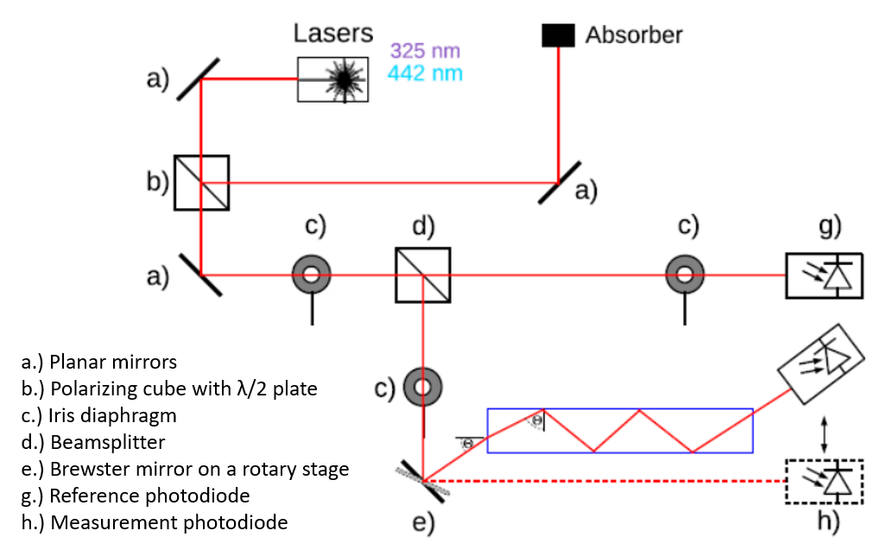

Fig. 1 – Test station diagram (provided by Grzegorz Kalicy)

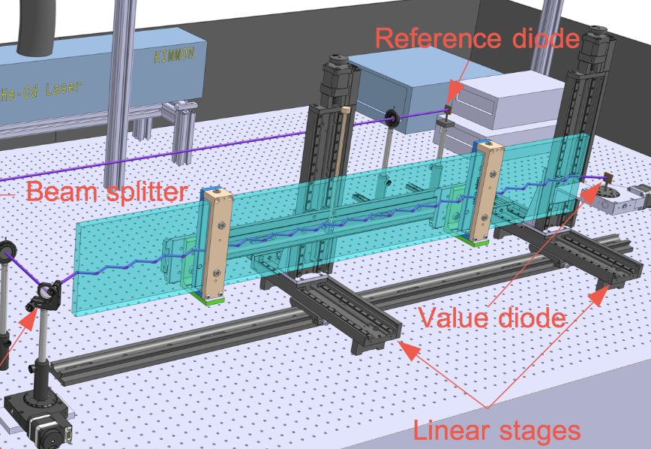

Fig. 2 – Test station 3D model (provided by Grzegorz Kalicy)