**DIRC Laser operations procedure**

Laser lab use:

The DIRC QA lab located in EEL108 will be used to evaluate synthetic fused silica bars received from SLAC for their mechanical and optical quality.

The optical quality of the bar end surfaces and bulk material is determined by projecting the laser along the long axis of the bar while measuring the effective attenuation length.

The coefficient of the total internal reflection of the bar will be determined using the same setup after the bar and mirror are moved to create a different entry angle for the laser on the bar end, creating up to 52 internal reflections. In both cases, the laser intensity is monitored by two diodes. The measurement is started using a pre-programmed sequence on a DAQ computer.

Operation:

Unpacking, cleaning, and inspection of fused silica bars:

1. Don PPE (lab coat, cut resistant gloves)
2. Unpack bars at the cleaning station and place them in temporary storage
3. Pull a single bar from storage and inspect visually for surface damage and pollution using the halogen light at the inspection station
4. Clean old adhesive from the ends of the bars with isopropanol and/or Hastelite
   1. Dispose of any cleaning materials in a standard trash receptacle
   2. The trash receptacle should be moved outside the fencing at the end of the shift
5. Cleaned bars will be stored in long-term storage drawers
6. Bars ready for laser measurements will be mounted to bar holder and placed in wheeled, short-term storage before moving to the laser room

Fused silica bar installation procedure:

1. Before entry into the laser room, don PPE (laser eye protection, appropriate lab coat, cut resistant gloves)
2. Disable the laser by removing the outside room key
   1. Attempting to enter the laser lab will trigger the interlock system
3. Move short-term storage into the laser lab and install a bar on the table
4. If the laser is aligned – exit the room, enable the laser with the outside-room key enable to start measurements
5. If the laser needs to be aligned - proceed to the alignment procedure

Alignment procedure:

1. Alignment of the laser requires:
   1. personnel to visually observe the laser while it is on, inside the room
   2. This requires bypass of the main interlock
2. Entry into the laser lab will trigger the interlock system to disable the laser output
3. Repositioning components on the optical table is done while the **laser is disabled**
4. To operate the laser, configure the laser to low power mode by positioning the filter directly in front of the beam
5. filter will reduce laser power to less than or equal to the power of a 3R laser
6. The table side shields should be up/in position to stop the beam from going past the extent of the table
7. The final step to enable the laser is to insert the in-room key and rotate it to enable
8. The laser will be enabled
9. Outside-room key control will be disabled

**Laser specification:**

Model: Kimmon Helium Cadmium (He-Cd) IK5351R-D

Wavelength (nm): 325/442

Power (mW): 14/44

Transverse Mode: TEM00

Polarization: Linear

Polarization Ratio: > 500:1

Beam Diameter 1/e2 (mm)*1: < 0.9/1.0

Beam Divergence (mrad)*2: < 0.5

Noise P-P, @30kHz~ 2MHz (%)*2: < 10/10

Noise RMS, @30kHz~ 10MHz (%)*2: < 2.0/2.0

Power Stability (%)*3: ≤ ± 2.0 (4 hours)

Warm-up Time (90% Power) (minutes)*3: 20

Laser Class: 3B/IIIb

Weight (kg): 16

Max Current (A): < 5.5

Power Consumption (W): < 500

Power Supply: KP2014C

Input Voltage: (100 ~240)

Weight (kg): 8.0

Laser lab/room layout

Interlock system diagram

Interlock system schematic

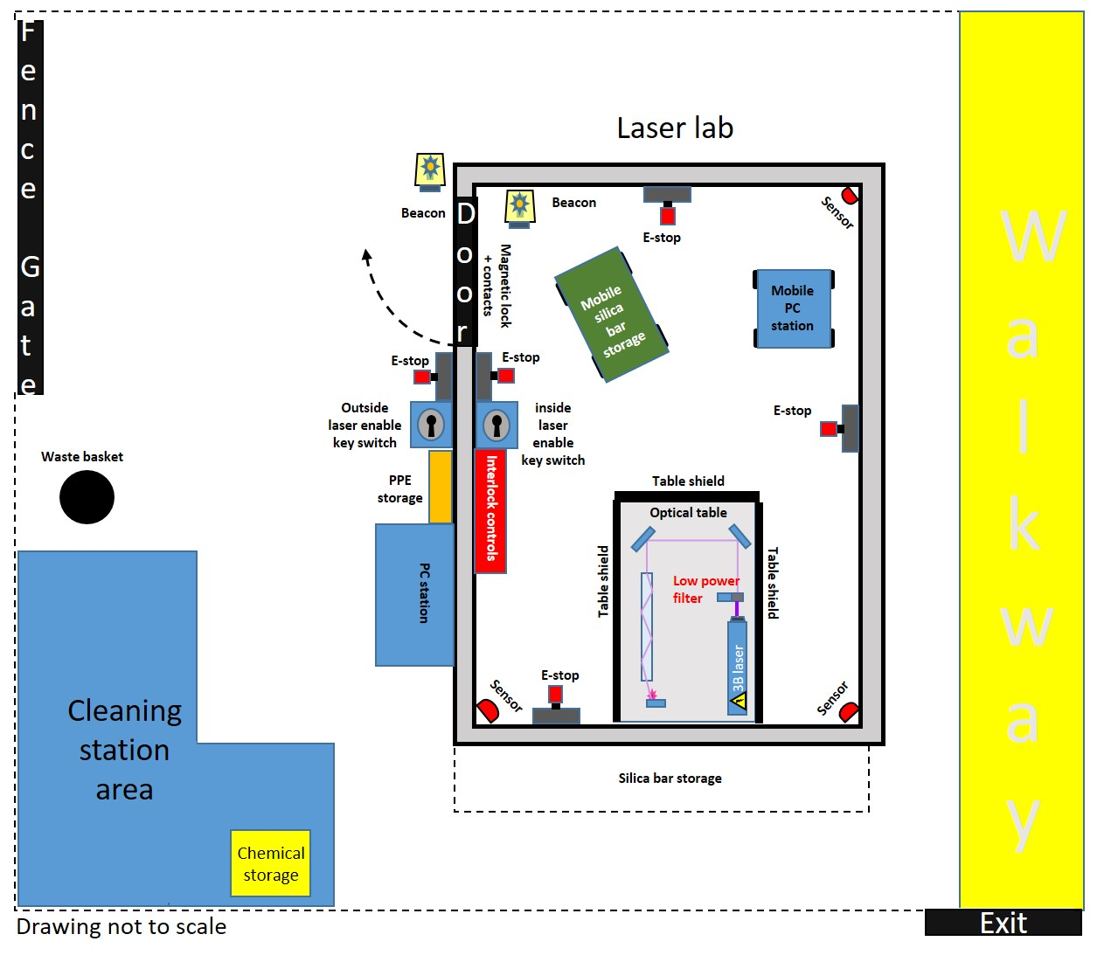

Figure . Map of laser controlled area

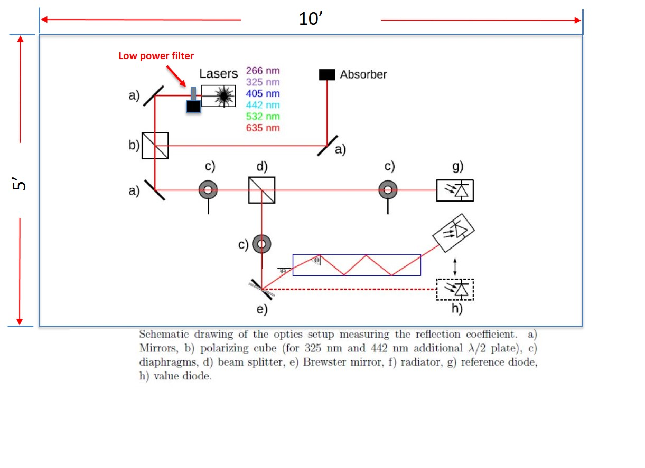Figure . Diagram of optical table layout with laser components

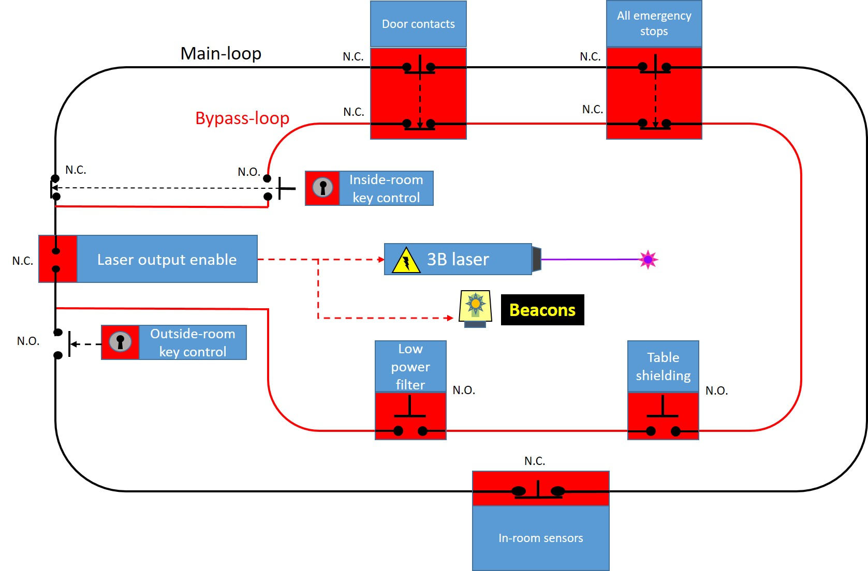

Figure . Laser output interlock diagram