 | Laser Operational Safety Procedure (LOSP) THA Guidance  (See ES&H Manual Chapter 6410 Appendix T1  Laser Operational Safety Procedure)
- Purpose

To provide the Laser System Supervisor (LSS) with a guide to help develop the Task Hazard Analysis (THA) and the associated Laser Operational Safety Procedure (LOSP).

- Scope

This guidance document is intended for use with Class 3B and Class 4 laser systems, but can also be used for lower powered laser systems. It is non-mandatory.

- Hazard Identification

Development of the LOSP starts with creating the THA. Although each laser system is unique, there are hazards common to Class 3B or Class 4 lasers. The following THA (pages 2-6) captures many of the hazards and can be used to develop your THA. It is not intended to be cut and pasted into your THA, but should be tailored to the specific laser system.

- Work Planning

After the completion of the THA, the LOSP can be developed. The first page identifies the location and describes the project. List the lasers to be used in the system, record the wavelength power level, and laser class on the form. Referring to the information on the THA complete the LOSP form. Use the explanatory information found in the marked up LOSP starting on page 7 of this document.

 | Task Hazard Analysis (THA) Worksheet  (See ES&H Manual Chapter 3210 Appendix T1  Work Planning, Control, and Authorization Procedure)

THA must be accompanied by a LOSP
Author: | Marc McMullen |  |  | Date: 10/20/2022
Task Title: |  | Operation of the DIRC 3B laser |  | Task Location: | EEL 108 DIRC laser lab
Engineering Control requirements: |  |  | Administrative requirements:
Laser enclosure with interlocks for tooled housing.  Interlocked Laser Controlled Area (LCA) for room with multiple laser hazards not inside a Class 1 enclosure. |  |  | Training:  - SAF114O Laser Safety Orientation  - MED02 Laser eye exam  - SAFXXX Laser Specific Training  - SAF104 Lock, Tag, Try for service & maintenance |  |  | Postings/Labels/Warning systems:  - LCA warning signs at entrance  - Laser Class and aperture labels  - Laser on indicator (yellow flashing light)

Laser Process | Potential Hazards  Select hazard applicable to your LCA (delete non-applicable or add other hazard if not listed) | Consequence Level | Probability Level | Risk Code (before mitigation) | Proposed Mitigation  (Required for Risk Code >2)  Select control applicable to your LCA (delete non-applicable or add other mitigation if not listed) | Safety Procedures/ Practices/Controls/Training  Select control applicable to your LCA (delete non-applicable or add other mitigation if not listed) | Risk Code  (after mitigation)
OPERATIONS | Temporary or permanent eye damage | M | M | 3 | Standard operation (quartz crystal measurement) is done from outside LCA  For alignment of components done inside LCA, the interlock system requires a filter to be positioned which reduces the laser power to less than MPE. | Engineered controls: Interlock system includes a sweep function latching switch inside the laser room to ensure the room has been verified clear for laser output  Authorized admittance  Required laser training  Laser specific protective eyewear | 1
OPERATIONS | Specular reflection hazard | M | M | 3 | The LCA is a closed room with interlocked controls.  Standard operations are done from outside the LCA. No exposure is possible due to the interlock system. | Engineered controls: interlock system includes a sweep function latching switch inside the laser room to ensure the room has been verified clear for laser output  No jewelry, watches, portable electronics, or reflective clothing | 1
OPERATIONS | Exposure to high voltages (i.e. pockel cells) | M | L | 2 | Electrically insulated connections | Installation of electrical components will be done by QEW | 1
OPERATIONS | Chemical exposure (skin /eyes) | L | L | 1 | Safety Data Sheet review by Industrial Hygiene (IH) | Controls per IH based on SDS review | 1
OPERATIONS | Human Error | M | M | 3 | A robust interlock system is designed prevent the human error factor  Apply the hierarchy of controls  Identify and manage error precursors | Prevention through design should be applied up front to eliminate or reduce hazards  Incorporate one or more of the HPI tools (such as Three-way Communication, Independent Verification, Pre-task Brief, Procedure Use & Adherence, Job Site review, etc.) | 1
OPERATIONS | Temporary or permanent eye damage | M | M | 3 | Optical beamline layout at or below waist level  The controls prevent beam-on exposure without a power reducing filter that lowers the laser power to ≤ Class 3R  Terminate the beam at the end of its useful path. | Engineered controls: interlock system with low power filter  Laser specific protective eyewear  Locate any specular reflections of the beam and block them as close to the source as possible, before moving to the next optical component or section  Use Beam blocks behind optics (mirrors) to terminate beam in case of misalignment  All beams and reflections are properly terminated prior to high power operation | 1
ALIGNMENT | Specular reflection hazard | M | M | 3 | The controls prevent beam-on exposure without a power reducing filter that lowers the laser power to ≤ Class 3R  Optical beamline layout, beam stops | Engineered controls: interlock system with low power filter  Laser specific protective eyewear | 1
ALIGNMENT | Manual measurement: Specular reflection hazard, human error | M | M | 3 | The controls are set to expert mode. Only personnel designated by the LSS and approved by the LSO may configure the set-up for manual measurements  Expert mode measurements are only to be done after the alignment procedure (in low power configuration) | Laser specific protective eyewear  Additional training provided by the LSS  Manual measurement procedure adherence | 2
ALIGNMENT | Trip/fall due to low light or limited vision due to laser PPE | M | L | 2 | Clear walkways and effective housekeeping  Walkway lighting | LSS will ensure walkways are clear | 1
ALIGNMENT | Cleaning of laser components and optics | M | M | 3 | All manipulations of optical table equipment will be done with the laser off . | Less than 1L of solvents inside laser lab. Store solvents in flammables cabinet when not in use.  Engineered controls: interlock system with low power filter  DIRC laser alignment procedure | 2
ALIGNMENT | Replacement of components of parts | M | M | 3 | All manipulations of optical table equipment will be done with the laser off or in Low Power mode which reduces the laser output below MPE | Engineered controls: interlock system with low power filter  DIRC laser alignment procedure | 2
ALIGNMENT |  |  | Highest Risk Code before Mitigation: | 3 |  | Highest Risk Code after Mitigation: | 2

Laser Operational Safety Procedure (LOSP) Form
(See ES&H Manual Chapter 6410 Appendix T1
Laser Operational Safety Procedure)

Serial Number:
 |  |  |  | (Assigned by ESH&Q Document Control x7277)
*Attach the Task Hazard Analysis (THA) related to this procedure
Issue Date: |  |  |  |  |  |  | Expiration Date:
Title: | Operation of the DIRC 3B laser
Location where the laser will be used: |  |  |  |  | EEL 108 DIRC laser room
Description of Project |  |  | The DIRC laser will be used to evaluate synthetic fused silica bars received from SLAC for their mechanical and optical quality
Document Owner(s):  Usually the LSS, but could be someone else |  |  |  |  |  | Benedikt Zihlmann, Marc McMullen |  |  | Date: | 10/20/2022

Laser Inventory
Laser Serial # |  |  | Laser Class |  |  | Wavelength(s) |  |  | Maximum Power/Energy
 | S5935 |  |  | 3B |  |  | 325nm/442nm |  |  | 14mW/44mW

Approval Signatures: |  |  |  |  |  | Print Signature |  |  | Date:
Laser System Supervisor: |  |  |  |  | Benedikt Zihlmann
Laser Safety Officer: |  |  | Jennifer Williams
Division Safety Officer
Department or Group Head:
Other Approval(s): |  | Class 4 will require Fire Protection SME
 | Where applicable, SMEs for LTT, IH, High Voltage, etc.

Document History:
Revision: | Reason for revision or update: | Serial number of superseded document
Distribution: ESH&Q Document Control (x7277, MS6B); affected area(s); Document Owner; Division Safety Officer

Introduction: In areas containing more than one laser, define operational sequence or parameters.
- The DIRC laser is located in EEL 108
- The operational use of the laser is to evaluate synthetic fused silica bars received from SLAC for their mechanical and optical quality
- There is a single Kimmon model IK5351R-D class 3b laser located in the LCA
- See Fig. 3 for a diagram of the LCA

Personnel  Only those authorized by the LSS are permitted to enter the location noted on the cover sheet of this document. | List:  - Training and qualification requirements (including refresher training).  - Medical requirements.  - Spectator protection requirements.
- The LSS is Benedikt Zihlmann and the Jlab LSO is Jennifer Williams
- Laser Operators must complete the following training:
  - SAF1140 – Laser Safety Orientation
  - MED02 – Laser Eye Exam
  - SAFXXX – Laser Specific Training for the DIRC laser
  - GERT
- Will spectators be allowed? Yes, they must adhere to the following stipulations:
  - LSS approval is required
  - Spectator shall be escorted at all times by a qualified laser operator
  - Spectator shall be briefed on the hazards within the LCA and the controls in place to mitigate the hazards
Laser | Define:  - Laser system specifications  - Laser system components  - Copy of laser operating manuals or reference the location of the manual(s).

The laser set up is on a 5’ wide x 10’ long optical table which is ~3’ tall. The beam path will stay level at a height of about 3 to 5 inches above the surface of the optical table. Blocking panels ensure the beam does not extent past the limits of the table top. The panels are interlocked to prevent laser output when the panels are down.
Figure 1. Optical table rendering with components. The beam path is in violet.

The schematic of the setup is shown in the figure above. All components are mounted on an optical table.

The He-Cd laser operates at two wavelengths, 325nm (“UV”) and 442nm (“blue”), which are selected with a manual switch at the front of the laser. The laser housing is mounted on a stage to adjust the height and assure the beam is parallel to the table surface. A pipe takes the hot air from the laser cooling fan away from the setup. At the laser exit, the UV line has an output power of up to 14mW, a beam diameter below 1mm, and a beam divergence of 0.5mrad. The blue line has an output power of up to 44mW, a beam diameter below 1mm, and a beam divergence of 0.5mrad.

UV-enhanced aluminum mirrors, coated with MgF2, guide the laser beam in the optical plane, which is parallel to the table surface. The Lambda/2 plate changes the orientation of the polarization plane of the beam.

The laser beam will be 3 to 6 inches above the surface of the table (36”). All segments of the beam will terminate at either an absorber or photo diode sensor.

All walls of the LCA will have at least one emergency stop to shut off the laser output.

- List each laser in use in your LCA, include the following information (examples below):
Laser Description | Kimmon IK5351R-D
Laser Type | Helium Cadmium (He-Cd)
Laser Class | Class 3B/IIIb
Laser Manufacturer | Kimmon
Laser Model Number(s) | IK5351R-D
Laser Serial Number(s) | S5935
Wavelength Range | (325nm/442nm)
Power Range | 14mW/44mW
Mode (i.e., time structure) | CW
Beam Diameter (collimated, typical) | 0.9/1.0 mm
Divergence (uncollimated, typical) | < 0.5 mrad^{*2} +/- 10%
Laser Eyewear O.D. | +2

Hazards and Mitigation | Define:  - Laser system hazards  - Occupational exposure hazards beyond laser light (e.g., fumes, noise, etc.)  - Credible non-beam hazards (e.g., environmental hazards)  - Describe all required personal protective equipment (include clothing requirements, e.g. no reflective jewelry, etc.). Refer to ES&H Manual Chapter 6410 Appendix T2 Laser Personal Protective Equipment (PPE)  - Control of Hazardous Energy (includes beam and non-beam hazards such as electrical)

Hazards:
- Specular reflection – mitigated by an interlocked door, interlock system controls, Jlab-required training, and laser eye protection (2+)
- Temporary/permanent eye damage – mitigated by an interlocked door, interlock system controls, Jlab-required training, and laser eye protection (2+)
- HV exposure – mitigated the use of NRTL-approved equipment installed by Jlab QEW and PPE. A separate task hazard analysis is required for task involving electrical hazards.
- Chemical exposure – mitigated through the use of Jlab IH-approved cleaning chemicals, disposal practices, and PPE
- Trips/Fall – mitigated by appropriate lighting of walkways, proper housekeeping, and oversight by LSS and area safety warden
- Human error - mitigated by an interlocked door, interlock system controls, Jlab-required training, and laser eye protection (O.D. 2+)
System Experts will determine any modifications or repairs needed to any equipment. Any work needed by external vendors (i.e. laser manufacturer) shall be reviewed by the LSS prior to assignment.
Laser Environment  System designs, including interlocks, require hazard evaluation review by SME. | Define:  - Laser system hazards  - Layout of the laser controlled area and/or table. Show beam location in relation to user – waist height preferable.  - Interlock schematic (or similar), including smoke detector interlocks.  - Room lighting conditions during laser use and alignment procedure(s).  - Targets.  - Primary and all likely beam paths (open or enclosed).

Figure 2. Map of DIRC laser lab area
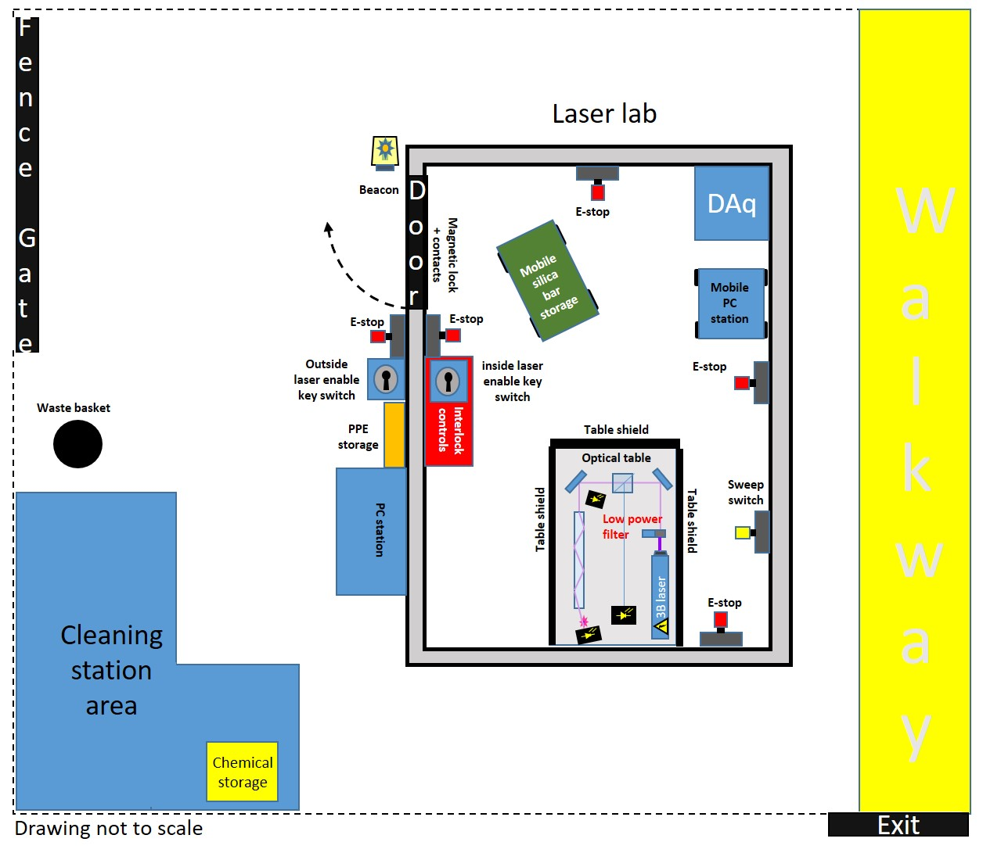

Figure 3. Optical table layout

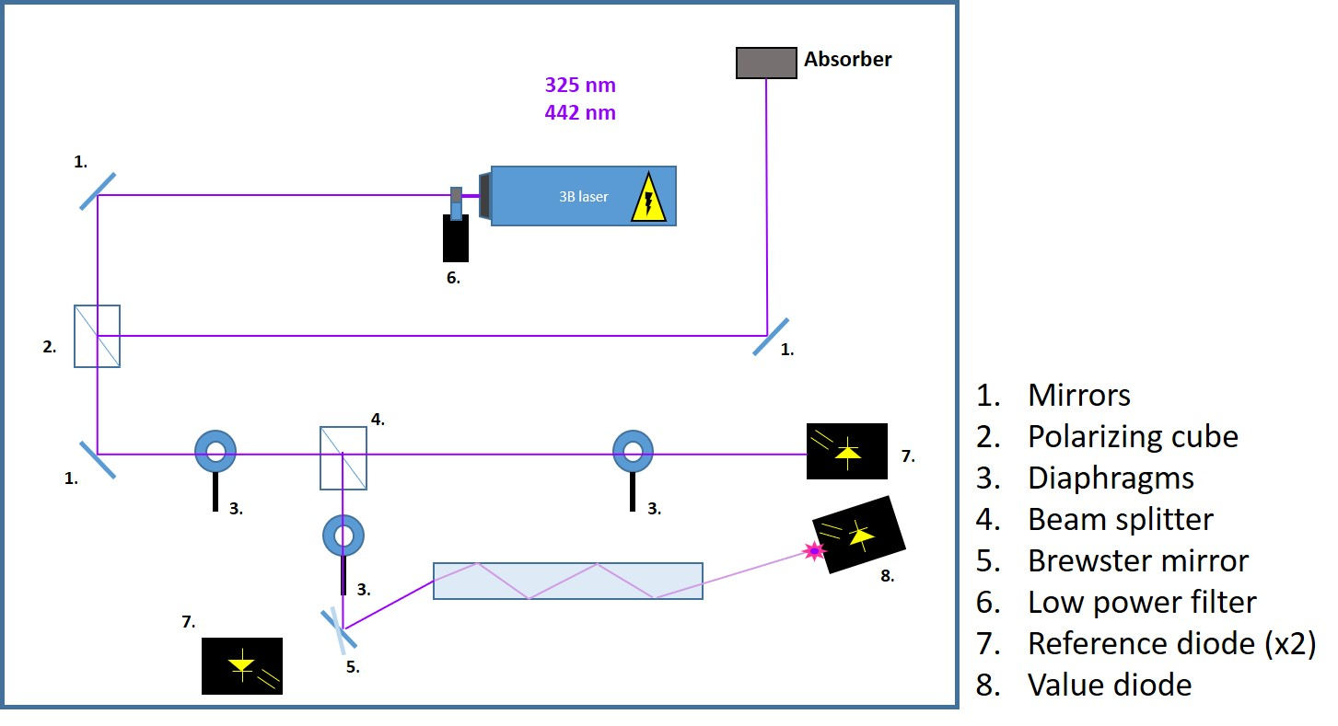

Written procedure for use and alignment | Provide:  - All process steps – including unattended operation controls.  - All process steps for detailed alignment – include manufacturer’s protocols for alignment.  - Maintenance and service  - Off-normal and emergency procedures (e.g., beam loss, fire).

Before entry, authorized staff shall don laser eye protection and lab coats.
Initial alignment procedure:
The initial alignment procedure will ensure the laser beam is controlled within the boundaries of the optical table and the beam alignment components, measurement sensors, and dump components are in the correct position.

- Alignment of the laser requires:
  - personnel to visually observe the laser while it is on, inside the room
  - Key access (via the Keywatcher enclosure in the hallway of the EEL building)
  - Sweep of the room and actuation of the “sweep” switch to confirm that the lab is ready for laser output

- Entry into the laser lab will trigger the interlock system to disable the laser output
- Repositioning components on the optical table is done while the laser is disabled
- To operate the laser, configure the laser to low power mode by positioning the filter directly in front of the beam
  - The filter will reduce laser power to less than or equal to the power of a Class 3R laser
- The table side shields should be up/in position to stop the beam from going past the extent of the table
- Visually confirm the status of the room (all hazards mitigated) and press the “sweep” switch
- The final step to enable the laser is to insert the in-room key and rotate it to “output enable”
  - The laser will be enabled
  - Outside-room key control will be disabled
Expert Mode (Manual quartz bar measurement):
After initial alignment, manual measurements of the quartz bars will be done by a limited number of trained staff. The LSS shall assign the designation of “expert” to persons who have demonstrated knowledge of the system and adherence to the Jlab safety protocols concerning laser operations. Laser eye protection and lab coats must be worn at all times.
An “expert” key will be housed in the Keywatcher enclosure, and only be available for checkout by the designated experts.
Experts shall be qualified to use the “expert” key switch position which will configure the laser to full power from the inside the room key position. Laser eye protection and lab coats must be worn at all times.
Manual quartz measurements are done with the “expert” inside the LCA, during beam-on operations, without the low-power filter in place. The table side shields will contain the laser during operations and confine the beam to the boundaries of the optical table.
After initial alignment of the laser and optical components (In low power configuration), manual measurements must be done to ensure that the quartz bar and the measurement diodes are positioned correctly for all measurement points. The quartz bar is mounted to a linear stage, which is moved by a stepper motor through the laser beam. In addition to the quartz bar stage, photodiodes are used to establish maximum laser intensity at specific positions of the optical table:
Sensors:
- Receives half of the laser intensity after the laser is split, monitors laser intensity
- Monitors laser intensity reflected from the face of the bar
- Monitors laser intensity after it has passed through the front face of the bar and has reflected throughout the body of the bar (up to 55 reflections)
Automated measurement mode
Automated measurement mode can be done after the optimal position of the quartz bar has been established and the position of the measurement photodiodes has been verified.
Prior to enabling the output of the laser, the operator shall perform a sweep of the laser lab. Operator actions during the sweep are as follows:
- Enter the laser room and verify no personnel are in the room
- Actuate the sweep switch on the wall opposite the door
- Exit the room

Automated measurement mode is done via the operating position outside of the LCA. The laser is armed from the key position on the outside of the laser room after verifying that the room is clear of personnel.
Once the room and all interlock latches have been cleared, the key is inserted and the laser is armed and ready for output.
A control program will aid in the performance of the measurement. Any actuation of the door or an emergency stop will shut down the laser and latch the appropriate interlocks.

Maintenance and Service:
Maintenance of the laser system or the interlock system is not standard procedure for operating the DIRC laser. Any maintenance of the laser system or the interlock system will require a Task Hazard Analysis for that task, and potentially a Temporary Operating Safety Procedure. The LSS and LSO will be consulted and make any determinations for this work.
During standard operation or alignment of the laser equipment, personnel and equipment safety is governed by engineering controls and the procedure. During all laser operations covered in this document and the LOSP, a LOTO procedure is not required.

Laser Controls | Based on the information developed in the THA:  - Describe all controls (administrative and engineering) required to be in place during laser operations.  - If a different control is recommended, describe the rationale for not using a typical/recommended control.

An engineered control-based interlock system has been developed with the following elements:

- Key control switches
- magnetically locked door with contacts
- Emergency stop switches
- Interlock shields for the table sides prevent the laser beam from extending beyond the table
- A filter to reduce the laser power during alignment
- Latching interlock switches and contacts
- Personnel sweep switch

The system is designed to disable the laser output if any element triggers the interlock. The system is designed to latch in a way that forces the operator to affirm all interlocks are cleared before resuming laser output.

Figure 4. Laser interlocks diagram

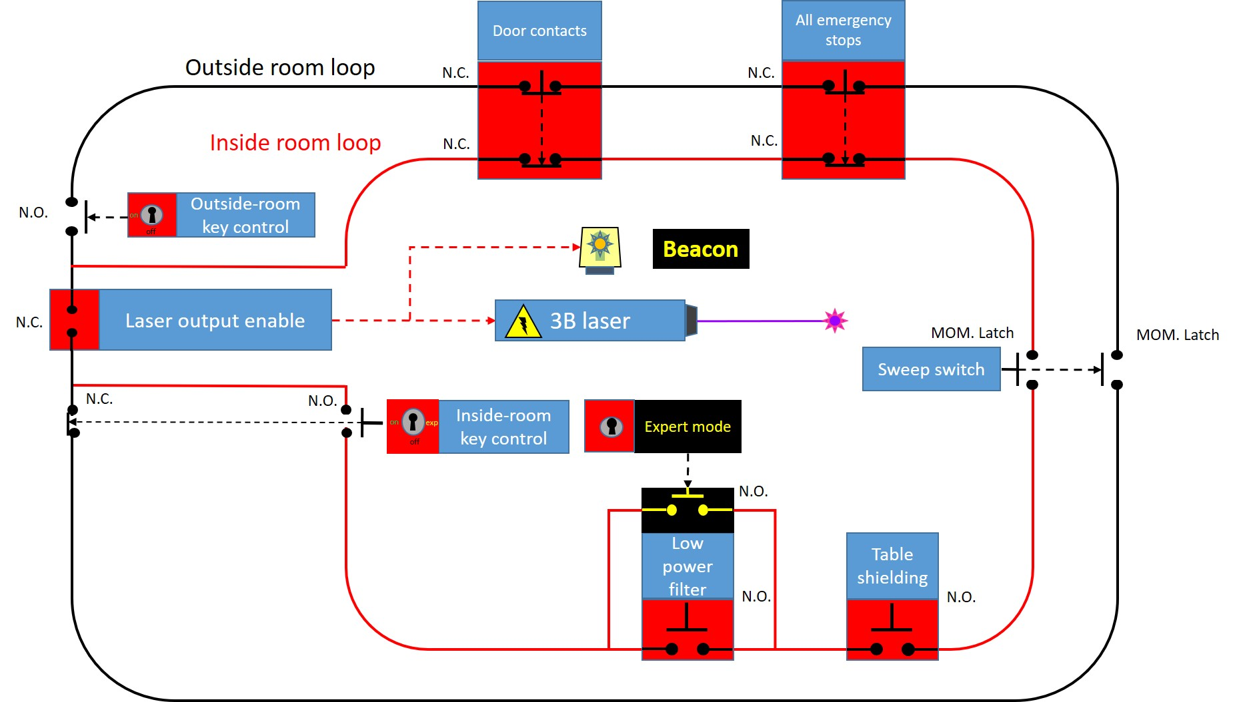

Describe low power filter, model/part number, show calculation or some other evidence that it will reduce power to 3R level.

Required Calculations | - Maximum permissible exposure.  - Optical density.  - Nominal hazard zone.

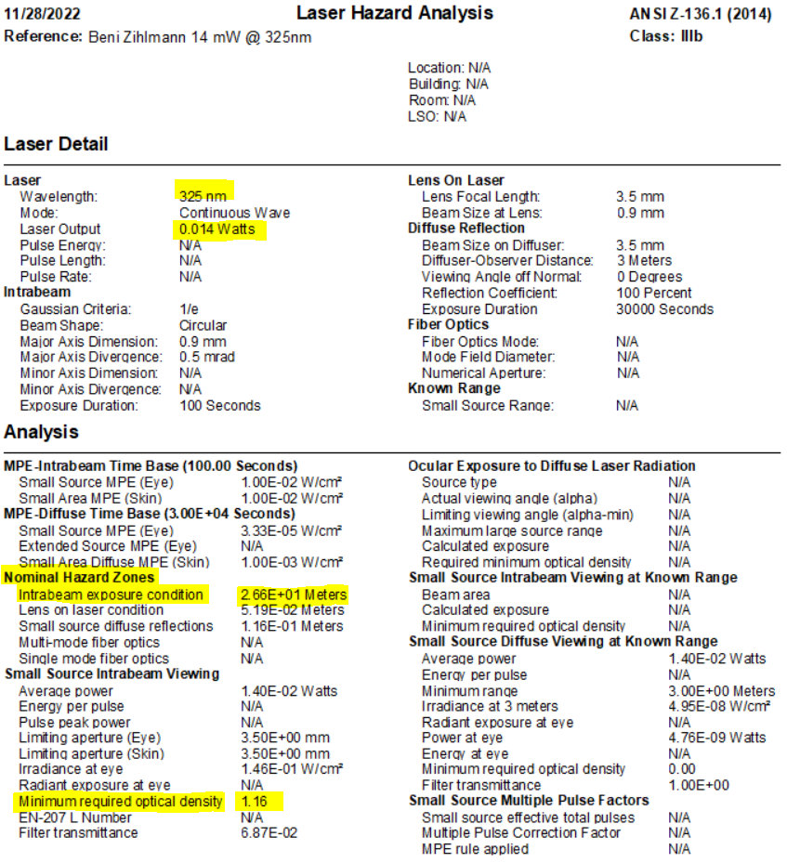

Figure 6: Laser hazard analysis 14 mW @ 325 nm
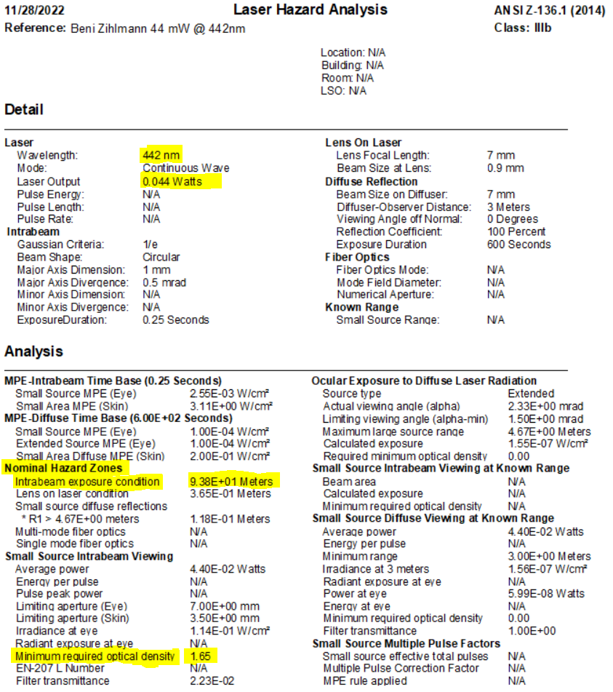

Figure 7: Laser hazard analysis 44 mW @ 442 nm

Minimum required optical density is 2+ at both 325 nm and 442 nm.
O.D. results confirmed with Laser Institute of American Evaluator online software.

Labeling/Posting  See ES&H Manual Chapter 6410 Appendix T6 Laser Labeling/Posting Requirements | - Equipment/area labeling/posting requirements  - Area signs
- Signage will be posted for a Class 3B/IIIb laser at the entry way of the area and doorway into the LCA

Authorized/Trained Individuals
Print Name/Signature | Date

