Modification Instructions for the Six New EIC DIRC Shipping Crates

Step 1 – Hard Point Additions to the Interior Box Base for the Air Springs and Brackets

1. Remove Exterior Box Top
2. Remove Exterior Box Front and Rear Sides
3. Remove Interior Box Top
4. Remove Interior Box Front and Rear Sides
5. Remove Interior Box Ends
6. Rotate the Interior Box Base so the Bottom Faces Up
7. Place ~6” of Cribbing Between the Interior and Exterior Box Bases
8. Dry Fit the 32” long 4”x4” lumber sections according to Diagram #1
   1. The 4”x4” lumber should fit tightly with good surface to surface contact
   2. Hard Point Locations may vary up to +2/- 0”
   3. Mark the Interior Crate Base to show Hard Point Locations and Translate these locations to the Frame of the Interior Box Base

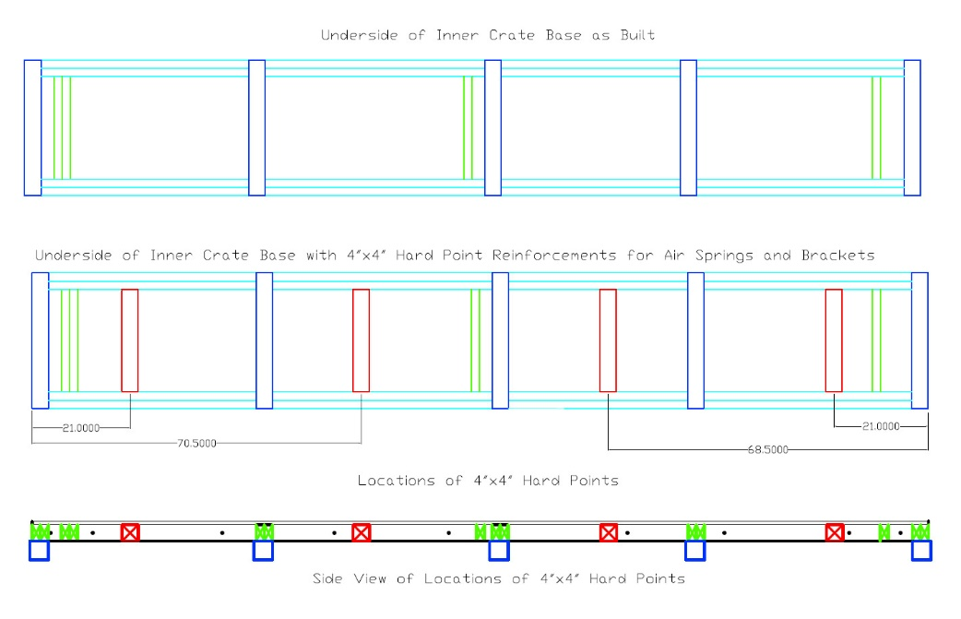

DIAGRAM 1 – Air Spring Hard Point Location Diagram

1. Remove the Hard Point 4”x4” Lumber and Spray Glue on all Contact Surfaces, both on the Hard Point Lumber and the Interior Crate Base. Replace the 4”x4” Hard Point Lumber to the Correct Location and use a clamp on each side of the Hard Point. Continue to the Next Step Before the Glue Dries.
2. Mark Locations for the Lag Bolt Pilot Holes and Drill Pilot holes using a 5/16” extended length Drill Bit. See Diagram 2 for Detail.

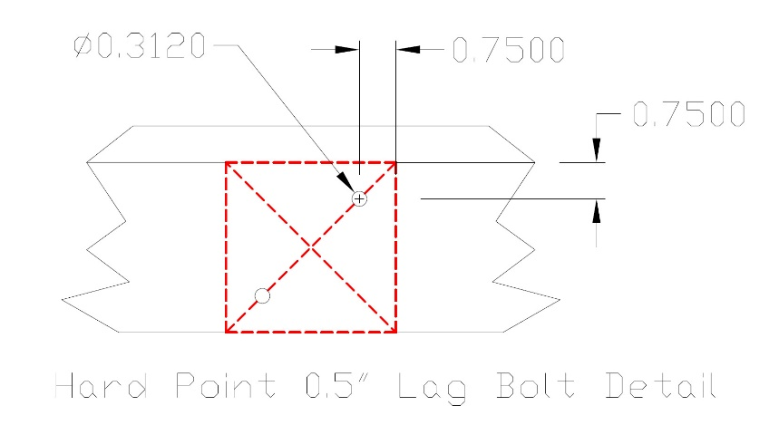

DIAGRAM 2 – 4x4 Hard Point Lag Bolt Location Diagram

1. Install the Two ½” Lag Bolts with both the Flat and Lock Washers, on each side of the Hard Point, using a ratchet with a ¾” socket.
2. Allow the Glue to Dry Overnight before removing the C-clamps

Step 2 – Installing the Crate Base Air Spring Brackets and Air Springs

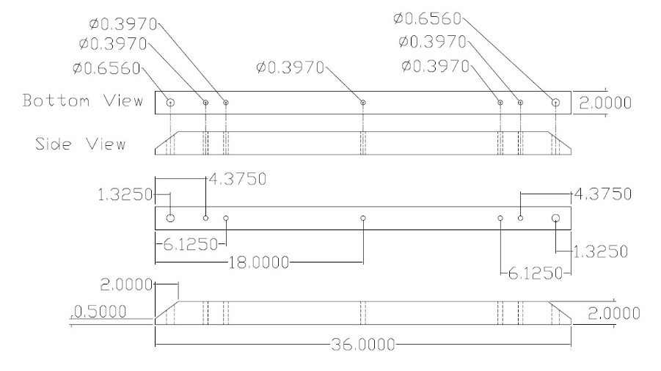

DIAGRAM 3 – Air Spring Bracket Dimensions Diagram

1. Place One Air Spring Bracket, see Diagram 3, in the Center of Each Hard Point and Translate the Five Lag Bolt Hole Locations to the Hard Point
2. Remove the Air Spring Brackets and Drill Pilot Holes Using a 15/64” drill
3. Install five 3/8” Lag Bolts per Bracket using both Flat and Lock Washers using a 9/16” Socket
4. Lift the Interior Box Base, Remove the Cribbing and Rotate the Base 180 degrees, such that the Air Spring Brackets Face Down
5. Install the Eight Lower Air Springs using thread locker

Step 3 – Installation of the Foam Padding on the Base of the Interior Crate

Glue the foam padding sections B, C and D to the base locations as shown in DIAGRAM 4

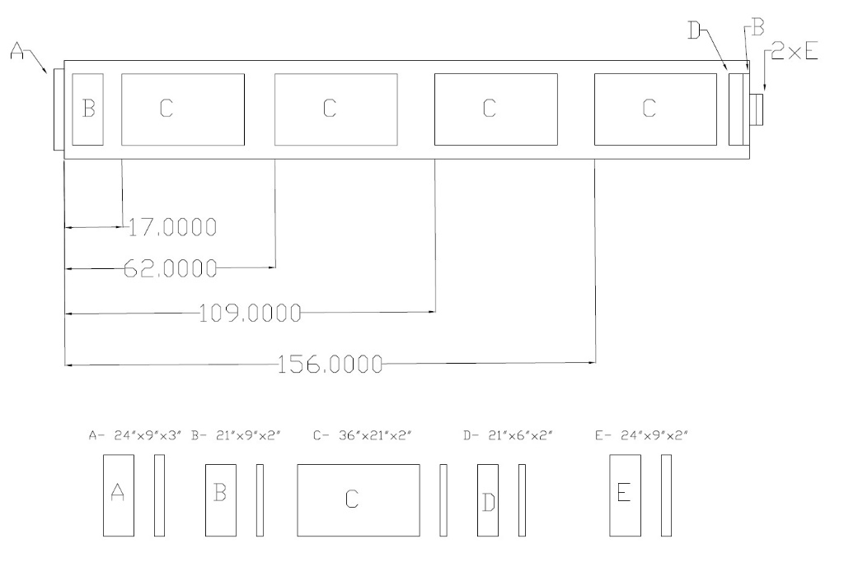

DIAGRAM 4 – Foam Padding Locations and Sizes for the Interior Crate

Step 4 - Re-installing the Interior Box Front, Rear and End Panels

1. Install the Interior Box End Panels – Verify proper fit with Base with no air gap between the Side Panel and Base
2. Install the Interior Box Rear Panel
   1. Determine the locations on the inside of the Rear Panel that Require Recesses to be cut out for the Hard Point Lag Bolt Hex Heads and Hex Head bolts on the Base Frame.
   2. Verify proper fit with Base and no air gap between the Rear Panel and Base
3. Install the Interior Box Front Panel
   1. Determine the locations on the inside of the Interior Box Front Panel that Require Recesses to be cut out for the Hard Point Lag Bolt Hex Heads and Hex Head bolts on the Base Frame.
   2. Verify proper fit with Base and no air gap between the Rear Panel and Base
4. Center the Inner Crate on the Exterior Crate Base

Step 5 – Installing the Speed Limiter Bracket Assemblies

There are 4 Speed Limiter Assemblies per crate, one in each corner. These Limiter Assemblies limit the vertical movement speed of the inner crate during transport.

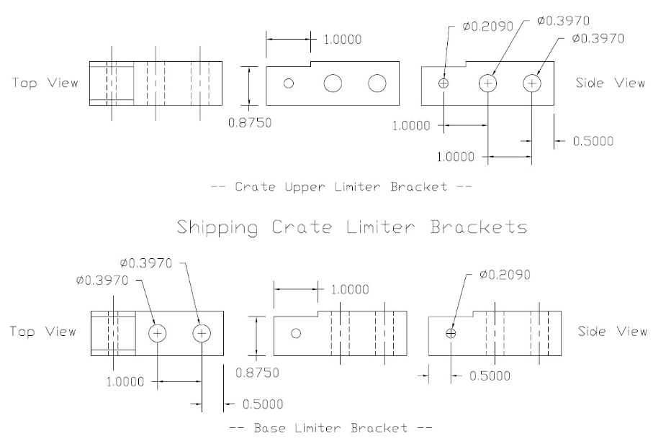

DIAGRAM 5 – Shipping Crate Speed Limiter Bracket Dimension Diagram

The Limiter Assemblies are located at each corner. The assembly consists of an upper bracket, the speed limiter and the lower bracket. See DIAGRAM 6.

The brackets are mounted to the crate using 3/8”x5” Lag Bolts. The bracket locations indicated in the diagrams have been chosen to ensure sufficient lumber thickness for the lag bolt length exists.

The Assemblies are mounted vertically in each corner. See DIAGRAMS 7 through 10 for location details.

In each location, the lower base bracket is mounted 1.25”+/-0.25” from the Exterior Crate Inner Side Wall.

The vertical distance from the Limiter upper ball joint to the Exterior Crate Base is 7.0”

Procedure for mounting the brackets

1. Determine mounting location of the Crate Upper and Lower Limiter Bracket. Mark the locations and translate the mounting hole locations to the crate
2. Drill pilot holes for the 3/8” lag bolts using a 15/64” extended length drill bit
3. Attach the bracket to the crate panel using 3/8”x5” lag bolts with lock washers
4. Attach the Speed Limiter to the brackets. Use threat lock on the m5 fastener

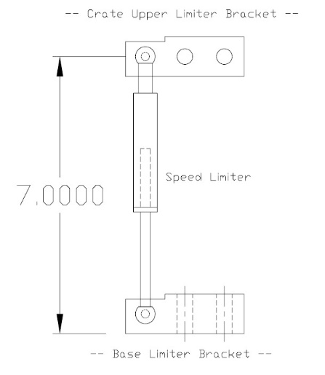

DIAGRAM 6 – Shipping Crate Speed Limiter Assembly

1. Rear Side Panel Left Side Speed Limiter Location

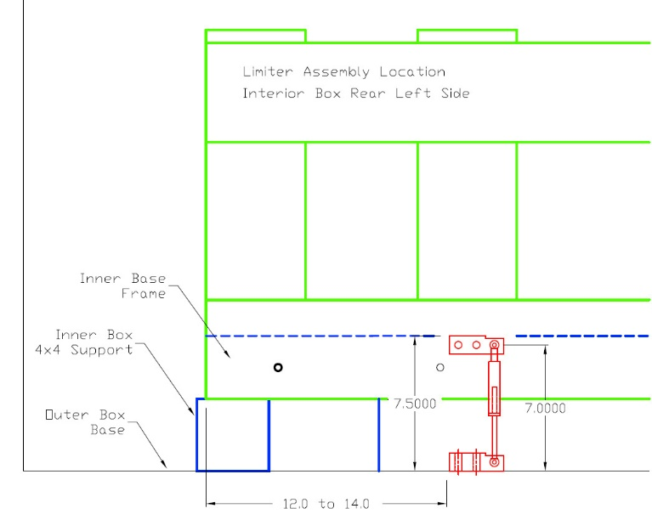

DIAGRAM 7 – Interior Box Rear Panel Left Side Speed Limiter Assembly Location

1. Rear Side Panel Right Side Speed Limiter Location

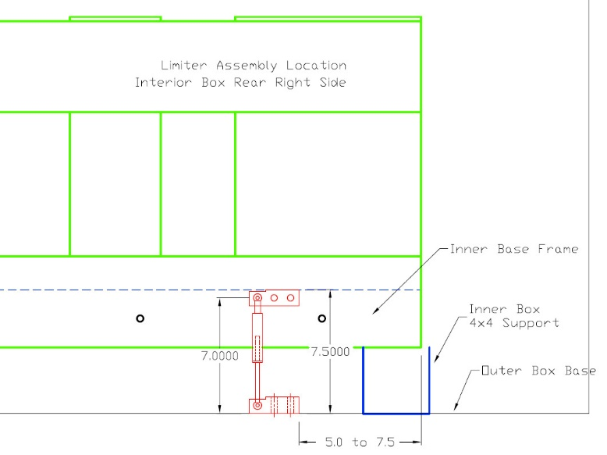

DIAGRAM 8 - Interior Box Rear Panel Right Side Speed Limiter Assembly Location

1. Front Side Panel Right Side Speed Limiter Location

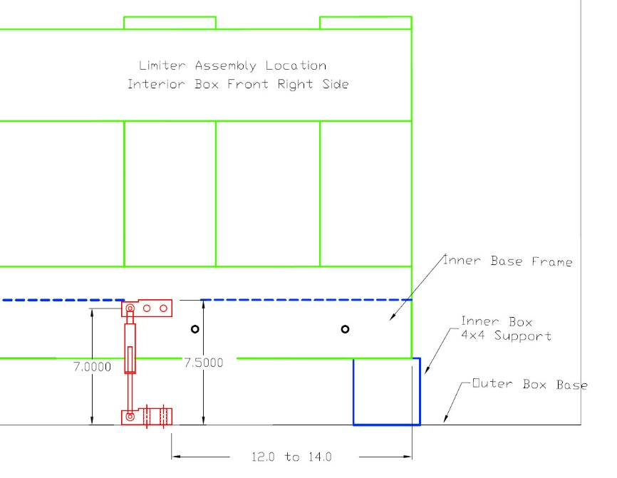

DIAGRAM 9 - Front Side Panel Right Side Speed Limiter Location

1. Front Side Panel Left Side Speed Limiter Location

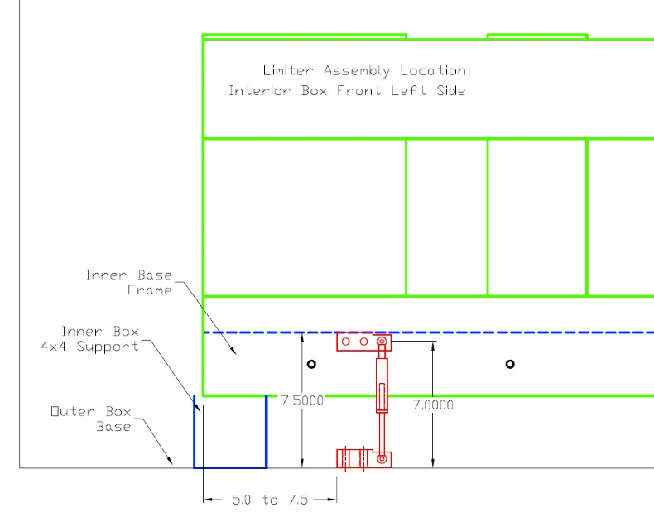

DIAGRAM 10 - Front Side Panel Left Side Speed Limiter Location

Step 6 – Installing the Crate Lateral Air Spring Brackets and Air Springs

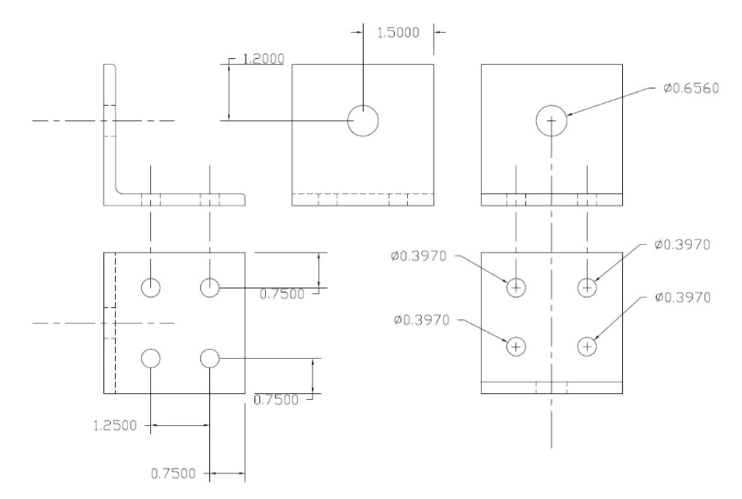

DIAGRAM 11 – Inner Crate Lateral Air Spring Bracket Dimensional Diagram

The Lateral Air Springs limit and dampen any side to side motion. These are mounted on the inner crate top. The brackets are mounted 2.0” from the Box Top Edge, See DIAGRAMS 12 and 13.

Bracket Mounting Instructions

1. Place the bracket in the center of the 1”X6” Stile and 2.0” from the edge. Mark the location and translate the mounting holes to the Stile.
2. Drill the 3/8” mounting holes using a 0.397”, X letter bit
3. Attach the bracket using 3/8” nuts, bolts and washers, both flat and lock, with the nuts facing upward.
4. Attach the Air Springs using lock tight on the threads
5. Verify the Air Springs are straight/vertical using a level. Add shims are needed.
6. Once the brackets are in the final position, tighten the bolts and use thread locker

Diagram 12 shows the left side box top lateral air spring bracket and spacer mounting locations.

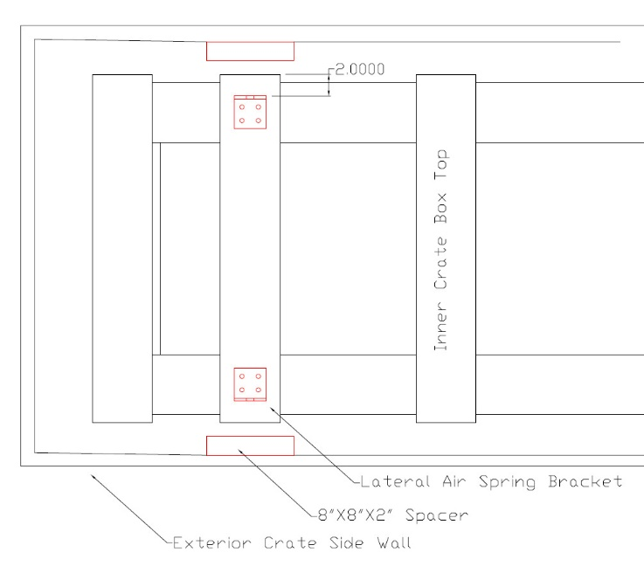

DIAGRAM 12 - Shipping Crate Left Side Lateral Air Spring Bracket Mounting Location Diagram

DIAGRAM 13 below shows the right side box top lateral air spring bracket and spacer mounting locations.

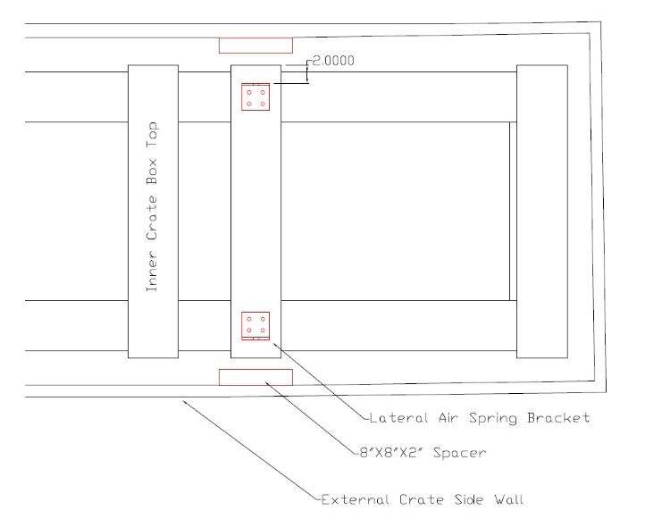

DIAGRAM 13 Shipping Crate Right Side Air Spring Bracket Mounting Location Diagram

Step 7 – Installing the Air Spring Pneumatics System Components and Lines

The Air Spring pneumatics system supplies the air to the air springs. The six new crates will use the pneumatics system shown in diagram 14.

The pneumatic system components and tubing will be attached to the Interior crate only, using ¼” tubing clamps and screws.

The lateral air spring lines and components will only be connected to the Interior box top.

The vertical air spring lines and components will only be connected to the sides and the supply end of the interior box.

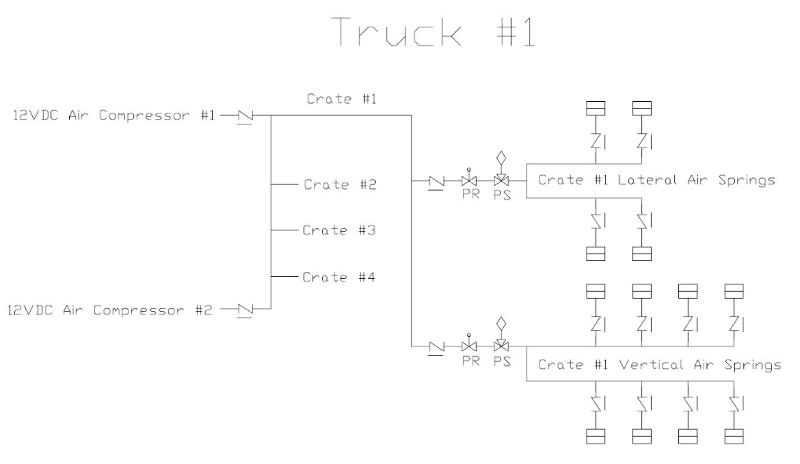

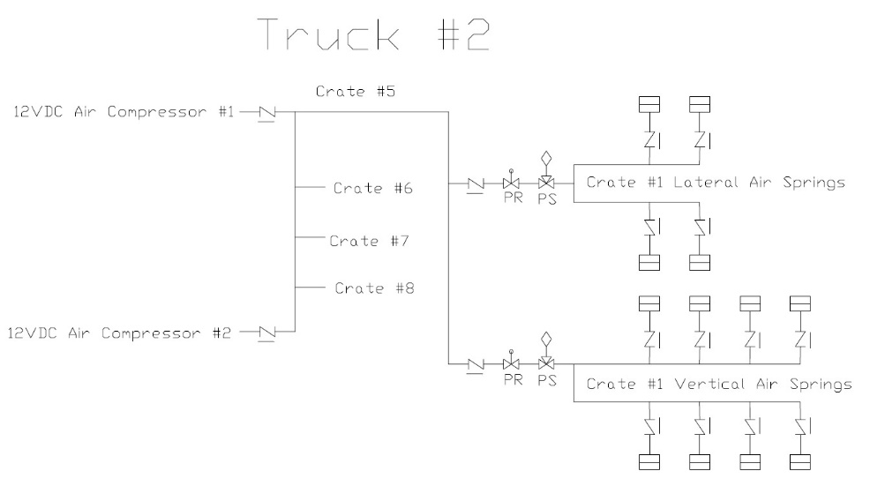

Diagram 14 – Air Spring Pneumatic System Diagrams for Truck #1 and #2

Step 8 – Re-installing the External Crate Sides and Lateral Air Spring Spacers

1. Re-install the Exterior Crate side walls
2. Dry fit the spacers for the lateral air springs as shown in DIAGRAM 12 and 13 and mark the locations on the inside of the panel.
3. Translate the spacer locations to the outside surface of the panel
4. Properly locate and mark the screw hole locations on the exterior side panel as shown in diagram 15.
5. Spray glue on both the spacer and inside panel. Place the spacer into the correct location and use clamps to hold the spacer in place

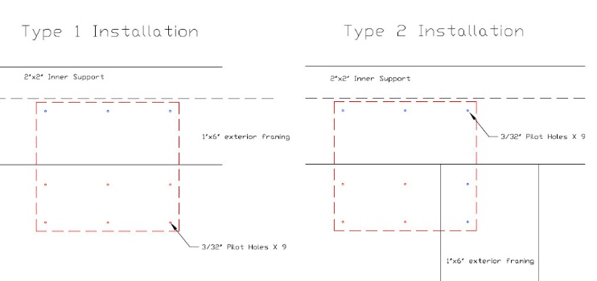

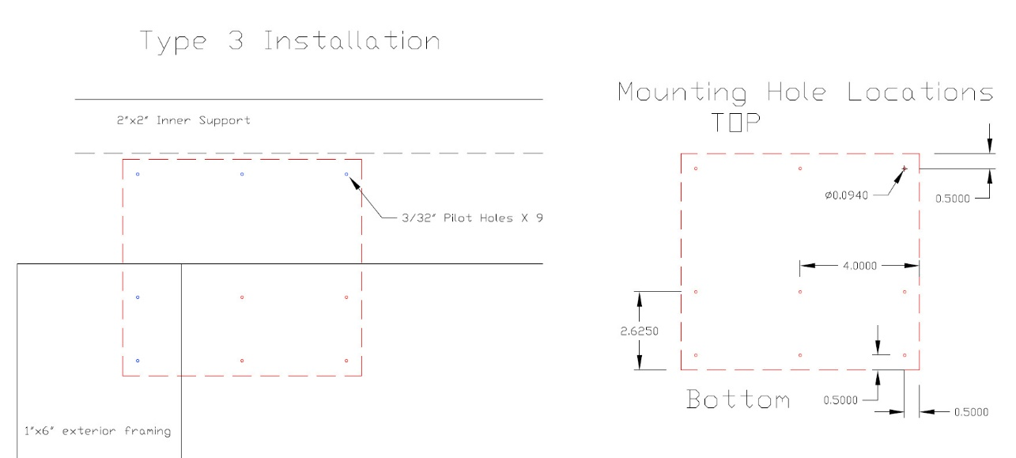

DIAGRAM 15 – The 3 types of spacer installation for the 4 spacer locations is shown

1. Drill pilot holes using a 3/32” drill bit as shown in diagram 15
2. There are 3 different installation types due to the external crate framing. Each installation uses 9 screws. Two lengths of screws are required due to the differences in thickness of the exterior wall panels. See DIAGRAM 15.
   1. Red holes – 1 ½” screw length
   2. Blue holes – 2 ½” screw length
3. Install the screws with a drill or driver.
4. Wait until the next day to remove the clamps