|  |  |
| --- | --- |
|  | |
|  | **Laser Operational Procedure (LOP) Form**  **(See ES&H Manual Chapter 6410 Appendix T1** |
|  | |

|  |  |  |  |  |  |  |  |  |  |
| --- | --- | --- | --- | --- | --- | --- | --- | --- | --- |
|  | | | | | | | | | |
|  | | | | | | | | | | |
| **Issue Date:** | |  | | | | **Expiration Date:** |  | | | |
| **Title:** | Functionality test of the DIRC 3B laser | | | | | | | | | |
| **Location where the laser will be used:** | | | | EEL 108 DIRC laser room | | | | | | |
| **Description of Project** | | | This test will confirm the operation and functionality of the DIRC 3B laser by turning it on from outside the LCA | | | | | | | |
| **Document Owner(s):**  **Usually the LSS, but could be someone else** | | | | | Benedikt Zihlmann, Marc McMullen, Dave Gaskell | | | **Date:** | 06/05/2024 | |
|  | | | | | | | | | | |

|  |  |  |  |  |  |  |  |  |
| --- | --- | --- | --- | --- | --- | --- | --- | --- |
| **Laser Inventory** | | | | | | | | |
| **Laser Serial #** | | | **Laser Class** | | **Wavelength(s)** | **Maximum Power/Energy** | | |
| 1. | S5935 | 3B | | 325nm/442nm | | | 14mW/44mW |
| 2. |  |  | |  | | |  |
| 3. |  |  | |  | | |  |
| 4. |  |  | |  | | |  |
|  |  |  | |  | | |  |

|  |  |  |  |  |
| --- | --- | --- | --- | --- |
| **Approval Signatures:** | | **Print Signature** | | **Date:** |
| **Laser System Supervisor:** Benedikt Zihlmann/ Dave Gaskell    **Laser Safety Officer:** Jennifer Williams    **Division Safety Officer Department or Group Head:**  **Other Approval(s): Where applicable, SMEs for LTT, IH, High Voltage, etc.** | | | | |
| **Document History:** | | | | |
| **Revision:** | **Reason for revision or update:** | | **Serial number of superseded**  **document** | |
|  |  | |  | |



**Introduction:** In areas containing more than one laser, define operational sequence or parameters.

* The DIRC laser is located in a room within EEL 108
* The operational use of the laser is to evaluate synthetic fused silica bars received from SLAC for their mechanical and optical quality
* There is a single Kimmon model IK5351R-D class 3b laser located in the LCA
* See Fig. 3 for a diagram of the LCA

|  |  |  |
| --- | --- | --- |
| **Personnel**  Only those authorized by the LSS are permitted to enter the location noted on the cover sheet of this document. | **List:**   * Training and qualification requirements (including refresher training). * Medical requirements. * Spectator protection requirements. |  |

* The LSS is Benedikt Zihlmann or the deputy LSS Dave Gaskell and the Jlab LSO is Jennifer Williams
* Laser Operators must complete the following training:
  + SAF1140 – Laser Safety Orientation
  + MED02 – Laser Eye Exam
  + SAF114 (DIRC 3B)– Laser Specific Training for the DIRC laser
  + GERT
* Will spectators be allowed? **Yes, spectators (without training) may be escorted in the LCA when the laser output is disabled**:
  + LSS approval is required
  + Spectator shall be escorted at all times by a qualified laser operator
  + Spectator shall be briefed on the hazards within the LCA and the controls in place to mitigate the hazards
  + No spectators are allowed in the room during alignment or manual measurement operations



**Define:**

* Laser system specifications
* Laser system components
* Copy of laser operating manuals or reference the location of the manual(s).

**Laser**

The laser set up is on a 5’ wide x 10’ long optical table which is ~3’ tall. The beam path will stay level at a height of about 3 to 5 inches above the surface of the optical table.

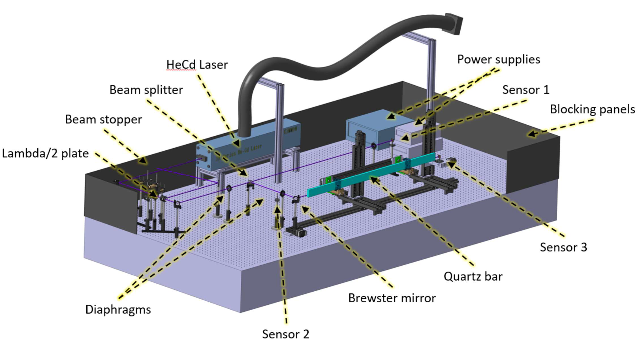

**Figure 1. Optical table rendering with components. The beam path is in violet.**

The schematic of the setup is shown in the figure above showing operational setup when all components are mounted on an optical table. For the laser's operation/function test, only the laser, mounting bracket, laser card, and camera will be located on the table.

The He-Cd laser can be configured at two wavelengths, 325nm (“UV”) and 442nm (“blue”), which are selected with a manual filter positioner at the front of the laser. The filter positioner also has a position to allow both wavelengths. The laser housing is mounted to the optical table at a fixed height to ensure the beam is parallel to the table surface. At the laser exit, the UV line has an output power of up to 14mW, a beam diameter below 1mm, and a beam divergence of 0.5mrad. The blue line has an output power of up to 44mW, a beam diameter below 1mm, and a beam divergence of 0.5mrad.

The laser beam will be 3 to 6 inches above the surface of the table (36”). All segments of the beam will terminate at either an absorber or photo diode sensor.

All walls of the LCA will have at least one emergency stop to shut off the laser output.

* List each laser in use in your LCA, include the following information (examples below):

|  |  |  |  |
| --- | --- | --- | --- |
| Laser Description | Kimmon Koha IK5351R-D | | |
| Laser Type | | Helium Cadmium (He-Cd) | |
| Laser Class | | Class 3B/IIIb | |
| Laser Manufacturer | | Kimmon Koha | |
| Laser Model Number(s) | | IK5351R-D | |
| Laser Serial Number(s) | | | S5935 |
| Wavelength Range | | | (325nm/442nm) |
| Power Range | | | 14mW/44mW |
| Mode (i.e., time structure) | | | CW |
| Beam Diameter (collimated, typical) | | | 0.9/1.0 mm |
| Divergence (uncollimated, typical) | | | < 0.5 mrad*2 +/- 10% |
| Laser Eyewear O.D. | | | +2 |

**Hazards and Mitigation**



**Define:**

* Laser system hazards
* Occupational exposure hazards beyond laser light (e.g., fumes, noise, etc.)
* Credible non-beam hazards (e.g., environmental hazards)
* Describe all required personal protective equipment (include clothing requirements, e.g. no reflective jewelry, etc.). Refer to ES&H Manual Chapter 6410 Appendix T2 Laser Personal Protective Equipment (PPE)
* Control of Hazardous Energy (includes beam and non-beam hazards such as electrical)

Hazards:

* Specular reflection – mitigated by an interlocked door, interlock system controls, Jlab-required training, and laser eye protection (O.D. 2+)
* Eye & Skin exposure to ultraviolent (UV) – mitigated by interlocked door, room light-tight, laser protective eyewar (OD2+), and labcoat
* Temporary/permanent eye damage – mitigated by an interlocked door, interlock system controls, Jlab-required training, and laser eye protection (O.D. 2+)
* HV exposure – mitigated the use of NRTL-approved equipment installed by Jlab QEW and PPE. A separate task hazard analysis is required for task involving electrical hazards.
* Trips/Fall – mitigated by appropriate lighting of walkways, proper housekeeping, and oversight by LSS and area safety warden
* Human error - mitigated by an interlocked door, interlock system controls, Jlab-required training, and laser eye protection (O.D. 2+)

System Experts will determine any modifications or repairs needed to any equipment. Any work needed by external vendors (i.e. laser manufacturer) shall be reviewed by the LSS prior to assignment.

|  |  |
| --- | --- |
| **Laser Environment** | **Define:** |
| System designs, including interlocks, require hazard evaluation review by SME. | * Laser system hazards * Layout of the laser controlled area and/or table. Show beam location in relation to user – waist height preferable. * Interlock schematic (or similar), including smoke detector interlocks. * Room lighting conditions during laser use and alignment procedure(s). * Targets. * Primary and all likely beam paths (open or enclosed). |

### Figure 2. Map of DIRC laser lab area with power meter

### 

### Drawing not to scale

### Figure 3. Map of DIRC laser lab area with camera

### 

### Drawing not to scale

**Written procedure for use and alignment**



**Provide:**

* All process steps – including unattended operation controls.
* All process steps for detailed alignment – include manufacturer’s protocols for alignment.
* Maintenance and service
* Off-normal and emergency procedures (e.g., beam loss, fire).

## Before entry, authorized staff shall don laser eye protection provided by the JLab LSO and lab coats remove all jewelry and badges.

**Interlock system test (see Figure 4 for diagram)**

The interlock system test is done to verify all elements of the system are functioning before using the laser.

* 1. Enter the room with eye protection and lab coat until the power supply key has been removed from the power supply and secured
  2. **Ensure the laser power cable is disconnected from the laser**
  3. Ensure the laser power supply interlock contacts are connected to the interlock box located on the wall next to the door
  4. **Verify the in-room and outside-the-room interlock controls are operational**
     + - Insert the power supply key and turn on the supply
       - Close the room door and press the sweep button
       - With the key in the interlock box turned to the enabled selection press the reset button to clear all latches, the only lit indicator should be “Unit Enabled”
       - If any other indicator is lit the interlock is still engaged, latched, and the laser will not output
       - Exercise all laser interlocks (i.e. crash buttons, door maglock)

## Laser functionality tests (Trained staff only):

The primary laser functionality test will confirm that the laser is functional and is verified by remote viewing of the laser spot on the power meter head (S120VC). The sensor will be positioned in front of the laser. Monitoring will be done using a camera focused on the power meter display.

The secondary functionality test will be done to verify the profile of the laser beam using the BC207VIS beam profiler camera.

The interlock system will be active and a sweep of the room will be done before the test. The laser operation will be controlled outside the LCA with the operation key and interlock reset button.

No personnel will be in the room for the test, the outside interlock controls will be used to put the laser in “Unit enabled” mode.

**Alignment of the laser for the functionality test (see Figure 2)**

1. **Before entering the laser room, don eye protection and lab coat**
2. **Eye protection must remain on until the laser power supply key has been removed from the laser power supply and is secured**
3. **The installation of components to the optical table is done with the laser power supply key removed from the laser power supply and secured**
4. The Thor Labs PM400 power meter and S120VC power meter head will be installed within 6 to 10 inches from the output of the laser, directly in the laser line to terminate the laser light – how is the alignment verified (i.e. straight edge or 3R between laser head to power meter)?
5. A tablet with a camera will be positioned to observe the PM400 display remotely

**Start primary laser functionality test**

1. Don laser protective eyewear and lab coat
2. Ensure room door is closed
3. Enable the laser power supply via the key switch on the supply
   1. At this point the interlock system controls the output of the laser
4. Visually confirm the status of the room (all hazards mitigated) and press the “sweep” switch
5. **All personnel will exit the laser room**
6. **Laser protective eyewear and lab coat is removed outside of the laser room**
7. The final step to enable the laser is to insert the outside-room key and rotate it to the “Unit enabled” position
8. Press the “Reset” button to clear all latches and start the laser output
   1. If any other indicator is lit, except “Unit enable”, the interlock is still engaged, latched, and the laser will not output
9. Monitor the laser power level using the remote monitoring screen which shows a view of the PM400 display
10. After the test, the laser will be switched off using the outside switch key. Staff will don PPE before entering the laser lab
    1. Entering the laser lab or hitting any stop button will trigger and latch the interlock
    2. Ensure the laser is in a safe configuration by removing the key from the laser power supply, **Do not remove eye protection until the laser power supply key has been removed from the laser power supply**
11. At this point the test the power meter test can be concluded or the laser output filter can be changed to test the laser at the other wavelength
12. After the filter position has been switched the test can be restarted by starting at step 1 this section

**Secondary functionality test: laser to camera alignment (see Figure 3)**

**This procedure is to be done with the laser disabled**

1. This procedure starts with the laser power supply key removed and secured
2. Reconfigure the optical table by removing the PM400 and its head unit from the path of the laser
3. Install the BC207VIS camera in the path of the laser on the optical table

**Start secondary laser functionality test**

1. Don laser protective eyewear and lab coat
2. Enable the laser power supply via the key switch on the supply
3. At this point the interlock system controls the output of the laser
4. Visually confirm the status of the room (all hazards mitigated) and press the “sweep” switch
5. **All personnel will exit the laser room**
6. **Laser protective eyewear and lab coat is removed outside of the laser room**
7. The final step to enable the laser is to insert the outside-room key and rotate it to the “Unit enabled” position
8. Press the “Reset” button to clear all latches and start the laser output
   1. If any other indicator is lit the interlock is still engaged and latched, the laser will not output
9. Monitor the laser using the remote monitoring screen which shows a view camera
10. After the test, the laser will be switched off using the outside switch key. Staff will don PPE before entering the laser lab
11. Entering the laser lab or hitting any stop button will trigger and latch the interlock
12. **Ensure the laser power supply key is removed from the power supply before doffing PPE**

## Maintenance and Service:

Maintenance of the laser system or the interlock system is not standard procedure for operating the DIRC laser. Any maintenance of the laser system or the interlock system will require a Task Hazard Analysis for that task and potentially other work control documents. The LSS and LSO will be consulted and make any determinations for this work.

During standard operation or alignment of the laser equipment, personnel and equipment safety is governed by engineering controls and the procedure. During all laser operations covered in this document, a LOTO procedure is not required.

**Laser Controls**



Based on the information developed in the THA:

* Describe all controls (administrative and engineering) required to be in place during laser operations.
* If a different control is recommended, describe the rationale for not using a typical/recommended control.

An engineered control-based interlock system has been developed with the following elements:

* + Key control switches
  + magnetically locked door with contacts
  + Emergency stop switches
  + A filter to reduce the laser power during alignment – this will not be used during this function test, correct? If so I suggest removing from this LOP.
  + Latching interlock switches and contacts
  + Personnel sweep switch

The system is designed to disable the laser output if any element triggers the interlock. The system is designed to latch in a way that forces the operator to affirm all interlocks are cleared before resuming laser output.

**Figure 4. Laser interlocks diagram**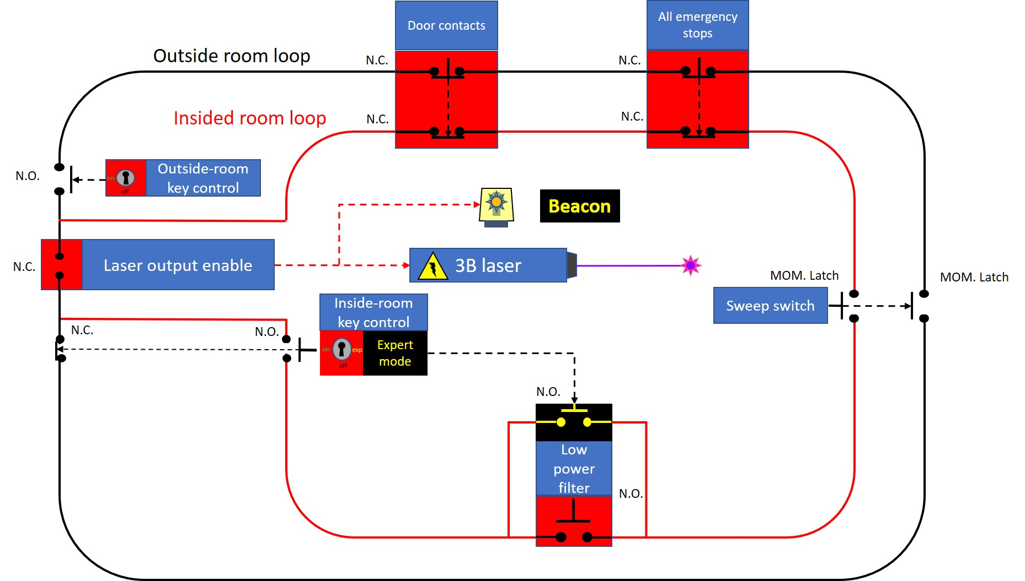

Low power filter:

Filter: ThorLabs NE20A - Ø25 mm Absorptive ND Filter, SM1- Threaded Mount, Optical Density: 2.0 Actuator: ThorLabs MFF101 - Motorized Filter Flip Mount with Ø1" Optic Holder, 8-32 Tap

The normal position of the flip mount actuator positions the filter in the path of the laser (0 degrees). During Automated and Expert measurement modes the actuator will rotate the filter out of the path of the laser (90 degrees). Should the system lose power, the laser output would not be available

and the interlocks will put the entire LCA in a safe position. When power returns, the flip mount actuator will return to the 0-degree position (in the path of the laser).

The filter will reduce the power of the laser by a factor of 100. This reduces the laser power to that of a Class 3R laser or less.

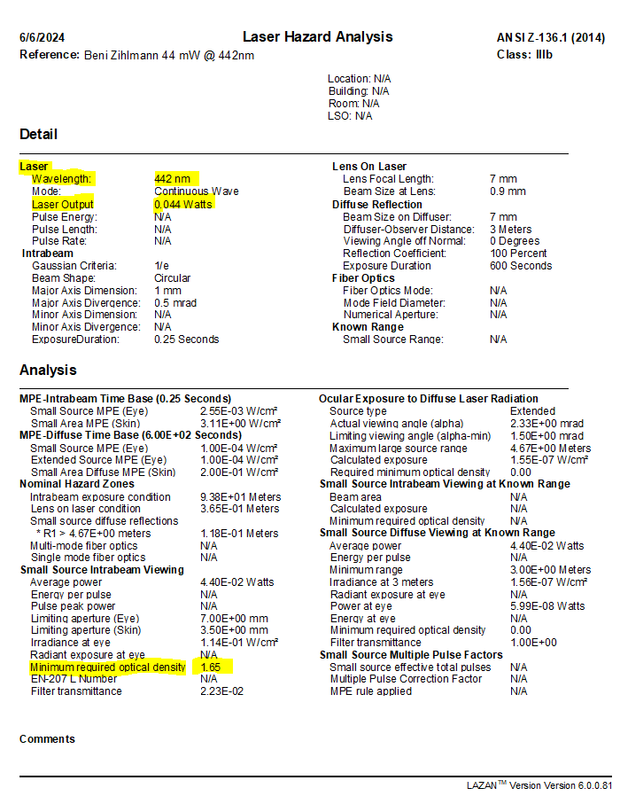

* Signage will be posted for a Class 3B/IIIb laser at the entry way of the area and doorway into the LCA.

|  |  |
| --- | --- |
| **Authorized/Trained Individuals** | |
| **Print Name/Signature** | **Date** |
|  |  |
|  |  |
|  |  |
|  |  |
|  |  |
|  |  |

**Labeling/Posting**

See ES&H Manual Chapter 6410 Appendix T6 Laser Labeling/Posting Requirements



* Equipment/area labeling/posting requirements
* Area signs