Lesson Plan

Course Name:
Laser Specific Training for EEL 108 DIRC 3B laser

Unit Lesson:
1

Approximate Time:
2 hours

Target Audience - required
Check all that apply:
Workers needs to work in the EEL102A laser room
x
employees supervisors & mentors
☒
users people new to the Lab
x

contract services others
xxx

Instructional Method:
Instructor lead

Responsible Parties
HR Reviewer:
N/A
SME: - required
Name: Beni Zihlmann email: zihlmann@jlab.org Ext: 5310
SME: - optional
Name: email: Ext:
Approval Authority:
Name: Jennifer Williams email:jennifer@jlab.org Ext: 7883

Aids/Handouts - optional
Copy of the current LOSP for the laser system
Brief Description: laser system for

Suggested Maximum Attendance:
3, (1 during MEDCON 5)

Prerequisites – required (if any)
SAF114O Laser Safety Orientation
MED02 Laser User Eye Exam

Certification Period – required (if any) Expires after months
36

SRL Skills Taught – if the course is linked to any skills (or knowledge, abilities, etc.) tracked in a Skill Requirements List (SRL), include the skill code and title of the skill(s) here
Skill Title and Code: laser worker for EEL 108 laser test stand | Title:

Learning Objectives (required) & Standards of Behavior
A learning objective is a desired outcome/result of the training provided. Learning objectives are expressed in different ways according to the level of learning desired by the instructor. Select an appropriate verb from based on the table below and then type in the subject.
Know all the laser hazards in the laser room. Be familiar with the LOSP.

A Standard of Behavior (SoB) is the actual behavior, observation, or activity that must be performed by a student in order to attain a specific learning objective. They are normally used for testing or measuring mastery of the objective. The Training Office can suggest SoBs for your review, but if a quiz or review is included in your course, enter your own SoBs that reflect the quiz questions.

As a result of completing this course, each student should meet the following learning objectives and related SoBs:
Objective A - | Be familiar with the Class of the Laser System Covered By LOSP
SoB A.1 | List the wavelength of the laser(s).  The DIRC silica bar measurement laser uses a Kimmon model IK5351R-D Helium Cadmium dual wavelength laser (325nm and 442nm)
SoB A.2  SoB A.3 | Describe where information regarding the class of laser(s) can be found  The class (3B) of the laser can be found on the signage at the entryway of the laser room and the laser radiation warning label. This label is located on top of the laser towards the beam aperture (beam output side)  Know the appropriate laser eye protection for the system  The Kimmon model IK5351R-D outputs two wavelengths:  325nm at 14mW and 442nm at 44 mW. The minimum optical density for exposure protection is ~ 2+.
Objective B | Understand the hazards associated with your laser system
SoB B.1 | Discuss the beam and non-beam hazards associated with this specific laser system  - Specular reflection/refraction – from the operation of a class 3B laser  - Electric shock – from the installation of a class 2 power supply, and the interlock components  - Walkway – from operating the laser in low light conditions, walkways must remain clear  - Sharps – from the installation of mechanical devices to the optical table and interlock components throughout the space  - Human error – This exists in all applications, the best mitigation is the design of engineered controls, appropriate training, adherence to procedures, and properly worn PPE
SoB B.2  SoB B.3 | Describe the control measures in place to mitigate the associated hazards  - The laser will be housed in an interlocked room with a limited entry for authorized personnel. The room is regarded as the Laser Controlled Area (LCA) and the Nominal Hazards Zone (NHZ).  - A robust interlock system will be used to control the laser output using engineered controls that are not reliant on software or power. The system is designed to fail in a safe configuration (laser output disabled)  - A key(s) configuration system will be used to arm the laser for operation in all control modes  - Lab/DOE laser training, specific training for the DIRC laser, as well as standard lab practices and training (Electrical safety, HPI, skill of the craft)  - Rated laser eye protection and a lab coat must be donned before entry into the laser room  Describe actions if suspected laser exposure occurs  - Engage emergency stop for the laser  - Contact 911  - Contact supervisor/LSO
Objective C | Perform safe laser operation (Normal Operations)
SoB C.1 | Describe entry procedures including any restrictions  Before entry authorized personnel will don laser eye protection, a lab coat, and observe posted signage.  The interlock system will prevent the entry door magnetic lock from allowing access until the laser output is fully disabled. A yellow beacon will indicate when the laser output is disabled.  Actuation of the door contact sensors will always trigger the interlock system which will disable the output of the laser.  In an emergency, the door magnet can be crashed. This will immediately disable the laser.  Prior to enabling the laser output, the operator will ensure the condition of the lab is safe for operation in the specific laser running configuration (automated, alignment, or expert). After verifying the condition of the lab, the operator will actuate the “sweep” switch. The “sweep” switch is located on the opposite wall from the doorway. This position is intended to allow the operator to visually see the room condition prior to confirming the lab for laser operation by actuating the “sweep” switch.  The system will utilize a key control system to arm the laser. The laser lab will have two key control positions to enable/disable the laser output. A single key will arm the laser controls at either position.  The in-room key control position will have an additional key. This second key will allow a designated “expert” to configure the laser to full power operation.  When the laser lab is not in use, all keys will be housed in the Keywatcher cabinet in the EEL building main hallway. The Keywatcher system limits access to the key to authorized personnel.  The in-room key control position will enable the laser output, provided the following:  - The laser is configured for low power via a power-reducing filter (power reduced to ≤ a class 3R laser)  - All optical table side shields are in place (closing table interlock contacts)  All interlocks will latch when triggered. The laser output will remain disabled until all latches are cleared.
SoB C.2  SoB C.3  SoB C.4  SoB C.5  SoB C.6  SoB C.7 | Demonstrate knowledge of emergency stops locations  All emergency stops will disable the laser output. Emergency stop buttons are located at the entry door on the inside and outside. All walls of the laser room will have an emergency stop button. (SoB F.1)  Describe applicable warning sign(s)/beacon  Room signage will be posted by the laser room entry door and the fenced area. The signage will include the laser class, required PPE, and contact information for the Laser System Supervisor (LSS), the LSO, and Jlab security. A yellow beacon will indicate the condition of the laser.  Authorized personnel will review the posted signage for changes daily. The LSS will maintain applicable signage and update all affected personnel on changes to signage.  Perform pre-use laser eye protection inspection  Authorized personnel will inspect laser eye protection prior to donning per the instruction provided in the lab-approved training module. The LSO shall approve the level of eye protection available for use and conduct periodic inspections of the PPE.  Perform laser start-up procedure  Prior to the start of all laser use authorized staff will ensure the functionality of the yellow beacon and interlock system. This can be done by setting the key switch in the “laser enabled” position (beacon on) and actuating the door lever or engaging an emergency stop (beacon should shut off). A second verification is to check the monitoring system for indications of laser power.  After performing a sweep of the laser lab, the operator can start the output enable procedure for the desired laser operation (automated, alignment, or expert).  To enable the laser output:  - Clear all latched interlocks  - Insert the key into the key switch and rotate to “Output enable”  The laser will now be available for manual or automated use.  The LSS should run a full verification of the interlock system periodically to ensure the functionality of the beacons and interlocks.  Laser operation  Silica crystal installation and measurement procedure:  - Before entry into the laser room, don PPE (laser eye protection, appropriate lab coat)  - Disable the laser by removing the outside room key  - Attempting to enter the laser lab will trigger the interlock system  - Move short-term storage into the laser lab and install a bar on the optical table  - After verifying the interlock system operation and laser condition, PPE can be removed for non-alignment, laser-off activity  - If the laser is aligned – exit the room, enable the laser with the outside-room key enable to start measurements  - If the laser needs to be aligned - proceed to the alignment procedure  Perform the normal shut-down procedure  The silica bar measurement system is automated. The laser beam will cease after the measurement is completed. Manual measurements will require the user to stop the beam with the controls system.  After measurements are concluded the laser operation key should be rotated to the safe position “laser disabled”, and the key should be removed from the key switch. When not in use the interlock system keys are stored in the Keywatcher system in the hall way of the EEL building  The engineered controls will prevent any beam exposures to personnel.
 | Perform laser alignment (Only for individuals who will be authorized by LSS to perform alignment operations)
SoB D.1 | Discuss potential hazards during alignment and ways to mitigate the hazards  The primary hazard during alignment is specular reflection. Alignment must be done with the laser on while the personnel is inside the room.  Attempted entry into the room will trigger the interlock system, which will disable the laser and latch until the interlocks are cleared. The interlocks triggered with personnel in the room would be the door contacts and the in-room sensors (motion/pressure mats).  Room interlocks:  - Attempting to open the door or actuating an emergency stop will always trigger the interlock and disable the laser output  - All interlock contacts and sensors are latched and must be cleared at the controls console, even after the contacts have returned to the “normal” position  - The in-room sensors will remain engaged (tripped position) unless the room is confirmed cleared (by the sensors) or the interlock system has been configured to “bypass”  With the laser disabled, authorized staff can make adjustments to equipment on the optical table to better align the laser. However, the laser output will not function until the room has been configured to bypass the main interlocks and all latches have been cleared.  Alignment configuration:  - The low-power filter must be positioned in front of the laser  - The table side shielding is in place  The low-power filter will reduce the laser power by a factor of 10, making it safe in the case of a laser beam exposure occurs. The table side shielding will contain the beam within the frame of the table, but will not limit the viewing of the beam.  Expert Mode configuration:  After alignment, designated experts will have to do fine alignment of components to ensure the positions of the quartz bars and photodiodes are at optimal positions. During these “manual measurements”, the expert will be inside the LCA, with the beam on at full power.  Additional training and expertise is needed for measurements with this configuration. The LSS will qualify and designate those individuals as experts and provide the experts with access to an additional key. Once inserted in the in-room key location, the expert key will bypass the low-power filter and enable the laser output at full power.
SoB D.2 | Demonstrate the performance of laser alignment activity  Before entry, authorized staff shall don laser eye protection and lab coats.  Initial alignment procedure:  The initial alignment procedure will ensure the laser beam is controlled within the boundaries of the optical table and the beam alignment components, measurement sensors, and dump components are in the correct position.  - Alignment of the laser requires:  - personnel to visually observe the laser while it is on, inside the room  - Key access (via the Keywatcher enclosure in the hallway of the EEL building)  - Sweep of the room and actuation of the “sweep” switch to confirm that the lab is ready for laser output  - Entry into the laser lab will trigger the interlock system to disable the laser output  - Repositioning components on the optical table is done while the laser is disabled  - To operate the laser, configure the laser to low power mode by positioning the filter directly in front of the beam  - The filter will reduce laser power to less than or equal to the power of a Class 3R laser  - The table side shields should be up/in position to stop the beam from going past the extent of the table  - Visually confirm the status of the room (all hazards mitigated) and press the “sweep” switch  - The final step to enable the laser is to insert the in-room key and rotate it to “output enable”  - The laser will be enabled  - Outside-room key control will be disabled  Expert Mode (Manual quartz bar measurement):  After initial alignment manual measurements of the quartz bars will be done by a limited number of trained staff. The LSS shall assign the designation of “expert” to persons who have demonstrated knowledge of the system and adherence to the Jlab safety protocols concerning laser operations. Laser eye protection and lab coats must be worn at all times.  An “expert” key will be housed in the Keywatcher enclosure, and only be available for checkout by the designated experts.  Experts shall be qualified to use the “expert” key switch position which will configure the laser to full power from the inside the room key position. Laser eye protection and lab coats must be worn at all times.  Manual quartz measurements are done with the “expert” inside the LCA, during beam-on operations, without the low power filter in place. The table side shields will contain the laser during operations and confine the beam to the boundaries of the optical table.  After initial alignment of the laser and optical components (In low power configuration), manual measurements must be done to ensure that the quartz bar and the measurement diodes are positioned correctly for all measurement points. The quartz bar is mounted to a linear stage, which is moved by a stepper motor through the laser beam. In addition to the quartz bar stage, photo diodes are used to establish maximum laser intensity at specific positions of the optical table:  Sensor 1. Recieves half of the laser intensity after the laser is split, monitors laser intensity  Sensor 2. Monitors laser intensity reflected from the face of the bar  Sensor 3. Monitors laser intensity after it has passed through the front face of the bar and has reflected throughout the body of the bar (up to 55 reflections)  Automated measurement mode  Automated measurement mode can be done after the optimal position of the quartz bar has been established and the position of the measurement photo diodes have been verified.  Prior to enabling the output of the laser, the operator shall perform a sweep of the laser lab. Operator actions during the sweep are as follows:  - Enter the laser room and verify no personnel are in the room  - Actuate the sweep switch on the wall opposite the door  - Exit the room  Automated measurement mode is done via the operating position outside of the LCA. The laser is armed from the key position on the outside of the laser room after verifying that the room is clear of personnel.  Once the room and all interlock latches have been cleared, the key is inserted and the laser is armed and ready for output.  A controls program will aid in the performance of measurement. Any actuation of the door or an emergency stop will shut down the laser and latch the appropriate interlocks.
Objective E | Perform general maintenance activities that an user may be required to perform (Only for users that will be required to perform maintenance operations)
SoB E.1 | Discuss potential hazards associated with maintenance activities  Specular reflection is the primary hazard during the operation of the DIRC laser. Maintenance of the laser system or the interlock system is not standard procedure for operating the DIRC laser. Any maintenance of the laser system or the interlock system will require a Task Hazard Analysis for that task, and potentially a Temporary Operating Safety Procedure. The LSS and LSO will be consulted and make any determinations for this work.
SoB E.2  SoB E.3 | Discuss the control of hazardous energy  For the DIRC laser, hazardous laser energy is contained by the room itself, and controlled by the interlock system. Trained and authorized personnel are protected by a robust engineering control-designed interlock system, and a detailed procedure. The interlock is designed to fail in a safe condition.  Demonstrate the Lockout/Tagout (LOTO) process defined in the LOSP  During standard operation or alignment of the laser equipment, personnel and equipment safety is governed by engineering controls and the procedure. During all laser operations covered in this document and the LOSP, a LOTO procedure is not required.  Any task not covered in this document or the LOSP must be reviewed per the standard Jlab procedures (THA, ATlist, TOSP…etc). The LSS and LSO will be consulted and make any determinations for this work.
Objective F
SoB F.1 | DIRC laser room area  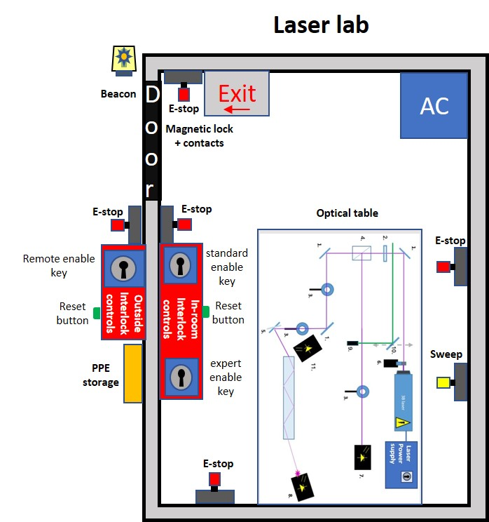
SoB F.2 | Optical table diagram  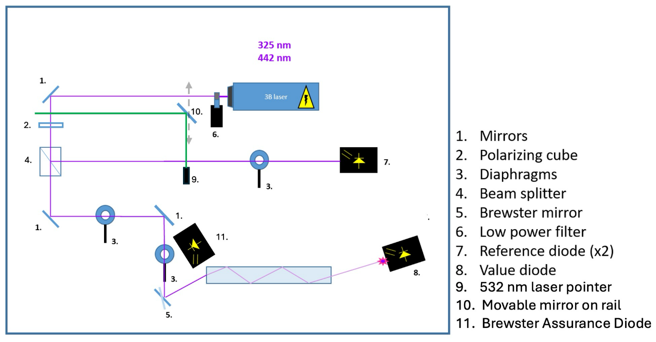
SoB F.3 | Interlocks diagram  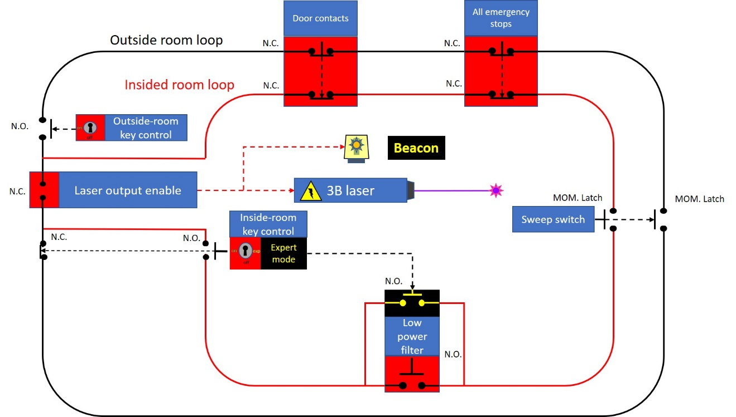

Course Agenda (List objectives in the order you’d like them presented – (optional)

Glossary for Course Development
Agenda | Term in a lesson plan outlining the sequence in which topics will be covered in the course. (see Lesson Plan)
Application level | Learning objectives at this level of learning use words like apply, reproduce, diagnose, and troubleshoot. Students take information they have learned and apply it themselves to produce a result or outcome. At the Application Level, the SoB might use verbs such as demonstrate, simulate, replace, repair, assemble, or disassemble. (see Level of Learning, SoB, and Lesson Objective)
Certification | A method of determining if a skill, qualification, or course is current; can be a record, license, or document from a professional organization, service or an SME; often has a defined expiration period. (see SME)
Class | A single event or offering of a course, often including a specific date, time, and location.
Comprehend level | This level of learning is characterized by objectives using words like understand or comprehend. Students not only learn the information, but how it fits together coherently, how it fits into a larger context, and how it used in practice. A Comprehension Level objective would have SoBs that use verbs/phrases such as describe, explain, or list in order. (see Level of Learning, SoB, and Lesson Objective)
Course | An organized structured mechanism designed to teach specific new information, skills, or abilities. (see Training)
Curriculum | A collection of training courses, programs, or qualifications related to a common subject or system.
Equivalent | A course, certification, or qualification that confers the same proficiency as another course, certification, or qualification.
Event | See Class.
Integration level | The highest level of learning characterized by objectives using words like design, manage, control. The student puts a variety of learned information and skills together to deal with situations that may not have been specifically presented during training. At this level, the SoBs might require the student to actually create something, or even teach it to others. (see Level of Learning, SoB, and Lesson Objective)
Knowledge level | The lowest level of learning where students learn simple information. A Knowledge Level objective, using words/phrases like know or be familiar with, would use SoB verbs such as recognize or select from a list. (see Level of Learning, SoB, and Lesson Objective)
KSA | Knowledge, Skill, and Ability (sometimes Attitude)
Learning Objective | A desired outcome of a training course; the mastery of one or more KSAs associated with a course. Learning objectives are expressed in different ways according to the level of learning desired by the instructor. (see Level of Learning)
Lesson Plan | A written outline that includes relevant information useful for an instructor or developer to develop and/or teach a training course.
Level of Learning | The kind of learning necessary for a student to successfully perform all the SoBs associated with the learning objectives in a course. (see SoB) We use four levels of learning: Knowledge, Comprehension, Application, and Integration.
Prerequisite | A certification or qualification that must be acquired before taking a course; it may be acquired by completing another course.
Proctor | An individual who is proficient enough in one or more KSAs to oversee and evaluate a student’s mastery of them; also an individual who manages a testing environment.
Proficiency | The level of one’s mastery of a KSA or, collectively, of a qualification.
Program | See Course.
Qualification | A collection of related skills, knowledge, and abilities that, once mastered, define a student’s capability.
Skill | The ability to carry out a particular action correctly and replicate it at will; generically used in place of any knowledge, skill, or ability. (see KSA)
SME | Subject Matter Expert; the individuals most proficient in the content of a course or curriculum.
SoB | Standard of Behavior; the actual behavior, observation, or activity that must be performed by a student in order to attain a learning objective. How SoBs are expressed depends of what kind of learning objective they support. The SoB must be expressed with a verb that matches the objective’s level of learning. (see Level of Learning)
Target Audience | An item in the lesson plan that identifies the type of student, in terms of skills and experience, for whom the course is designed.
Training | Learning (or the delivery vehicle for learning) specific new information, skills, or abilities. Determining what training delivery vehicle is appropriate requires knowing the level(s) of learning associated with its SoBs. SoBs for knowledge or comprehension can be delivered in a variety of ways including reading or listening to a lecture or recorded narration and can be assessed by answering quiz questions, re-ordering lists, recognizing objects, etc. All of this can be done in either a self-study or classroom setting. Teaching application and integration level SoBs is usually not that effective with one-way learning methods. Assessing these levels of learning requires that the student do what he/she has been taught to do. This is most effectively done in a real-world practical exercise or OJT. Online self-study can also be effective if realistic computer simulations are included.  (see Level of Learning and SoB)

Helpful Action Verbs
Level of Learning | Definition | Learning Objective Verbs (i.e., desired outcome) | SOB Verbs (i.e., demonstration, observation)
Knowledge Level (see glossary) | Students learn simple information. | Know  Be Familiar With | Recognize  Select from a List
Comprehension Level (see glossary) | Students not only learn the information, but how it fits together coherently, how it fits into a larger context, and how it is used in practice. | Understand  Comprehend | Describe  Explain  List in Order
Application Level (see glossary) | Students take information they have learned and apply it themselves to produce a result or outcome. | Apply  Reproduce  Diagnose  Troubleshoot | Demonstrate  Simulate  Replace  Repair  Assemble  Disassemble
Integration Level (see glossary) | Students put a variety of learned information and skills together to deal with situations that may not have been specifically presented during training. | Design  Manage  Control | Create something  Teach others

