**DSG Engineering Meeting Agenda**

**Date: January 09, 2023**

**Time: 2:00PM – 3:00PM**

*Attendees:*

1. Hall A - Moeller

Mary Ann Antonioli, Brian Eng, Marc McMullen

* 1. Phoebus screens
     + Mary Ann completed 9 so far, covering VT and RTD (also some LCW) for all 4 downstream magnets
     + Need one specifically for Test Lab setup, with all information on a single screen
     + EPICS IOC is currently being developed with separate PVs
  2. Instrumentation diagrams
     + Mary Ann created general overview for Test Lab setup, no details since subject to change, but types of sensors are listed. All expected to be single digits.

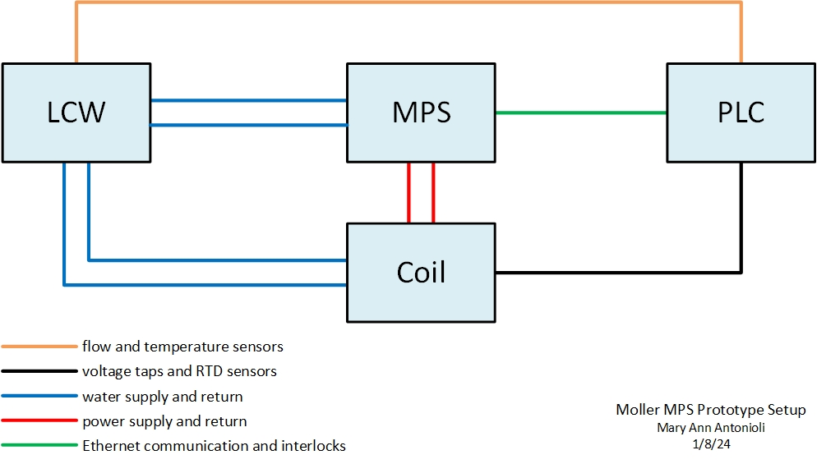

* 1. SAT (Site Acceptance Test, testing prototype MPS at JLab)
     + Generally duplicating same tests done during FAT, but with actual coil instead of test load (which didn’t allow for full power testing).
  2. Magnet mapping
     + Marc designed smaller PCB with MLX90393 magnetometer sensor, up to 500 G
     + Will most likely end up using Adafruit development board as-is despite being larger in area
       - <https://www.adafruit.com/product/4022>

1. Hall B – ALERT

Marc McMullen

* 1. What is the design?

1. Hall C - NPS

Aaron Brown

* 1. Correlation coefficient
  2. Test stand LabVIEW issues
  3. HV cable testing/repair - ePAS

1. EIC – DIRC/RICH

Tyler Lemon

* 1. What is being measured in the upcoming test?
  2. Latest AutoCAD drawings of crates
  3. Interlock board test results