**DSG Engineering Meeting Agenda**

**Date: January 23, 2023**

**Time: 2:00PM – 3:00PM**

*Attendees:*

1. Hall B – ALERT

Marc McMullen

* 1. MFC and solenoid valve connections

1. Hall C - NPS

Aaron Brown

* 1. HV cable testing data analysis
     + Cable #26 channel #26 had voltage and current issues
     + Channels #16, #30, and #31 appear to have problems as well

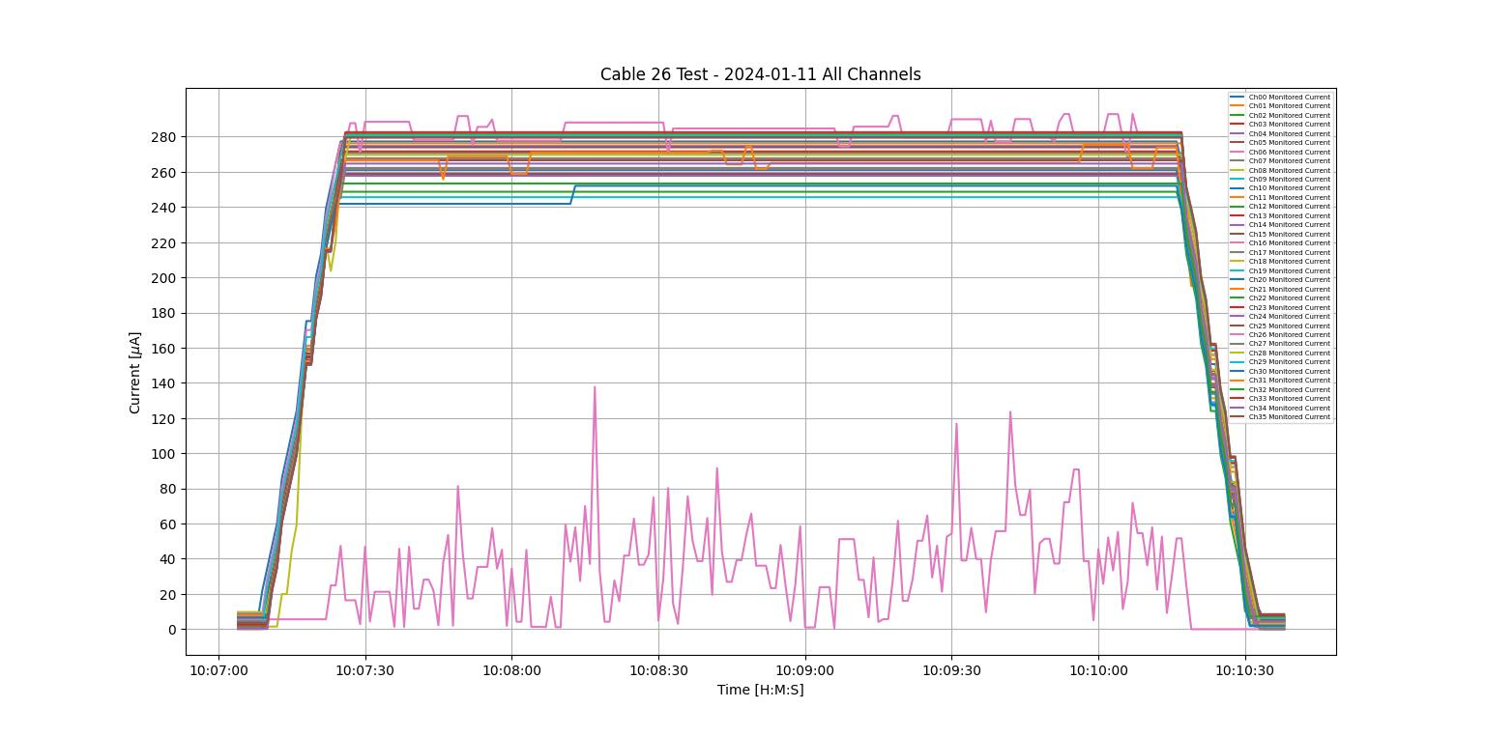

Plot of all hv channel currents for cable #26

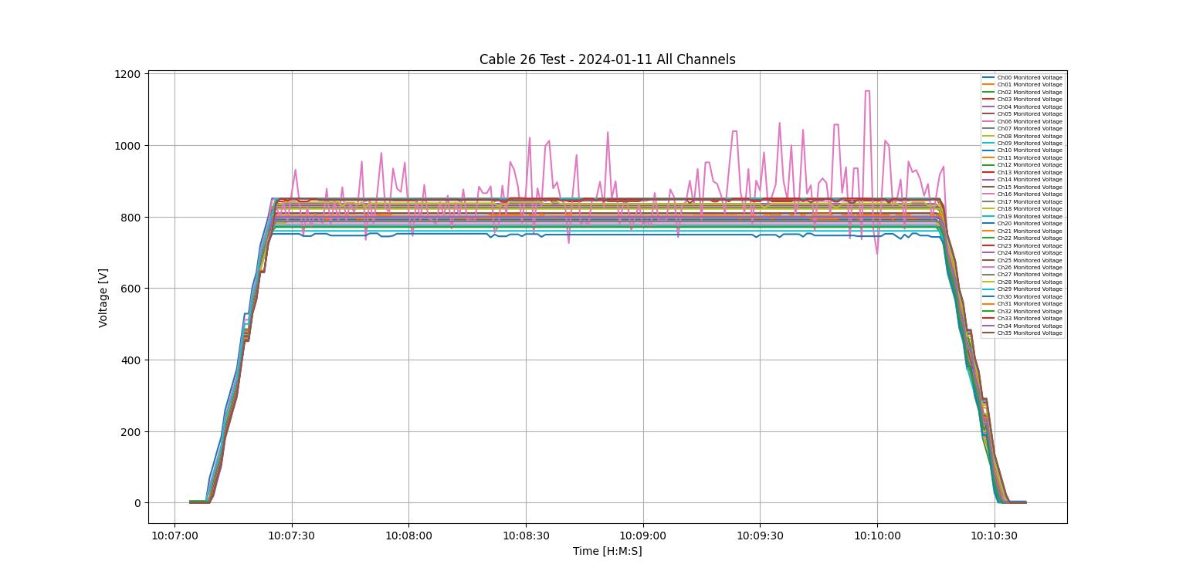

Plot of all hv channel voltages for cable #26

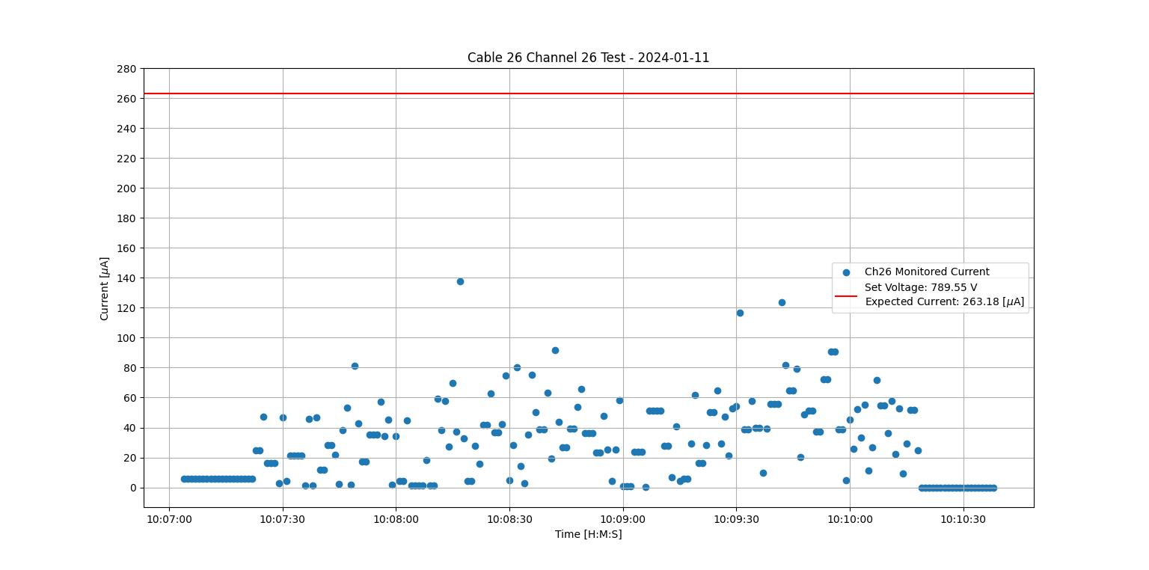

Plot of hv cable #26 channel #26 monitored current

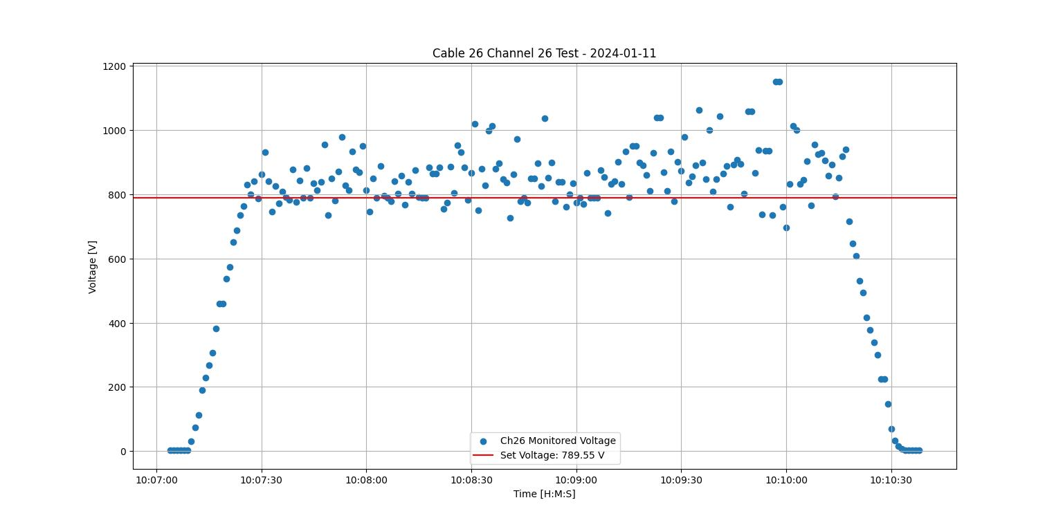

Plot of hv cable #26 channel #26 monitored voltage

* 1. Plotting/fitting temp data – plots for crystal 185
     + For front temps and ambient temps: *r*=0.857
     + For back temps and ambient temps: *r*=0.600

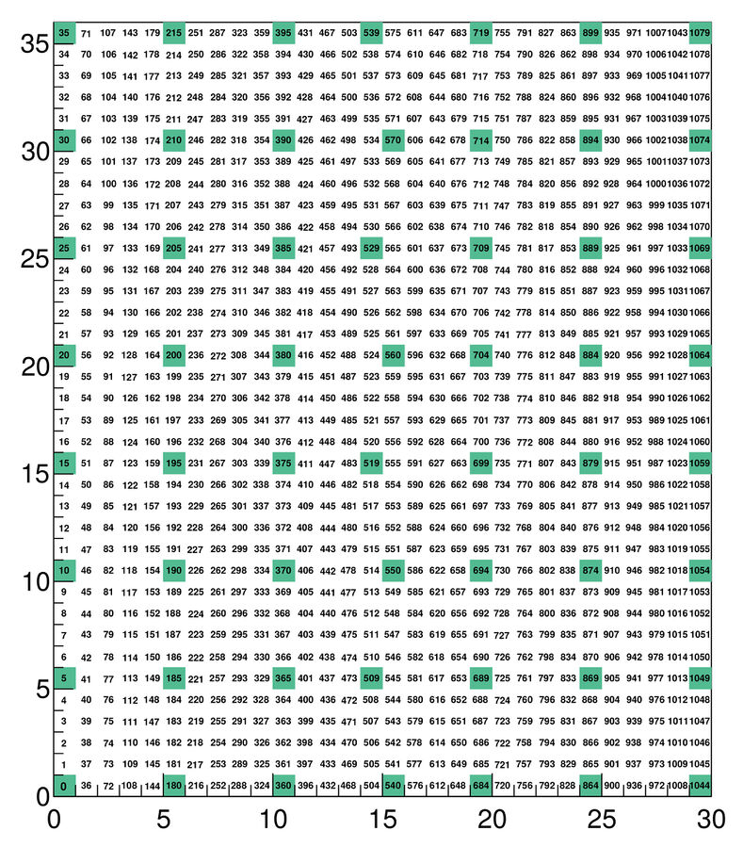

Location of crystal 185 (circled in red)

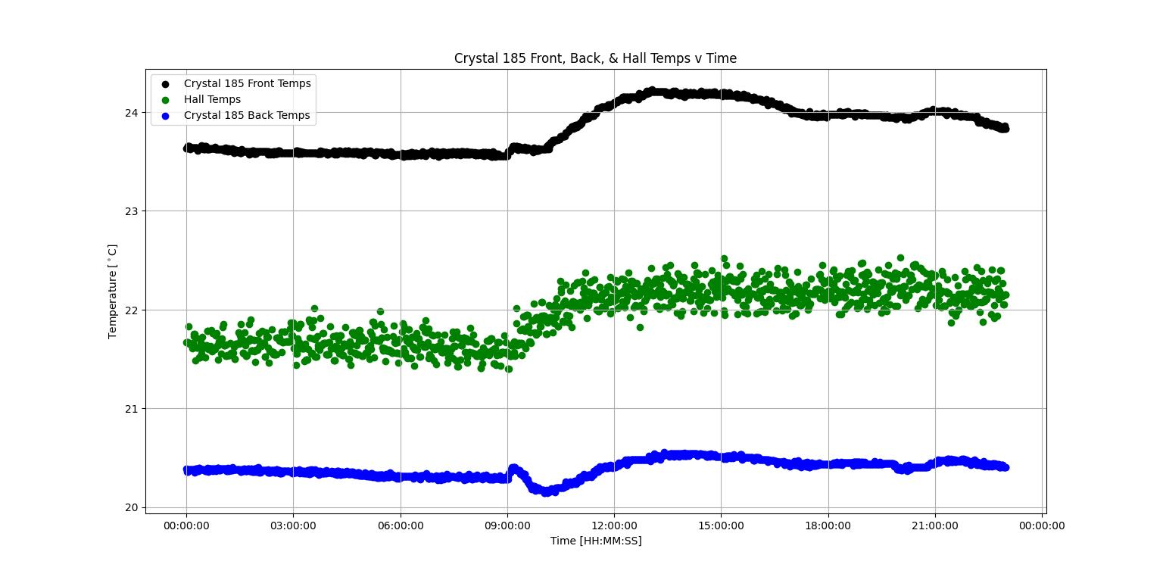

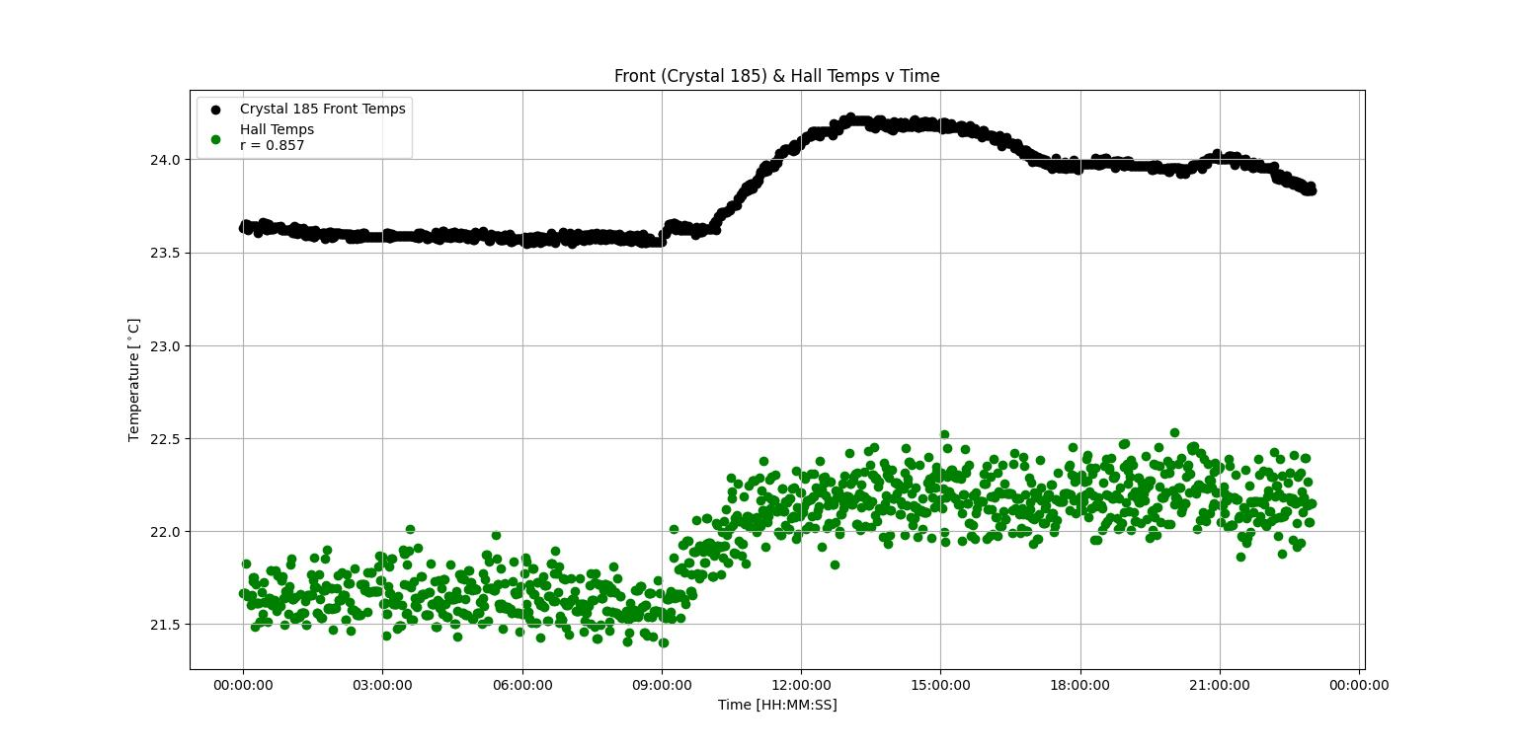

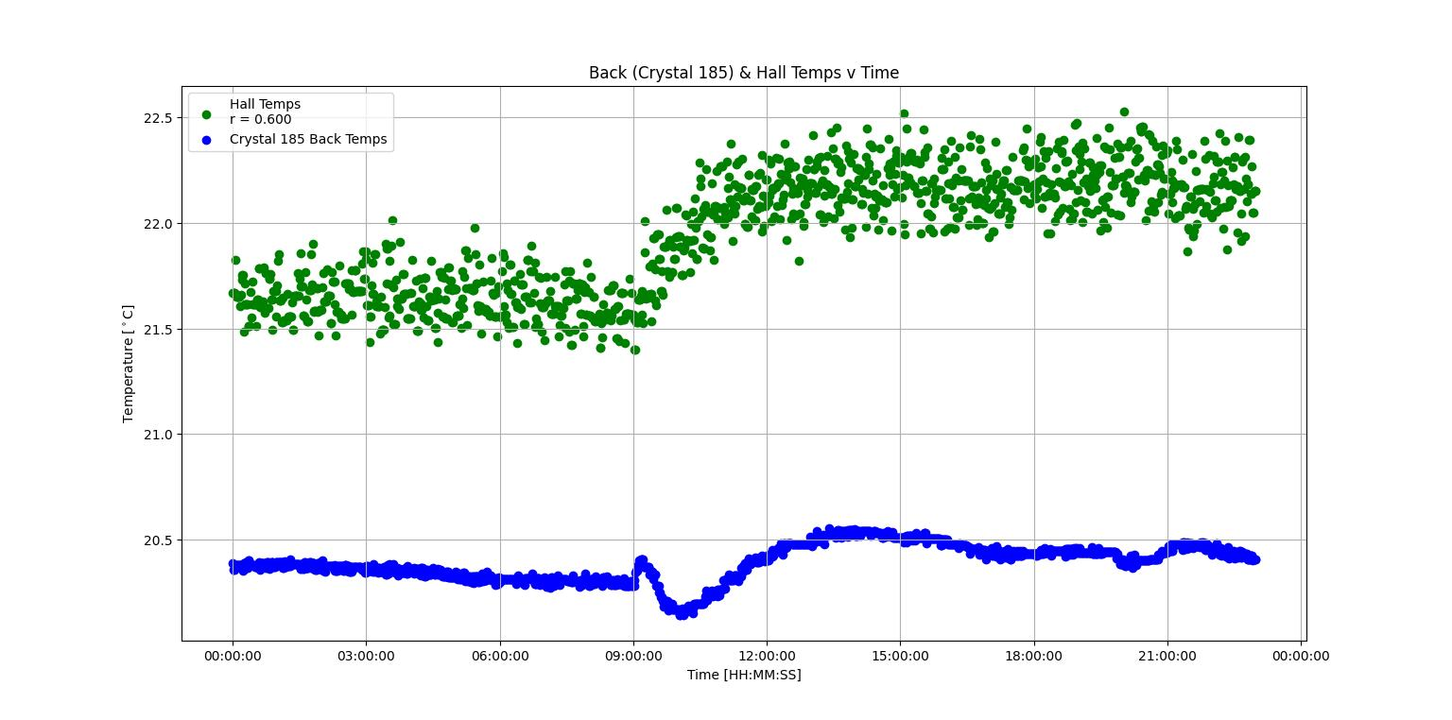

* 1. LabVIEW debugging/testing
     + Combined sensor enables, averaging enables, and interlock enables – they all now work from the front panel
     + Had to redo the configuration file utility subVI to reflect changes to arrays and array sizes
     + Noticed problem: problems with program execution
       - Sometimes the program will freeze after initialization and we’ll have to reboot the cRIO (happened multiple times in the past week)