**DSG Engineering Meeting Agenda**

**Date: June 04, 2024**

**Time: 2:00PM – 3:00PM**

*Attendees:*

1. Hall A - GEM

Aaron Brown

* 1. Radiall pinout for CAEN module connector
     + Not the same as the pinout for the A7030TN modules we’ve previously tested
     + New cables necessary to test modules? Would [R52 to SHV adapter](https://www.jlab.org/div_dept/physics_division/dsg/presentations2/HV%20Test%20Chassis%20Development.pdf) work?
     + Is this something that we’ll have to wait for the energized work to resume before we can start testing?

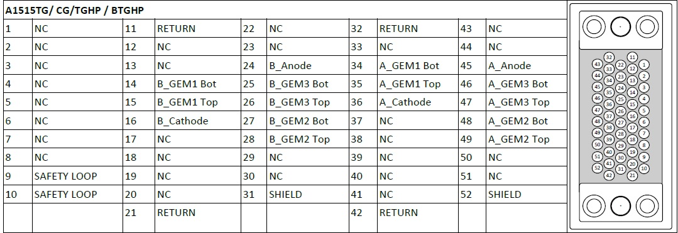

1. EIC – DIRC

Tyler Lemon

* 1. Deputy Laser System Supervisor selection

1. DSG R&D - Phoebus

Peter Bonneau and Mindy Leffel

* 1. Sensor chassis fabrication