**Hall A ECal Supermodule Assembly Meeting**

**Date: September 21, 2021**

**Time: 1:30**

*Agenda:*

1. Scope of work
   1. Hall A should define the request of support
      1. Complete assembly of supermodules?
      2. How many units are needed?
   2. Project time frame
2. Is there documentation
   1. Are there assembly drawings or a model?
   2. Is there a written procedure?
   3. Special handling or tools?
3. Photos

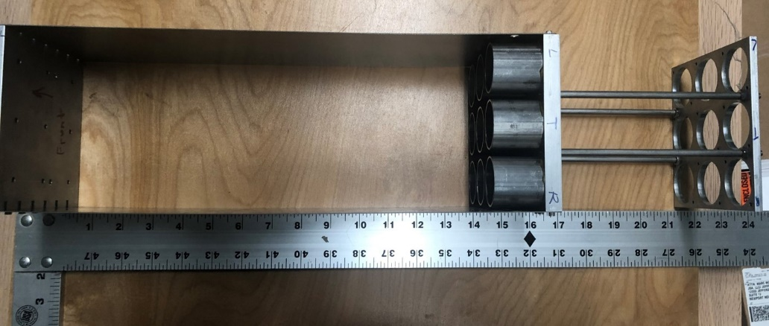

Figure 1 Supermodule frame_top view. The frame is about 2' long.

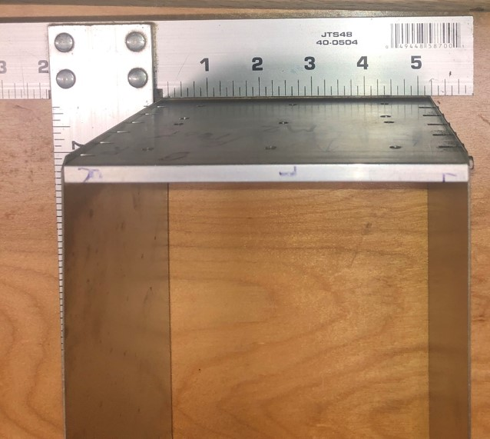

Figure 2. Supermodule frame top view, width is just over 5".

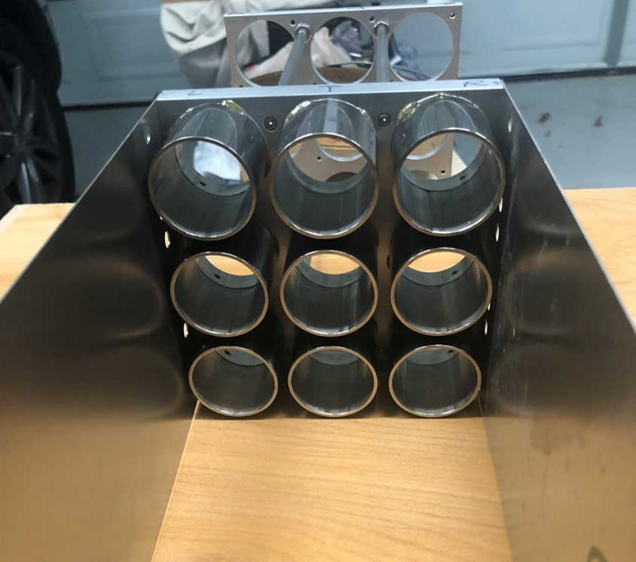

Figure 3. Inside view of the base direction.

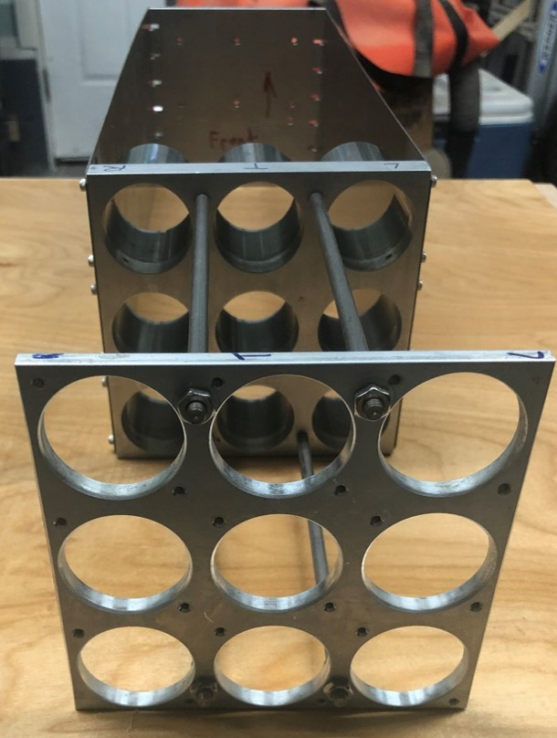

Figure 4. Rear view.