DSG Bluejeans meeting instructions

1. By Phone
   1. Dial the U.S. toll free number 1-888-240-2560
   2. You will be prompted to type in the meeting ID. This ID is listed on the invitation.
      1. For Tuesday 09/21/21 the ID is **757 269 7738**
   3. You will then be on the meeting, you can hear and talk to everyone, everyone in the meeting can hear and talk to you.
2. By Laptop (or PC with a microphone)
   1. Open the invite sent from Marc at 06:42am on September 19, 2021

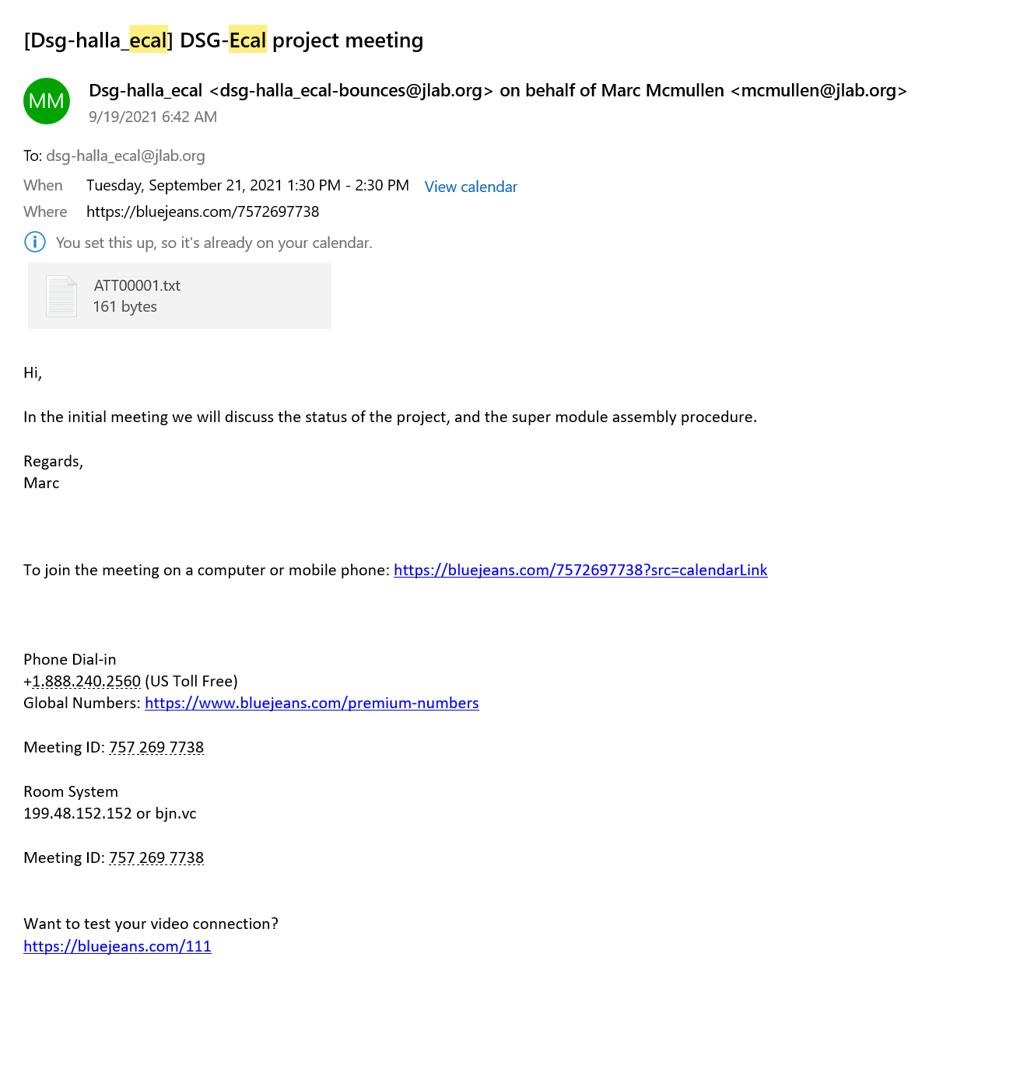

**Click this link to join**

* 1. Scroll down until you see the blue “Join Meeting” button and click it.
  2. You will be asked if you want to join with an app, but at the bottom click “Join With browser”.

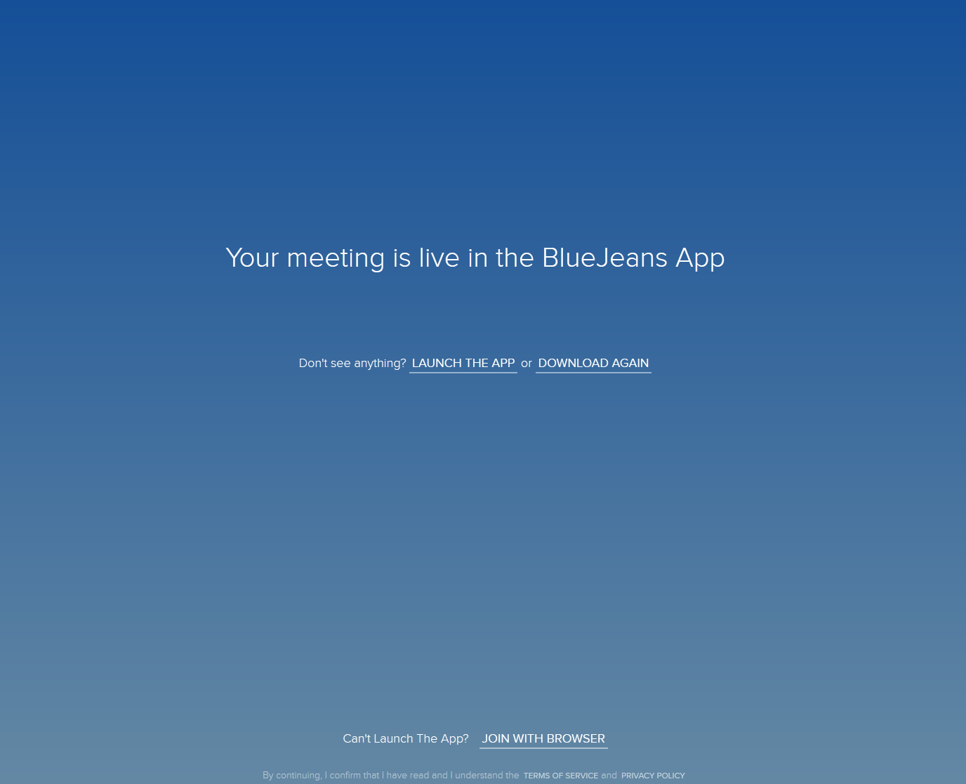

* 1. Follow the prompt instructions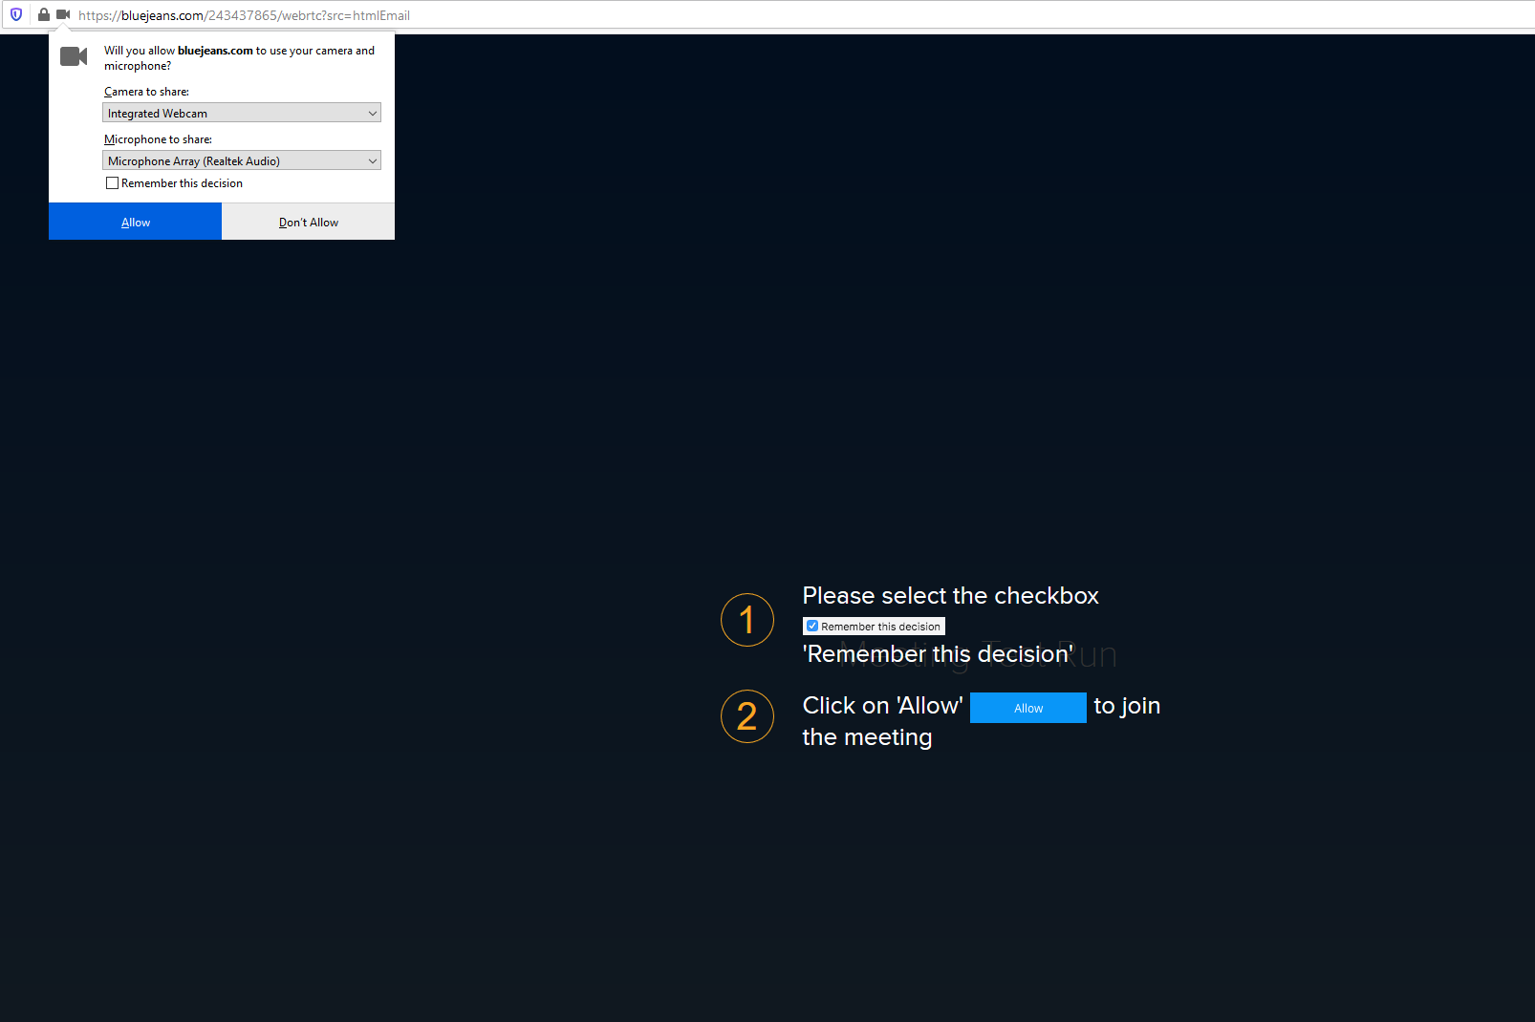
  2. Select use computer audio (make sure the volume is up)

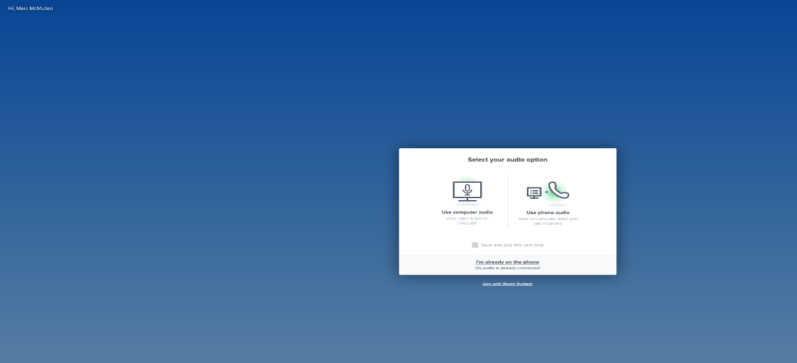

Figure 1. If you use this method skip to "f"

Or



Then

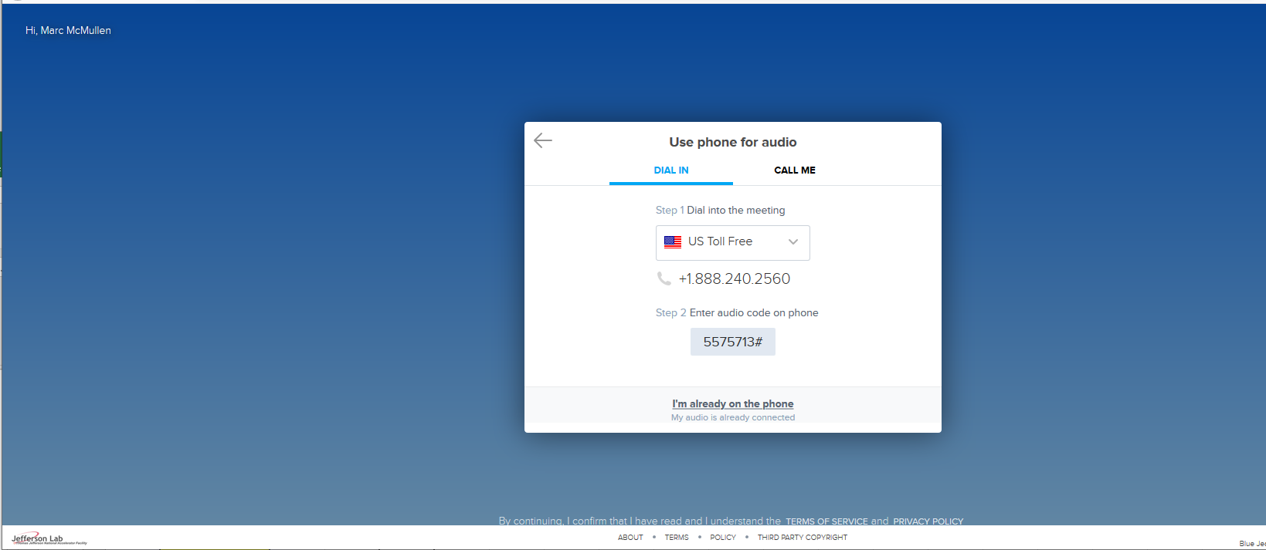

Figure 2. Follow the prompts, at the end of the prompts wait 30 seconds while looking at this screen. It will put you in the meeting.

* 1. Join Meeting

