Marc McMullen

2024-05-09 ECAL Controls Update

**Hall A – ECAL**

* Remotely reconnected the expansion chassis in the hall on 5/3 due to disconnection of all the temperature and current readback signal
  + - No issues since 5/3
    - Two spare cRIO expansion chassis were ordered
    - **DSG reccomends that the full system controls cRIOs are located in the DAQ bunker to reduce radiation damage to the equipment**
  + Received a quote from Cleveland Electric for the thermocouple extension cables to compare with the quotes received so far
    - Automation Direct – 8 pair @ $4 per foot
    - Audio Video Electric – 8 pair @ $7 per foot, 16 pair @ $13 per foot (half the cable runs), 24 pairs @ $18 per foot (one third of the cable runs)
    - ~200 total channels (1 pair per channel)
    - **Cleveland Electric – 4 pair @ $2 per foot, 4 pair @ $3 per foot, 16 pair @ $5 per foot, 24 pair @ $8 per foot, 36 pair @ $11 per foot**
      * **Waiting on confirmation on specification to ensure cable has shield**
  + Submitted PR 430586 to have the power supply interface chassis parts fabricated with Par-Metal
    - Procurement complete – 4 units for approval will ship on 5/17
  + Continued model of the controls rack with four cRIO expansion chassis and thermocouple terminal blocks
    - Ordered 48” rack
    - Redesigned thermocouple din rail mount to “staged” configuration to improve space utilization
    - Added a mounting panel for the Omega process controllers

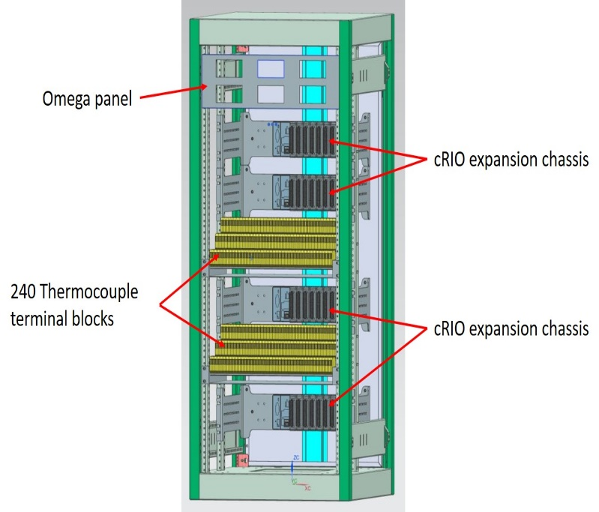

NX12 model of ECAL heater controls rack for the full system