**Pressure variation test**

Keep flows for channels 1 – 4 at ~75 sccm

Keep flows for channels 6 and 8 at ~100 sccm

**Starting condition**:

Reduce pressure regulator on regulator panel to 1 psi. After each adjustment of the pressure regulator allow 10 minutes for the flow to settle at that pressure.

The flows **should not** be adjusted during the test. The value of the flow should be recorded before the pressure is adjusted again.

Values can be monitored from the [GEM monitoring page](https://epicsweb.jlab.org/wedm/screen?edl=%2fcs%2fopshome%2fedm%2fdsg%2fGEM_flow_press.edl)

**Step adjustments:**

|  |  |  |  |  |  |
| --- | --- | --- | --- | --- | --- |
| Panel Regulator Setting (psi) | 1 | 2 | 4 | 6 | 8 |
| Setting time | 10 min | 10 min | 10 min | 10 min | 10 min |
| Channel 1 flow (sccm) | 10 | 19 | 38 | 58 | 80 |
| Channel 2 flow (sccm) | 10 | 19 | 38 | 58 | 80 |
| Channel 3 flow (sccm) | 10 | 19 | 38 | 58 | 79 |
| Channel 4 flow (sccm) | 10 | 19 | 38 | 59 | 80 |
| Channel 6 flow (sccm) | 15 | 26 | 50 | 80 | 115 |
| Channel 8 flow (sccm) | 13 | 24 | 50 | 80 | 111 |

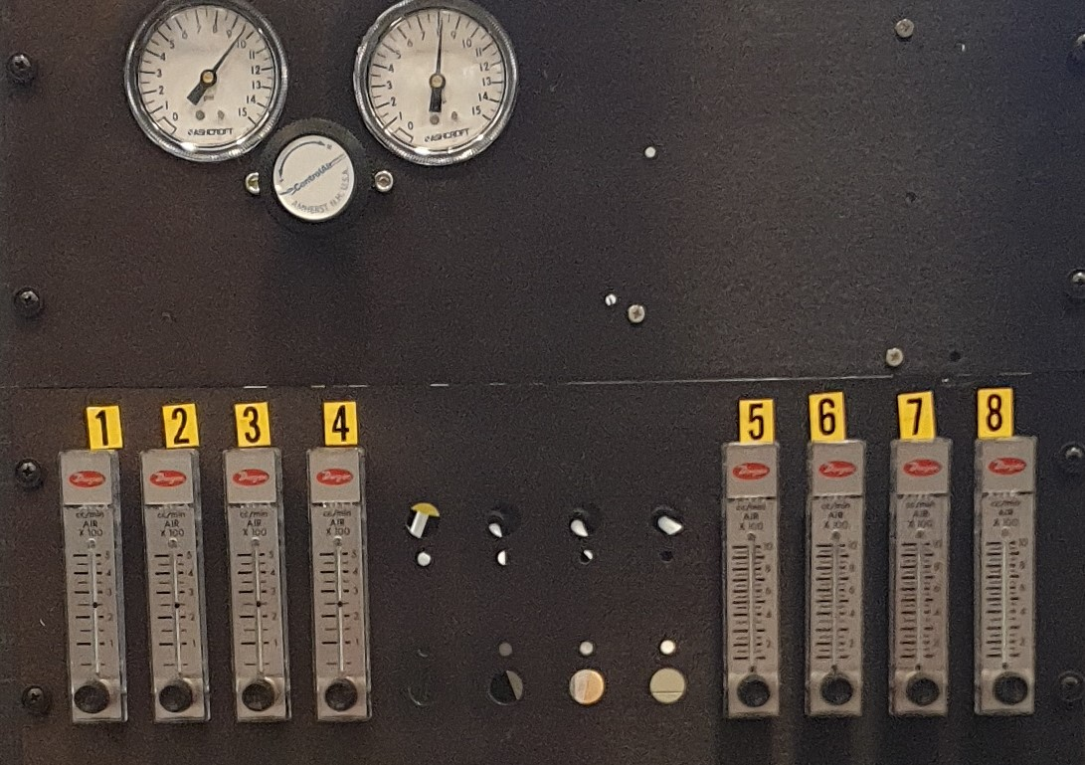

High flow valves

Standard flow valves

Output pressure (to GEMs)

Output pressure (from bottle)

Pressure Regulator control knob