**Additional Questions/Comments for SoLID Magnet Controls System Meeting Minutes of April 7, 2021**

Pablo Campero

*Controls-CLEO* spreadsheet, under *Voltage Tap* tab, at Column *G* shows the 10-pin vacuum feed-through, there is no way to know that there will be a 15-pin cable (at least to me).

I still have the following questions:

1. Does the 15-pin cable refers to a 15-conductor cable? Is this cable the one that DSG needs to research?
2. Will the 15-pin cable you mention connect the protective resistor box with the terminal strip in Instrumentation rack?
3. Is this "Current lead turret vacuum feed thru" you mentioned in your comment the same as the 10-pin vacuum feed-through shown in the given Controls-CLEO spreadsheet?
4. How are the connections between the 10-pin vacuum feed-through (if any) and the resistor box?
5. Are the following sequence below to connect the Voltage taps to the terminal strip in the rack right:
   1. For VT1 to VT5 and Flux Loops Taps:  Voltage Tap --> 10-pin VF--> Resistor Box (200 KΩ resistor) -->Terminal Strip.
   2. For VT6 and VT7: Voltage taps (at current leads) --> Resistor Box (200 KΩ resistor) -->Terminal Strip.

About your comment, “**Putting more than one drive motor on a 2A breaker runs the risk of unnecessary trips. Also having a single breaker per valve makes finding a faulty motor quicker, helps in trouble shooting”**

That should be applied to Hall C SHMS valve controls since at least from the drawing I can see that two drive motors are connected to a single 2-amp breaker. See picture below

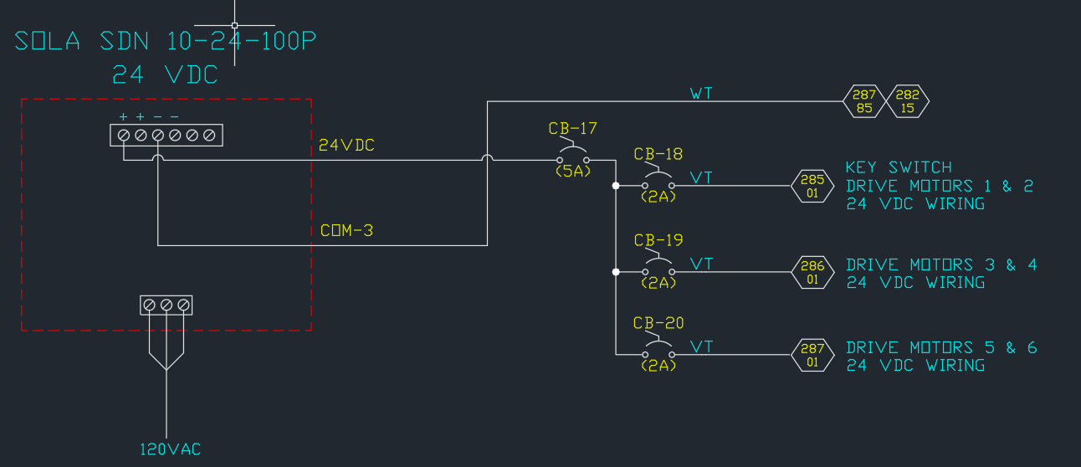

Hall C SHMS 24 VDC Power Distribution Wiring Diagram