**Additional Questions/Comments for SoLID Magnet Controls System Meeting Minutes of April 7, 2021**

Pablo Campero

*Controls-CLEO* spreadsheet, under *Voltage Tap* tab, at Column *G* shows the 10-pin vacuum feed-through, there is no way to know that there will be a 15-pin cable (at least to me).

I still have the following questions:

1. Does the 15-pin cable refers to a 15-conductor cable? Is this cable the one that DSG needs to research? **Yes**
2. Will the 15-pin cable you mention connect the protective resistor box with the terminal strip in Instrumentation rack? **Yes**
3. Is this "Current lead turret vacuum feed thru" you mentioned in your comment the same as the 10-pin vacuum feed-through shown in the given Controls-CLEO spreadsheet? **Yes**
4. How are the connections between the 10-pin vacuum feed-through (if any) and the resistor box? **See the SHMS drawing 67125-00111 revB sht 1 for an example.**
5. Are the following sequence below to connect the Voltage taps to the terminal strip in the rack right:
   1. For VT1 to VT5 and Flux Loops Taps:  Voltage Tap --> 10-pin VF--> Resistor Box (200 KΩ resistor) -->Terminal Strip.
   2. For VT6 and VT7: Voltage taps (at current leads) --> Resistor Box (200 KΩ resistor) -->Terminal Strip. **The drawing SHMS drawing 67125-00111 revB sht 1 should help answer this.**

**Note: there are spare resistor enclosures with resistors and terminal strips from the SHMS that can be used for CLEO. They will have an excess of resistors but the hardware exist. The connector can be changed out if needed.**

About your comment, “**Putting more than one drive motor on a 2A breaker runs the risk of unnecessary trips. Also having a single breaker per valve makes finding a faulty motor quicker, helps in trouble shooting”**

That should be applied to Hall C SHMS valve controls since at least from the drawing I can see that two drive motors are connected to a single 2-amp breaker. See picture below

**Good Point, I mis-understood why the question was being raised. Placing two JT motors on single 2A breaker has proven to work reliable for the SHMS and therefore should be ok for CLEO (Nullifies my previous answer). Saves on 2A breaker qty as well. CLEO will have one more JT motor than the SHMS. So it may be a good idea to replace the leading 5A breaker with a 10A breaker? Use the SHMS design as a reference.**

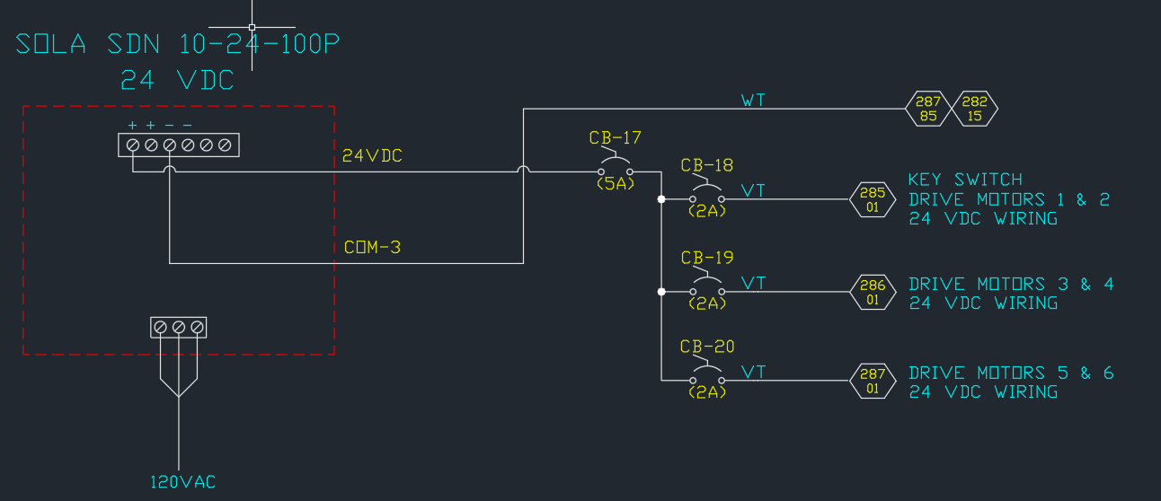

Hall C SHMS 24 VDC Power Distribution Wiring Diagram