 | Rich Detector Clean room  DRAFT | 
Instructions:
This form must be completed for each lift using a mobile crane, forklifts with suspended loads or a critical lift, with an overhead crane or forklift. This form should be used for a non-routine lift with overhead cranes or incorporated into a Temporary Operational Safety Procedure.
STEP 1 – Planning the Lift
Lift Title: | Rich Detector
Location: | EEL clean room rm 125
Lift Date (s):
Lift Plan Prepared by: | Print Tilles Phone # 810-9576 Date
JLab Approved by: | Print Tilles Phone # 810-9576 Date
JLab Work Coordinator: Doug Tilles
DOE Lift Classification: |  |  | CRITICAL |  | PRE-ENGINEERED PRODUCTION |  | X | ORDINARY
Load Weight # 2500 lbs |  |  |  |  |  | Load Weight Determined By:  - X Equipment Manufacturers Data Plate  - Rigger Estimate  - Labeled Shipping Weight  - Dyno Measured
Describe the Load:
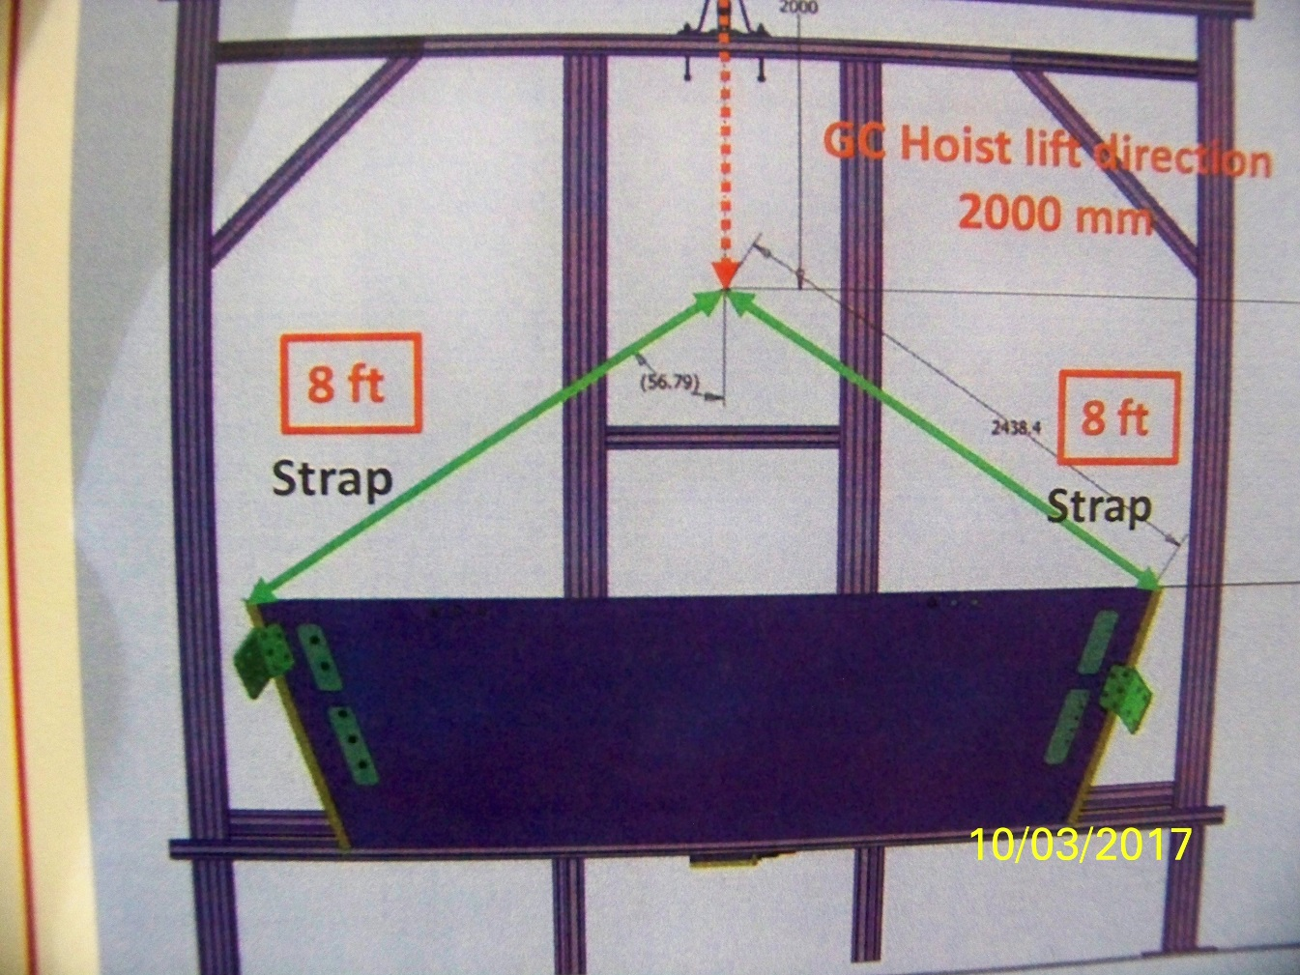
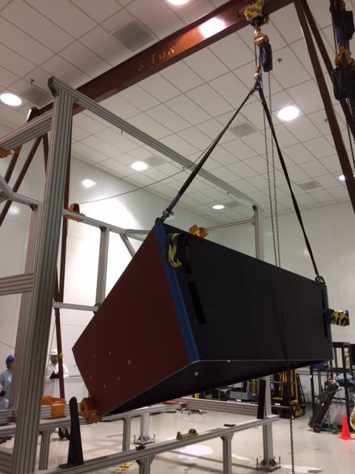

Rigging Hardware Required:
List all items (size & load rating) to be used under the hook to accomplish the planned lift.

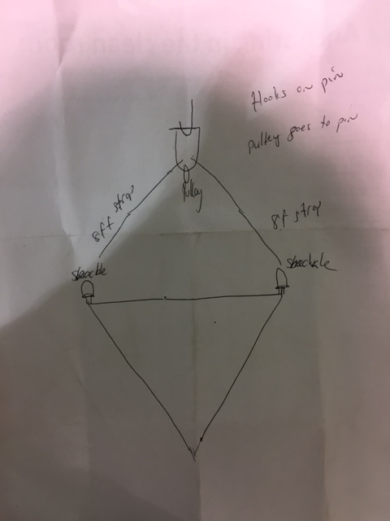

Material Handling Lift Plan
Plan View:
Show the Following:

- Load with CG labeled | - Underground Utilities, manholes and valve boxes
- Mobile Crane, Pivot and Outriggers | - Overhead Obstructions
- Outrigger ground loading | - Lift Perimeter Demarcation
- Distance from load CG to Crane Pivot | - Ground Bearing Reactions

Material Handling Lift Plan

ELEVATION
Show the Following:  - Load with CG labeled  - BTHLD’s  - Sling Horizontal Angles  - Sling Tensions  - Label Rigging Gear, size & WLL  - Label D/d ratios | 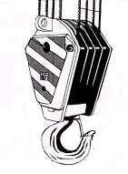

Material Handling Lift Plan
STEP 2 – Setup for Lift
Equipment Make:_________________________________ Type:___________________________________

Model#:_________________________________________ Serial#:__________________________________

Owner:__________________________________________

Annually Inspected By:_____Foley_____ Date:___2017________________________________

Monthly Wire Rope Inspection Documented: Y / N
Daily Inspection Documented: Y / N

Equipment Operator^{i}____________________________________________________________________

Certification/Qualification: _________________________________________________________________
CCO No.____________________________________ Expiration Date:______________________________
Employer:_______________________________________________________________________________

Lead Rigger: ____________________________________________________________________________
Certification/Qualification: __________________________________________________________________

Lift Director (ASME) or PIC (DOE)^{ii}:_________________________________________________________

Site Supervisor^{iii}:__________________________________________________________________________

- Establishes a perimeter that clearly identifies the area of the lift.
- Ensures ALL personnel within the perimeter wears proper PPE required for the area.
- Conducts a Pre-Lift Meeting where the sequences of actions that will occur to accomplish the lift are presented.
- Attend the Pre-Lift Meeting.

Signal Person:______________________________________________________________________________

 |  |  | Material Handling Lift Plan
 |  | STEP 2 – Setup for Lift
 |  | PPE Requirements:  - Hard Hat  - Safety Shoes  - Safety Glasses |  | - List any additional PPE needed to perform the lift
 |  | Watch Personnel _{(Maintains Lift Perimeters)} :__________________________________________________________________________________
 |  | Identify a Muster Point:____________________________________________________________________
 |  | Emergency Procedures (in case of injury)
1. Stop Lift
2. Lower Load to a safe position
3. _____________________________________________________________________________________
_____________________________________________________________________________________
_____________________________________________________________________________________
Limits of Safe Operation (i.e. wind, rain, lighting or traffic)
STEP 3 - Lift
- Accomplish the lift according to the Lift Plan.
- Document minor adjustments required to accomplish the lift.
- Re-approval is required if Operators, equipment or rigging changes after initial approval.
Post Lift De-Brief
What went well? _______________________________________________________________________________
_____________________________________________________________________________________________

Areas of Improvement: __________________________________________________________________________
_____________________________________________________________________________________________
_____________________________________________________________________________________________

Documentation – Send a copy of this COMPLETED LIFT PLAN to:
Name: | Bob Sperlazza | sperlazz@jlab.org | 28G

Print e-mail address Mail Stop

Material Handling Lift Plan

- Rigging Hardware must be inspected and marked in accordance with the criteria contained in the following documents:

  - ASME B30.9 Slings
  - ASME B30.20 Below the Hook Lifting Devices
  - ASME B30.26 Rigging Hardware
  - 29 CFR 1926.251 Rigging Equipment for Material Handling

- 5-3.1.3 Responsibilities

While the organizational structure of various projects may differ, the following roles are described here for purposes of delineating responsibilities. All responsibilities listed below shall be assigned in the work site organization. A single individual may perform one or more of these roles.

i Equipment Operator: directly controls the equipment’s functions.
ii Lift Director: directly oversees the work being performed by a crane and the associated rigging crew. This position equates to the Person-In-Charge (PIC) identified in the DOE Hoisting & Rigging Standard.
i^{ii} Site Supervisor: exercises supervisory control over the work site on which a crane is being used and over the work that is being performed on that site.
Form Revision Summary

Revision 2.1 – 01/25/17 – Updated TPOC from D.Kausch to B.Sperlazza
Revision 2.0 – 12/04/14 – Form revised to create uniformity between ALL material handling equipment
Revision 1.1 – 03/22/12 – Update to format only
Revision 1.0 – 04/12/10 – Update to reflect current laboratory operations

 | ISSUING AUTHORITY | FORM TECHNICAL POINT-OF-CONTACT | APPROVAL DATE | REVIEW DATE | REV.
 | ESH&Q Division | Bob Sperlazza | 01/25/17 | 01/25/20 | 2.1
This document is controlled as an on line file. It may be printed but the print copy is not a controlled document. It is the user’s responsibility to ensure that the document is the same revision as the current on line file. This copy was printed on 3/10/2017.

