RICH Drawing Review

Bob Miller

August 17, 2017

General Comments:

1. Paint all parts safety yellow (even the lifting arms should be yellow – not a big problem, we are just trying to standardize our colors so everyone knows that a yellow part is tooling)
2. Note for weld specification: AWS D1.1 or D14.1
3. Check weld symbols; near side fillet weld is shown under the arrow

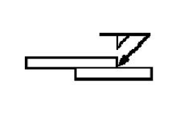

1. Specify units; some drawings have dual units, some are in inches
2. When using dual units, note that units are in mm, put inches in parenthesis
3. Some holes sizes have incorrect mm to inches conversion
4. Holes for bolts should have clearance holes, i.e. ½ inch bolts require a free fit hole size of 0.531 inches.
5. All bolts should be grade 5, and the bolt torque should be stated
6. Use decimals instead of fractions, see tolerance table on drawing B00000-07-00-0017
7. Provide stp files for all parts. Machine shops will use these when they make the parts.

Trolley for RICH Transport

1. Sheet 1: drawing should be 2/8 and 5/8
2. Sheet 2, 5: item 5 is a nut,
3. Sheet 2, 3, 5, 6: I beam is ASTM A36 or A572 steel

Strongback / RICH Interface Parts

1. Sheet 2: 5/16 welds on both sides of the 3/8 gussets will warp the plate, consider ¼ inch welds

Load Test Assy

1. Show parts to be made in yellow like the other drawings
2. Sheet 11, call out welds for both sides of the gusset

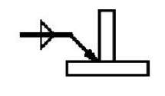

1. Sheet 11: remove note 2, pipe material
2. Sheet 12, check bolt hole sizes and unit conversion
3. Sheet 14, same comments as sheet 11
4. Sheet 15, add bolt hole sizes