SHMS COntrols

Documentation for the PLC controls for the SHMS Magnets, Cryogenics and Power Supplies
2014

CONTENTS:

Introduction

- Thermometers
  - Temperature Sensors and Locations
  - Carbon Ceramic Temperature Sensors
1.2.1 Carbon Ceramic Sensors Signals
  - Diode Temperature Sensors
1.3.1 Diode Temperature Sensors Signals
  - PT102 Sensor
1.4.1 PT102 Sensor Signal
  - I/O Module 1756-IF16 for Temperatures and Fault Conditions
- Pressure
  - Helium and Nitrogen Pressure Measurement
    - Pressure Sensors
    - Location of Pressure Sensors
    - Pressure Measurement
  - Vacuum Pressure Sensor
    - Location of Vacuum Pressure Sensor
    - Vacuum Pressure Measurement
- Forces
  - Strain Gage Sensors
  - Location of Strain Gage Sensors
  - Strain Gage Measurement
  - Support Link Force Limits for Q1
- Control Valves
  - Control of the JT Valves
    - Linear Variable Differential Transducers
    - Electric Linear Actuator Drive motors
    - Location of JT Valve Actuators
  - Valve Controls
- Vapor Cooled Current Lead He Mass Flow Controllers
  - Mass-flow sensors
  - Method of Mass Flow Measurement
- Liquid Volume Measurement and Heat Load Calculations
  - Liquid Helium Volume, Level and Heat Load
  - Liquid Nitrogen Volume, Level and Heat Load
- Cool Down
  - Helium Cool Down Logic
  - Helium Warm Up Logic
  - Nitrogen Cool Down Logic
- Power Supply and Magnetic Field Measurements
  - Communications
  - Power Supply Communications
  - NMR
  - Hall Probes
- Voltage Signals
9.1 Variable tap information
9.2 Voltage tap Measurements
9.3 Danfysik Quench Detector
- Interlocks
- EPIC Variables

1 Thermometers
1.1 Temperature Sensors and Location
Three different types of temperature sensors are used to monitor and control magnet temperatures from room temperature to 4K. The sensors used are:
- Carbon Ceramic (CC) Sensors for temperatures below 70K and located in high magnetic fields and high radiation areas. CC’s are used in the magnet and Cryo-can to monitor temperatures of the cold mass, conductor, current leads and bottom of the Liquid He reservoir.
- Diodes Sensors are used for all temperature ranges, in low magnetic fields regions and lower radiation areas. These sensors are used in the magnet’s cryo-can reservoir, SHMS transfer line and it’s Heat Exchanger (HX).
- PT 102 sensors are used for temperatures above 70K. These sensors are used on the magnet’s LN2 Shields, the magnet’s cold mass during warm-up and cool-down, the magnet’s cryo-can reservoir’s LN2 circuit, and the room temperature end of the current leads.
All temperature sensors that are non-accessible have redundant sensors.

Figure 1 I/C schematic for SHMS Magnets.

  - Carbon Ceramic Temperature Sensors

Magnet Helium temperatures will be measured using CC sensors from Temati. These CC sensors are inversely, nonlinear and monotonic in their resistance vs temperature characteristics between 1.5 Kelvin and 375 Kelvin and have a fast response time of 1 ms for mK variations. The resultant magnetic field dependence is quite weak and CC sensors are insensitive to nuclear radiation. CC sensors comes with a three-point calibrated data from 4.2 Kelvin (-269°C) to 300 Kelvin ( 27°C) and each sensor has its own discrete resistance-temperature characteristic. A curve fitting routine, cross referenced to a fully calibrated sensor, is used to obtain a complete resistance-temperature response for each sensor (1).

Table 1 Carbon Ceramic Sensors
Type | Temati D2 Carbon-Ceramic-Sensor
Temperature | 1.5K to 375K
Stability | <1mK per yr over 20 yr period
Repeatability | <10mK at 4.2K
Sensitivity | 400 – 1600 Ohms/K
Response time | 1mS
Resistance | 900 to 1KΩ at 300 K  1.2 to 1.4KΩ at 77K  2.5 to 4KΩ at 4.2 K
Figure 2 Typical Temati D2 Carbon-Ceramic Temperature Sensor Curve
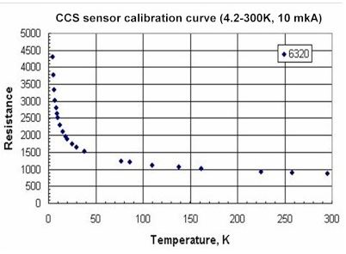

1.2.1 Carbon Ceramic Sensors Signal

Carbon Ceramic sensors are wired using a four wire cable. Individual 10 uA (9.68uA) constant current source is passed through each diode sensor to induce a voltage. This voltage, ranging from 10mV to 50mV, is then buffered, isolated, conditioned and amplified by a Dataforth SCM5B30-02D conditioner with a gain of 10V/50mV, (a gain of 200). The conditioned voltage signal is sent to the PLC’s 1756-IF16 I/O module which converts the scaled voltage signal back into a sensor output voltage by means of its front end calibration. The 1756-IF16 input module also preforms any signal offset and filtering if needed, before storing the value into a PLC tag. Routines within the PLC then converts the sensor voltage back into a resistance and computes the temperature from the standard diode curve.

Figure 3 1756-IF16 Front End Signal Conditioning for Carbon Ceramic Sensors
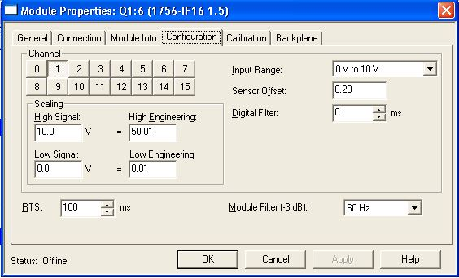

  - Diode Temperature Sensors

Lakeshore Diodes will be used to monitor temperatures in low magnetic fields and over a large temperature range, 300K to 4K. The Diode sensors use a standard curve 10 voltage to temperature conversion. These sensors are located within the magnet’s cryo-can and monitor the cool-down, He cold supply, He cold return and warm return He gas.

Figure 4 Standard Diode Sensor curve 10.
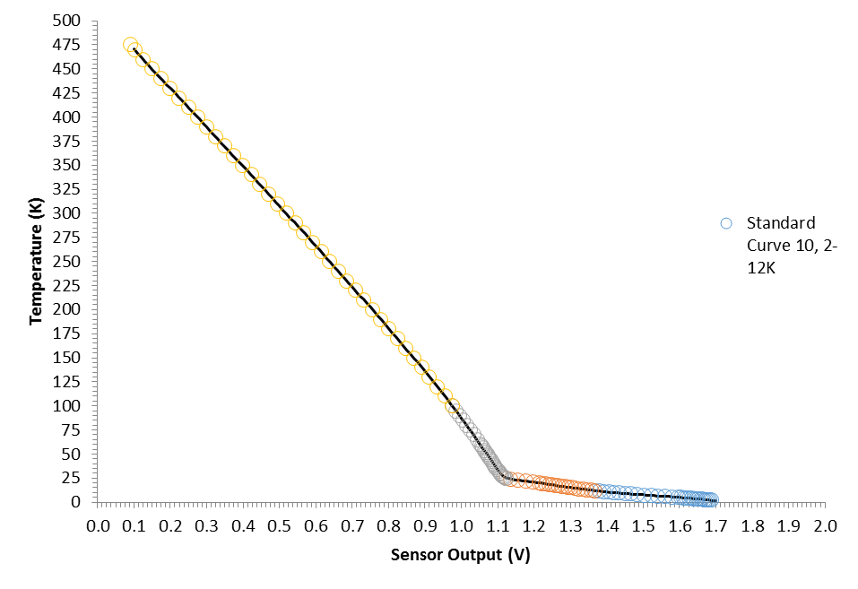
    - Diode Temperature Sensors Signal

Diode sensors are wired using a four wire cable. Individual 10 uA (9.68uA) constant current source is passed through each diode sensor to induce a voltage. This voltage, ranging from 10mV to 30mV, is then buffered, isolated, conditioned and amplified by a Dataforth SCM5B43—05D conditioner with a gain of 10V/5V, (a gain of 2). The conditioned voltage signal is sent to the PLC’s 1756-IF16 I/O module which converts the scaled voltage signal back into a sensor output voltage by means of its front end calibration. The 1756-IF16 input module also preforms any signal offset and filtering if needed, before storing the value into a PLC tag. Routines within the PLC then converts the sensor voltage to a temperature using curve fits to the standard diode curve 10.
Figure 5 1756-IF16 Front End Signal Conditioning for Diode Temperature Sensors
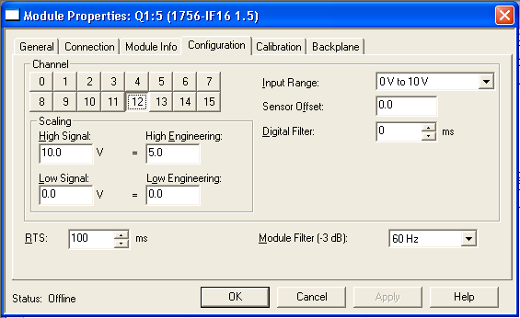

  - PT-102 Sensors

PT-102s will be used to measure temperatures within the range of 375K to 75K. These sensors are used on the magnet’s cold mass, LN2 shields, cryo-can reservoir and on the current leads warm end.

1.4.1 PT-102 Sensors Signal

PT-102 sensors are wired using a three wire cable. Excitation current and signal voltage conditioning are handled by a Dataforth SCM5B34-1562 RTD module. The module excites the PT102 and sends out a 0 to 5Vdc signal, proportional to the PT102 temperature, to the PLC’s 1756-IF16 I/O module which converts the scaled voltage signal back into temperature reading by means of its front end calibration. Each Dataforth 1562RTD module has its own unique voltage to temperature curve internally stored. The 1756-IF16 input module also preforms any signal offset and filtering if needed, before storing the value into a PLC tag. See figure 6 below.
Figure 6 1756-IF16 Front End Signal Conditioning for PT-100 Temperature Sensors
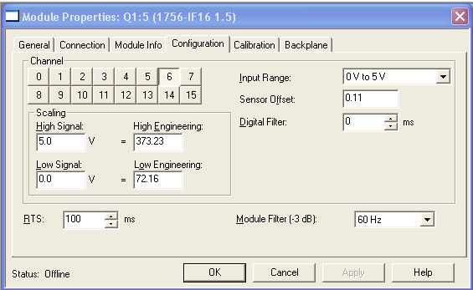

  - I/O Module 1756-IF16 for Temperature Sensors and Fault Conditions

The 1756-IF16 I/O module for the temperature sensors is configured as a 16 point single-ended input module with a resolution of 16 bits (160uV/cnt) and time response of 1 to 31 msec /per channel. I/O module update rate to the PLC is user selectable and is set from 2,000 to 3,000 msec.
Refer to drawings 67185-00235 to -00240 and 67185-00305, -00306 for the wiring schematics of the temperature sensors.
The PLC looks at the following temperature sensor fault conditions:
Resistance calculation out of range (Max, Min)
Temperature out of range (Max, Min)
Voltage input to 1756-IF16 out of range (Max, Min)
Sensor input fault
Broken or unconnected cable.

2 PRESSURE
Pressure measurements include the measurement of the nitrogen pressure, the helium pressure and the vacuum pressure in the SHMS magnets and the cryo-transfer line.

  - Helium and Nitrogen Pressure Measurement

    - Pressure Sensors
The pressure of helium and nitrogen will be measured with absolute pressure transducers from OmegaDyne. The sensing element consists of a membrane with thin film strain gage application in a full bridge circuit. The output is mV.

Table 2 Pressure Sensor Parameters
Type | PX35D1-100GV
Class of accuracy | 0.25% linearity, hysteresis & repeatability  combined
Measurement range | 5 bar
Characteristics at 5 bar | 3mV/V
Temperature range | -73 to +149 ° C
Proof Pressure | 150% of rated pressure

2.1.2 Location of Pressure Sensors
The pressure sensor for measuring the helium pressure, is located on the top plate of the magnet’s cryo-can reservoir. Via a capillary tube the sensor detects the pressure in the liquid helium reservoir. In the description and schematics the helium pressure valve is labeled p_He.
Similarly the pressure sensor for measuring the nitrogen pressure, is placed on the top plate of the magnet’s cryo-can reservoir. Via a capillary tube the sensor detects the pressure in the liquid nitrogen reservoir. In the description and schematics the nitrogen pressure value is labeled p_N2.
He and LN2 pressure sensors are located at the downstream end of the SHMS transfer line. They are located on the top plate of service can #3.

2.1.3 Pressure Measurement
Dataforth module SMC5B38-35D is used to excite the full bridge stain gage and measure the response voltage of the pressure unit. The Dataforth module uses a scale of 10V/20mV (gain of 500). The amplified voltage signal is passed to the PLC’s I/O module 1756-IF16, where it is converted back to the measured signal. A block routine within the PLC converts the signal into pressure reading.
Interlock signals are generated when the Helium pressure is greater than 1.8 atm or less than 1.0 atm.
LN2 interlocks are generating at pressures greater than 2.5 atm and less than 1.0 atm.

See Drawings 67185-00245, -00246 and -00306 for pressure and vacuum schematics.

  - Vacuum Pressure Measurement

    - Vacuum Pressure Sensors
The vacuum pressure measurement uses a single wide range vacuum unit from Edwards. It has a continuous and linear output over its measurement range. It uses a Pirani Technology for the upper pressure range and an inverted magnetron for the lower portion.
Table 3 Wide Range Vacuum Gage Sensor Parameters
Type | WRG-S-DN40CF
Measurement range | Atmosphere to 10 ^{–9} mbar
Measurement Type | Pirani and Inverted Magnetron
Accuracy | +/- 15% <100mbar  +/- 30%<10⁻³mbar
Temperature range | +5 to +60 ° C
Figure 7 Wide Range Vacuum Gage Typical Performance Curve
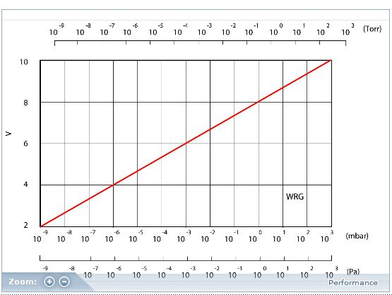

    - Location of Vacuum Pressure Sensor
An Edward’s wide range vacuum gage (WRG-S-ON40CF) is used to detect the vacuum pressure, tag name = vacuum, It is placed on top of a T coming off the top lateral area of the magnet’s cryo-can reservoir.

2.2.3 Vacuum Pressure Measurement
The output of the Edwards gage is 0 to 10V. This signal is fed into a Dataforth signal conditioner SCM5B31-03D where it is buffered, isolated, and conditioned. The gain is 1:1. The I/O module 1756-IF16 then reads the voltage and passes it along to the PLC routine where the voltage is converted into a pressure reading or error signal.
Interlock signal is set for a vacuum reading greater than 0.01 Torr for more than 3 seconds.
3 FORCES
Strain gages are used to measure magnet weight, thermal cool-down stresses and magnetic loads. These strain gages are mounted on the magnetic support links that carry the cold mass to the OVC vessel. The support links are used to support and align the magnet’s cold mass relative to the outer vacuum vessel.

Q1 Magnet: There are four vertical support rods, made from Nitronic 50 material and four axial Glass re-enforced fiber (GRF) bands that are mounted to SS 316 rods. The maximum and minimum loads for the support links for the magnet in situ, cold and with up to 0.25 g loads are listed in table 4.⁽¹⁾ The PLC will alarm and interlock when a strain gauge exceeds 110% of the maximum load and 90% of the minimum load.
Table 4 Magnet Q1 Forces in Support Links
Q1 | Maximum Load N (lbf) | Minimum Load N (lbf)
Vertical Support links | 22,153 (5,000) | 4,431 (1,000)
Axial support Links | 11,984 (2,700) | 5,992 (1,350)

  - Strain Gage Sensors
The constantan strain gages CEA-06-125UT-350 are strain gages with wire lattice in two directions.

Table 5 Strain Gage Sensors Parameters
Type | CEA-06-125UT-350
Temperature range | 100 °C to 400°C
Strain Limits | Approx. 5% of strain length
Nominal Resistance | 350.0 + 0.4 %
Gage Factor (at 24°C) | 2.09 + 1.0 %
Transverse sensitivity (at 24°C) | (+0.7 + 0.2%)

  - Location of Strain Gage Sensors
The strain gage sensors are placed on the room temperature end of the support links. Each strain stud is equipped with two strain gages across the circumference at distances of 90°to each other. Two opposite strain gages in a strain stud are connected to a full bridge circuit and measure the stress of the link. Redundant strain gages are employed due to the difficulty in accessing the gages.

  - Strain gage measurement
The strain gages are excited by a Dataforth SCM5B38-35D strain gage module. The Dataforth module uses a scale of 10V/20mV (gain of 500). The buffered, isolated and amplified voltage signal is passed to the PLC’s I/O module 1756-IF16, where it is converted back to the measured signal. A block routine within the PLC converts the signal into force reading.
Weight Calculation
The Q1 magnet’s colds mass is supported by four vertical support links. The cold mass is centered within the cryostat by means of the vertical links and four horizontal links. Forces during cool down and warm up are monitored to ensure no excessive or unequal thermal loads are applied to the links. During normal magnet operation the forces should be balanced as to ensure no asymmetrical loading and that the magnet is centered to its outer vacuum vessel.
Using the Dataforth strain gage to excite and measure the output of the strain gages .

Force per link: 2*A*E*Vr / [GF*((nu+1)- Vr*(nu-1))]
Where for a 1.25” diameter SS rod:
A = Cross section area of support link (1.2272 in^2)
E = Young’s Modulus of Link (26Msi)
S = Signal Voltage in V (0.02) (maximum output signal)
P = excitation Voltage V (10V)
GF = Gage Factor (2.09)
Nu = Possion’s Ratio (0.285)
Vr = S/P
Gives a force of, F = ~19,000 Lbs or a stress of 39,000 psi, as a maximum value the Dataforth can send out.

3.4 Support Links Force limits for Q1
The Nitronic 50 vertical supports links maximum force per link is calculated to be less than 9,000 lbf (40kN, safety factor of 4.4 over UTS of 175.3kN). The horizontal support links are limited by the GRP bands to a maximum load of 6,700lbf (30kN, safety factor of 3.6 over UTS of 107.6kN)⁽²⁾.
The PLC monitors and sets interlocks to either the cool down control, rotation or the magnetic power supply when a tension link reaches 100% of the maximum calculated load condition.

- Control Valves
JT valves and ball valves are used to control the flow of liquid cryogens, cool down gas, and exhaust gas to and from the cryogenic system of the SHMS magnet. The valve actuators provide the positional control for the JT valves. Each JT valve actuator consists of a valve actuator support assemble, a Linear-Voltage-Differential-Transducer (LVDT), an electric linear actuator. The ball valve is used for the warm He return line and consists of a 3” ball valve with a remote/local actuator.

  - Control of the JT Valve Actuators
    - Linear-Voltage-Differential-Transducers
A Linear-Voltage-Differential-Transducer (LVDT) is applied to indicate the seat position of a valve. An operator at the PLC has the capability of seeing any position from 0% (soft seat) to 100% (full open), and also negative percent valve position, which indicates the valve is fully seated (-6%).
The LVDT contains three galvanic separated coils. A magnetic stainless steel housing provides electromagnetic and electrostatic shielding. The lightweight core in the center bore of the cylindrical housing varies the electrical coupling between the coils, dependent of its position.
The LVDT core motion is the sum of stroke length and 1/16 inch seating motion of the motor mounting plate at the valve actuator assembly.

Table 6 LVDT Parameters
Type | MHR 250
Input Voltage | 3 V rms (nominal)
Frequency range | 400 Hz to 20 KHz
Temperature range | 220K to 420 K
Null voltage | <0.5 % full scale output
Diameter | 9.53 mm
Length | 47 mm
Core dimensions:
Diameter | 2.75 mm
Length | 28.5 mm
Table 5.1: Characteristics of the LVDT

    - Electric Linear Actuator Drive Motors

The valve actuator is capable of strokes up to 5/8 inch with a seating force of 200 pounds. The stroke speed is approximately 30 seconds full stroke with continuous drive.
Table 7 Characteristics of the actuator drive motor
Type | SURA part #001
Supply voltage | 24 Vdc
Current | 1.5 A
Power | 36 W
Dimensions (Actuator):
Length | Approx. 0.20 m
Width | Approx. 0.20m
Height | Approx. 0.25 m

    - Location of JT Valve Actuators
The valve actuators for the JT valves are located on the top plate of the reservoir. The valve actuators for the current lead return gas are located on the lateral side of the reservoir.
Designation of the JT valves:
JTV1 liquid nitrogen supply to the magnet during cool down. Bottom Fill.
JTV2 liquid nitrogen supply to the reservoir. Top Fill
JTV3 gaseous helium supply to the magnet during cool down. HX valve.
JTV4 liquid helium supply to the magnet during cool down. Bottom Fill.
JTV5 liquid helium supply to the reservoir. Top Fill.
JTV6 cold helium gas return from the reservoir. Cold Return.

The LVDT’s half-bridge, is excited by a Modular Macro-sensors LVDT signal conditioner (LVC-2412). The Macro-sensors sends the control valve (true-valve) position via a 4-20mA signal to a 1756 IF-16 Allen Bradley module. A 20 mA corresponds to 100% open valve, while a 4mA signals represents a hard seat condition or valve setting of -6%.

Figure 8 1756-IF16 Front End Signal Conditioning for LVDT Signals
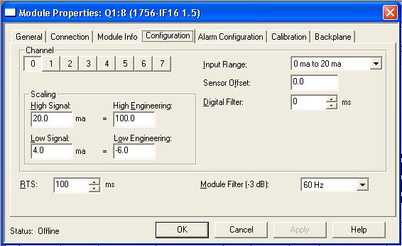

4.2 Valve Controls
There are three remote and one direct method of controlling the JT valves. The first two modes are done through the PLC controls system, PLC remote and PLC Manual modes. The third method is by manual valve control at the local control rack situated within the electronics room of the SHMS detector hut. The fourth method is by means of local box controller, directly hooked up to the JT assembly on the magnet’s cryo-can top plate. In case of PLC automatic control (switch in “Auto” position), the digital output signal activates the relay on the relay card for opening (or closing) the valve. The motor opens (or closes) the valve in short pulses, until the deviation between the set-value and the true-value becomes a minimum, within a dead-ban tolerance. In PLC auto mode, the JT valve set point is determined by process variables, within min and max software limits. In PLC manual mode, the JT valve set point is determined by a constant user entered value, within user defined min and max limits.
In Local Manual mode (Control rack switch in “Man” position), the operator can open (or close) the valve by pressing the switch on the front panel to the chosen position. The motor runs continuously as long as the button is engaged, until manual limit switches are reached.
When all else fails, a local hand held power source, (Blue Box) can be connected directly to the JT motor connection.
The PLC uses PIDE controls to set cryogenic valves to their proper position. The PLC looks at magnet status, cryogenic parameters from the ERS or CHL, transfers line thermometer, magnet pressures, vacuum, tension links, magnet current, mass lead flow readings and cryogenic liquid levels to determine valve set points. The output of the PIDE routines are used to trigger the 1756-OW16I relay modules, which then in turn trigger isolated 24Vdc relays the power the valve motors. The following valve functions can be set and controlled from within the PLC:
Table 8 Valve Control Set Point Parameters
Valve Open Rate | Power On Time Max | Integral Gain
Valve open max value | Valve position time out | Proportional Gain
Valve close min valve | Dead band Max | Derivate Gain
Power On Time Min | Dead band Min | Valve Set point

- Vapor Cooled Current Lead He Flow Controllers
A mass-flow meter measures the vaporized room temperature helium flow through each of the high current leads. Each of the VCL has its own mass flow controller. The vapor cooled Current Leads (VCL) require liquid He cooling of 1.8 L/hr/kA/lead. The static no current load is 3W/lead and they produce <6W/lead at 5,000A. At 5kA and 6w of heating the amount of room temperature Helium gas is:
6W / 20.486J/g = 0.3g/s of Helium vaporization at 4.5k and 1.3atm.
Density of He at 25C, 1.1atm = 0.18493 g/L
Flow = 0.3g/s * 60s/min / 0.18493g/L = 97 SLM
The PLC monitors the status of the PSU and the computes the maximum current by taking the higher value of the PSU set current or the actual read back current. A flow increasing factor can be set to add safety margin to the cooling of the current leads. A minimum flow of 50 L/min is imposed when the PSU is turned off, to prevent excessive heat load into the liquid helium.

  - Mass Flow Sensors
The All M Series Gas Flow Meters (and MC Series Gas Flow Controllers) are based on the accurate measurement of volumetric flow. The volumetric flow rate is determined by creating a pressure drop across a unique internal restriction, known as a Laminar Flow Element (LFE), and measuring differential pressure across it. The restriction is designed so that the gas molecules are forced to move in parallel paths along the entire length of the passage; hence laminar (streamline) flow is established for the entire range of operation of the device. Unlike other flow measuring devices, in laminar flow meters the relationship between pressure drop and flow is linear.
Table 9 He Mass Flow Controllers Parameters
Type | MCR-500SLPM-D
Full scale range ( for nitrogen) | 500 SLM
Accuracy | +1.0 % of F.S
Repeatability | +0.2 % of F.S
Operating temperature range | -10 to 50 C
Response time | 100 milliseconds
Maximum inlet pressure | 145 psig
Warmup Times | <1 sec
Output signal | 4 to 20 mA

  - Mass Flow Measurement and Control

The MCR-500SLPM-D mass-flow meters are supplied by an external 24 Vdc power supply. The mass-flow meter is calibrated to He gas and sends a mass flow dependent voltage output signal to the Dataforth SCM5B31-03D. This voltage, ranging from 0V to 5V, is then buffered, isolated, conditioned and amplified by a Dataforth conditioner with a gain of 10V/10V, (a gain of 1). The conditioned voltage signal is sent to the PLC’s 1756-IF16 I/O module which converts the scaled voltage signal back into a sensor output voltage by means of its front end calibration. The 1756-IF16 input module also preforms any signal offset and filtering if needed, before storing the value into a PLC tag. Routines within the PLC convert the sensor voltage back into a mass flow measurement.
The PLC program determines the amount of cooling needed by the VCL, based upon the magnet status, the higher value of the set point current or the actual read back current of the power supply and any user define flow increasing factor assign to the VCL. The PLC uses a PIDE loop to generate an output voltage proportional to the valve position of the flow meter. The output voltage is generated from a 1756-OF4 module. 5V is fully opened and the minimum voltage is set to 0.45V. In the event of loss of power, the mass flow control will shut its valve.
The Helium gas mass-flow controllers have their own PD loop, zero dead band and signal averaging filtering. The signal averaging filter can be considered as the response time constant (in milliseconds) and can be set from 1 to 256 ms.
Initial values used for the Q1 magnet are:
P = 1000 D=100 Averaging = 200, Zero = 0.
The PLC I/O has a digital filter of 4,000 millisecs on the mass flow input signal.

Figure 9 1756-OF4 Front End Output Signal Conditioning for He Mass Flow Controllers.
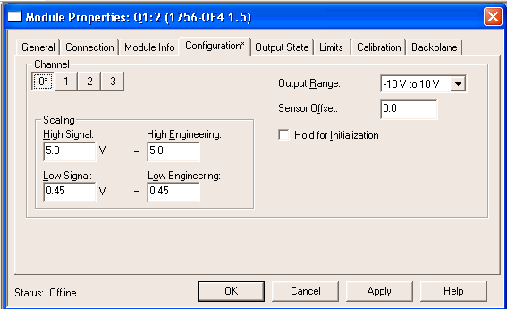

6. Liquid Helium Volume, Level and Heat Load
6.1 Liquid Helium Volume, Level and Heat Load
The volume of Liquid Helium within the He reservoir is
Diameter=21.50” Height = 15.5”
LHe Volume = 90.76L (after subtracting CL & Piping = 1.45L).
Active part of LHe Probe starts 0.394” from the bottom of the probe. The active length of LHe probe is 15.25”. The top portion of the active probe extends slightly into the top plate of the LHe reservoir by 0.144”.
LHe Volume / height = 90.76L/15.5in = 5.86L/in
Un-measurable level at bottom = 0.395in = 2.3 L.
Actual probe scale is (90.76-2.3)L/ (15.25-0.144)in = 88.5L /15.1in = 5.86L/in.
One inch of probe length is 6.56% of the active probe length.
Amount of LHe as a percentage of active probe length is 0.894L/%.

Heat of vaporization of LHe at 4.5K &1.3 atm is 20.513J/L and has a liquid density of 118.63kg/m^3. This gives a cooling power of 2,433.5 J/L for helium.
Specification for the heat leak rate for the magnet does not include the heat leak due to the current leads (6W/pair at zero current). For a 30 W magnetic heat load plus the 6W from the current leads, (not taken into account sensible heat), the Helium boil off should be less than 0.015l/sec. The liquid level should not fall faster than 1.0%/min. This gives a holding time of 1.7 hours, from 100% liquid level reading to zero (88.5L boiled off).

6.2 Liquid N2 Volume, Level and Heat Load
The volume of the LN2 reservoir is 53.8L with height of 21.38in. The LN2 probe active length is 21.25” and starts 0.394in from the bottom of the LN2 probe. 0.26in of the active probe extend out of the top of the LN2 reservoir. The active probe length within the LN2 reservoir is 20.99in.
LN2 Volume/height = 53.8L/21.38 = 2.52L/in.
LN2 unmeasured at bottom is ~1L.
LN2 Volume over probe active length = 52.77L
LN2 Probe scale is 2.51L/in or 52.77L/%

Heat of vaporization for LN2 at 78K and 1.08atm is 77.8kJ/kg with a liquid density of 802.4kg/m^3. This gives 62,402 J/L cooling power.
Heat Leak rate for LN2 circuit should be below 100W. LN2 boil off should be less than 0.1L/min. The LN2 liquid level should not fall faster than 0.18%/min. This gives a holding time of 9.15hr., from 100% LN2 level reading to zero (52.77L boiled off).

7 Cool Down
In this task the set values for the values are calculated for all the cooling functions.
The main cooling functions are
- Cool-down
- Warm up
- Stand by at LN2 temperature
- Liquid level control
- Cooling error
The status cooling error shows that no cooling function is selected or is improperly defined by temperatures and magnet status.

7.1 Helium Cool Down Logic
The cool down of the magnet from temperatures greater than 90K to 4.2K is worked in four stages. The cool down stages are:
- Cool down magnet using 300K He gas cooled via Heat Exchanger (HX) with LN2, while maintaining proper temperature gradients across magnet and between Inlet and magnet temperature. Return gas by warm return line.
- Cool down 4K transfer lines and internal 4K piping by mixing with 80K HX He gas and 4K bottom fill path. Return vent gas by warm return line.
- Cool down using 4K LHe via bottom fill valve. Return gas using warm return line until return gas drops below 5K. Transition He return flow from warm return line to cold return line.
- Fill magnet and magnet’s LHe reservoir and maintain LHe level control. Return using cold return line.
It is possible to select one or more cool down stages. If all functions are selected the magnet will be cooled automatically, in a sequential manner, starting from the highest order.

7.2 Helium Warm Up Logic
The warm up of the magnet can be done in three stages.
The warm up stages are:
- Slow Warm up due to magnet’s own heat load by switching off LHe supply. Shut off LN2 shields after magnet’s temperature surpass 80K. Vent He gas by warm return line.
- Warm up to room temperature using controlled temperature helium gas from HX. Vent He gas by warm return line.
- Long Term standby Mode: Warm up to LN2 temperatures and keep magnet at LN2 by keeping LN2 shields cold, supplemented by using HX cooled LHe gas as needed. Vent He gas by warm return line.

7.3 Nitrogen Cool Down Logic
The cool down of the nitrogen shield is working in two steps. The nitrogen cooling functions are
- Cool down the shield with LN2
- LN2 level
The program selects automatically the nitrogen cooling function. In case of the main cooling functions cool down or stand by is selected the nitrogen cooling is active

8 Power Supply & Field Measurements
Control of the power supply can be done through its local front panel control panel or by commands sent from the PLC or for the case of the SHMS Dipole magnet’s the NMR field measurement. The control status of the power supply is either local, remote or locked, where the local controls panel locks out any commands from the remote line.

  - Communications
The PLC communicates with the Magnet’s Power Supplies units (MPS) by means of RS232 basic commands either directly or through the NMR’s communication port. The RS232 protocols is given in Table 9. MPS commands are pre-defined within the PLC code and are sent to the MPS by HMI screen buttons, or by an automated, repeated series of status commands sent to the MPS when its main power is sensed by the PLC to be turned on. Timers within the PLC are used to determine when communications timeout errors occur.
Table 10 ASCII Parameters for Power Supply and NMR Communications
Baud Rate | 2400
Parity | None
Data Bits | 8
Stop Bits | 1
RTS On | 0
RTS Off | 1
Handshaking | None  #None,RTS/CTS, DTR/DSR, XON/XOFF
Rx Term Char Count | 1
Rx Term Characters | 13
Rx Packet Length | 26
Rx Message Timeout | 200
Rx Intercharacter Delay | 30
Rx Swap Bytes | No
Tx Message Timeout | 5000
Tx Minimum Delay | 0
Tx Swap Bytes | No

8.2 Power Supply Commands
The following commands can be passed to the MPS from the PLC.
MPS ON
MPS OFF
Reset Interlocks (and Energy Dump switch)
Set Slew rate
Set Current ###
Set Polarity (Negative or Positive)
Set MPS Control (Local, Remote)
Errors reporting
MPS Status Checks (output voltage, output current, polarity, interlock status, source of control.)

8.3 NMR
The NMR unit is used to set the current or field and the polarity of the SHMS Dipole magnet. An acquired B vs I curve is stored into its memory. The PLC sends the set field parameter to the NMR, which in turns send the appropriate current command to the MPS. The NMR has the capability of acting in a transparent mode, where commands from the PLC are sent directly to the MPS. Field stabilization and correction signals are sent to the MPS by current set point adjustment communicated to the MPS via RS232 or by a small current correction signal that is transposed onto the MPS precision current read back transducer. The field is measured by one of the five NMR probes positioned with the body of the magnet and is sent back to the PLC by RS232 signals.

8.3 Hall Probes
Individual, single axis, Hall probes from Cryomagentics, GM-700 series, will be utilized within the warm bore of the HB,Q1,Q2 and Q3 magnets. These probes are used as auxiliary feedbacks to the users that the magnet is energized, stable and operating near expected momentum setting. The locations of the Hall probes within the Quadrupole warm bore tube will be optimized during magnet commissioning.

9 Voltage Tap Sensors
Voltages across the super conducting coils, the vapor cooled current leads and across any splices are detected with voltage taps wires routed out of the cryostat and to a Danfysik quench detector module. All internal voltages are wired with a redundant wires.
Internal wiring is AWG-28 polyimide insulated wires from HABIA CABLE AB. Each voltage tap is protected by external mounted 200 kOhm resistors in series to prevent voltage tap failure in the event of a fault to ground.

9.1 Location of Voltage Sensors
Voltage taps are located on both ends of each of the vapor cooled current lead, on either side of any splice and on each end of every coil. Figure 10 shows a schematic for the voltage taps for the Q1 magnet.

Figure 10 Q1 Magnet Voltage Taps Locations Schematic

9.2 Voltage Tap Measurement
The primary coil protection is preformed using the Danfyisk Quench Detector unit. The PLC monitoring of the coil voltages adds a secondary layer to the magnet’s protection. Voltage signals from selected potential taps are fed into a Dataforth signal conditioner SCM5B31-09D. The SCM5B31-09D module can handle input voltages up to 250Vrms, but for input voltages above 40V the output signal is clamped. The coil voltages are then sent to a 1756 IF-16 I/O module operating in Differential Voltage mode. The PLC monitors and logs the voltages across each coil, and across the current leads. Magnets voltages are recorded at a higher sampling rate from other sensors input signals, of the order of 100 Hz .
9.2.1 Danfysik Quench Detector
Primary coil protection is the through the Danfysik Quench Detector. The unit is a four channel module. Each channel can either buck two voltages signals against each other or be used an absolute measurement. The voltages across the current leads are measured as absolute voltages while the voltage signal from two coils are bucked against each other, and this difference is compared to a trip threshold. Upon sensing a threshold being exceeded for a settable dwell time period, the quench detector sets a status bit (read by the PLC) and opens a mechanical relay that breaks the connection to the PSU fast dump circuit. The minimum voltage threshold of detection for the Danfysik QD is 10 mV and the dwell time can range from 0 to 1000 ms. The minimum threshold and dwell time will be employed that gives the maximum magnet protection while avoiding spurious nuisance trips.

10 Interlocks
10.1 Cool Down Interlocks
Cooling down of the magnet from temperatures greater than 90K to liquid helium temperatures is protected by monitoring the temperature difference across the magnet and between the output of the HX and the magnet’s average temperature to be less than 50K. In the event of a temperature gradient exceeding the 50K limit, the inlet valves are closed and the cool down is halted. The forces on the support links are monitored and cool down is halted when any strain gauge readings exceeds 110% of their maximum expected limit or becomes less than 90% of minimum value. Cool down is also stopped or slowed when the supply and or return flow exceeds limits imposed by the ERS by the closing of the supply valve to the magnet. In the event of high He pressures, the supply valves will shut and both the cold and warm return valve will open.

10.2 PSU Interlocks
Magnet interlocks will be characterized into two groups, interlocks that provided for a fast discharge of the magnet and those that provide for a slow discharge or prevents the PSU from turning on. Primary magnet protection will come from hardware as much as possible with the PLC providing redundant interlocks. Figure 11 gives a schematic of the hardware interlocks, external to the PSU itself.

10.1 PLC PSU Interlocks
Fast Interlocks | Slow Interlocks
Software Quench Detector | PSU Dump Switch Status
Hardware Quench Detector relays | Helium Liquid Level < 10%
HMI/PLC Panic Button | Magnet Temperatures > 10K
MPS-CPU reset command | HMI/PLC Slow Discharge Button
PLC Keep Alive Timer Relay > 10sec | Vacuum > 0.01 Torr
1.0 < He Pressure > 1.8 atm | Current Lead Mass Flow
Broken Wire Detection Voltage Taps | 1.0 < LN2 Pressure > 2.5 atm
 | Min < Support Link Forces > Max
 | Fast Interlock present
 | Broken wire detect temperature sensors

Figure 11 Magnet Hardware Interlock Schematic
11 EPICS Variables
The following EPIC tags from the CHL/ESR are read by the PLC and are used in the cryo control logic portion of the program.

PLC | Description
CEV6711C | 4K Flow Limit
CEV6711C_ORBV | 4K Supply Valve Position
CEV6721C_ORBV | 4K Return Valve Position
CEV6731C_ORBV | 15 K Supply Valve Position
CEV6741C_ORBV | 20 K Return Valve Position
CEV6751C_ORBV | LN2 Supply Valve Position
CEV6781C_ORBV | 4 K to 20 K Return Cross Over Valve Position
CFI6010 | Warm He Supply Flow
CFI6030 | Lead Return Flow all Halls
CFI60DLP | Warm He Return Flow
CFI6711A | Hall A 4K Supply Flow
CFI6711B | Hall B 4K Supply Flow
CFI6711C | Hall C 4K Supply Flow
CFI6731C | 15 K Supply Flow
CFI6751C | LN2 Supply Flow
CLL671SC | 4.5 K Buffer Level
CLL675SC | LN2 Buffer Level
CPI6010 | Warm He Supply Pressure
CPI6030 | Lead Return Pressure all Halls
CPI603QC | Quench Line Pressure
CPI60DLP | Warm He Return Pressure
CPI671SC | 4K Supply Pressure ESR
CPI671T | 4K Supply Pressure
CPI672 | 4.5 K Return Pressure all Halls
CPI673 | 15 K Supply Pressure
CPI674 | 20 K Return Pressure
CPI6751 | LN2 Supply Pressure
CPI9521 | 4K Return Pressure
CTD671SC | 4K Supply Temperature
CTD672 | 4.5 K Return Temperature all Halls
CTD673 | 15 K Supply Temperature all Halls
CTD674 | 20 K Return Temperature
CTD9521 | 4K Return Temperature
CTP6751 | LN2 Supply Temperature
[1] “JLAB Q1 Cold Mass Suspension Rods design Analysis” SMI Report Fred Domptail.

