CAEN A7030TN Connector

During a preliminary inspection of the Hall C modules, DSG noticed that some of the contacts appeared not to be inserted fully. (see fig. 1).

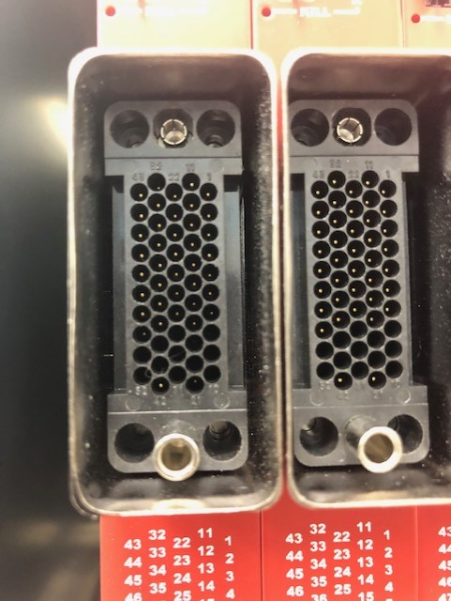

Pin 21.

Figure 1. Pin 21 is not inserted to the depth of Pin 42.

After reviewing the assembly procedure for the mating plug, it is noted that CAEN gives instruction on step 17 to pot. Presumably, to keep the pins from backing up the channel tube (see Fig. 2)

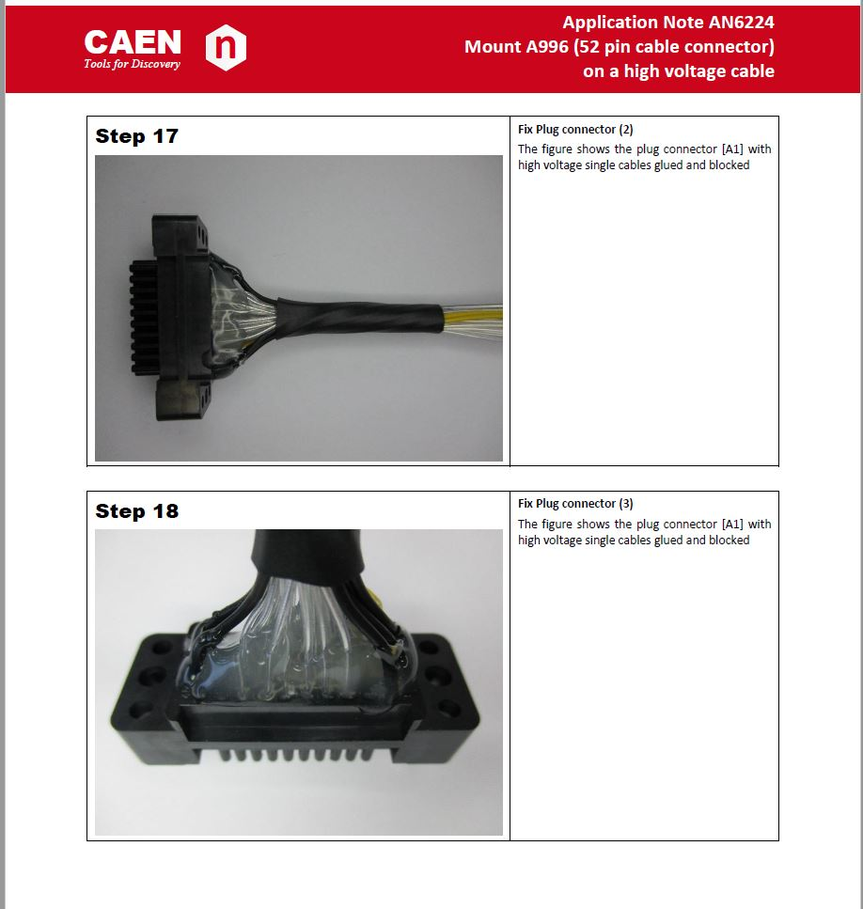

Figure 2. Page 11 from CAEN Application Note AN6224

Below is a photo of the back side of the connector on the slot 0 module. No potting is applied, and it is unclear if there is a procedure to pot the socket during assembly.

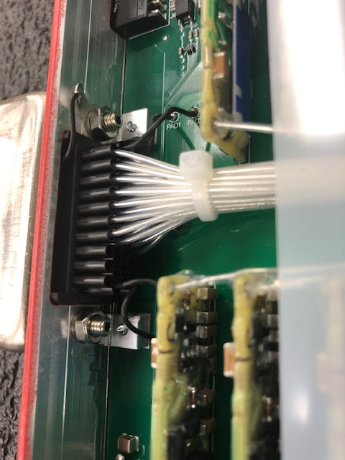

Figure 3. Slot 0 module back side of Radiall connector.

CAEN should be contacted to address this issue.