**I. Status of problems detailed in Xiangdong’s report of Dec 5/16** Jan 26, 2017

While we know that there has been some progress in the last weeks, so that nothing is

overlooked, it would be helpful to compare to Xiangdong’s last list of issues (Dec 5/16).

Please comment on each of the following and, if the problem has been resolved, please specify

the parameter range over which the system has been tested:

1. Field scan issues (A – page 10) and (B – page 11):
2. In the *CT-­‐Box enabled* condition (page 10), the field signal noise appears way too

high, on the order of 2 gauss (as in the bottom panel). This is a significant fraction of

the NMR line width, and so must be reduced.

**Field signal noise of 2 gauss could be due to hardware configuration. Will be investigated.**

1. When *CT-­‐Box Off* is chosen, the field plotted by the NMRS program should be

reporting the IPS power supply value. Comparing the bottom plots on page 10 and

11, this does not seem to be the case, since in the *CT-­‐Box Off* condition the noise is the

same as with *CT-­‐Box enabled*.

**CT-Box Off needs to be chosen before running the VI. Selecting CT-Box Off during VI run will not turn the CT-box off. Plotted field reports IPS power supply value when CT-Box off is chosen before running VI.**

1. As indicated by the red circled items, the times requested in the input file [*Tdown, Tbott,*

*Tup, Twait*] are ignored

**Requested times are no longer ignored. Graphs now display appropriate times.**

1. As indicated by the blue circled item in the bottom panel, the *Bcenter* value in the input

file is not properly implemented.

**This is an issue with CT-Box calibration. Calibration has been added to properly implement Bcenter.**

1. Field scan issues (C – page 12):
2. In the *CT-­‐Box enabled* condition (page 12), when requesting times *Tdown* ≠ *Tup* in the input file, the times appear completely ignored by the NMRS program. -­‐ eg. in the top panel, *Tdown* =60, *Tup* =10 and *Twait* =4s were requested but the program responded with *Tdown* =36, *Tup* =36 and *Twait* =0s

**As stated in 1.c, requested times are no longer ignored.**

1. RF Switch-­‐Box display (page 14):

The original intent of the display would be to show the actual output (rather than just an echo of desired settings – as an independent verification). However, since that seems too complicated to retrofit, it would be sufficient to show the setting. But this should be reliably displayed.

**There has been some confusion regarding this. The VI run on the computer requests the RF box to display the output. From there, the output is sent to the display. The display is showing actual output, not an echo of the run table.**

1. Fast Resonance Scan program (page 15):

The FRS program needs to run reliably.

**FRS program is now installed on NMR rack and all issues that were reported have been fixed. Tests by HDice will need to be done to verify that it works as expected.**

**NMR program should be tested again to ensure these changes are desired. The program should also be tested with negative scans.**

**II. Variable NMRS parameters in the *NMRS_setup Table***:

Below we summarize the required range of each of the independent variables to be specified by the user in the setup table for the NMR scan program:

• RF Power: settable throughout the range from -­‐63 dBm to 0 dBm

(RF synthesizer is set to a fixed value of +5.3 dBm; the *power* parameter

selects the appropriate attenuators to be used.)

**Unchanged from original version**

• RF frequency: full range of the RF synthesizer

**Unchanged from original version**

• FM frequency: full range of the RF synthesizer

**Unchanged from original version**

• AM frequency: full range of the RF synthesizer

**Unchanged from original version**

• phase: full range of the Lock-­‐in amplifier

**Unchanged from original version**

• B(center): ± full range of the Oxford IPS that is used with the NMR rack

**Unchanged from original version**

• B(span): 10 to 1000 gauss

**Changed and tested**

• T(down): 300 s, independent of any other time setting

**Changed and tested**

• T(bott): 10 s, independent of any other time setting

**Changed and tested**

• T(up): 300 s, independent of any other time setting

**Changed and tested**

• B(wait): ± full range of the Oxford IPS that is used with the NMR rack

**Unchanged from original version**

• T(wait): please verify how this is used.

**T(wait) holds the B field after the T(up) ramp.**

• L1(level): full range of the Lock-­‐in amplifier

**Unchanged from original version**

• L1(TC): full range of the Lock-­‐in amplifier

**Unchanged from original version**

• Expand: full range of the Lock-­‐in amplifier

**Unchanged from original version**

The above list reflects the range sent to Peter by Xiangdong on April 14, 2015. The explanatory graph from that exchange is repeated on the next page.

1. Please clarify the status of each of these required capabilities.

**Most required capabilities have not been changed and should work as it did in the**

**original program.**

1. The NMRS program must also ask at launch which dewar is being used with the rack, so that the auto-­‐generated files have the correct names.

**This request has been added. The name of the files are either Run #PD-I, Run #PD-II,**

**Run #IBC-axial, Run #IBC-trans, or Run #SD.**

1. Details of parameter space for NMRS, depending upon application- from April14, 2015.

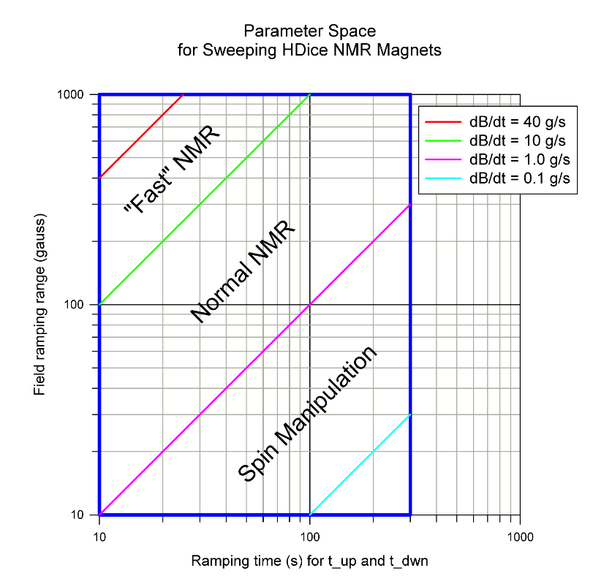

The parameter space for ramping HDice NMR magnets is shown as the blue rectangle. The field ramping range varies from 10 gauss to 1,000 gauss, while ramping time varies from 10 seconds to 300 seconds. Three "region of interest" are separated by 4 colored lines, representing 4 different ramping rates (40, 10, 1 and 0.1 gauss per second). Rates faster than 40 g/s and/or slower than 0.1 g/s are no interested. The center field for the ramping is set independently.

Because the current to field ratio and ramping rate limits for each magnet is different, a separate table will be provided.

**III. Synchronizing multiple scans**

In order to provide the required capability it is essential to understand the end goal, and with this in mind, a short description is needed. When the NMR system is calibrated in terms of absolute hydrogen polarization, the NMR signals are very small and the chief limitation is noise. To reach a high accuracy for this calibration it is necessary to add many hundreds of sequential NMR sweeps together, so as to average out the noise.

The lock-­‐in amplifier outputs a stream of up to 16,300 values. For example, in one field cycle of

300 s down and 300 s up, the lock-­‐in would provide a pair of numbers (Vx, Vy) every

600/16300 = 0.037 s. At the same time the current to the magnet provides a third column to

the data stream. This sequence repeats in the next field sweep, and so on. . .

If the LabView commands issued to the Lock-­‐in and to the Oxford IPS really caused the Lock-­‐in and the IPS to start their scans at the “same time” (ie. to within about 10 ms), then one can simply add all the scans together (in the lock-­‐in) assuming zero time is the same start field and we’re done. But if there is any time jitter, the NMR signal in the sum can be washed out. (Has anyone tried to measure that coincidence with the existing new equipment?)

**Because the lock-in amp does not have an external trigger output or time stamping, accurate timing of lock-in measurements are not possible. It is also on the same com bus GPIB as the power supply, only one instrument can “talk” at a time.**

With the threat of jitter in mind, we suggested obtaining a shunt to directly read the output current coming from the IPS and going to the magnet. The DSG has found a shunt that provides an accurate reading, although we (HDice) are not sure about how fast it can respond. A few options come to mind for consideration, depending on the capabilities of the shunt:

• if the shunt can provide an accurate reading (with current accuracy corresponding to ~

0.1 gauss at 1 tesla) every few msec, then it could be used to generate a trigger for the lock-­‐in

when a user-­‐specified a threshold is crossed. Each lock-­‐in scan would then be guaranteed to start at the same field; the lock-­‐in then does the sum for us. This would be the cleanest solution.

**The shunt provides a reading rate of up to 100 KHz and accuracy of <0.005%. See attached specifications.**

• if the shunt requires some significant averaging time to reach the required accuracy, then the problem shifts to software. We can imagine two paths, depending on the shunt:

(a) if the shunt reports accurate values, but only in spaced intervals that would contain

many lock-­‐in reports, software would be needed to interpolate the shunt readings and associate a (Vx, Vy) pair of lock-­‐in readings that could be associated with a user-­‐ defined current threshold. This could then be identified as the “starting field” for that particular field sweep. This could be done with every sweep; this would align the starting points for each sweep, which would allow the (Vx, Vy) lock-­‐in arrays to be all lined up and summed together in software without jitter.

(b) If the shunt can report on few msec time scales, but only with poor current

resolution, the accuracy can be still regained by again fitting many readings, interpolating those shunt readings and associating a (Vx, Vy) pair of lock-­‐in values with a user-­‐defined current threshold. A software sum of many field sweeps could then be constructed as in (a).

The characteristics of the CAEN shunt are still unclear to us (HDice), and so we are not sure what options you are considering. It would be helpful to learn which of these, or possibly some other path, is being pursued in the DSG.

**DSG is investigating an external trigger for the lock-in amplifier. We asked CAENels to provide a firmware upgrade allowing for an external trigger in oscilloscope mode. This upgrade provides a trigger from 10 Hz to 100 KHz. This is currently being programmed and tested. If this works, we will test triggering the lock-in amp with the external trigger. The lock-in amp input can only trigger up to 512 Hz. Additionally, the manual states after receiving the trigger, the lock-in amp will take up to 2 ms to acquire a sample on receipt of trigger.**