# **Introduction / Executive summary**

This document describes the experimental setup, equipment, and procedures to be used at the Brookhaven National Laboratory (BNL) and other EIC institutions around the world when needed, for evaluation of the first five High Rate Picosecond Photodetectors (HRPPDs) by Incom Inc, built according to the design optimized for their usage in various Particle Identification (PID) subsystems of the ePIC detector at the Electron-Ion Collider (EIC) at BNL.

To the extent possible, and within the limits defined by the apparatus readily available at BNL and the Argonne National Laboratory (ANL), the methodology will mostly follow the one established by Albert Lehmann (University of Erlangen) for the evaluation of other pixelated Micro-Channel Plate Photomultiplier Tubes (MCP-PMTs) and presented in his [talk](https://indico.bnl.gov/event/20816/contributions/81794/attachments/50383/86166/Lehmann_eRD110_Oct2023_final.pdf) for the EIC eRD110 Consortium in October 2023.

The proposed performance evaluation will focus on the specifications outlined in the Statement of Work (SOW) of the “Design, First Engineering Test Articles, and Sensor QA Validation of HRPPDs Towards a Final EIC Sensor” Project Engineering Design (PED) contract between Jefferson Lab (TJNAF) and Incom Inc. The main focus will be given to systematic active area scans, in terms of the Quantum Efficiency (QE), Photon Detection Efficiency (PDE), achievable gain, Dark Count Rate (DCR), single photoelectron (SPE) timing resolution, and their uniformity across the sensor surface, as well as to the resilience with respect to the magnetic field.

# **HRPPD photosensors by Incom Inc.**

HRPPDs by Incom Inc. are Micro-Channel Plate (MCP) vacuum photosensors with dimensions of a ~120mm x 120mm size (Figure 1, left), and an active area of 104mm x 104mm in their EIC implementation. The sensors have a fused silica window covered by a UV-enhanced bialkali photocathode on the inside, ceramic side walls and a ceramic anode base plate produced by Kyocera (Japan), acting as a pre-routing PCB. The base plate is pixelated into 32x32 square pads with a pitch of 3.25 mm on the inner side and 4x4 groups of 8x8 square pads with a pitch of 2.0 mm on its outer side (Figure 1, center), for a total of 1024 channels.

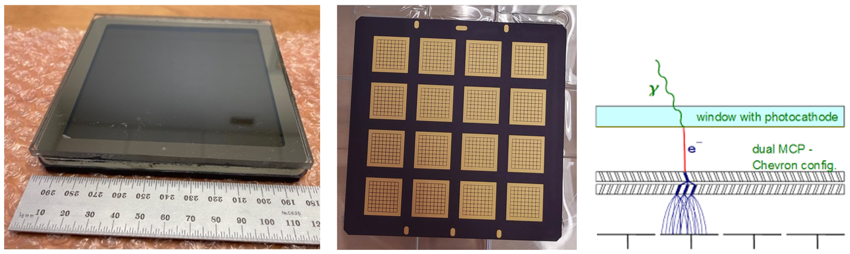

Figure 1 Left: HRPPD photosensor (original design). Center: rear sensor side with sixteen 8x8 pad fields (Kyocera anode plate by BNL design). Right: Illustration of HRPPD operation principle.

Two 600 mm thick MCPs provide primary photoelectron amplification via secondary electron emission off narrow 10 mm diameter channel walls during an avalanche process caused by a bias voltage up to ~1 kV applied to the top and bottom surfaces of each MCP, see Figure 1 (right) for an illustration.

The ePIC Collaboration is planning to use 68 such sensors for its proximity focusing Ring Imaging Cherenkov detector (pfRICH) and potentially up to 72 sensors more for its high performance Detection of Internally Reflected Cherenkov light detector (hpDIRC).

# **LAPPD / HRPPD test stand equipment at BNL**

This test stand was originally built for the primary evaluation of Incom’s Large Area Picosecond Photodetectors (LAPPDs), and was adapted to HRPPDs over the course of 2023. The test stand will be upgraded with other equipment readily available in the BNL Physics Department. It will consist of :

* a compact light tight enclosure (a dark box) with 2” Thorlabls MTS50-Z8/M translation stages in a remotely controlled XYZ configuration and focusing optics, see Figure 2.
* several light sources, coupled to the dark box via either single mode (SM) or multi-mode (MM) fibers, including
  + a PiLas picosecond laser with a nominal wavelength of 420 nm by Advanced Laser Diode Systems
  + an Elmo 780 femtosecond laser by Menlo Systems (390 nm)
  + an LED pulser box provided by JLab (405 nm)
  + an Oriel 77250/7340 monochromator and light source with Xe and Hg lamps that cover a wavelength range of 190-990 nm
* a six channel MSO 6-BW-6000 Tektronix scope with an 8 GHz analog bandwidth and up to 50 GS/s sampling rate
* up to 480 channels of DRS4 electronics with a sampling rate up to 5 GS/s (fifteen CAEN V1742 VME modules)
* A pair of Keithley 6487 picoammeters
* A bare sensor CMOS camera (AmScope MD 310-BS) for light spot profiling

Additional equipment includes all the necessary NIM logic and a Linux DAQ PC running an instance of the [RCDAQ](https://www.phenix.bnl.gov/~purschke/rcdaq/rcdaq_doc.pdf) data acquisition system.

For the purposes of this HRPPD evaluation, the existing setup will undergo certain modifications, described in the following two subsections.

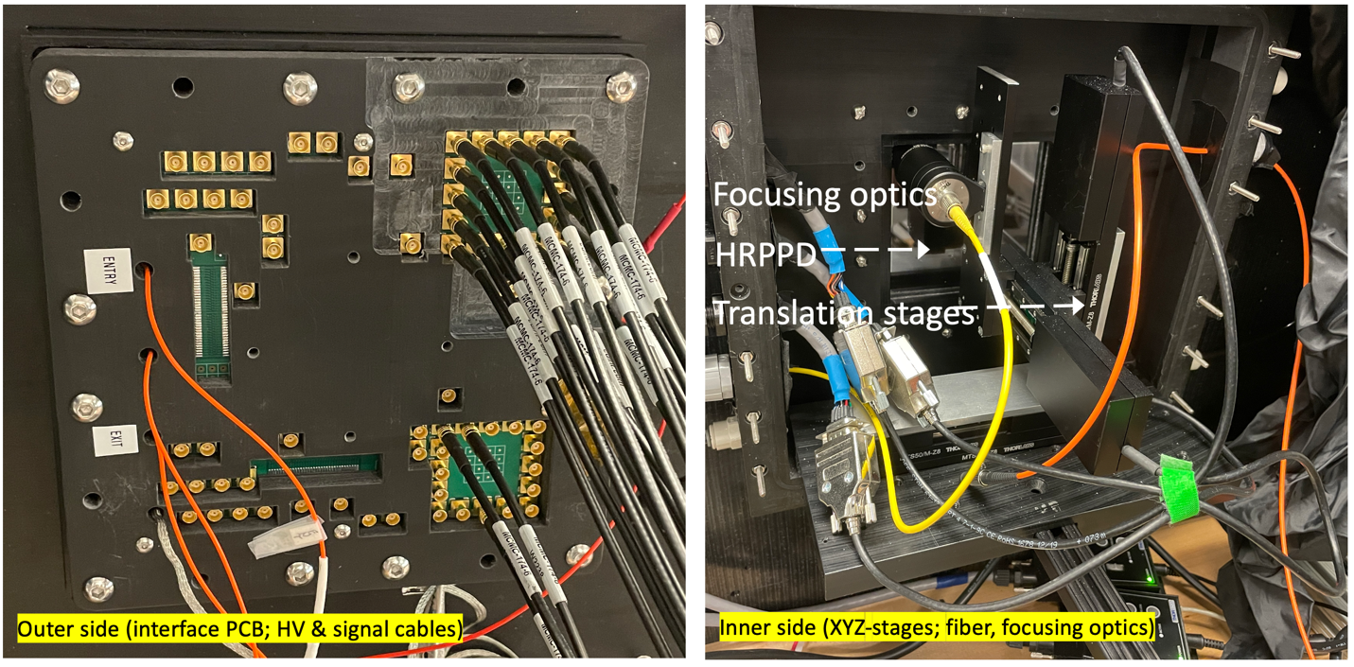

Figure BNL HRPPD test stand. Left: a 172mm x 172mm large HRPPD enclosure attached to the side wall of a compact dark box. The MCX connector locations indicate the boundaries of the photosensor active area (used to be 4” x 4” in the current HRPPD implementation). Right: Inner side of the dark box, including focusing optics, automated 2" translation stages, and the incoming fibers, with the HRPPD window seen in the rear.

## Dark box modifications

The essential part of the evaluation will consist of various surface scans, to be performed in a well-controlled and reproducible fashion. Therefore, the Thorlabs XY-stages with their limited 2” nominal travel will be adjusted *once* with respect to the HRPPD active area, and never moved afterwards. These stages have an actual travel of at least 52 mm, which is sufficient to scan a single HRPPD quadrant at one position. A moveable 3D printed assembly mounted onto these stages will have four 1” diameter openings (slots) for a modified focusing optics head (see Figure 3), with a +/-26 mm travel range with respect to the centers of the four respective HRPPD quadrants. The measurement procedure will require opening the dark box, repositioning the fiber optics to the next quadrant, and a sensor “warming up” for a yet to be defined period of time. Edge effects outside of the 104mm x 104mm HRPPD active area will be studied separately, should they become of interest.

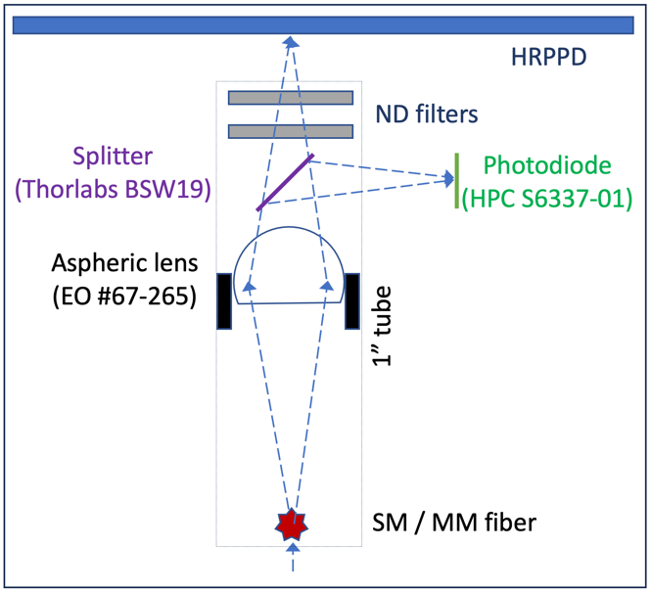

Figure A modified compact optical head design.

A 50:50 beam splitter (Thorlabs BSW19) and a Hamamatsu reference photodiode S6337-01 will be added to the focusing optics assembly, as shown in Figure 3.

## HRPPD packaging and readout interface

A new custom interface board will be built, and a modified 3D printed enclosure, matching the requirements for scanning a single 16x16 pad HRPPD quadrant at a time, see Figure 4.

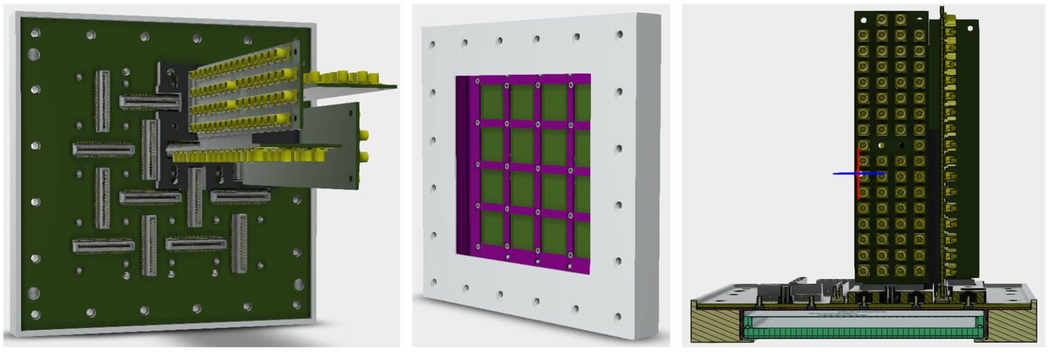

Figure Left: Rear side of the HRPPD enclosure with four 64-channel MCX adapter cards mounted. Center: Front side of the HRPPD enclosure, with a 3D printed spacer shown in purple. One can see sixteen 21mm x 21mm square slots for the compression interposers, as well as a 5x5 grid of screws brazed on the HRPPD rear side. The HRPPD itself and the interposers are not shown in the picture. Right: a crosscut of the whole assembly, with the HRPPD shown in cyan.

This board will have sixteen Samtec MEC8 DV (vertical) female connectors. Each group of MEC8’s serving a single HRPPD quadrant will allow one to connect simultaneously four readily available 64-channel MCX adapters with matching slot fashioned connectors (a la CAMAC), as shown in Figure 4 (left and right). A set of 256 6” long MCX-MCX cables will be used to connect these adapters to eight V1742 digitizers, all readily available as well. The MEC8 connectors of the other three quadrants will be shortened to ground by 1.60 mm thick brass plates. A fifth adapter card installed in one of the other three quadrants plus a pair of existing additional V1742 digitizers can be used to study long-range excitations.

The HRPPD will be fixed to this board by its 25 small screws brazed onto the ceramic anode plate, together with a 1.0 mm thick spacer (see Figure 4, center). The bottom side of the interface board will be patterned identical to the HRPPD rear side (see Figure 1, center). Custom Samtec compression interposers will be used to provide a signal and a ground connection (see Figure 5).

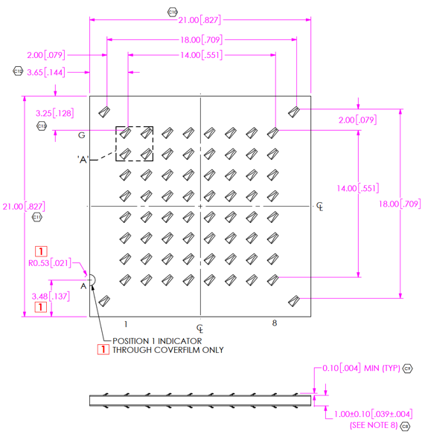

Figure A custom Samtec compression interposer with 8x8 signal pads and four ground pads.

The board itself then gets mounted to a 3D printed enclosure, and the whole assembly is then bolted to the dark box. Once this is done, the HRPPD will no longer be re-positioned with respect to the dark box , but rather the MCX adapters will be moved from quadrant to quadrant (requires ramping the HV off and on, and moving the grounding plates to a different quadrant). Light tightness is provided along the boundaries of the 3D printed enclosure (with respect to the dark box side and the 3D printed spacer, respectively).

# **Overall HRPPD characteristics**

This section is included in the document largely in order to confirm that the first five EIC HRPPDs are built to the EIC specifications, in general.

## Size, active area, pixellation

According to the actual design, a nominal size of the EIC HRPPD ceramic anode plates and fused silica windows is ~119.6mm x 119.6mm, with a 104mm x 104mm active area, pixelated into 32x32 square pads with a pitch of 3.25 mm on the inner side, for a ~75% active area fraction.

The actual extent of the high gain and high overall efficiency area will be determined during the respective surface scans close to the window edges.

The High Temperature Co-fired Ceramic (HTCC) base plate has a thickness of 2.90 mm. The side walls are 4.05 mm wide and the fused silica window is 5.00 mm thick. The full sensor thickness is 14.10 mm.

Two MCPs with 10 mm diameter and ~13 mm center-to-center distance pores are 600 mm thick, which follow the description in the Appendix to the PED contract, and are biased individually (a so called *gapped* configuration) in this HRPPD iteration.

The accuracy of the relative alignment between the anode base plate, the side walls and the window, which determine the actual sensor footprint, was not specified for the first five tiles. However, as agreed with the manufacturer, the tiles will be packaged (fit) in their individual thin walled enclosures for their use on a test stand (see Figure 4, center). The enclosures will have a square opening of 120.5mm x 120.5mm, which effectively defines the respective tolerance.

The nominal gaps between the photocathode and MCP#1, between the two MCPs and between MCP#2 and the anode plate in the stackup are ~1.10 mm, ~1.20 mm and ~2.50 mm, respectively.

## Connectivity

Several modifications to the original design were made during the first phase of the PED contract.

The high voltage interface inside of the tiles was changed to using stainless steel springs.

The rear side of the ceramic base plate has now six HV stainless steel pins with a diameter of 1.6 mm (1x photocathode, 2x2 MCP bias, 1x ground), brazed onto small circular spots, electrically connected to the HV “wiring” inside of the tile.

Contrary to the initial HRPPD design, the new EIC HRPPDs have a non-trivial trace routing between the inner and the outer pads of the anode ceramic base plate, see Figure 6. Traces are implemented in a so-called coplanar waveguide configuration, with 50 Ohm matching, similar to the design of the regular BNL readout boards of the capacitively coupled LAPPDs. As directly measured using a Fluke xxx DVM, trace resistivity does not exceed 1.5 Ohms (TBC), and a combined pad+trace capacitance does not exceed ?? pF, which are well within the limits defined by the EICROC ASIC design (TBC).

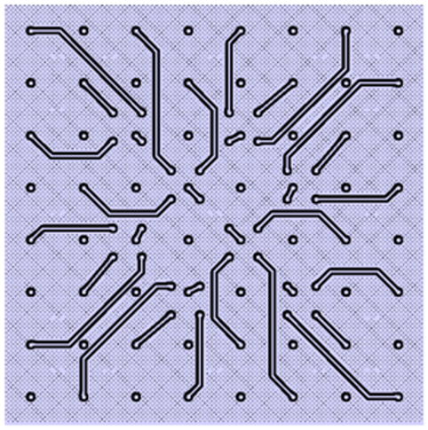

Figure Internal routing of the HRPPD ceramic anode plate. Only one half of the traces of a single 8x8 pad spot is shown.

Reducing the pad size on the outer side of the ceramic anode plate allowed one to have enough space for brazing small socket head screws (stainless steel in this iteration), used to mount the sensor onto the readout board assembly, as shown in Figure 4 (center).

The electrical interface to the readout backplane is provided via sixteen 64-pad Samtec compression interposers, see Figure 5.

# **Performance measurements on a test stand**

Although some of the proposed measurements can be performed simultaneously, in the following they are described separately, for the sake of clarity.

Scans, which require usage of V1742s for *amplitude* measurements only, will be performed on a grid matching the 3.25 mm HRPPD pad pitch, to minimize a sheer data volume. Only one of the 8x4 DRS4 chips will be read out at a time (the one which serves an illuminated pad), and only the first 136 out of 1024 samples of the wave form at 5 GS/s, containing a prompt peak will be written to disk. Under these circumstances, we will be recording ~2 kB per event at a rate of ~9 kHz. Assuming that a single pad does not require more than 105 events, for any practical purposes (including SPE data with ~95% “empty” events), and re-positioning of the stages and re-starting the DAQ takes no longer than 10 seconds, a full scan of a *single HRPPD quadrant* will take less than an hour, and the total data volume for the *whole set of 1024 HRPPD pads* will be ~200 GB, which does not pose any substantial challenge for either the local or remote (RACF @ BNL) storage. Processing of a single event takes at most ?? msec, for a total of ?? per scan.

*Timing* measurements (surface scans) using the V1742s, will require recording of a trigger waveform from the Elmo femtosecond laser photodiode as well, and will most likely mean recording of 512 samples because of the trigger latency (TBC), thus limiting the DAQ rate to ~5 kHz. Since these scans are not really needed with a high granularity, one may want to limit the data volume by scanning only a fraction of pixels (say on a grid of 2*3.25 mm).

Other measurements (like a QE uniformity scan at a fixed wavelength), where the V1742s are not involved, can be performed with a smaller step if needed.

## Gain uniformity

A typical scenario would be running with the PiLas laser at a ~10kHz external trigger rate, tuning the intensity down to a “single photon mode” (or adding appropriate ND filters), focusing light onto a small (few hundred mm diameter) spot in a scanned HRPPD pad center, and collecting ~105 events per pad with say ~95% of the events producing no detected photoelectrons (Poissonian distribution with <m> ~ 0.05). Gain saturation is not an issue in this mode. Information from the neighboring pixels is of no interest (but can be a topic of a limited scale separate study). The ratio of single photon events to the multi-photon ones is ~40:1 . ~5k “useful” events is sufficient to evaluate the MPV, perhaps without even folding in a multi-photon part of the distribution. With a proper DRS4 calibration, this allows one to evaluate the absolute gain. Also, for this measurement, the photon flux monitoring is not really needed.

One may want to perform such a scan for several combinations of the photocathode, bias, and transfer voltages, but a single measurement where HRPPD achieves a gain of ~106 should suffice.

Such a scan (perhaps at a 2.5 GS/s sampling rate though, see later) should also allow one to define thresholds per pixel for the DCR measurements.

## Spectral Quantum Efficiency

These measurements will be performed at five different locations on the HRPPD surface (a center and four corners), for a discrete set of wavelengths in the range from ~250nm to ~700nm.

An Oriel 77250/7340 monochromator / light source equipped with Xe and Hg lamps will be used. The wavelength setting of the monochromator grating can be automated or operated manually, with a step of 20-50 nm, depending on the wavelength (more points in the near UV range). When coupled into a UV-enhanced MM fiber with a 600 mm diameter core, this device produces a measurable current down to at least ~250 nm (see Figure 7), sufficient for the purposes of a primary HRPPD evaluation.

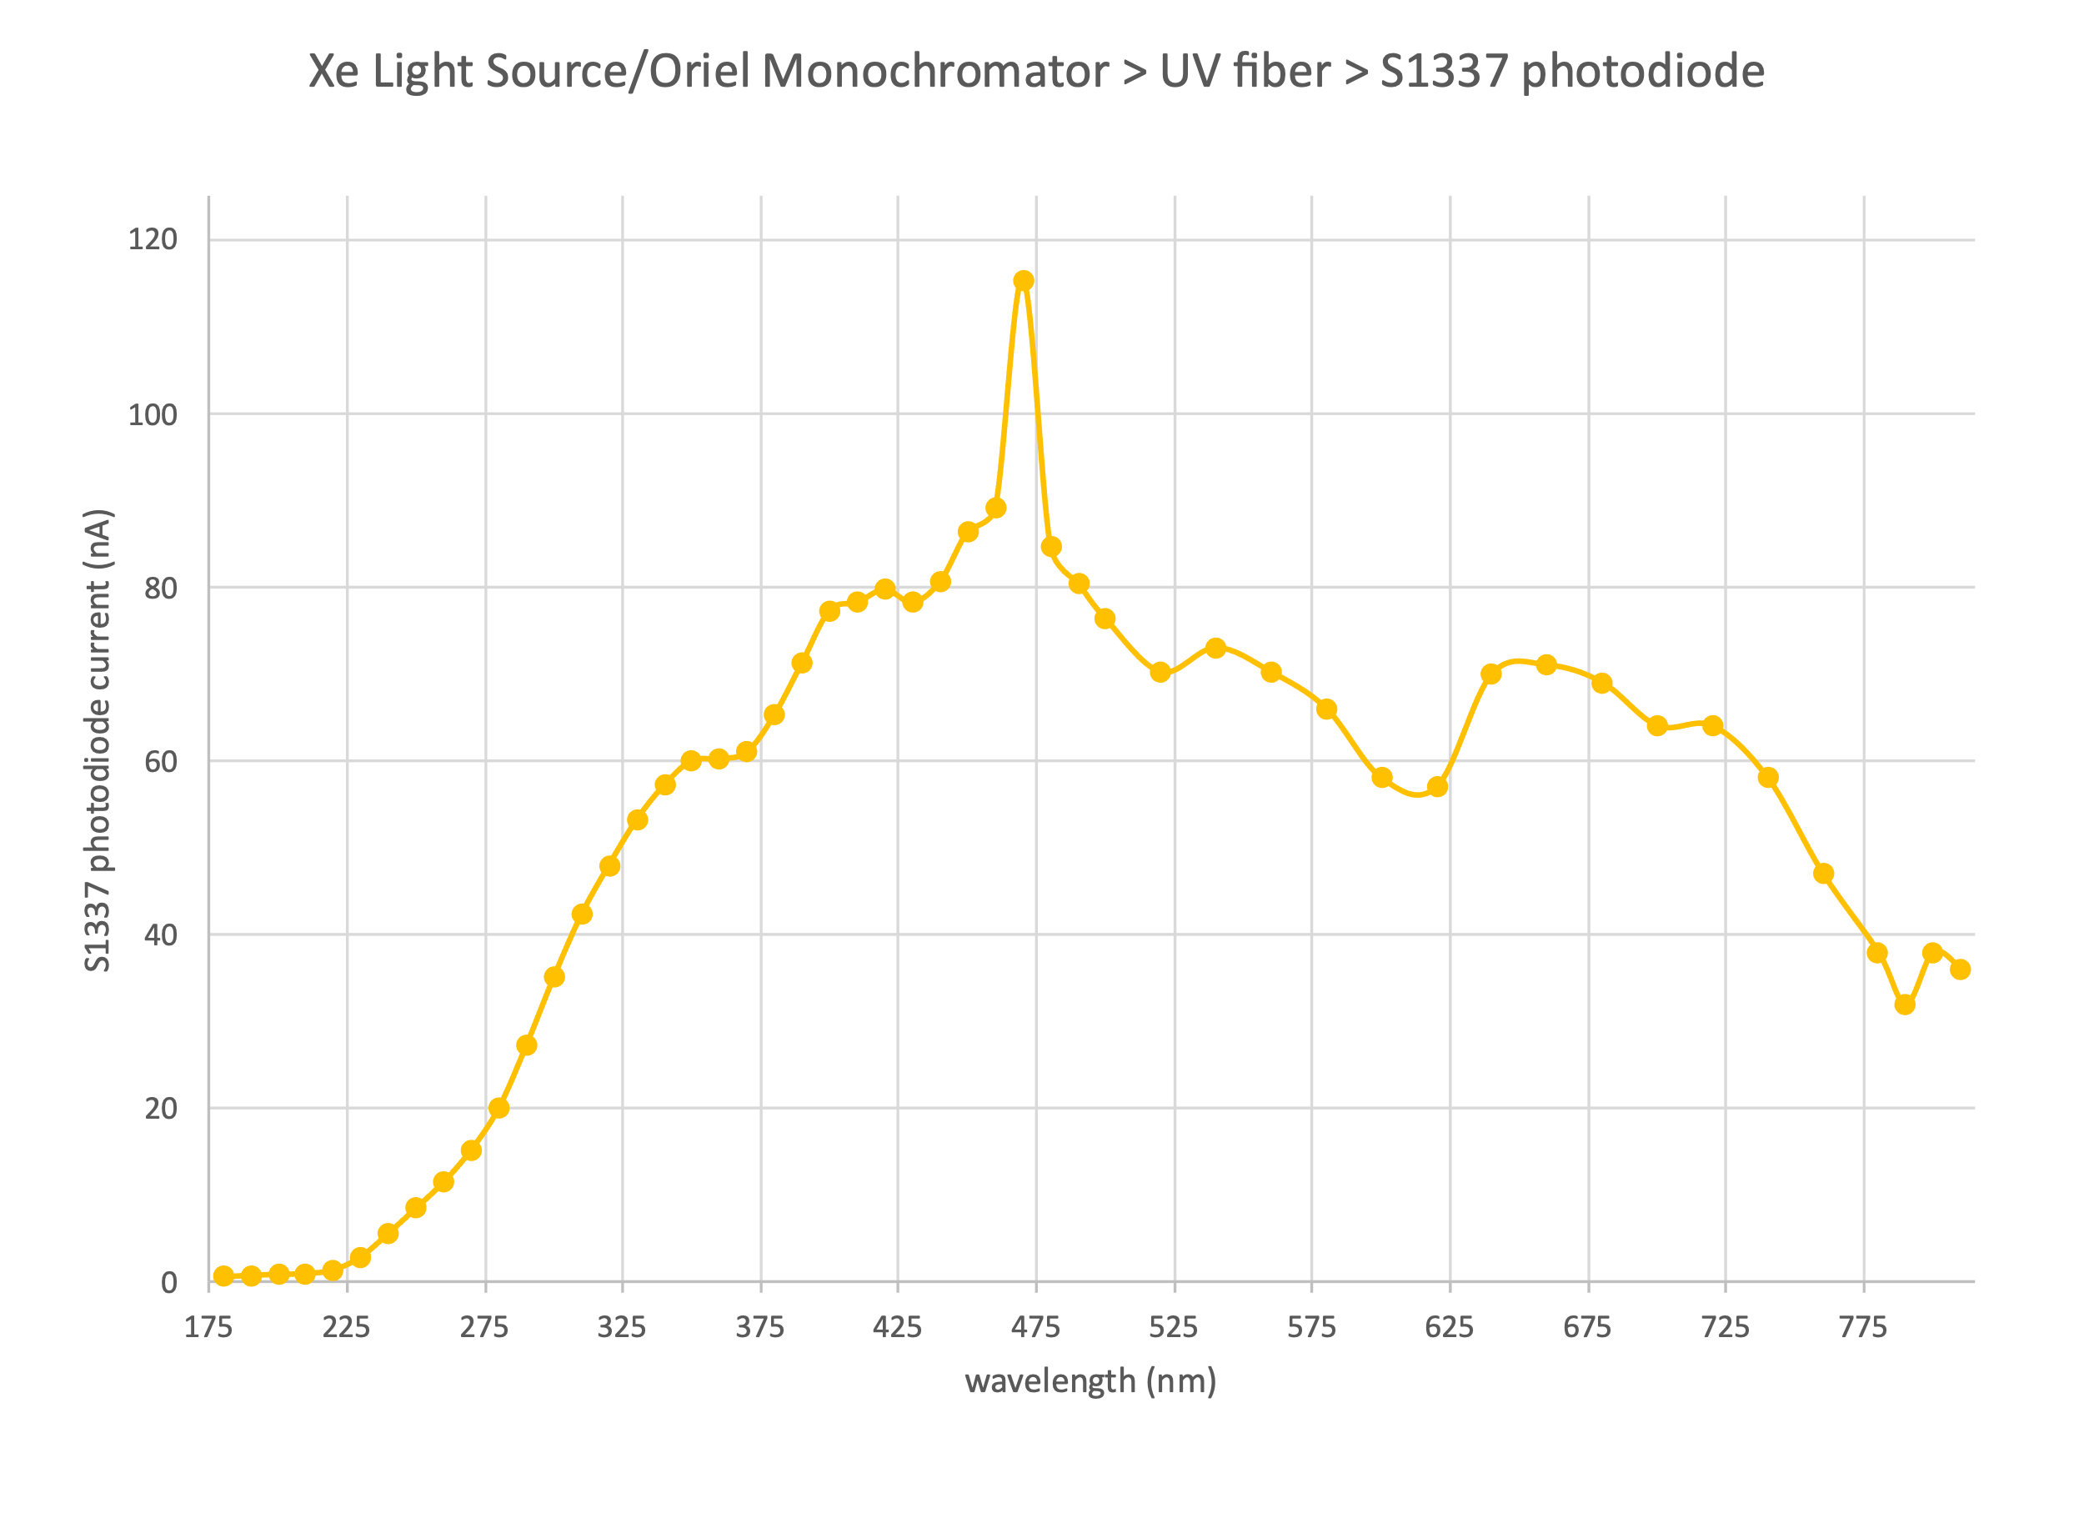

Figure A typical current produced by Oriel 77250/7340 monochromator with a Xenon lamp, in a configuration with both slits fully open (FWHM ~17 nm @ 500 nm).

Light will be split in a ~50:50 ratio by a Thorlabs BSW19 beam splitter installed in a focusing optics assembly inside of the HRPPD dark box, as shown in Figure 3. A splitting ratio as a function of wavelength should be cross-calibrated in advance by using a pair of Hamamatsu S6337-01 photodiodes (TBC), since it can vary substantially for a BSW19 beam splitter in the wavelength range of interest.

Light will be de-focused into a spot of ~3-5mm diameter on the HRPPD photocathode.

For the QE measurement, the top electrode of MCP#1 will be shortened to ground, and the photocathode set to 100-200V (negative). The light intensity and slit settings will be chosen later, perhaps different for different wavelength ranges, with the objective being to produce a current on the order of a few nA in both the Hamamatsu reference photodiode and the HRPPD. Since the HRPPD PDE is expected to be few times smaller than that of the Hamamatsu S6337-01, one can consider using an asymmetric splitter.

A pair of Keithley 6487 picoammeters will be used to measure the S6337-01 and HRPPD currents, and the ratio of their readings provides a measure of the HRPPD spectral QE. Automation is not really needed for these measurements.

## Quantum efficiency uniformity

This measurement will be performed at a (yet to be defined) number of fixed wavelength settings, by automating the XY translation stage re-positioning and the current reading procedure outlined in the previous section. A Keithley 6487 RS-232 and a Thorlabs TDC101 linear stage controller Linux drivers for RCDAQ exist. Granularity of these scans does not need to be synchronized with the HRPPD pitch, and a measurement grid can be 1-2mm if needed (though one may then want to decrease the light spot size).

## Photon Detection Efficiency uniformity

The measurement will be performed in a counting mode.

A 420 nm PiLas laser available at BNL does not allow triggering at frequencies above 1 MHz. In its present configuration (PiL040X head adjusted to a SM fiber), at this frequency, with a 0% tune (max intensity), it provides only ~3nW of power, as measured by Thorlabs xxx, which means a rather small expected current overall.

The measurement will therefore be performed using the 405 nm LED pulser box provided by Jefferson Lab. At its maximum external trigger frequency ~1 MHz, and a highest driver voltage of 30.0 V, the LED box produces a photon flux up to ~100 nW, as measured by the same Thorlabs device, being coupled to the sensor via a MM fiber with a ~300 mm core diameter. The single photon timing distribution has a width of ~800 ps RMS, which is sufficient for this type of measurements.

A flux of ~100 nW at the fiber end means ~50 nW as seen by a Hamamatsu S6337-01 photodiode after the beam splitter (be aware that BSW19 beam splitter has a nominal reflectance to transmission ratio of around 1:1 at 405 nm). A S6337-01 photodiode has a photosensitivity of ~0.2 A/W at 405 nm, therefore it will produce a current of an order of ~10 nA. This seems to be in the right ballpark for a Keithley 6487 picoammeter to provide a reliable reference measurement.

A similar ~50 nW flux would be seen after the beam splitter by the HRPPD itself. At a ~1 MHz frequency and 405 nm (~3.0 eV photon energy) this would mean ~105 photons per pulse. Assuming that the HRPPD peak PDE will not be more than ~20%, and a reliable evaluation of a Poissonian <m> in a single photon mode should be better performed with a ratio of “empty” and “non-empty” triggers of about 1:1, this probably means that the photon flux needs to be attenuated by a factor of ~2*104 or so by either using a pair of ND2 filters or by reducing the LED box driver voltage or both. The actual attenuation of each filter can be evaluated one by one, by using the same setup with a pair of S6337-01 photodiodes. The absolute normalization accuracy of this procedure is yet to be confirmed.

The rest of the scanning procedure is a matter of taking V1742 data with the LED light focused into a ~300 mm spot in the center of each pad (defined by a MM fiber core diameter), at the same ~9 kHz on tape rate evaluated earlier. Statistics of at most ~10k events per point should suffice.

## Timing resolution

According to the specifications, our new Elmo 780 femtosecond laser provides sharp low intensity pulses of less than 1 ps width at a 390 nm wavelength. It is also equipped with a fast photodiode, which provides a timing reference of a presumably a few ps accuracy. So far, we verified that in a single photon mode as seen by a Photonis FP-16 single anode MCP-PMT (signal leading edge ~180 ps), a timing difference between the Elmo photodiode and the FP-16 is ~10 ps RMS, where obviously a larger contribution is coming from the MCP-PMT itself.

An ultimate spot check evaluation of the HRPPD timing response (including the distribution tails up to 1-2 ns) under a variety of the MCP bias and photocathode voltages will be performed using the 8 GHz bandwidth 50 GS/s Tektronix scope, mentioned earlier. Contrary to a possible use of the PiLas picosecond laser, unfolding of the laser pulse distribution shape will not be required.

We are going to take V1742 data at 5 GS/s, around ~10k events per HRPPD pad, as routine surface scans. The Elmo laser photodiode signal will be used as a V1742 TR0/1 trigger (via a digital fan-out), but one can consider digitizing this waveform directly as well using an existing passive splitter.

## Dark Count Rate

Similar to the other measurements, this measurement can also be done in different ways.

Ultimately, one can take V1742 data on a pad-by-pad basis in a self-triggered mode, setting the threshold to say 0.2 single photoelectron response for this particular pad (as measured during the gain scans). Since V1742 self-triggering does not work at a 5 GS/s sampling rate, one should probably perform gain scans at 2.5 GS/s as well. A trigger count vs real time defines the DCR, which is supposed to be ~1-2 kHz / cm2, which is effectively the surface occupied by eight pads served by a single DRS4 chip. Since the DAQ is capable to take data at up to ~9 kHz, this procedure may work.

A different approach would be to take data for all 256 pads of a given quadrant at once, using a random trigger, and digitizing the waveforms at 1 GS/s (for a higher data taking efficiency), which means a ~1 ms timing window per waveform. Every pad is expected to have a DCR above threshold of a couple of hundred Hz (~10 mm2 surface area), meaning one such event with a measurable pulse out of every ten thousand triggers. A precise determination of this number on the bench is not really needed, but rather just an upper limit.

Other numbers of interest are as follows. An SPE pulse at a reasonable gain of few times 106 is around 50 mV in a 50 Ohm load (check!). A ~0.2 p.e. threshold level is therefore ~10 mV. This number should be compared to the pedestal RMS. Under quiet lab conditions with a low level of environmental noise, the pedestal width is dominated by the DRS4 ASIC intrinsic noise itself, which is ~0.35 mV as can be verified directly, after a thorough offset and gain calibration.

# **Resilience to the magnetic field**

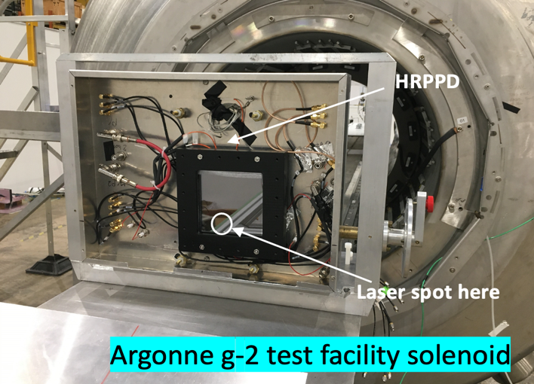

Figure HRPPD #6 ready to be inserted inside of the bore of the Argonne g-2 test facility solenoid.

These studies will be mostly performed at the Argonne g-2 test facility in summer 2024, with participation of ANL, BNL, JLab and USC physicists. The technique and equipment, successfully used for the evaluation of LAPPDs in 2021-2022, as well as the recent measurements with HRPPD#6 in February 2023, will be used (see Figure 8).

An existing Argonne dark box will be used as shown in Figure 8. A PiLas picosecond laser in a low intensity (a single photon mode) will be used as a light source. V1742 digitizer electronics and other elements of the DAQ system will be provided by Brookhaven.

The ultimate goal of the measurement program is to demonstrate the full recovery of the selected working conditions by tuning the HV settings, for a representative setting of the field strengths and field-to-normal orientations at the location of pfRICH and hpDIRC detector sensor planes, in a way such that the selected baseline performance at B=0T is fully restored. If a full restoration is not possible, we will have to quantify the implications. The representative field settings are:

* pfRICH: B = 1.4T, a = 100 – 130 to normal
* DIRC: B = 0.3T, a = 290 – 350 to normal

Parameters of interest, for a comparison between zero and non-zero B-field cases, are:

* Signal amplitude
* Width of the timing distribution (both central peak gaussian sigma and RMS of the whole distribution within a fixed range of a couple of ns) as defined by the leading edge fit or any other means and determined by a convolution of the sensor TTS and the laser timing jitter
* Width of the spatial distribution in X&Y at the pad boundaries (with expected collimation in case of a strong magnetic field)
* Dark Count Rate
* Relative efficiency (count of events where HRPPD had a visible pulse above a ~0.2 p.e. threshold with respect to the achieved gain, at a constant laser repetition rate)
* Ion feedback (afterpulsing)

It is important to verify that the “recovery HV settings” can be chosen to not only guarantee the performance *in the center* of the 104mm x 104mm HRPPD active area, but *in all corners at the same time*, since in particular the field *orientation* can vary by several degrees across the sensor surface.

A loss of the active area due to the Lorentz angle effect should be quantified for a selected set of the photocathode, MCP bias, and transfer voltages, as well as the respective systematic effects on the SPE position (and timing?) reconstruction.

Optionally, one should verify the performance in all four tile orientations with respect to the solenoid axis (00 , 900 , 1800 , 2700 ), as placed inside of the sheet metal box. The rationale is that the MCP plate pores are biased at 130 with respect to the sensor normal, and it would be beneficial to experimentally confirm the best orientation with respect to the magnetic field line direction in the experiment.

What do we want to write about the INFN Trieste / Genova B-field program here?

# **Ageing studies**

[taken verbatim from the eRD110 FY24 R&D proposal; do we need to write more?]

Ageing tests in terms of QE degradation and gain reduction versus the integrated extracted charge will be performed by INFN Trieste using a subset of techniques developed earlier at the University of Texas, Arlington [ref?].

A spot on the HRPPD photocathode will be illuminated using a sufficiently powerful light source. Periodically, typically every couple of days, the intense illumination will be paused, and a single photoelectron illumination mode will be used to measure both the gain and the detection rate. These periodic measurements, performed after increased integrated illumination, will allow us to disentangle a possible HRPPD degradation in two essential parameters: a photocathode QE and an MCP gain.

A required integrated photon flux will be estimated using the ePIC Monte-Carlo, assuming realistic luminosity, Deep-Inelastic Scattering (DIS) cross section and electron-beam-gas interaction rates, expected number of Cherenkov photons per charged particle track, as well as an expected conservative HRPPD gain of up to ∼ 106 to be used in the experiment.

# **Beam Test(s)**

[taken almost verbatim from the eRD110 FY24 R&D proposal; do we need to write more?]

A test beam campaign at either the Fermilab Test Beam Facility or at DESY in May-June 2024 will be aimed at establishing the timing performance of the EIC HRPPDs in a single-photon mode (for hpDIRC application) and in a multi-photon mode (for pfRICH application), see Figure 9.

Figure Schematic of the beam test setup in FTBF area MT6.2C, shown in a configuration with an aspheric lens radiator (S1 .. S2 – scintillating counters, G1 .. G4 – GEM tracker stations).

A pair of fast MCP-PMTs will be used as a timing reference.

A configuration with an aspheric lens as a Cherenkov light radiator will be used to generate dozens of easily identifiable coherent photons distributed along the circumference of a ∼76 mm diameter ring, in order to mimic HRPPD performance in a high hit density single photon mode for hpDIRC.

A signal from dozens of Cherenkov photons in a flash generated by a 120 GeV proton passing through the 5.0 mm thick fused silica window of the sensor will be used to evaluate the expected pfRICH HRPPD performance in providing a reference timing signal for other ePIC TOF subsystems. This configuration will also allow us to assess by how much small amplitude single photon pulses are disturbed by a large pulse from a Cherenkov photon flash generated by a charged particle in the sensor window.

We consider building a custom 512-channel DRS4 backplane for this beam test, instrumenting a fraction of 1024 HRPPD pads along the circumference of the ~76 mm diameter ring, as well as a small number of pads in the HRPPD center area, expected to detect a multi-photon flash.