**EIC Seminar: Dr. Zhoudunming (Kong) Tu**

Title: Capturing the Heart of Matter - An imaging program from RHIC to the Electron-Ion Collider

Wednesday, June 25, 2025 2:00PM (EST) 1005S 3rd Floor Seminar Room / ZoomGov

<https://bnl.zoomgov.com/j/1611302130?pwd=mtjpf18GASM8kYbjR0LDZ7HapzKYbT.1>

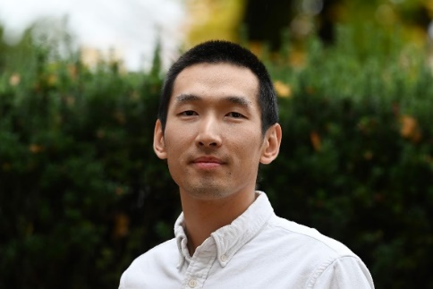

**About the speaker**

Dr. Zhoudunming (Kong) Tu is an Associate Scientist in the Physics Department at Brookhaven National Laboratory (BNL) and an Associate Adjunct Professor at Stony Brook University. As an experimental nuclear and particle physicist, he plays an active role in the exclusive physics program at the future Electron-Ion Collider (EIC), contributing to both the scientific goals and the development of the next-generation Cherenkov detector for the ePIC experiment. He is also involved in physics analyses within the STAR experiment at the Relativistic Heavy Ion Collider (RHIC). His research focuses on Quantum Chromodynamics (QCD), with a particular emphasis on color confinement—the mechanism that binds quarks and gluons within hadrons.

In addition to his experimental work, Dr. Tu is engaged in phenomenology, contributing to the emerging field of quantum information science in nuclear physics, including studies of quantum entanglement within the proton. He joined BNL as a Goldhaber Fellow in 2018 after completing his Ph.D. in heavy-ion physics on the CMS experiment at Rice University. Since 2021, he has served as a staff scientist in the Physics Department at BNL.

**Abstract:**

Understanding the fundamental structure of visible matter is a central goal of modern nuclear physics. At the heart of this effort is the imaging program at the future Electron-Ion Collider (EIC), which will provide unprecedented access to the internal landscape of protons, neutrons, and nuclei. In this talk, I will introduce the core concepts behind imaging and explain how the EIC will enable us to achieve the finest-scale pictures of nuclear matter, with profound implications for our understanding of Quantum Chromodynamics. I will also discuss the contributions and insights gained from current experiments at the Relativistic Heavy Ion Collider (RHIC), which have already advanced this effort through similar imaging techniques. Finally, I will highlight the key differences between the RHIC and EIC programs and explore the major advantages the EIC brings to this next frontier in nuclear science.