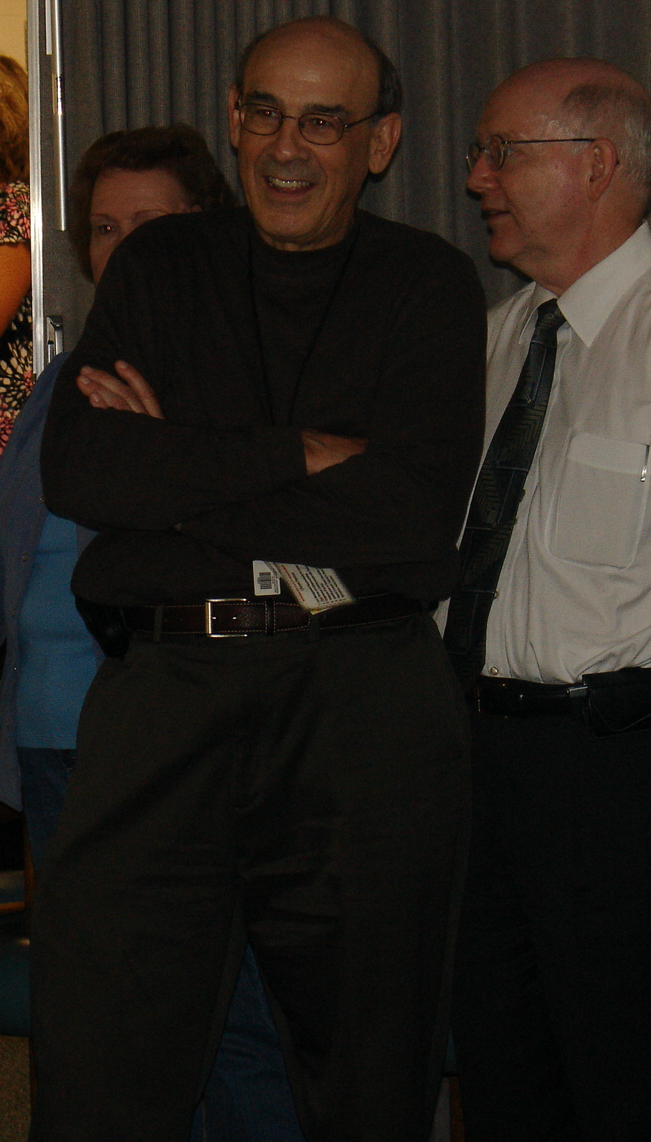
Please join Procurement as we wish Mark Waite a fond farewell and celebrate his long and outstanding career at Jefferson Lab.
WHEN: Thursday, May 10th, 2 to 4pm
Where: CEBAF Center 102/104
Refreshments will be served

