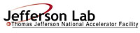 |  | TITLE: | ES&H Manual
DOCUMENT ID: | 6105 Office Safety

DRAFT
- Purpose

The purpose of this chapter and its associated appendices is to provide individuals with Jefferson Lab’s office safety requirements. Though not considered the most hazardous of environments, hazard issues do exist in an office setting and are to be addressed appropriately in order to ensure the safety and health of individuals, equipment and the environment.

This program satisfies applicable federal, state, and local requirements as outlined in ES&H Manual Chapter 2410 Appendix T1 Hazard Issues List.

- Scope

Because of the unique environment at Jefferson Lab, no two office environments are alike. If an area combines office space with other work, all hazard mitigation measures apply to all workers within the area. This chapter and its appendices provide mitigation requirements for the hazard issues associated with typical office work.

- Responsibilities
NOTE: Management authority may be delegated at the discretion of the responsible manager.

  - Everyone at Jefferson Lab
- Correct and/or report problems to someone who can resolve them. (Generally this would include submitting a Facilities Management Work Request.)
- Wear work attire appropriate for the area’s hazards. (See ES&H Manual Chapter 6620 Personal Protective Equipment (PPE) Program.)

  - Office Workers
- Be aware of the hazard issues associated with your work area.
- Follow manufacturer and product label recommendations.
- Enforce good housekeeping techniques.
- Make a request to your Supervisor/Subcontracting Officer’s Technical Representative/Sponsor for an ergonomic consultation if you have problems or concerns related to ergonomic conditions. (It is appropriate to request an ergonomics consultation for prevention, or as a matter of best practice.)

  - Supervisors/Subcontracting Officer’s Technical Representative (SOTR)/Sponsor
- Ensure that Office Workers are aware of the hazard issues within their area.
- Ensure training, medical monitoring, equipment, and PPE is made available to Office Workers in accordance with the requirements of the ES&H Manual.
- Contact Occupational Medicine to request an ergonomic consultation when necessary.
- Provide for reasonable equipment accommodations as recommended by the Jefferson Lab authorized ergonomic consultant.

  - Occupational Medicine
- Perform ergonomic consultations as requested in accordance with recognized industry standards.
- Recommend reasonable equipment accommodations to alleviate the more common health issues related to office work.
- Provide a copy of the consultation findings to the Supervisor/SOTR/Sponsor and the Office Worker.

- Expectations

  - Office Safety Requirements
Most office hazards are easily controlled by using common sense; following manufacturer and product label recommendations; and enforcing good housekeeping techniques. However, some hazard issues can only be controlled during day-to-day operations with the cooperation of the individuals involved. ES&H Manual Chapter 6105 Appendix T1 Office Safety Requirements (Link to be established upon approval of document.) outlines the process steps to be used to ensure office safety.

  - Office Ergonomics
Good ergonomics minimizes physical distractions and reduces the risk of injury. ES&H Manual Chapter 6105 Appendix T2 Office Ergonomics (Link to be established upon approval of document.) provides some universally applicable suggestions that may be helpful when setting up an ergonomically correct work station. Jefferson Lab believes that ergonomics-related injuries are a hazard issue and offers ergonomic consultations and reasonable equipment accommodations to alleviate some of the more common causes of injury related to office work.

- Revision Summary

Revision 1: Updated to reflect current laboratory operations.

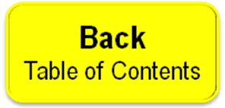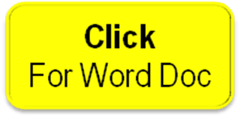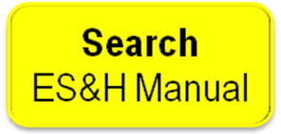

 | ISSUING AUTHORITY | TECHNICAL  POINT-OF-CONTACT | APPROVAL DATE | EFFECTIVE DATE | EXPIRATION DATE | REV.
 | ESH&Q Division | Smitty Chandler |  |  |  | 1
This document is controlled as an on line file. It may be printed but the print copy is not a controlled document. It is the user’s responsibility to ensure that the document is the same revision as the current on line file. This copy was printed on 7/28/2026.

