 |  | TITLE: | ES&H Manual
DOCUMENT ID: | 6132 Appendix T1  Ladders

DRAFT
- Purpose

There are two basic categories of ladders available for use at Jefferson Lab.
- Fixed ladders: these are permanently attached to buildings or other structures; and
- Portable ladders:
  - Step (self-supporting)
  - Extension
  - Mobile ladder stand
  - Mobile ladder stand platform

This appendix provides appropriate actions for inspection, set-up, and storage of all ladders available at Jefferson Lab.

- Scope

Actions not presented in this appendix are to be reviewed and approved by the worker’s supervisor prior to implementation.

Portable ladders are used for temporary operations. If regular access is required, a fixed ladder shall be installed. Submit a Facilities Management Service Request and see ES&H Manual Chapter 3110 Facility Design and Modification Review for selection, material, and installation requirements.

Jefferson Lab only authorizes the use of ANSI Type I (heavy duty – 250 pounds) ladders (or greater).

All ladders and are to meet the following current ANSI standard as applicable:
- ANSI A14.2 – Portable Metal Ladders
- ANSI 14.3 – Fixed Ladders
- ANSI 14.5 – Portable Reinforced Ladders
- ANSI 14.7 – Mobile Ladder Stands and Mobile Ladder Stand Platforms

Jefferson Lab does not authorize the use of step stools (or any other portable, non-motorized, equipment). See ES&H Manual Chapter 2410 Appendix T1 Hazard Issues List for other applicable federal, state, and local requirements.

The process steps of this document are performed in coordination with ES&H Manual Chapter 6132 Ladder and Scaffold Safety.

- Responsibilities
NOTE: Management authority may be delegated at the discretion of the responsible manager.

  - Ladder Workers
- Notify your supervisor if you have any health or physical condition that would affect your safety when working at an elevated height.
- Request guidance from your supervisor for equipment with which you are unfamiliar.
- Complete SAF 307 Ladder Safety training before using a ladder.
- Inspect, set-up, use, and store ladders in accordance with manufacturer’s instructions and Jefferson Lab’s requirements.
- If repair/maintenance is necessary tag the ladder out of service and contact your ESH&Q Liaison or your Safety Warden.

  - ESH&Q Liaison/Safety Wardens
- Inspect fixed and portable ladders in your area of responsibility during routine safety observations /monthly inspections.
- Facilitate repairs/maintenance as required/requested.

  - Supervisor/Subcontracting Officer’s Technical Representative (SOTR)
- Only purchase and authorize the use of ladders that meet or exceed ANSI Type I (heavy duty – 250 pounds) ladders (or greater).
- Ensure ladders are inspected, set-up, used, and stored in accordance with manufacturer’s and Jefferson Lab’s requirements.
- Ensure only those who are appropriately trained and qualified are assigned to use a ladder. (Provide appropriate training to those requesting assistance.)

  - Industrial Safety
- Provide ladder training.
- Serve as the technical point of contact for ladders.

- Process Steps

Unless otherwise stated, anyone at Jefferson Lab may perform the process steps outlined below.

  - Inspection:

    - Fixed Ladders Inspection Procedure: Performed prior to use, daily if in continual use and monthly during Safety Warden Inspections.

- Inspect the following items:
- Wall anchors are secure.
- Rung friction surface, tape, or paint, is in good condition.
- Minimum 7-inch clearance in back to provide adequate toe space.
- Clearance of 15-inches on each side of the center line, unless cages or well guards are in place.
- If there is a swing gate, chain, cage, or well guard; ensure it is secure.
- Side rails extend 3-1/2 feet above landings.
- A cage for ladders over 20 feet in length.
- A landing platform every 50 feet.
- Rungs are rigid, parallel, level, and uniformly spaced.

- If the answer to any of the above is “No” – do not use the ladder.
- Tag the ladder out in accordance with ES&H Manual 6111 Administrative Control using Locks and Tags.
- Contact your ESH&Q Liaison or your Safety Warden to facilitate repairs.
- When the ladder has been confirmed to have been repaired, the tag may be removed and work may continue.

    - Portable Ladders

      - Duty Ratings – Refer to the Identification Label on the ladder. If the label is missing contact your ESH&Q Liaison a replacement. (See the Figure 1 – Typical Marking Scheme)


Figure 1 – Typical Marking Scheme

A ladder’s “Duty Rating” is defined as the maximum safe gross load capacity of a ladder. A person’s weight – fully clothed, plus the weight of any tools and materials that are carried onto the ladder must be less than the “Duty Rating” of the ladder. {so we are not inserting the duting rating table here?}

    - Portable Ladder Inspection Procedure- Performed prior to use, daily if in continual use, and monthly during Safety Warden Inspections.

Step Ladder:  - Label is in place and legible.  - Spreaders/hinges are straight and in good working order. (Folding support brackets are securely mounted to the ladder’s side rails.)  - Rungs are secure with no play, or damage.  - Anti-skid shoes/feet and surfaces are intact and undamaged.  - No cracks or structural deficiencies present. | 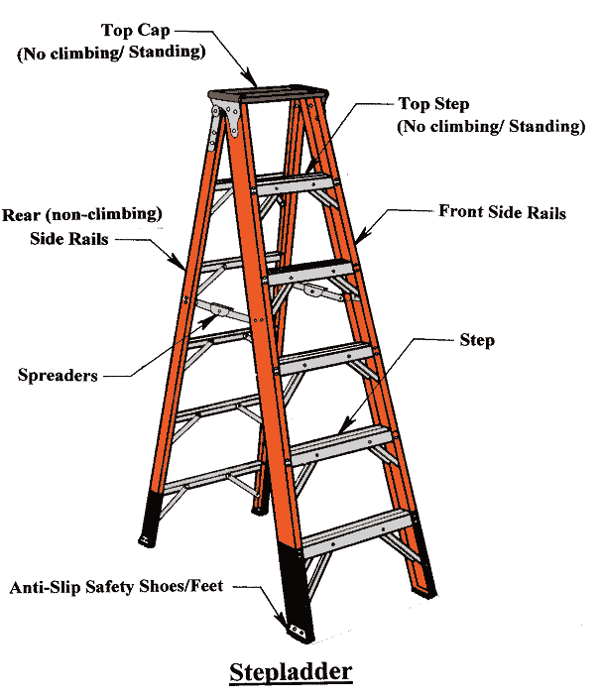

Extension Ladder:  - Perform any manufacture recommended inspection procedures.  - Ladder labeling is intact and legible.  - Rungs are secure with no play, or damage  - Rung locks swivel and grab properly.  - Rope and pulley system is in good repair.  - Anti-skid shoes/feet pivot properly and have rubber shoe in place.  - No cracks or structural deficiencies present. | 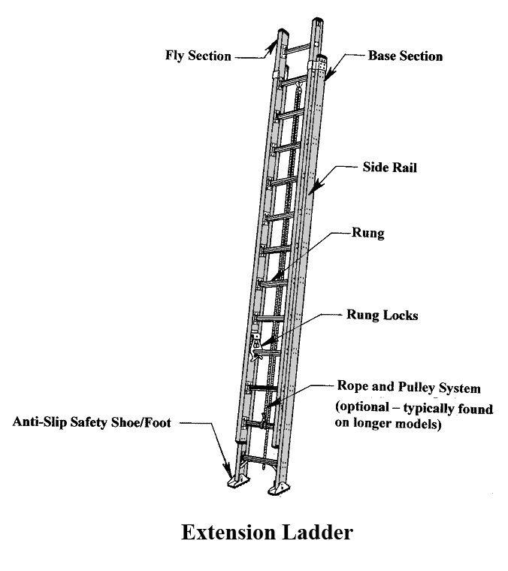

Mobil Ladder Stand and Mobil Ladder Stand Platform:  - Perform any manufacture recommended inspection procedures.  - All components are free from damage and unusual wear, deterioration, or corrosion. If necessary tighten loose bolts, nuts, or connections; and secure with locking hardware.  - All exposed surfaces are free from sharp edges and burrs.  - Steps and platforms are clear of debris.  - Rubber foot pads are free of wear and tear; and, when under load prevent horizontal movement.  - Wheels or casters lock when under load in a manner sufficient to prevent horizontal movement.  - Non-locking wheels or casters vertically retract when under load allowing the feet to make contact with the ground to prevent horizontal movement. | 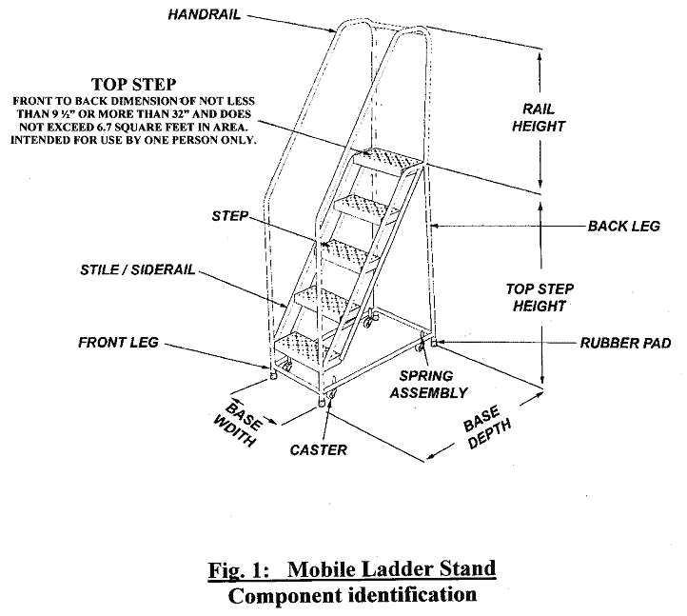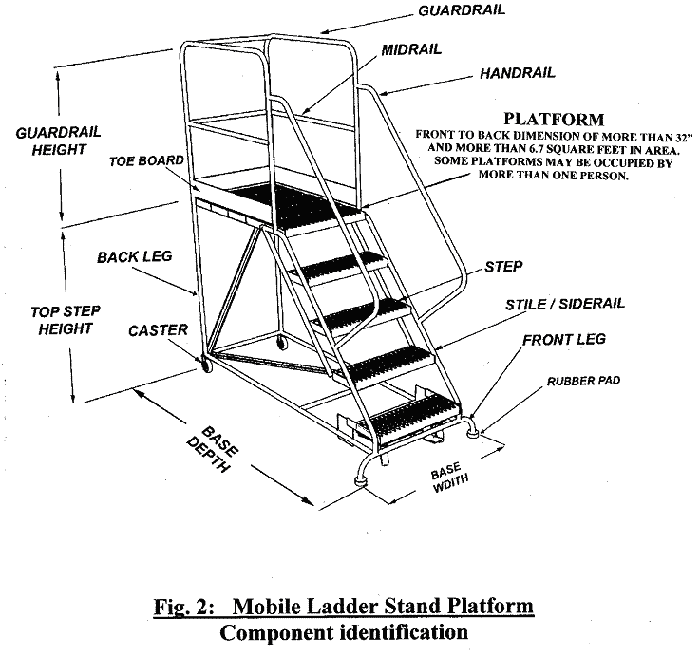

- If the answer to any of the above is “No” – do not use the ladder.
- Tag the ladder out of service.
- Contact your ESH&Q Liaison if repairs or disposal is required.
- When the ladder has been confirmed to have been repaired the tag may be removed and work can continue.

  - Setup

    - Step Ladder:
- Ensure you can access the work from no higher than two steps from the top of the ladder. (Step ladders, four feet or less in height, may be designed for standing closer to the top. Refer to the manufacturer instructions.)
- Fully expand, and lock supports prior to use. (Do not use folded or propped up against a vertical surface.)
- Use on a level surface, free of debris or obstacles

    - Extension Ladder:
- Ensure the ladder is 7 to 10 feet longer than the highest support or contact point (wall or roof line). This allows for:
    - enough length for proper setup,
    - overlap of ladder sections,
    - height restrictions of the highest standing level, and
    - where appropriate, the extension of the ladder to be above the roof line.
- Place the base a distance from the vertical wall equal to one-fourth the working length of the ladder plus the horizontal distance of the overhang (eve). (Refer Figure 2 – Extension Ladder Setup Diagram;).
- Ensure that the ladder extends at least three feet beyond the point of support (roof line).
- Tie the ladder off, or otherwise secure it in place. (A second person, or other security measure, is needed to brace the ladder at the base until it can be secured at the top.)

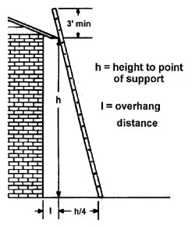
Figure 2 – Extension Ladder Setup Diagram

Height to Gutter or Top Support Point | Ladder Height | Maximum Reach
9' max. | 16' | 15'
9' to 13' | 20' | 19'
13' to 17' | 24' | 23'
17' to 21' | 28' | 27'
21' to 25' | 32' | 31'
25' to 28' | 36' | 34'
28' to 31' | 40' | 37'
Table 1 – Extension ladder setup

    - Mobile Ladder Stands and Mobile Ladder Stand Platforms:
- Mobile Ladder Stand Platforms may be used up to the top most level.
- Ensure the maximum work level height is no more than four times the smallest dimension of the base (if necessary use outriggers).
- Use on a level surface, free of debris or obstacles.
- Ensure all lockable wheels and casters are properly secured to prevent movement.

  - Use

    - All Ladders:
- Only one person on a ladder at a time (except for specially constructed, double-sided, step ladders or mobile ladder stand platforms).
- Face the ladder when ascending or descending (exception: when the slope of the steps on a fixed ladder or mobile ladder stand or platform, is 50 degrees or less above the horizontal.
- Maintain three-points of contact when moving up or down a ladder.
- Use a tool belt or handline to raise or lower equipment or tools.
- Place the ladder close to the work. Do not lean out/over the ladder rails (keep belt buckle area inside the rails).
- Use ladders made from fiberglass or wood if working near electrical hazards.
- Do not exceed the ladder load rating.
- Do not set-up in front of a door unless the door is:
  - Secured in an open position,
  - Closed and locked,
  - Attended or
  - Barricaded.

    - Portable Ladders:
- The highest point of use is two steps down from the top unless otherwise indicated on the ladder’s Identification Label (i.e.: the “Highest Standing Level).

    - Extension Ladder:
- A safety spotter is required until the top of the ladder is securely tied or attached to the structure.
- The highest standing level is four rungs down from the top.

    - Mobile Ladder Stands and Mobile Ladder Stands Platforms:
- Secure all lockable wheels and casters before ascending the ladder.
- Do not move if occupied.
- Do not store materials or equipment on the steps or platform of a unit.
- Do not add any type of extension or object to obtain additional height .
- Only step on steps or platforms.
- Access to or egress from any step or platform from any other elevated surface is prohibited unless the unit has been positively secured against movement.

  - Storage

    - Fixed Ladders: secure swing gate, chain, cage, or well guard.

    - Portable Ladders: Store out of the elements, upright if possible, and secured to prevent tip-over.

- Revision Summary

Revision 2 – _______ – Only ANSI Type I (heavy duty – 250 pounds) ladders (or greater) are authorized for use.
Revision 1 – 06/07/10 – Updated to reflect current laboratory operations.



 | ISSUING AUTHORITY | TECHNICAL  POINT-OF-CONTACT | APPROVAL DATE | EFFECTIVE DATE | EXPIRATION DATE | REV.
 | ESH&Q Division | Ned Walker | 06/07/10 | 06/07/10 | 06/07/15 | 2
This document is controlled as an on line file. It may be printed but the print copy is not a controlled document. It is the user’s responsibility to ensure that the document is the same revision as the current on line file. This copy was printed on 7/29/2026.

