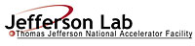 |  | TITLE: | ES&H Manual
DOCUMENT ID: | 6122 Appendix T3  Inspection of Welding and Cutting Equipment

DRAFT
- Purpose

Annual inspections of welding and cutting equipment are required to ensure it is kept in good operating condition. This document outlines the responsibilities and process steps established by Jefferson Lab to ensure compliance with this requirement.

- Scope

Only currently inspected welding equipment is approved for use at Jefferson Lab.

As of February 2011, Jefferson Lab did not have the certifications required to perform its own annual inspections on welding or cutting equipment. This document outlines the process steps to obtain a qualified outside vendor to perform this service.

The process steps for this procedure are performed in coordination with ES&H Manual Chapter 6122 Hot Work (i.e. Welding, Cutting, Brazing, and Grinding) Safety Program (Link to be established upon approval of document.)

- Responsibilities
NOTE: Management authority may be delegated at the discretion of the responsible manager.

  - Qualified Hot Work Operator
- Prior to use, check equipment’s inspection sticker. If expired:
  - Do not use, and
  - Notify equipment owner.

3.2 Equipment Owner
- Ensure equipment is inspected annually (at a minimum) and maintained in accordance with the Operator’s Manual and Jefferson Lab requirements.

- Process Steps

Unless otherwise stated, the Equipment Owner performs the process steps outlined below.

  - Annual Inspections

- Tag Equipment Out
If equipment is found to need inspection – the Equipment Owner tags it “Out” in accordance with ES&H Manual Chapter 6110 Appendix T1 Lock, Tag, Try Procedure.

- Requisition Vendor
Equipment Owner requisitions inspection services through the Jefferson Lab authorized requisitioning system (Maximo).

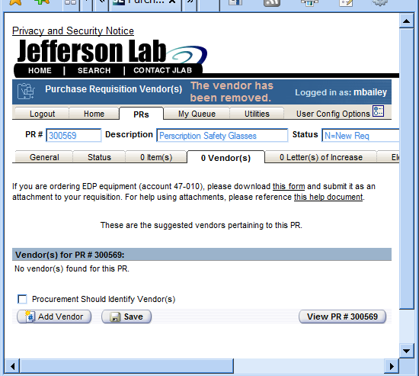 | Use “Procurement Should Identify Vendor” to ensure Vendor is qualified to perform the service requested.

- Schedule the Inspection
Once a vendor has been assigned the Equipment Owner ensures they are scheduled to provide services with the least possible impact on operations.

- Inspection Results
Vendor provides inspection results to the Equipment Owner.

IF:

Acceptable: Service provider applies appropriate sticker to equipment. Sticker includes both the inspection and expiration date.

Example Inspection Sticker:
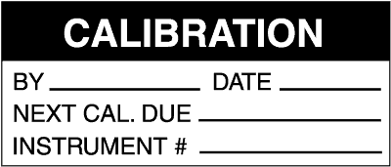

OR

Rejected: Equipment Owner ensures deficiencies are rectified by a certified repair person. (Go back to Step 1: Tag Equipment Out)

- Approve Equipment for Use
Equipment Owner approves equipment for use and removes tag-out device.

- Documentation
Equipment Owner retains inspection records in accordance with department procedures.

- Revision Summary

Revision 1 - ___________ - Updated to reflect current laboratory operations.

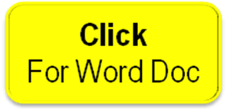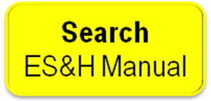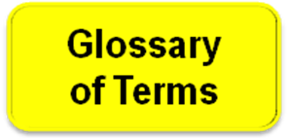

 | ISSUING AUTHORITY | TECHNICAL  POINT-OF-CONTACT | APPROVAL DATE | EFFECTIVE DATE | EXPIRATION DATE | REV.
 | ESH&Q Division | Mike Martin
This document is controlled as an on-line file. It may be printed but the print copy is not a controlled document. It is the user’s responsibility to ensure that the document is the same revision as the current on line file. This copy was printed on 7/28/2026.

