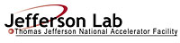 |  | TITLE: | ES&H Manual
DOCUMENT ID: | 6122 Appendix T4  Hot Work Area Posting Requirements

DRAFT
- Purpose

Jefferson Lab recognizes that hot work is inherently dangerous. It is therefore required that designated areas and associated equipment be labeled to provide warning of potential hazards. This appendix defines Jefferson Lab’s labeling and posting requirements; and how to update, repair, and maintain these labels.

NOTE: When secondary hazards are identified, such as high noise, these postings are supplemental to the Hot Work Area Signage.

- Scope

The process steps for this procedure are performed in coordination with ES&H Manual Chapter 6122 Hot Work (i.e. Welding, Cutting, Brazing, and Grinding) Safety Program (Link to be established upon approval of document.)

- Responsibilities
NOTE: Management authority may be delegated at the discretion of the responsible manager.

  - Qualified Hot Work Operator
- Request an equipment/area hazard evaluation from Industrial Hygiene if compliance with these requirements is unclear.

  - Industrial Hygiene
- Perform equipment/area hazard evaluation and provide postings as appropriate.

  - Supervisor/Subcontracting Officer’s Technical Representative (SOTR)/Sponsor
- Ensure that warning labels are posted in accordance with requirements.

- Process Steps

  - Equipment Labeling

    - Manufacturer’s Labels
Do not remove manufacturers’ equipment label(s). Contact the manufacture if labels are missing or damaged. Read and follow manufacturer’s warnings.

    - Equipment Inspection Label
Jefferson Lab requires annual inspection of welding and cutting equipment by a certified inspector, and that equipment be readily identifiable as being in compliance. See ES&H Manual Chapter 6122 Appendix T3 Equipment Inspection Procedure (Link to be established upon approval of document)

Example Inspection Sticker:
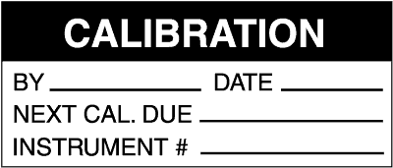

  - Area Posting Requirements

    - Hot Work Areas – All hot work is performed within designated limits. The safe distance is determined during the hazard evaluation and will be denoted on the Hot Work Permit or other work control document. At a minimum hazard cones, rope, and require signage are used to keep unauthorized individuals away.

Examples of Required Signage for Welding Areas
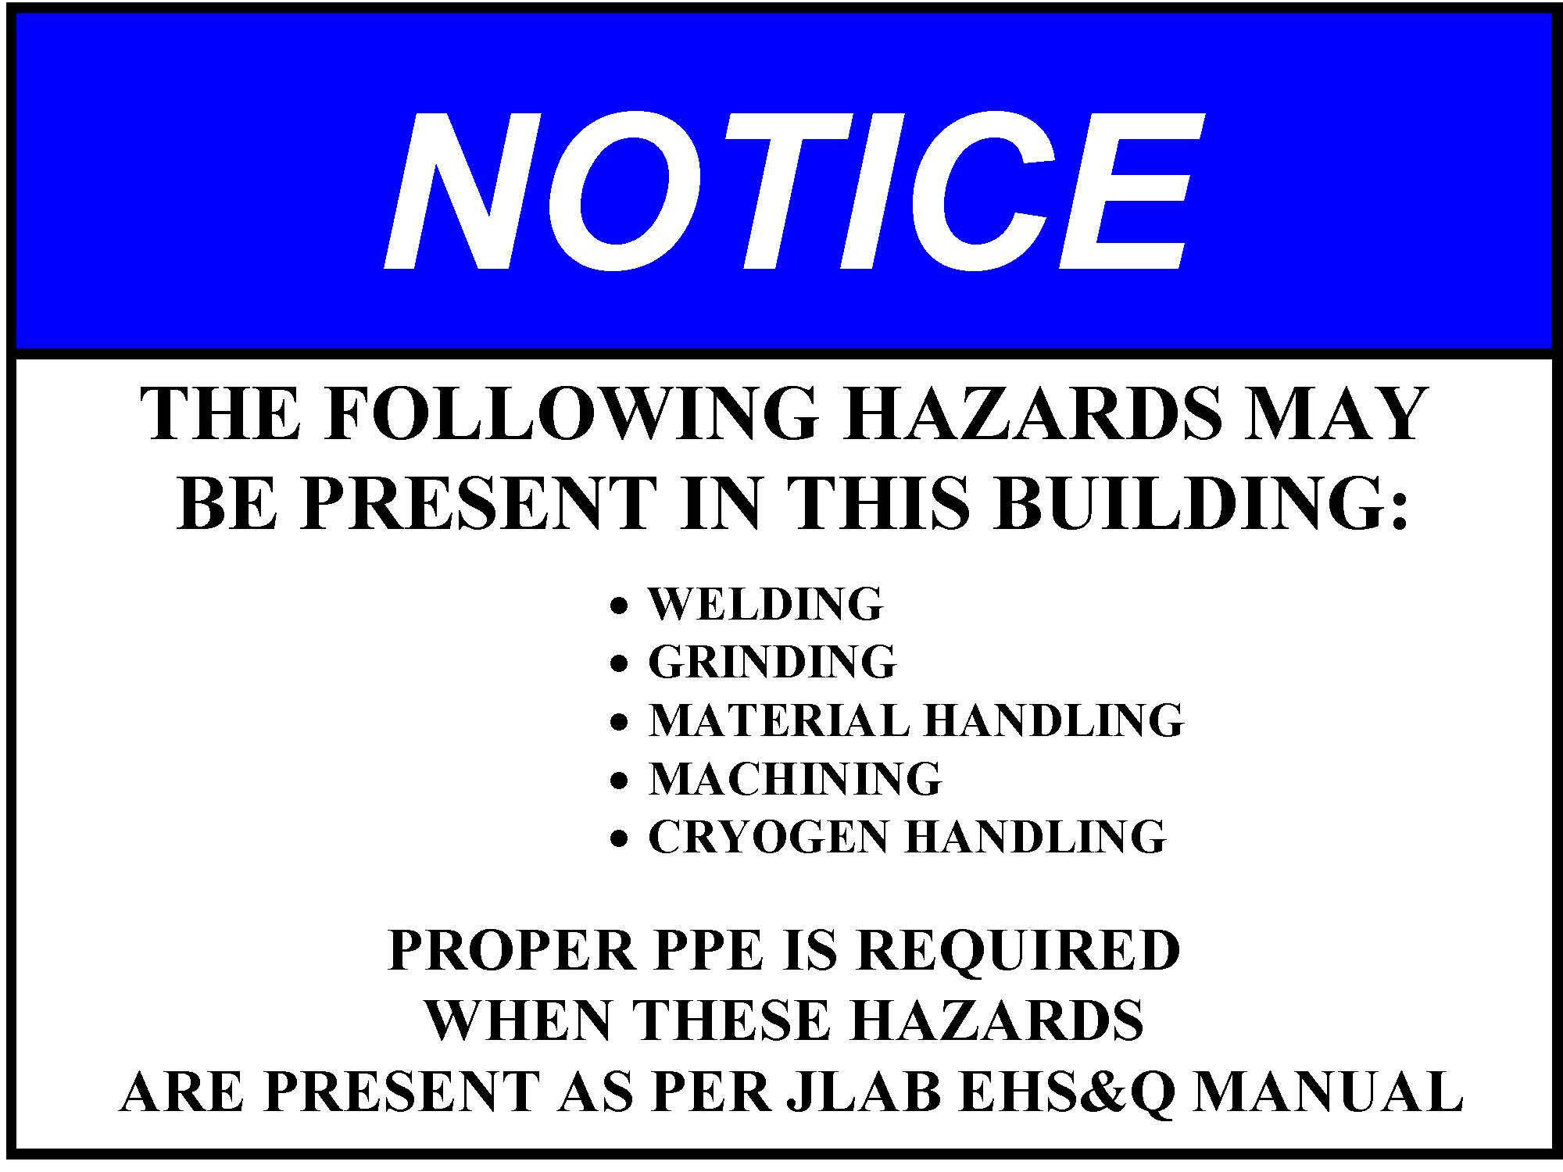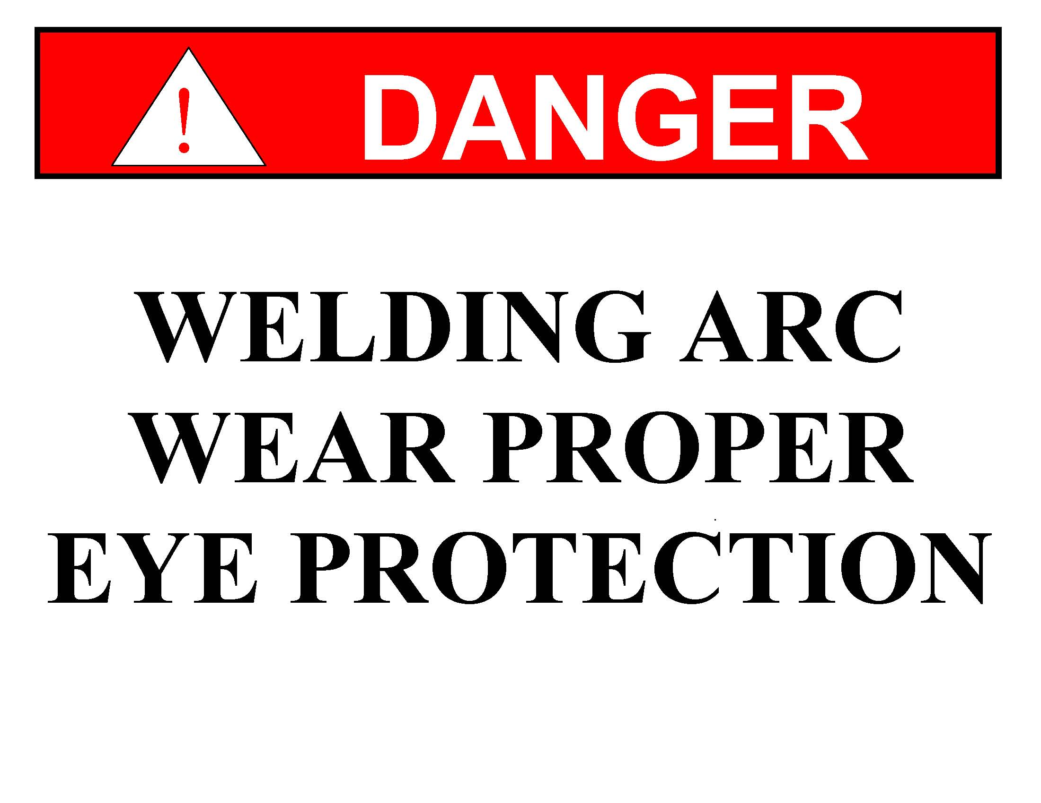

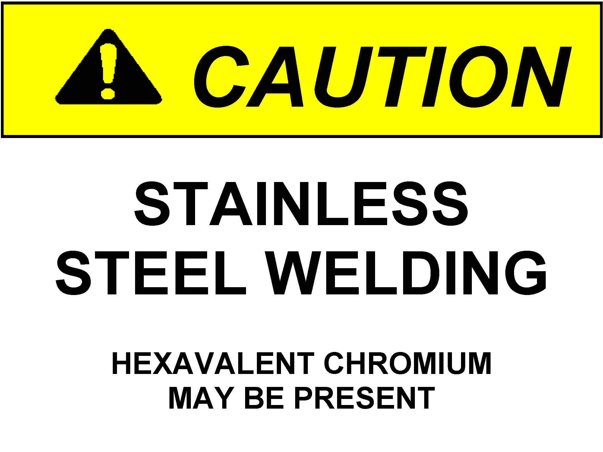

  - Update, Repair, or Maintenance to Labels
Anyone at Jefferson Lab may request new, update, repair, or maintenance to a hazard posting.

- Contact Industrial Hygiene and state the posting needing review.
  - If it is determined that the posting is defective, Industrial Hygiene will rectify the situation.
  - If posting is adequate – Industrial Hygiene informs the concerned party(s) of the determination.

- Revision Summary

Revision 1 – ______– Updated to reflect current laboratory operations.

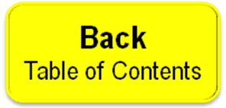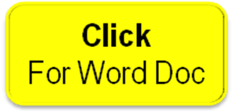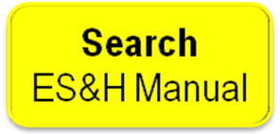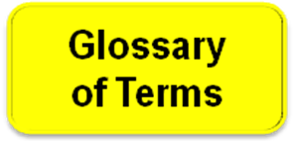

 | ISSUING AUTHORITY | TECHNICAL  POINT-OF-CONTACT | APPROVAL DATE | EFFECTIVE DATE | EXPIRATION DATE | REV.
 | ESH&Q Division | Mike Martin
This document is controlled as an on-line file. It may be printed but the print copy is not a controlled document. It is the user’s responsibility to ensure that the document is the same revision as the current on line file. This copy was printed on 7/30/2026.

