 | Oxygen Deficiency (ODH) Safety Review Form  (See ES&H Manual Chapter 6540 Appendix T1 ODH Safety Review for instructions)

PART 1 - PRELIMINARY ANALYSIS:
- INTRODUCTION
Task Title: |  |  |  |  |  |  | Task # (If applicable)
Location: Bldg/Room/Area |  |  |  |  | Effective Date: |  |  | Expiration Date:  (Not to exceed three years.)
Author/  Lead Worker: |  |  |  | Division: |  |  |  | Department:

- PRELIMINARY INFORMATION |  |  |  |  | √ if YES
Gas to be Introduced:  (List Name(s) and Concentration(s)) |  |  |  | Flammable
 |  |  |  | Corrosive
Is gas self-contained?  (In a Dewar or similar?) | Yes | No | Size | Toxic
Is gas self-contained?  (In a Dewar or similar?) |  |  |  | Other
Attach copies of any related “Oxygen Deficiency Hazard Risk Assessments” for the area, and any additional supporting documents/calculations.

ATTACH A ROOM FLOOR PLAN (Show location of ODH):

- PRELIMINARY ODH Calculation:
Source Inside Proposed ODH Area  (e.g. dewar, tank, etc.) |  |  |  | OR |  | Source outside Proposed ODH Area  (e.g. from a compressor, pump, etc.)
Total volume of room: | V_{R} (ft³) = |  |  |  |  |  | Total volume of room: | V_{R} (ft³) =
Volume of gas at room temperature and pressure | V_{G} (ft³) = |  |  |  |  |  | Volumetric flow rate of gas into room at room temperature and pressure  (Contact Engineering) | Q = (ft³/hour) =
21(V_{R} – V_{G})  V_{R} | = |  |  |  |  |  | 21(V_{R} – Q) *  V_{R} | =
* Assuming minimum one fresh air change per hour (ACH). If more than one ACH is needed additional review may be required.
If Resulting % Oxygen is: | Then:
>19.5 | Submit form to ODH Safety.
<19.5 | Continue to Part Two – Additional Information.

The above referenced hazard has been determined to be: ( ODH Safety to designate ODH designation)
ODH Classification Determination
(See ES&H Manual Chapter 6450 Appendix T2 ODH Hazard Classifications, Engineering and Administrative Control Practices, Training, and Medical Exclusions
ODH 0  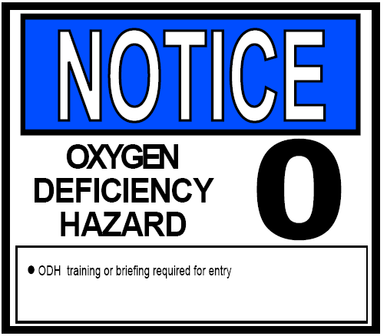  Estimated fatality rate:  > 10 million hours | ODH 1  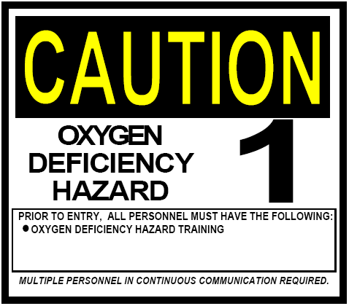  Estimated fatality rate:  100,000 to 10 million hours | ODH 2  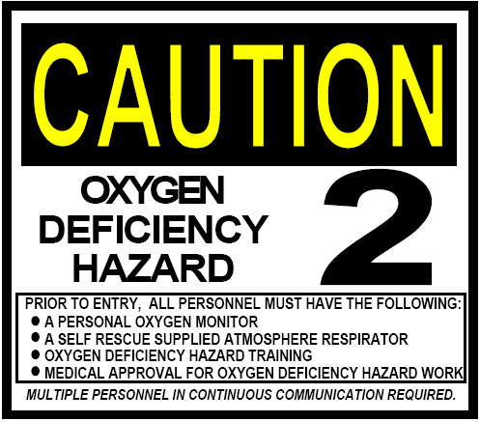  Estimated fatality rate:  From 1,000 to 100,000 hours | ODH 3  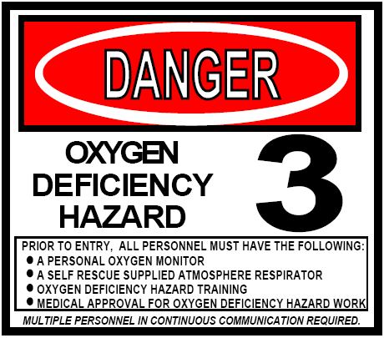  Estimated fatality rate:  From 10 to 1,000 hours | ODH 4  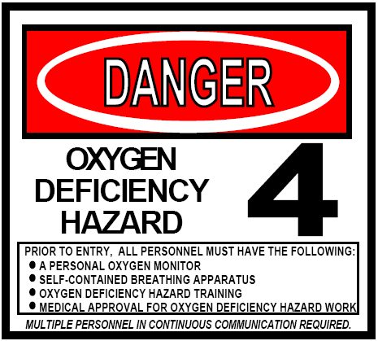  Estimated fatality rate:  Less than 10 hours

APPROVALS
 |  |  |  |  |  |  |  | Print Signature |  |  |  |  |  |  |  | Date:
ODH Safety
Additional Approvals per Department Procedures
 | Department or Group Head:
 | Division Safety Officer:
 | Other:
 | Other:
Review per Department Procedures
 |  |  |  |  |  |  | Print Signature |  |  |  |  |  |  | Date
 | Area Safety Warden:
 | Other:

PART TWO – ADDITIONAL INFORMATION:
- Engineering and Administrative Controls (be as specific as possible, provide existing and planned)
Engineering Controls:
Example: Fume hoods, critical orifice, etc.
Administrative Controls:
including, but not limited to:
(list names, types, and document numbers)
- Training Required
- Standard Protecting Measures
- Work Control Documents
Attachments - list all that apply:
(e.g.: Confirmation Communications, Risk Assessment, Task Hazard Analysis etc)
Submit: Completed form to ODH Safety for review and approval
After Approval Distribution:
Original: Document Author; Copies: affected area, all approvers, all reviewers, and ESH&Q Document Control.
 | ISSUING AUTHORITY | FORM TECHNICAL  POINT-OF-CONTACT | APPROVAL DATE | EFFECTIVE DATE | EXPIRATION DATE | REV.
 | ESH&Q Division | Dick Owen

