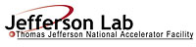 |  | TITLE: | ES&H Manual
DOCUMENT ID: | 4100 Safety Skill and Communication Requirements

DRAFT

- Purpose

Individuals have the right to know the hazard issues associated with an area or work assigned. Jefferson Lab uses a variety of methods to communicate hazard warnings and associated mitigation requirements. Since these are only effective if they are understood, skill development is provided to clarify the requirements. Certain hazards also require individuals to have specialized skills or certifications prior to use. This chapter defines how safety hazards are communicated; and how required skills are identified and confirmed.

- Scope

Jefferson Lab has identified its known hazard issues relevant to current activities. These are denoted in ES&H Manual Chapter 2410 Appendix T1 Hazard Issues List. This list identifies the issue; the appropriate Subject Matter Expert (SME); applicable laws, regulations, DOE Orders, Directives, Contract Clauses, and other references; and denotes the documents used to communicate procedure(s) for implementation. Hazard issues that require specialized skills include:

- Material handling equipment | - Lasers
- Confined space work | - Radio-frequency (RF) radiation
- Electricity | - Oxygen deficiency and cryogens
- Ionizing radiation | - Chemicals

Hazard communication methods (e.g.: signage, labeling or other posting requirements) that are specific to a particular issue and defined within the ES&H Manual are not repeated within this section.

- Responsibilities
NOTE: Management authority may be delegated at the discretion of the responsible manager

  - Everyone at Jefferson Lab
- Apply the knowledge and skills acquired from courses at all times.
- Take and maintain currency in all assigned Skill Requirements List (SRL) skills.

  - Supervisor/Subcontracting Officer’s Technical Representative (SOTR)/Sponsor
- Understand and abide by Jefferson Lab’s hiring and training requirements. (See Human Resources for more information.)
- Ensure everyone under your authority receives and maintains the skills Jefferson Lab requires to perform the work assigned.
- Ensure individuals, including new employees, who do not have appropriate skills or authorization, are provided an appropriate escort in accordance with ES&H Manual Chapter 1400 Communicating Safety to Visitors.
- Establish and review the SRLs of individuals under your authority at least annually.

  - Training Manager
- Maintain and allow access to SRL records – including expiration date(s).

- Expectations

  - How to Identify Skill Requirements
Prior to being allowed unescorted access to any area at Jefferson Lab, individuals are minimally required have at least one safety-related skill (SAF100 – ES&H Orientation). Depending on the hazard issues of the area(s) to be accessed, and the job responsibilities assigned – more skills are required. ES&H Manual Chapter 4100 Appendix T1 Identifying Skill Requirements (Link to be established upon approval of document) defines who is responsible for identifying appropriate courses; and how to maintain currency.

  - Communicating Safety Requirements
Many hazard issues at Jefferson Lab are mitigated through the use of Standard Protecting Measures, and “skill of the craft.” To augment these proficiencies, particularly when a hazard (e.g.: system specific training) does not have an assigned skill-related course, requirements are communicated through “hazard-awareness.” ES&H Manual Chapter 4100 Appendix T2 Communicating Safety Requirements (Link to be established upon approval of document) defines the two categories of hazard-awareness and outlines their key components.

- Revision Summary

Revision 1 – ##/##/## – Incorporated requirements and responsibilities from “ES&H Manual Chapter 3220 Communication of Hazards to Employees and Users.”

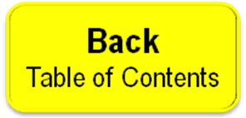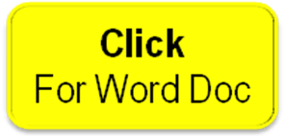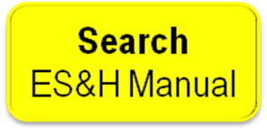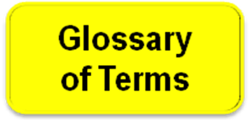

 | ISSUING AUTHORITY | TECHNICAL  POINT-OF-CONTACT | APPROVAL DATE | EFFECTIVE DATE | EXPIRATION DATE | REV.
 | ESH&Q Division | Bruce Ullman | 03/01/06 | 03/01/06 | 03/01/11 | 1
This document is controlled as an on line file. It may be printed but the print copy is not a controlled document. It is the user’s responsibility to ensure that the document is the same revision as the current on line file. This copy was printed on 7/28/2026.

Jefferson Lab Public Area Designation: CEBAF Center’s (Building 12) common areas, common rooms, and hallways are designated as a Public Area during core business hours Monday – Friday under the DOE Foreign Visits Program.

