 |  | TITLE: | ES&H Manual
DOCUMENT ID: | 6132 Appendix T3  Ladder Use on Scaffold or Elevated Platform

DRAFT
- Purpose

When a scaffold or other elevated work platform height is not adequate for a worker to safely reach a work area, the preferred method for elevating the worker is to add an additional level to the structure. When this is not feasible, Jefferson Lab allows a ladder to be used on the platform but only when specific requirements are met. This appendix provides these requirements.

- Scope

This appendix applies when a worker is on an elevated platform and is, by any means, elevated above the passive fall protection (i.e.: guardrails) system provided. (See ES&H Manual Chapter 6131 Fall Protection Systems for more information on passive fall protection.)

The process steps for this procedure are performed in coordination with ES&H Manual Chapter 6132 Ladder and Scaffold Safety.

- Responsibilities
NOTE: Management authority may be delegated at the discretion of the responsible manager.

  - Ladder/Scaffold Worker
- Complete SAF 307 Ladder Safety training before using a ladder on an elevated platform.
- Obtain authorization from the Competent Person – Scaffold or Supervisor prior to using a ladder on an elevated platform.
- Complete scaffold training (SAF 303 – Scaffold Safety) before using a ladder on a scaffold structure.

  - Competent Person – Scaffold/Supervisor
- Prior to authorizing the use of a ladder on a scaffold or elevated platform ensure an alternate method (e.g.: additional level, man-lift) is not feasible.
- Ensure platform setup meets fall protection requirements. (See also: ES&H Manual Chapter 6131 Fall Protection System.)

- Requirements

Unless otherwise stated only trained and qualified Ladder Workers may perform the process steps listed below.

  - Use of Ladder on Elevated Platform Requirements

- Examine the Platform:

- For All Structures: Ensure the passive fall protection (i.e.: guardrail) system on the working level of the platform meets or exceeds OSHA requirements; and all sides of the platform are protected. (Contact the Competent Person – Scaffold or Supervisor if system in inadequate.)

- For Scaffold Structure – Ensure the structure has been planned, selected, erected, and inspected in accordance with the requirements of ES&H Manual Chapter 6132 Appendix T2 Scaffolds.

- Inspect Ladder Equipment and Ensure Proper Use

- Inspect the ladder to be used in accordance with the requirements of ES&H Manual Chapter 6132 Appendix T1 Ladders.

- Ensure the “Highest Standing Level” (designated on the ladder’s Duty Rating Sticker) is adequate for the work.

- Set the Ladder Up

- Position the ladder at the location desired.

- Measure the distance from the ladder’s base to the nearest open platform edge.

IF | THEN
The distance from the ladder base to the nearest open platform edge (D₁) is less than the ladder’s highest standing level (D₂) plus 6 feet.   | Competent Person – Scaffold/Supervisor:  - Increase the top rail height of the guard rail to a distance adequate for the ladder’s highest standing level (D₂).  OR  - Incorporate another method of fall protection. (See ES&H Manual Chapter 6131 Fall Protection Systems.)
The distance from the ladder base to the nearest open platform edge (D₁) is greater than or equal to ladder’s highest standing level (D₂) plus 6 feet.   | Guardrail system, as designed, is considered adequate fall protection.
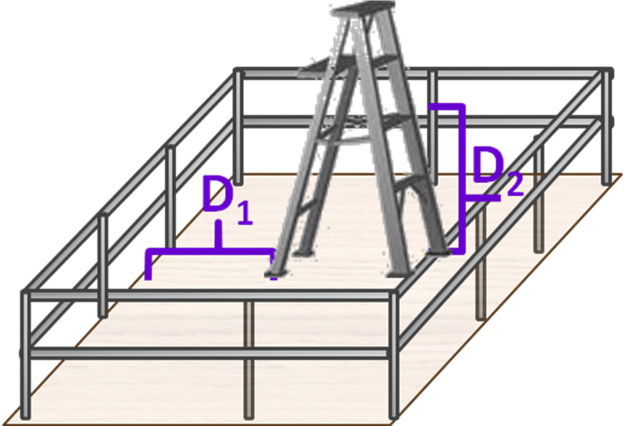

Figure 1: Ladder on Elevated Platform

- References

In all cases, when a ladder is used on a scaffold platform, the following mitigation is required in accordance with “29 CFR 1926 Subpart L 451(f)(15):
- When the ladder is placed against a structure which is not a part of the scaffold, the scaffold shall be secured against the sideways thrust exerted by the ladder;
- The platform units shall be secured to the scaffold to prevent their movement;
- The ladder legs shall be on the same platform or other means shall be provided to stabilize the ladder against unequal platform deflection, and
- The ladder legs shall be secured to prevent them from slipping or being pushed off the platform.”

- Revision Summary

Revision 0 – ##/##/## – This is new content.



 | ISSUING AUTHORITY | TECHNICAL  POINT-OF-CONTACT | APPROVAL DATE | EXPIRATION DATE | REV.
 | ESH&Q Division | Ned Walker |  |  | 0
This document is controlled as an on-line file. It may be printed but the print copy is not a controlled document. It is the user’s responsibility to ensure that the document is the same revision as the current on line file. This copy was printed on 7/31/2026.

Scaffold training is not required when using a ladder on a permanent elevated platform structure. These structures include but are not limited to: catwalks, decks, elevated open walkway, etc.

