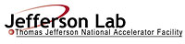 |  | TITLE: | ES&H Manual
DOCUMENT ID: | 6630 Appendix T1  Respirator Use and Approval Requirements

DRAFT
- Purpose

Respirators are required at Jefferson Lab when material substitution or engineering controls are not adequate to mitigate air contaminants to an acceptable level. This appendix provides the process step used to determine if a respirator is required; if required, how to determine the appropriate type; and how to obtain medical monitoring, training, and a fit test. Anyone may, at any time, request to use a respirator on a voluntary basis; however they must complete the process steps listed as if it were required, prior to use.

- Scope

This appendix applies to all respirators used at Jefferson Lab including those used during an emergency.

The process steps for this procedure are performed in coordination with ES&H Manual Chapter 6630 Respiratory Protection Program (Link to be established upon approval of document.)

- Responsibilities
NOTE: Management authority may be delegated at the discretion of the responsible manager.

  - Anyone at Jefferson Lab
- Determine if a respirator is required. Request an equipment/area hazard evaluation from Industrial Hygiene if you have concerns regarding air quality.
- Utilize alternate materials and engineering controls as recommended/required to avoid respirator use.
- Perform process steps as outlined to obtain a respirator.
- Obtain Occupational Medicine approval, as required.

  - Industrial Hygiene
- Perform an air quality evaluation when requested, or identified.
- Determine the appropriate respirator required.
- Provide fit-test, train, and certify individuals on its use.

- Process Steps

  - Determine if Respirator is Required

- Material Substitution
    - Evaluate the Task Hazard Analysis and related work control documents to determine if a less hazardous material can be used.

IF | THEN
An adequate substitution can be found. | Substitute the material and continue work.
An adequate substitution cannot be found. | Continue to Step 2.

- Engineering Controls
    - Review the Material Safety Data Sheet (MSDS). If the information is unclear or if you have concerns, request an air monitoring evaluation for the hazard.

IF | THEN
Engineering control(s) is recommended/required. | Ensure system(s) is in good repair and working adequately then continue work.
Engineering control(s) is not recommended or is unavailable. | Determine what is recommended; contact Industrial Hygiene for further assistance if necessary.

Examples of Engineering Controls:
- Exhaust Fans
- Glove Boxes
- Chemical Hoods
- Hepa Vacuums
- Mist Collectors
- Portable Welding Fume Hoods

  - Determine Respirator Type
If a respirator is required affected individual’s supervisor performs the following process steps:

- Complete the first section of the Respirator Use/Medical Approval Form.
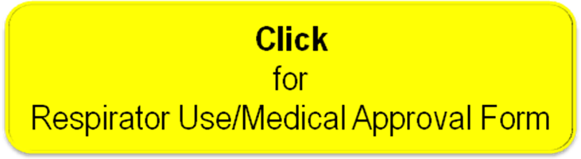Link to be established upon approval of document)
- Attach the MSDS for all hazardous materials of concern.

- Submit documentation to Industrial Hygiene.

Industrial Hygiene then performs the following process steps:

- Enter toxicology data for the material of concern.

- Perform a walk-through of the “Location” where work is to be performed.

- Determine the Class of respirator needed.

OR

Alternate Step 4: Determine engineering controls to be installed. (Go to ES&H Manual Chapter 3110 Facility Design and Modification Review.)

  - Medical Monitoring
Affected individual performs the following process steps to obtain Occupational Medical approval.

- Present to Occupational Medicine for an appropriate medical examination for the respirator class required (See ES&H Manual Chapter 6800 Occupational Medicine.)

IF | THEN
Medically approved. | Continue to Step 2.
Medically dis-approved. | Occupational Medicine will inform the individual and supervisor of the determination.

- Inform Industrial Hygiene of the results of the medical examination and schedule a fit-test for an appropriate respirator.

  - Fit Test
Industrial Hygiene provides the following:
- Training on appropriate Respirator (see box below for requirements).
- Fit-test to ensure proper fit.
- Cartridges – for use with the respirator (Industrial Hygiene will provide the cartridges.)

Self Contained Breathing Apparatus Requirements (SCBA) training (SAF109): Training Course: Self Contained Breathing Apparatus Requirements Booklet (Jefferson Lab Document); followed by written test.

Air Purifying Respirators (SAF200): Training Course: A Breath of Fresh Air, Coastal Cat. No. RESO6H booklet; followed by a written test.

Escape Pack Training (SAF210): Training Course: Classroom training; followed by written test.

- Voluntary Respirator Use

Jefferson Lab allows employees to wear respirators on a voluntary basis, when not required by OSHA. Anyone requesting the use of a respirator on a voluntary basis must complete the process steps listed above as if it were required, up to and including supervisor and medical approval. Employees must read and understand OSHA 29CFR 1910.134 Appendix D (Mandatory) Information for Employees Using Respirators When not Required Under Standard prior to use.

- Revision Summary

Revision 1 – ##/##/## – Updated to reflect current laboratory operations.

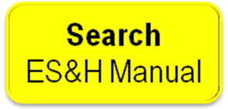

 | ISSUING AUTHORITY | TECHNICAL  POINT-OF-CONTACT | APPROVAL DATE | EXPIRATION DATE | REV.
 | ESH&Q Division | Jennifer Williams |  | Annual Review | 1
This document is controlled as an on line file. It may be printed but the print copy is not a controlled document. It is the user’s responsibility to ensure that the document is the same revision as the current on line file. This copy was printed on 7/31/2026.

Medical monitoring may not be required for voluntary use of a respirator dust mask. Contact Industrial Hygiene for further information and clarification of requirements.

